**Name: Anusha Amin**

**Class: BCS 6B**

**Registration No.: FA20-BCS-032**

**Date of submission: 25 March 2023**

**Mobile App Development**

**Assignment no. 2**

Q1. Explain built in functions of strings and arrays?

**Array Built in Functions**

**Array.prototype.filter():**

Filter() takes a function as an argument and returns a new array with all the elements in the original array that pass a certain condition defined by the function.

**Output:**

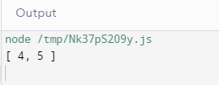

**Array.prototype.map():**

Map() takes a function as an argument and applies that function to every element in the array, creating a new array with the transformed values.

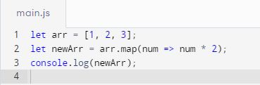

**Output:**

**Array.prototype.concat():**

This function is used to merge two or more arrays into a single array.

**Output:**

**Array.prototype.push():**

This function adds one or more elements to the end of an array.

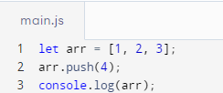

**Output:**

**Array.prototype.pop():**

This function removes the last element from an array.

**Output:**

**Array.prototype.shift():**

This function removes the first element from an array.

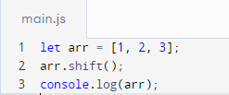

**Array.prototype.unshift():**

This function adds one or more elements to the beginning of an array.

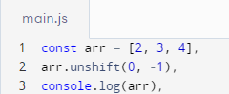

**Array.prototype.splice():**

This function adds or removes elements from an array.

**Array.prototype.slice():**

This function returns a new array that contains a portion of an existing array.

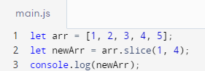

**Array.prototype.reverse():**

This function reverses the order of elements in an array.

**Array.prototype.sort():**

This function sorts the elements of an array.

**STRING FUNCTIONS**

**String.prototype.length:**

This property returns the number of characters in a string.

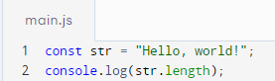

**String.prototype.charAt():**

This function returns the character at a specified index in a string.

**String.prototype.indexOf():**

This function returns the index of the first occurrence of a specified value in a string.

**String.prototype.lastIndexOf():**

This function returns the index of the last occurrence of a specified value in a string.

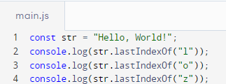

**String.prototype.slice():**

This function returns a portion of a string.

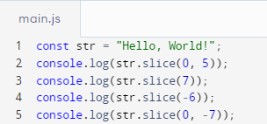

**String.prototype.substring():**

This function returns a portion of a string.

**String.prototype.replace():**

This function replaces a specified value with another value in a string.

**String.prototype.toLowerCase():**

This function converts a string to lowercase.

**String.prototype.toUpperCase():**

This function converts a string to uppercase.

**String.prototype.trim():**

This function removes whitespace from both ends of a string.

**String.prototype.split():**

Splits a string into an array of substrings based on the specified separator.

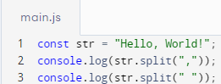

**Chessboard Design**

**Component Code (ChessBoard.js)**

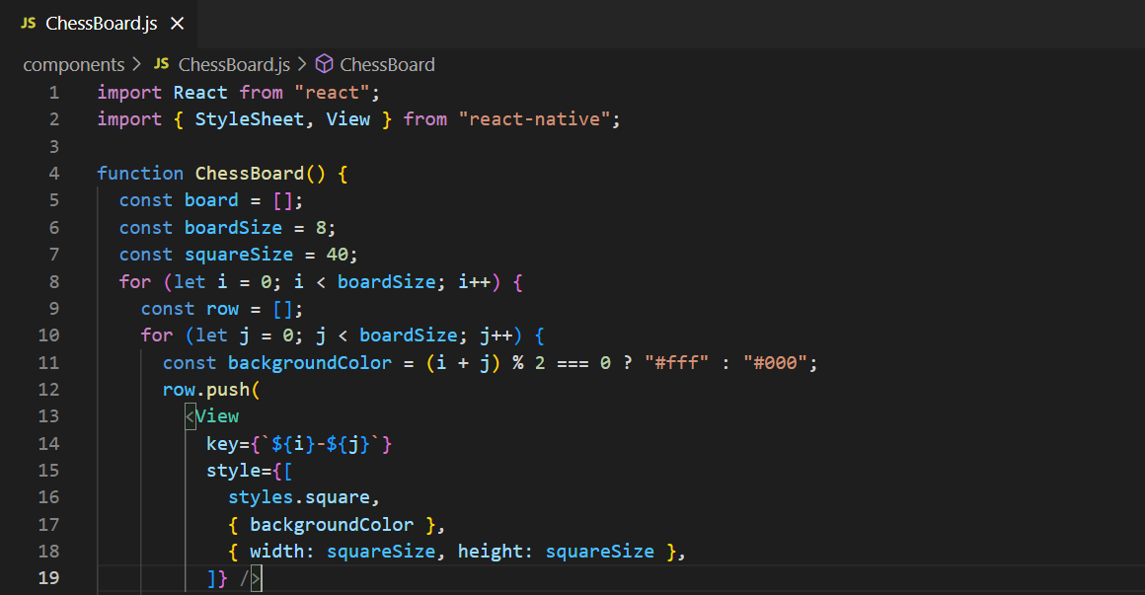

**App.js**