***Task 1: Create a set of four questions that you anticipate each business leader will ask and want to know the answers to. Make sure you differentiate your questions, as both the CEO and CMO view business decisions through different lenses.***

My Answers

CEO:

1. Which region offers highest sales value to our organization?

2. Which region are underperforming or are lowest?

3. How much revenue do our top 100 customers generate? How to retain them by providing more rich customer experience?

4. How can we optimize our product inventory based on sales trends to reduce overhead cost and avoid stockouts?

CMO:

1. Best selling and under selling products for each region? How can we promote best selling products in underperforming regions? What promotions helped us achieve best selling products.

2. Which regions has low conversation rates? How to improve them?

3. How to align our marketing strategies to align with seasonal trends?

4. What are the characteristics of customers who make repeated purchase? How to retain them?

Expected Answers

**Questions of interest to the CEO**

**Which region is generating the highest revenue, and which region is generating the lowest?**  
This question is important to the CEO as it is based on the fundamental source of income for the business, i.e., revenue. Revenue analysis is important to the CEO as top-level executives are always focused on earnings and how to increase it. Here, the CEO is interested in the viewing revenue by the regions, to assess which regions are generating the highest revenue and which regions are generating lower revenue. Using the data and  
analysis, the CEO will be able to decide on how to further generate revenue in the regions that are already generating the most revenue. For the regions that are not generating enough revenue, the CEO will then study the reasons why there is a lack of sales in those regions and try to improve the products and make them more suitable for those regions.

**What is the monthly trend of revenue, which months have faced the biggest increase/decrease?**  
A monthly trend of revenue will provide the CEO with insights on how the revenue is fluctuating each month. This will enable the CEO to analyze how the internal changes inside the company have had impact on the sales. E.g., how a new product launch has led to an increase in revenue during the month or how the introduction of a new region has led to an increase in revenue for the online store. The CEO can also analyze if there have been any delays internally that would have caused a potential decrease. Such analysis is vital for the senior management as it would enable them to plan ahead and try to make the customer experience as smooth as possible.

**Which months generated the most revenue? Is there a seasonality in sales?**  
In retail businesses, there are always months that will have a greater demand due to seasonality. There will be cases where the data will experience regular and predictable changes that recur every calendar year. Such seasonal months would be necessary to identify as the CEO would be interested in devising a strategy that would gain the maximum benefit from the months that have greater demands.

**Who are the top customers and how much do they contribute to the total revenue? Is the business dependent on these customers or is the customer base diversified?**  
This analysis is highly important as it would enable the CEO to identify what the main drivers are behind the total revenue. Looking at the top customers of the retail store would provide an idea of which customers are  
contributing the most to the revenue. The store can then derive a strategy where the top customers can be targeted with more products that they can buy. This will ensure higher revenue for the store as these customers  
are the top buyers from the store. Although having fewer customers buying in high volumes can be beneficial for a business, there can also be a drawback. Retailers would have less bargaining power with these customers because they drive the majority of the revenue for the store and can negotiate lower prices. The CEO needs to be notified of the diversification of the customers so that he can plan ahead of time. In cases wehre the business is highly dependent on a few customers, the plan would be to increase the customer base and target more customers that would bring more revenue to the store.

**Questions of interest to the CMO**

**What is the percentage of customers who are repeating their orders? Are they ordering the same products or different?**  
This question shows that the CMO is interested in viewing the trends in customer orders. He is interested to know how many customers out of the total are coming back to them and re-ordering. This analysis will help explain to the CMO what percentage of customers are buying from them more than once. Once this is identified, the CMO can come up with a strategy to target these customers with more offers and products that they would need. The analysis will also be done to see what they are buying the second time, this will provide the CMO trends into what products and sub products are in demand and then a marketing strategy can be devised to target these customers with better options.

**For the repeat customers, how long does it take for them to place the next order after being delivered the previous one?**  
This analysis will help the CMO identify the frequency of orders. This would mean determining how long the customers are taking to re-order from the store. The expectation is that those customers who have recently made a purchase would have the product on their mind and are expected to purchase or use the product again in the future. Once the information is gathered from the analysis, the CMO can create a strategy to get the recent customers to revisit the business and spend more. For the customers who have not made purchases again from the store, efforts can be made to remind them that it has been a while since they last purchased from the store. Incentivizing customers also comes into play in this scenario.

**What revenue is being generated from the customers who have ordered more than once?**  
Revenue stems from how much the customer spends to purchase the products from the store. Therefore, the analysis needs to be done to determine how much revenue is being generated from the customers who are regular buyers from the store. The CMO can devise a strategy to encourage customers who spend more money on repeat purchases to continue to do so. It is also important to note that if a customer has made a big purchase the first time, they should be encouraged to come and shop from the store again. A marketing strategy will ensure that the high paying customers will continue to bring more revenue to the store going forward, as well.

**Who are the customers that have repeated the most? How much are they contributing to revenue?**  
It is also important to assess which customers are repeating the most and how much are they contributing to the revenue. There would be customers who need the same products on a weekly or monthly basis, however, the products do not have a high monetary value. Therefore, the contribution to revenue for these customers will be low. On the other hand, there might be customers who are ordering twice a year and have very big orders in terms of revenue. These customers buy on certain months only, therefore, the management needs to ensure that enough supplies are available to accommodate their orders. The customers will high order volumes and low revenue would need to be offered more discounts so that they can buy in bulk and lead to more revenue.

**Task 2: Choosing Right visuals**

<https://www.analyticsvidhya.com/blog/2021/09/how-to-choose-the-right-chart-for-data-visualization/>

<https://towardsdatascience.com/a-comprehensive-guide-to-the-grammar-of-graphics-for-effective-visualization-of-multi-dimensional-1f92b4ed4149>

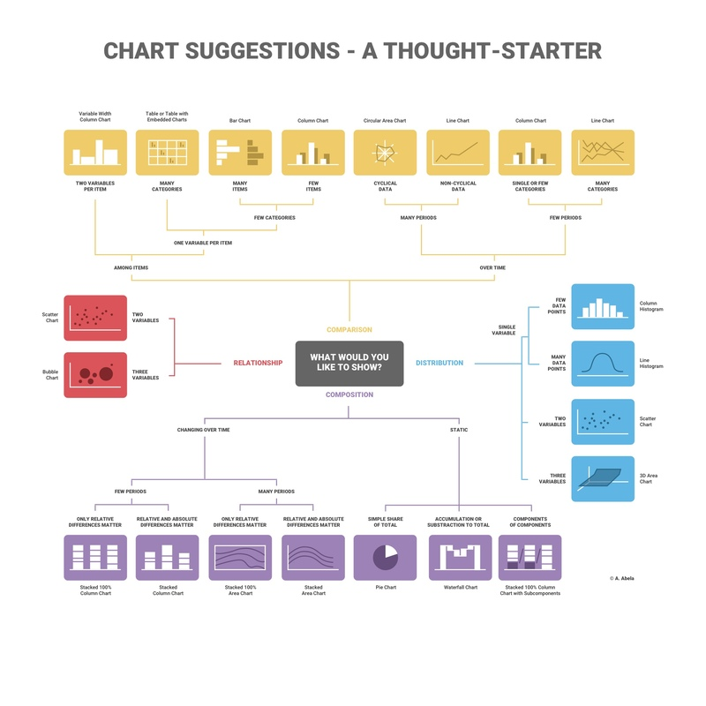

<https://infogram.com/blog/choose-the-right-chart/>

<https://towardsdatascience.com/ultimate-guide-to-choosing-the-right-visual-2a77aa8eec08>

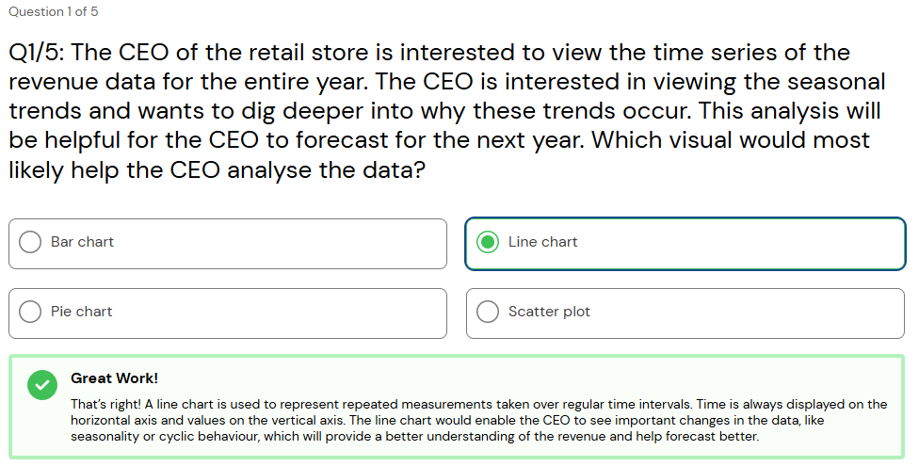

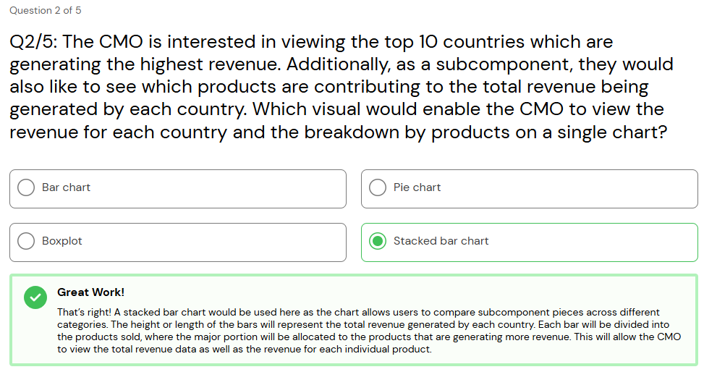

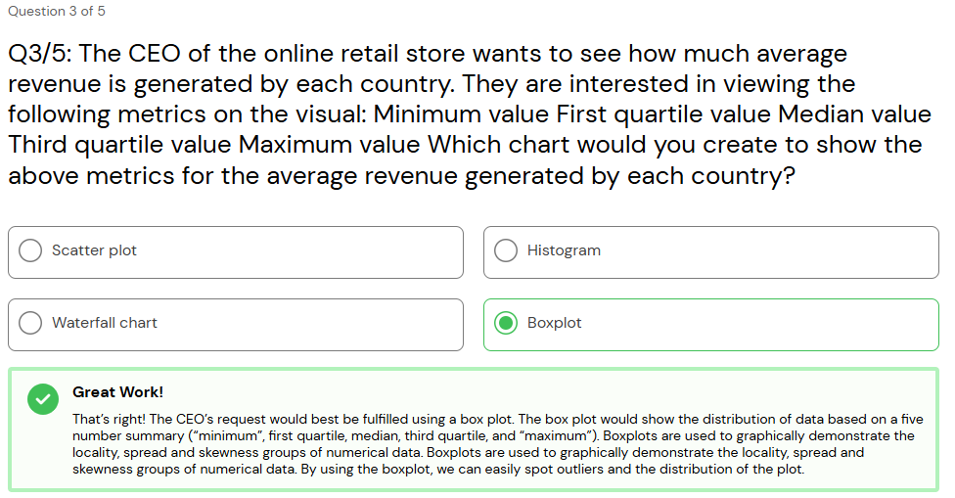

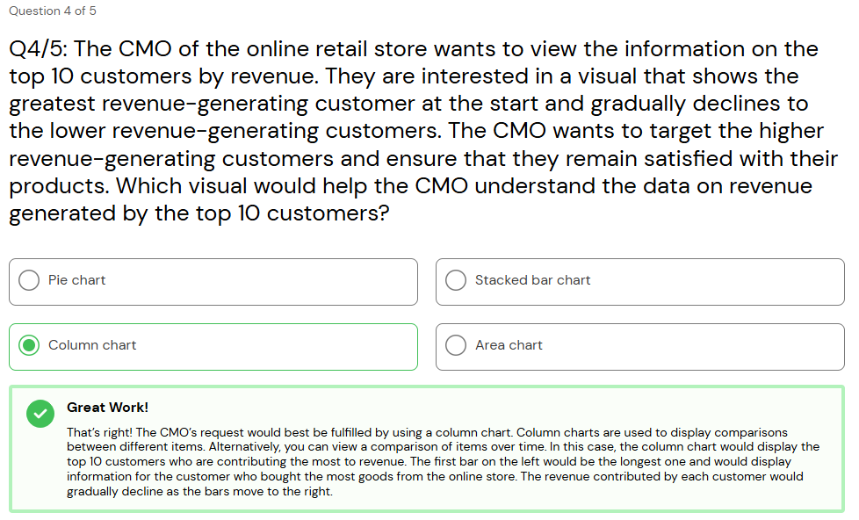

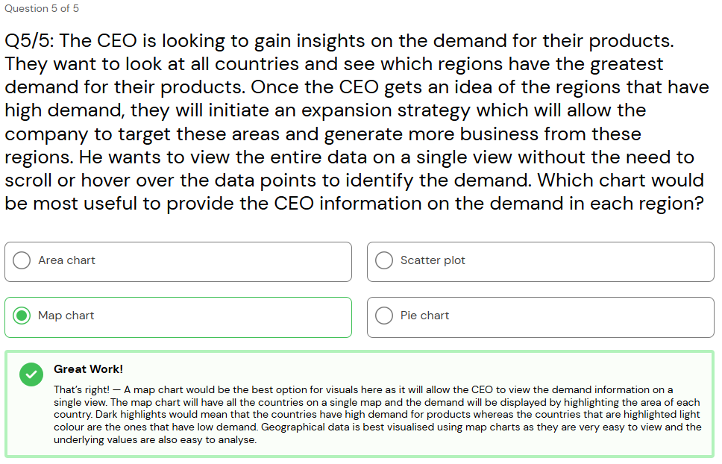

Task 3: Creating effective visuals

1. Data Cleanup
2. Create a check that the quantity should not be below 1 unit
3. Create a check that the Unit price should not be below $0

Cleaning data on Google Collab

1. Making Visuals using power bi

Question 1

The CEO of the retail store is interested to view the time series of the revenue data for the year 2011 only. He would like to view granular data by looking into revenue for each month. The CEO is interested in viewing the seasonal trends and wants to dig deeper into why these trends occur. This analysis will be helpful for the CEO to forecast for the next year.

Question 2

The CMO is interested in viewing the top 10 countries which are generating the highest revenue. Additionally, the CMO is also interested in viewing the quantity sold along with the revenue generated. The CMO does not want to have the United Kingdom in this visual.

Question 3

The CMO of the online retail store wants to view the information on the top 10 customers by revenue. He is interested in a visual that shows the greatest revenue generating customer at the start and gradually declines to the lower revenue generating customers. The CMO wants to target the higher revenue generating customers and ensure that they remain satisfied with their products.

Question 4

The CEO is looking to gain insights on the demand for their products. He wants to look at all countries and see which regions have the greatest demand for their products. Once the CEO gets an idea of the regions that have high demand, he will initiate an expansion strategy which will allow the company to target these areas and generate more business from these regions. He wants to view the entire data on a single view without the need to scroll or hover over the data points to identify the demand. There is no need to show data for the United Kingdom as the CEO is more interested in viewing the countries that have expansion opportunities.

Answering these questions

Task 4: Creating a presentation to present before ceo and cmo