TEAM 16

|  |  |  |  |
| --- | --- | --- | --- |
| SL.NO | NAME | USN | ROLL.NO |
| 1 | ANUSHA.G | 01FE20EC307 | 537 |

TIC TAC TOE GAME IN VERILOG

Introduction

TIC TAC TOE GAME is a very popular paper-and-pencil game in a 3x3 grid for two players. The player who makes the first three of their marks in a diagonal, vertical, or horizontal row wins the game.



The player/ computer wins the game when successfully placing three similar values in the following row pairs:- (1,2,3); (4,5,6); (7,8,9); (1,4,7); (2,5,8); (3,6,9); (1,5,9); (3,5,7)

|  |  |  |
| --- | --- | --- |
| 1 | 2 | 3 |
| 4 | 5 | 6 |
| 7 | 8 | 9 |

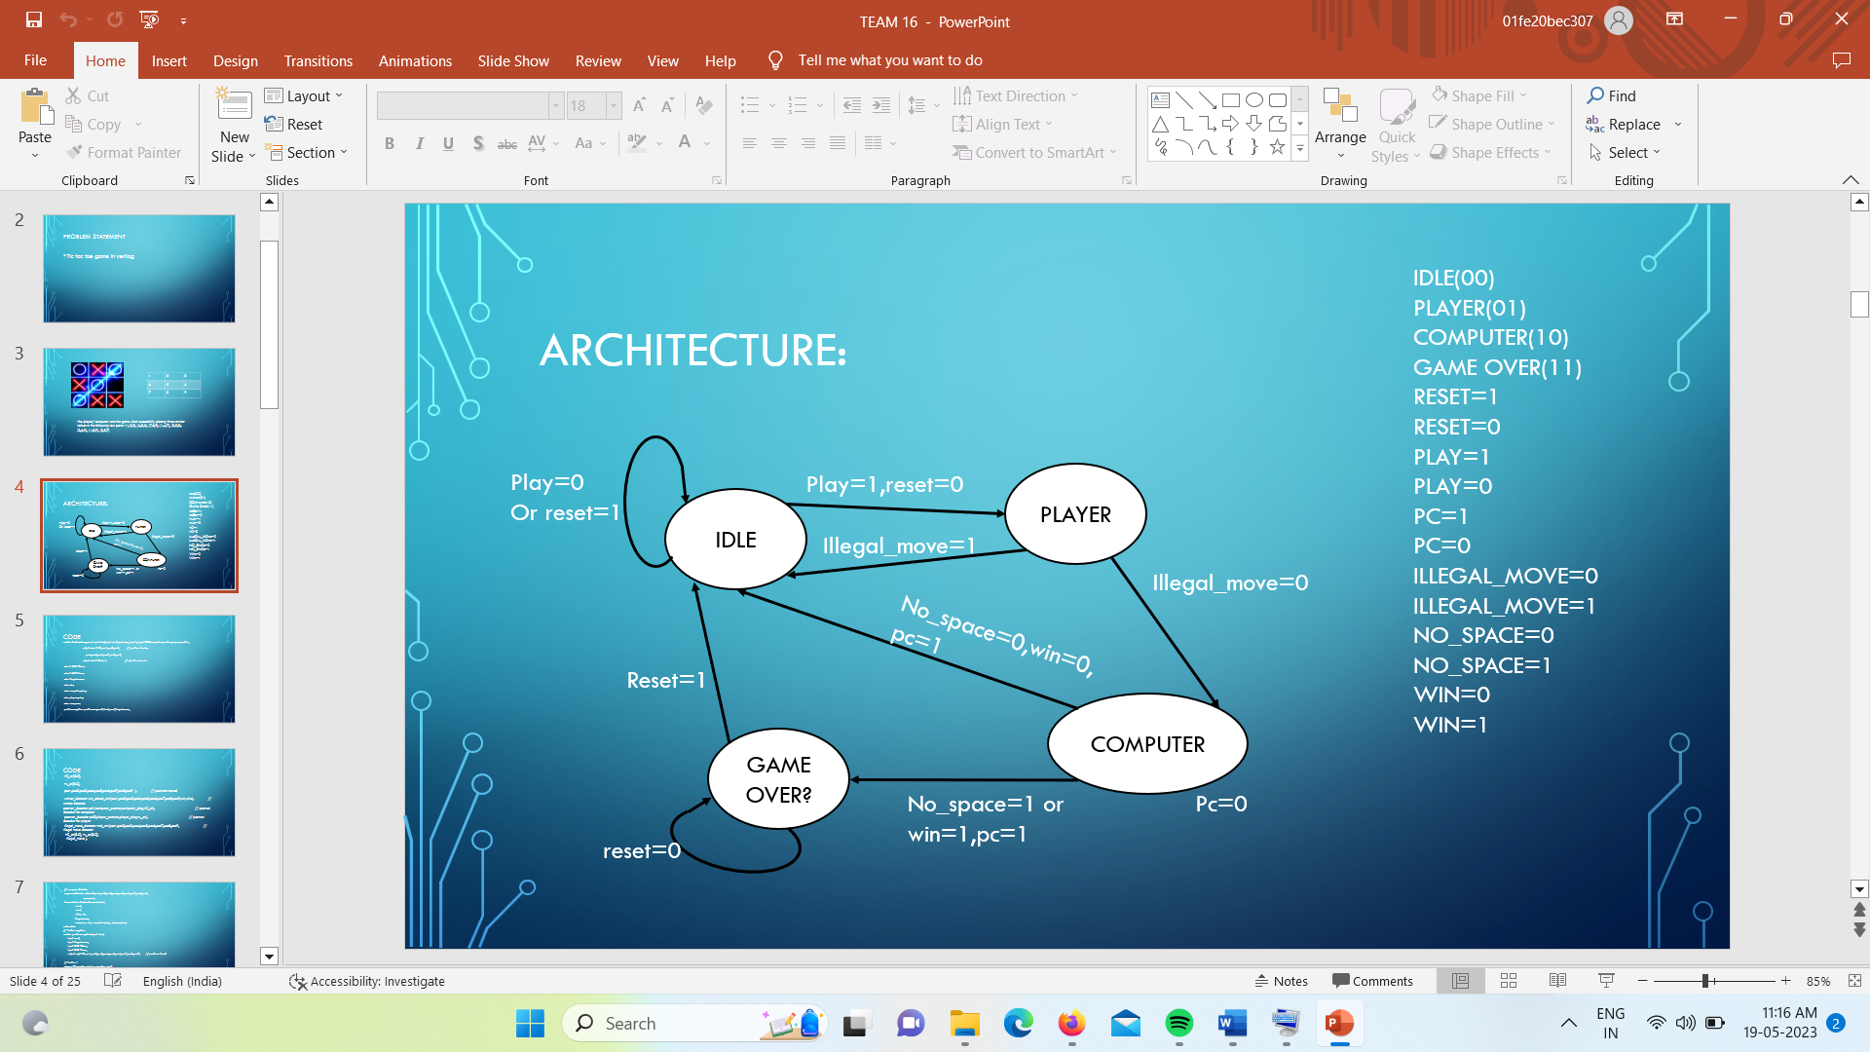

1. IDLE(00): when waiting for the player/ computer to play or when resetting the circuit, the FSM is at the IDLE state.

2. PLAYER(01): The player turns to play and “01” to be stored into the decoded position.

3. COMPUTER(10):

The computer turns to play and “01” to be stored into the decoded position.

4. Game_over(11): The game is finished when there is a winner or no more space to play.

Inputs of the controller of the Tic Tac Toe game:

a. Reset :

Reset = 1: Reset the game when in the Game_Over state.

Reset = 0: The game begins.

b. Play:

Play = 1: When in the IDLE state, play = 1 is to switch the controller to the PLAYER state and the player plays.

Play =0: Stay in the IDLE state.

c. PC

PC = 1: When in COMPUTER state, PC = 1 is to switch to the IDLE state and the computer plays.

PC =0 : stay in COMPUTER state.

d. Illegal_move

Illegal_move = 0: When in PLAYER state, Illegal_move = 0 is to switch to COMPUTER state and let computer plays when PC = 1.

Illegal_move = 1: Illegal moving from the player/ computer and switch to the IDLE state.

e. No_space

No_space = 0: still have space to play, continue the game.

No_space = 1: no more space to play, game over, and need to reset the game before playing again.

f. Win

Win = 0: Still waiting for the winner

Win = 1: There is a winner, finish the game, and need to reset the game before playing again.

**RESULTS**

