NAME- **Anusha Garg**

ROLLNO- **16121**

COURSE- **B.Sc. (Hons) Computer Science**

SUBJECT- **DBMS**

**Practical Question-1 : Writing SQL Commands:**

**Creating and using database schema ‘student_society’**



**Creating three tables- STUDENT, SOCIETY, ENROLLMENT**

1. **STUDENT**

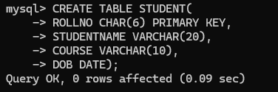

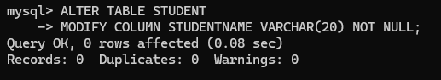

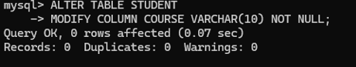

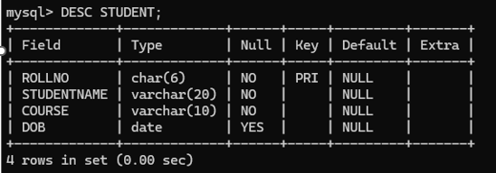

1. SOCIETY

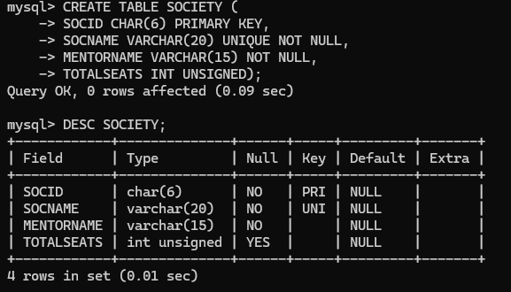

1. ENROLLMENT

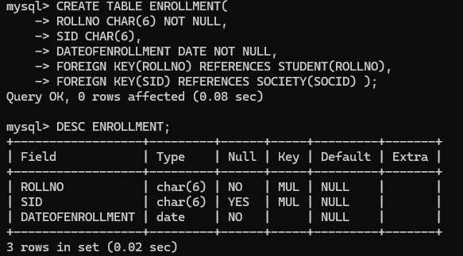

**Inserting values into the tables**

 

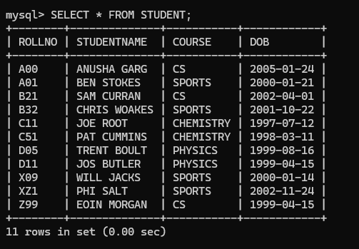



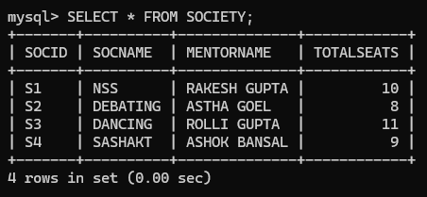

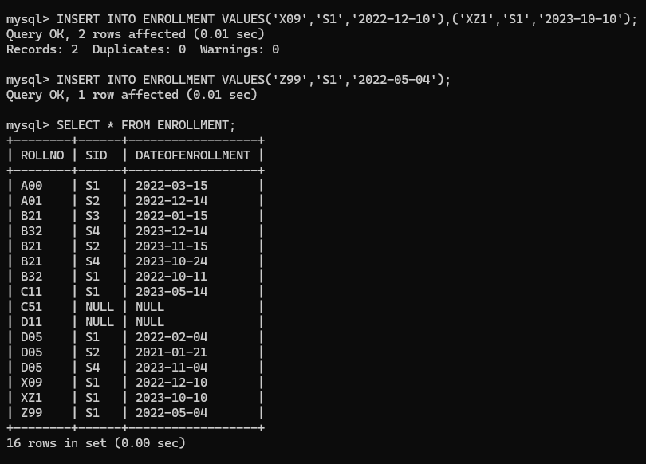

**APPLYING QUERIES:**

1. **Retrieve names of students enrolled in any society.**

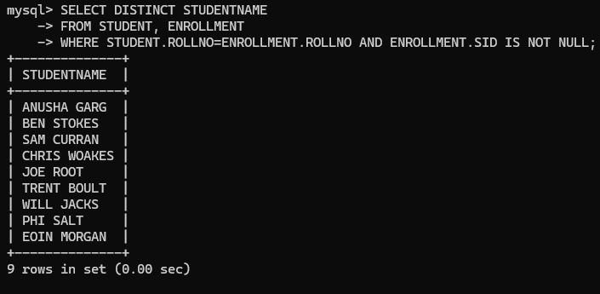

1. **Retrieve all society names.**

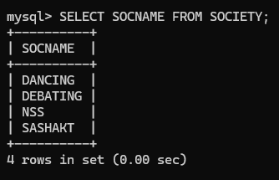

1. **Retrieve students' names starting with letter ‘A’.**

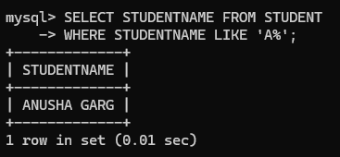

1. **Retrieve students' details studying in courses ‘computer science’ or ‘chemistry’.**

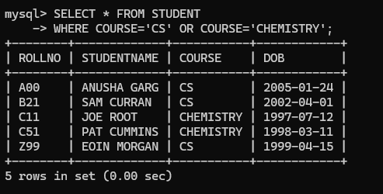

1. **Retrieve students’ names whose roll no either starts with ‘X’ or ‘Z’ and ends with ‘9’.**

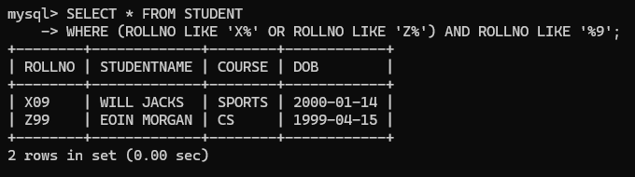

1. **Find society details with more than N Total Seats where N is to be input by the user.**

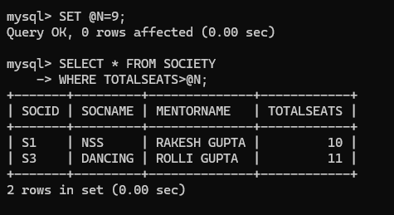

1. **Update society table for mentor name of a specific society.**

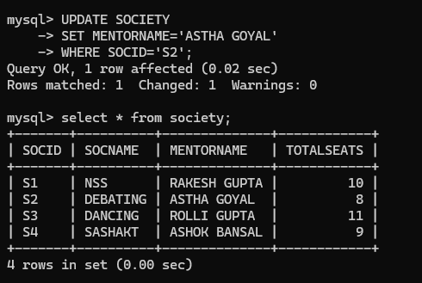

1. **Find society names in which more than five students have enrolled.**

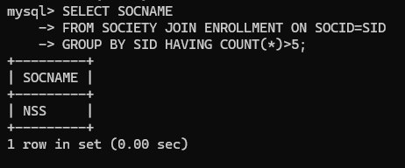

1. **Find the name of youngest student enrolled in society ‘NSS’.**

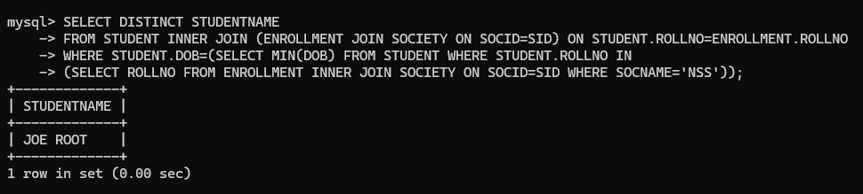

1. **. Find the name of most popular society (on the basis of enrolled students).**

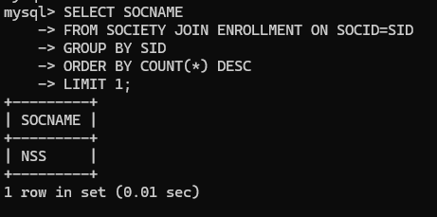

1. **Find the name of two least popular societies (on the basis of enrolled students).**

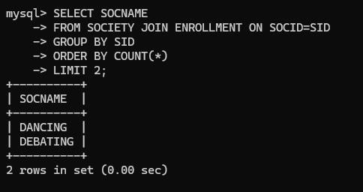

1. **Find the student names who are not enrolled in any society.**

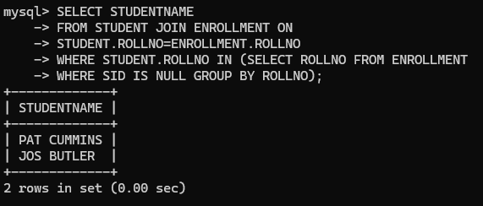

1. **Find the student names enrolled in at least two societies.**

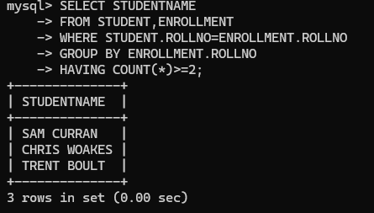

1. **Find society names in which maximum students are enrolled.**



1. **Find names of all students who have enrolled in any society and society names in which at least one student has enrolled.**

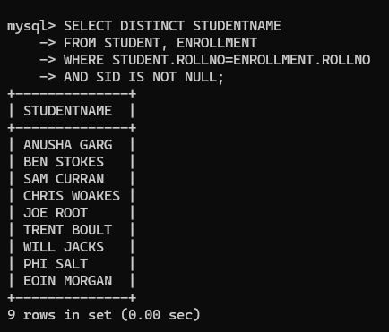

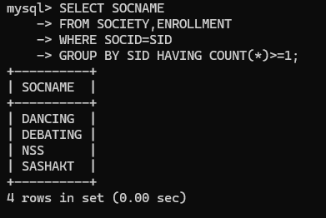

1. **Find names of students who are enrolled in any of the three societies ‘Debating’, ‘Dancing’ and ‘Sashakt’.**

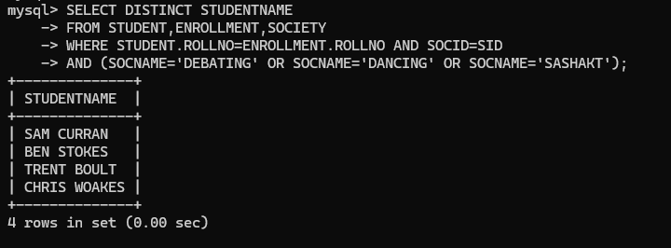

1. **Find society names such that its mentor has a name with ‘Gupta’ in it.**

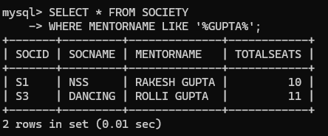

1. **Find the society names in which the number of enrolled students is only 10% of its capacity.**

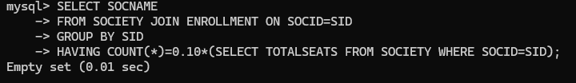

1. **Display the vacant seats for each society.**

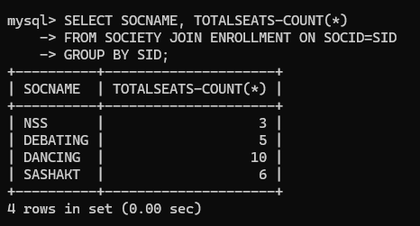

1. **Increment Total Seats of each society by 10%.**

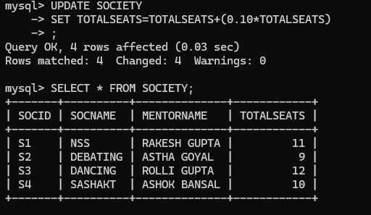

1. **Add the enrollment fees paid (‘yes’/’No’) field in the enrollment table.**

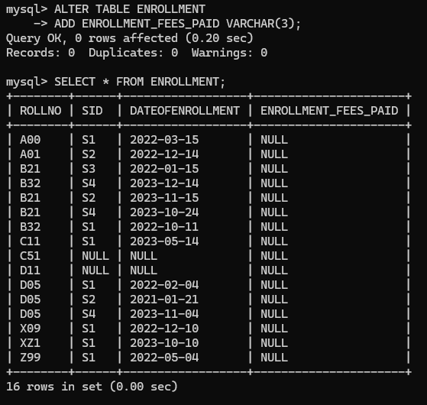

1. **Update date of enrollment of society id ‘s1’ to ‘2018-01-15’, ‘s2’ to current date and ‘s3’ to ‘2018-01-02’.**

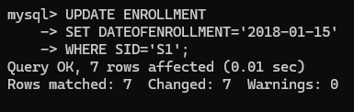

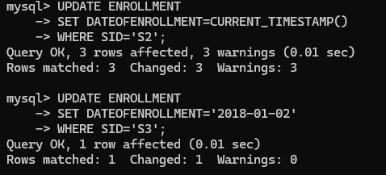

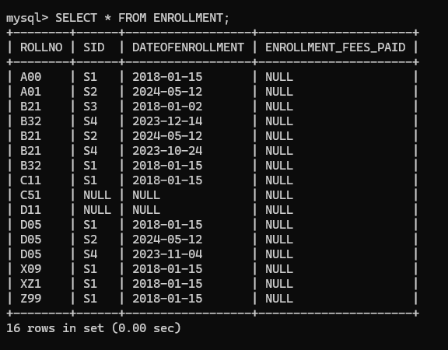

1. **Create a view to keep track of society names with the total number of students enrolled in it.**

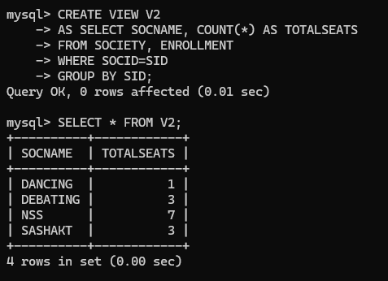

1. **Find student names enrolled in all the societies.**

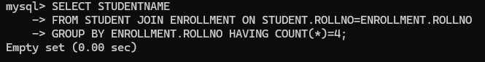

1. **Count the number of societies with more than 5 students enrolled in it.**

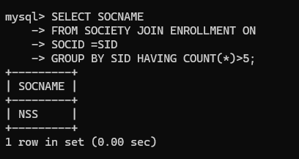

1. **Add column Mobile number in student table with default value ‘9999999999’.**

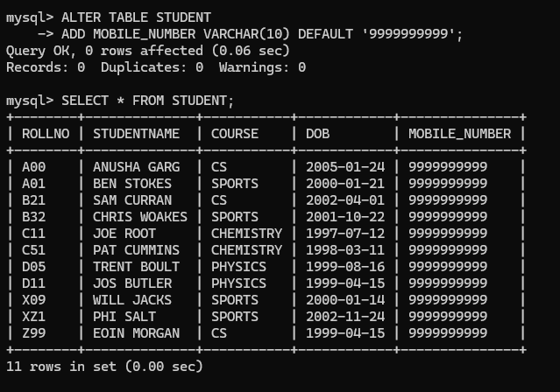

1. **Find the total number of students whose age is > 20 years.**

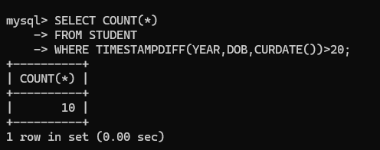

1. **Find names of students who are born in 2001 and are enrolled in at least one society.**

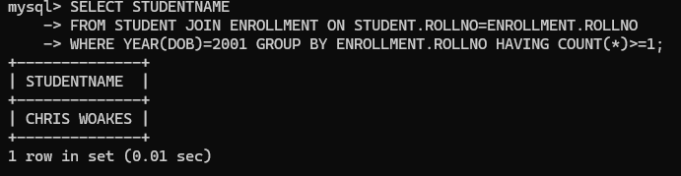

1. **Count all societies whose name starts with ‘S’ and ends with ‘t’ and at least 5 students are enrolled in the society.**

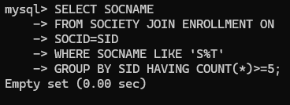

1. **Display the following information:**

**Society name Mentor name Total Capacity Total Enrolled Unfilled Seats**

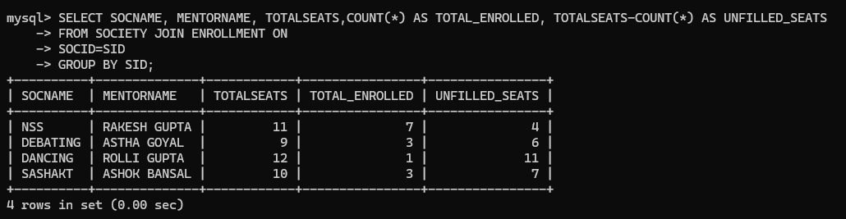

**-Anusha Garg**

**16121**