

**AWS Project**

Group : Fantastic 4!

Members:

1. Anusha Udaya Hegde ([hegde_anusha@lilly.com](mailto:hegde_anusha@lilly.com))

2. V Vidya Priya ([priya_v_vidya@lilly.com](mailto:priya_v_vidya@lilly.com))

3. Bhoomika SK ([s_k_bhoomika@lilly.com](mailto:s_k_bhoomika@lilly.com))

4. Shireesha mudawath ([mudawath_shireesha@lilly.com](mailto:mudawath_shireesha@lilly.com) )

1. Creating VPC

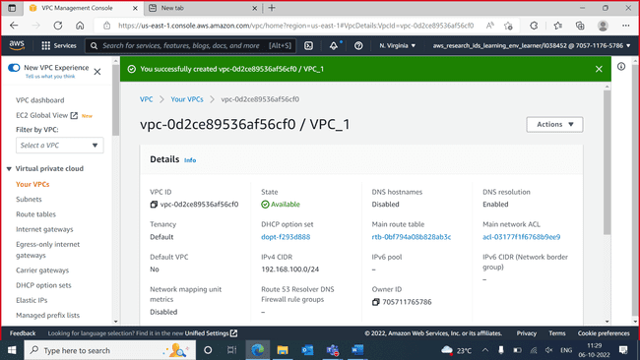

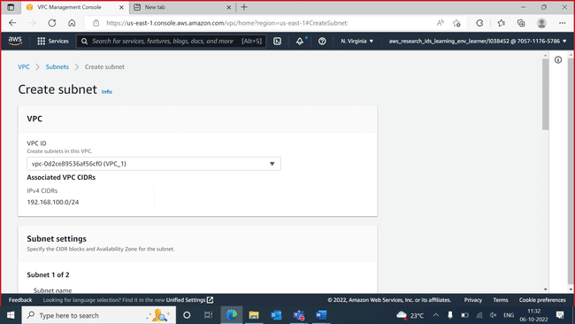

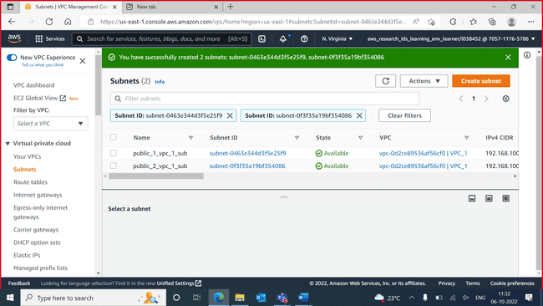

Private subnets

Route table for public

Route table for private

Internet gateway for public subnets

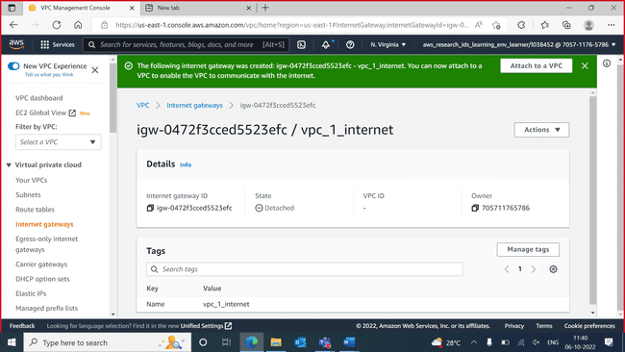

Adding internet route to public route table

Created NAT gateway for the private subnet

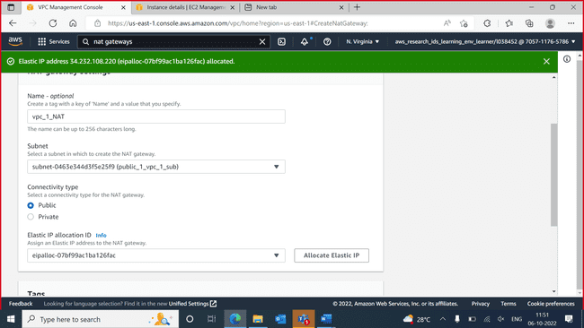

INSTANCES

1. Public -1

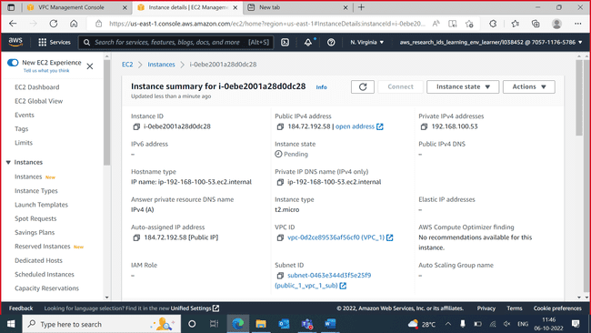

Public-2

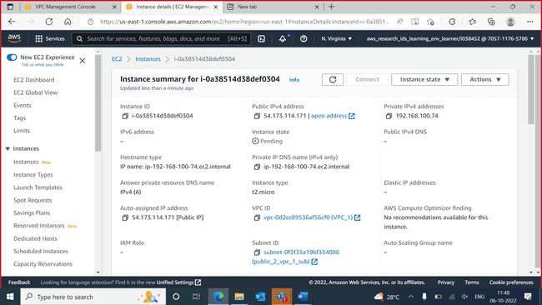

Private-1

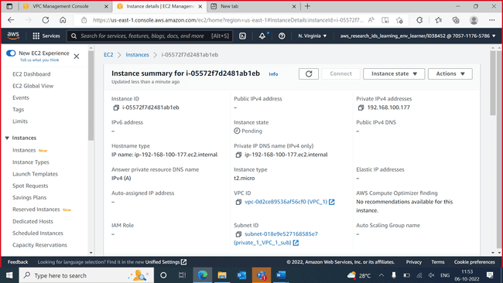

Private-2

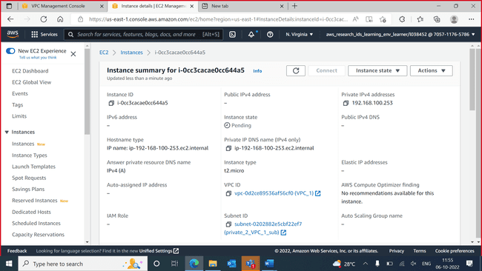

Public instance working

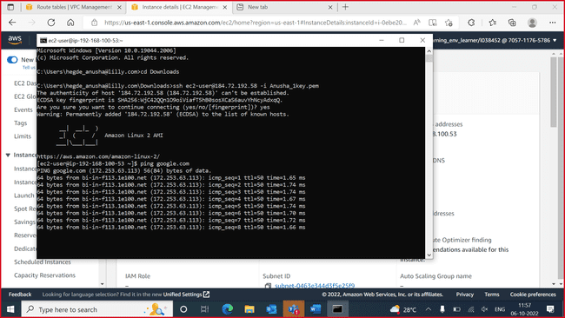

Transferring the pem file from system to public machine

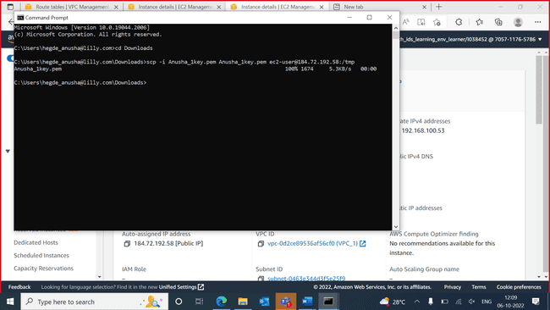

Private machine has no internet now

Creating image for public instance

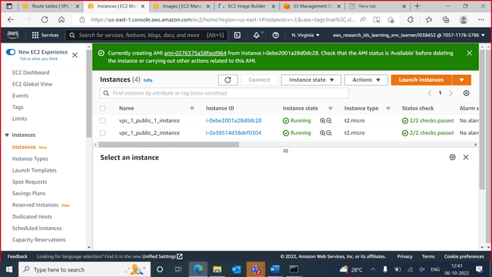

AMI created

AMI template created

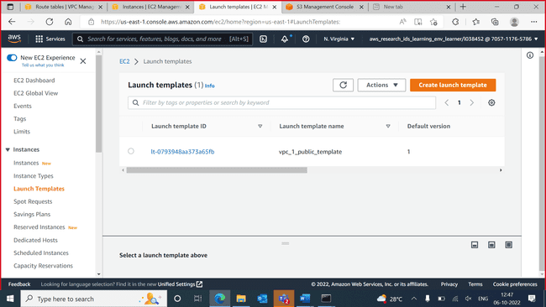

Autoscalling grp

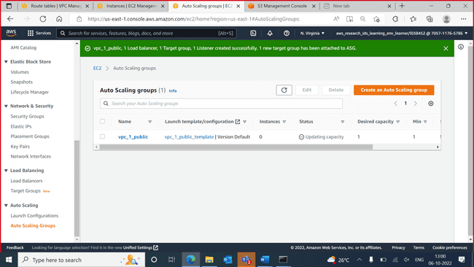

Dynamic scaling policy created

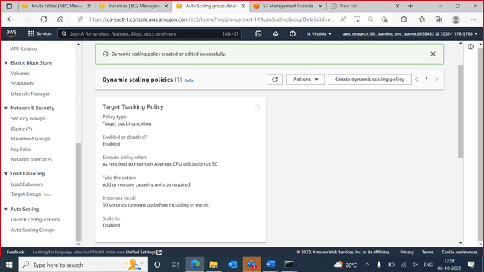

After autoscaling 🡪new instance is automatically created 🡪 delete previously created 2 public instances

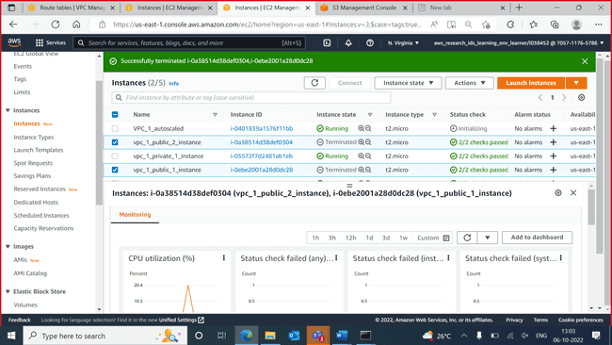

Instance created doesn’t have an public IP so we edited the template 🡪 put enable 🡪 then under auto scaling 🡪 details 🡪 put 2 versions

Autoscaled to 5 instances

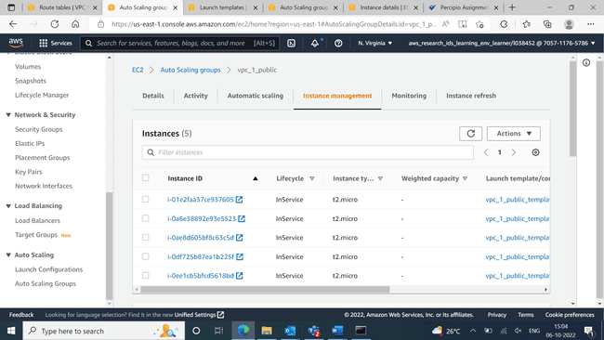

Endpoint created

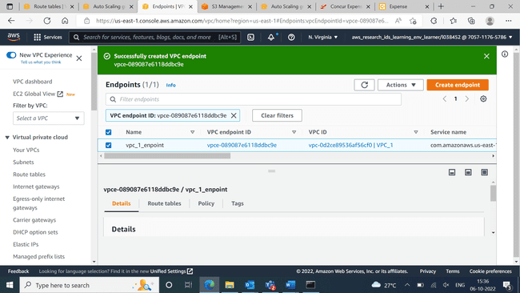

RDS creation

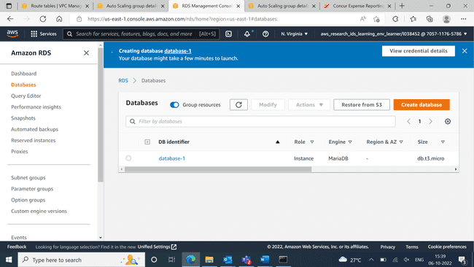

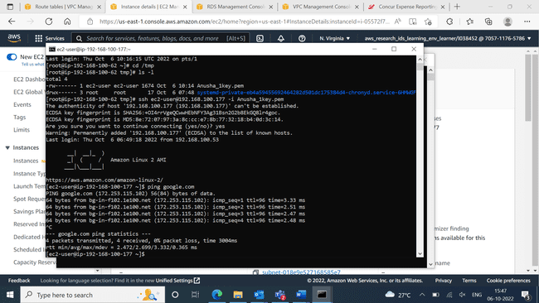

Connection to MariaDB

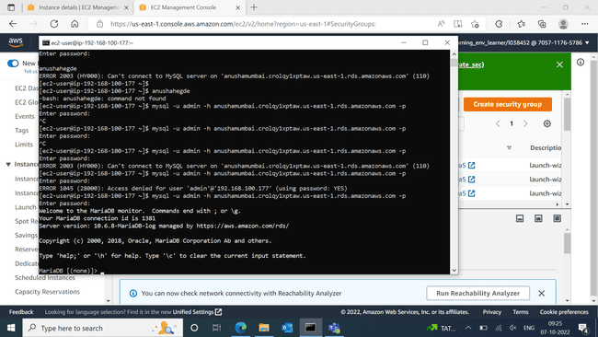

S3 bucket

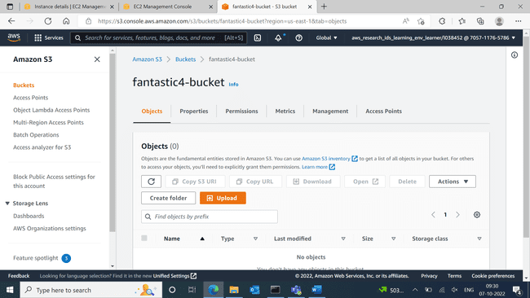

Lambda function creation

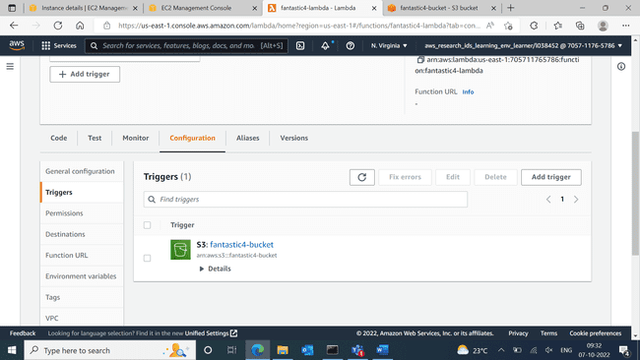

Table creation in DynamoDB

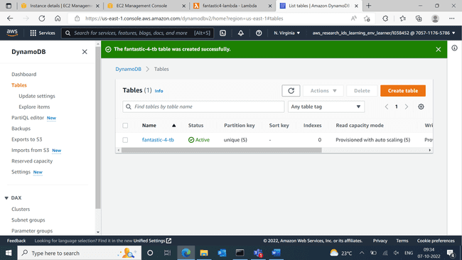

Uploading files in bucket

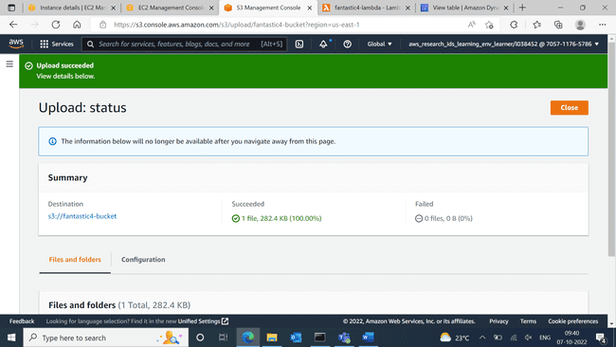

Lambda

Lambda code

Files displayed over DynamoDB

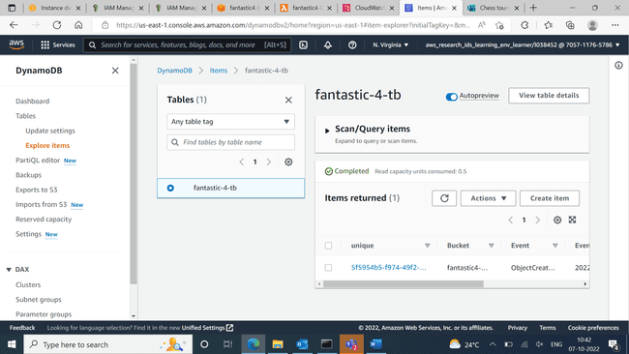

New policy created for mounting

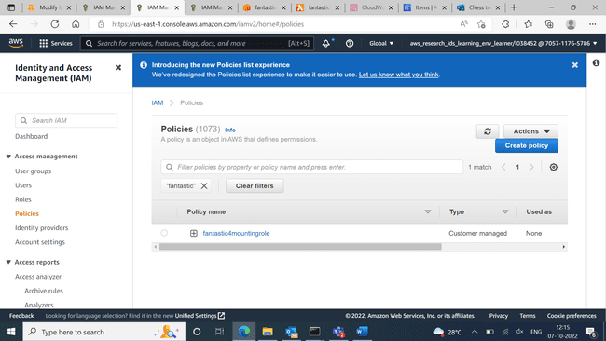

Mounted successfully over the instance

Second VPC created

2 subnets created for VPC 2

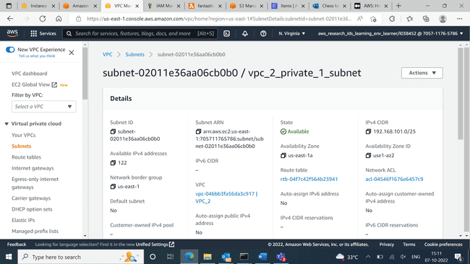

Route table for VPC – 2

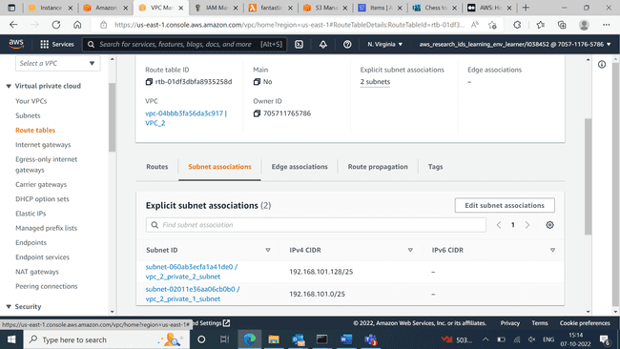

VPC peering between 2 VPCs

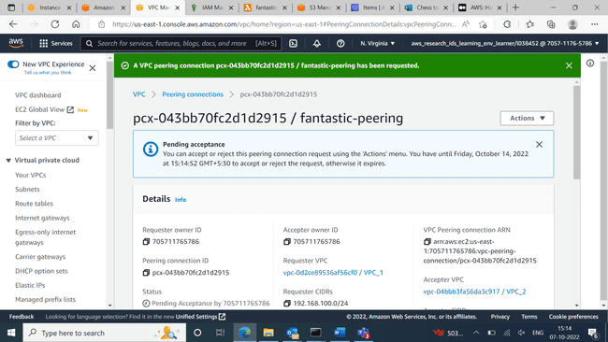

2 private Instance created for VPC 2

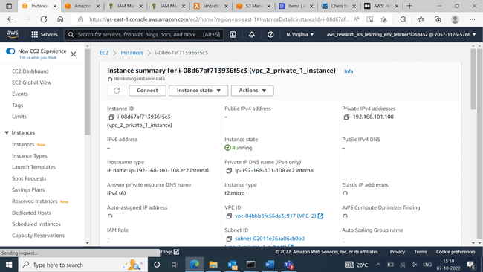

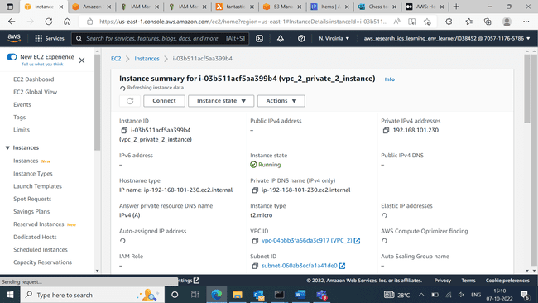

Route table entries of VPC peering

Route table – private 1 of VPC -1

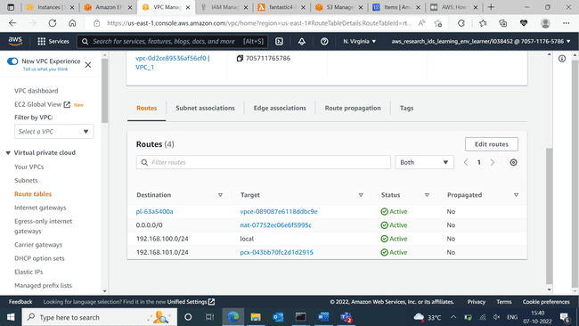

Route table – private 2 of VPC -1

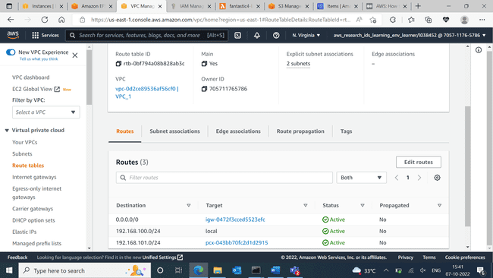

Route table – private of VPC – 2

After VPC peering, private instances of VPC 2 pinging

EFS created

EFS mounted into 1st private instance of VPC 2

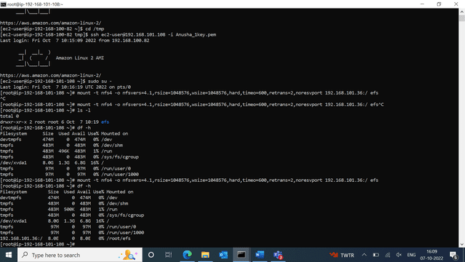

EFS mounted into 1st private instance of VPC 2

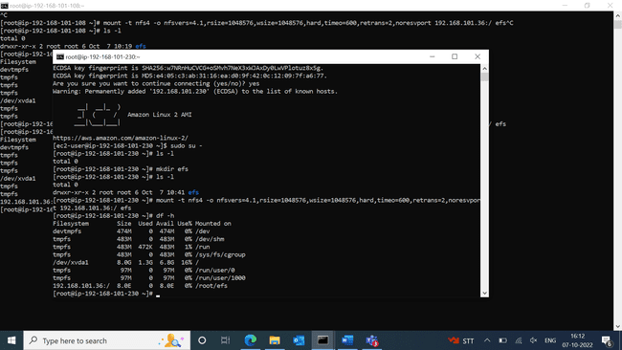

Created a new bucket

Uploaded csv file into new bucket

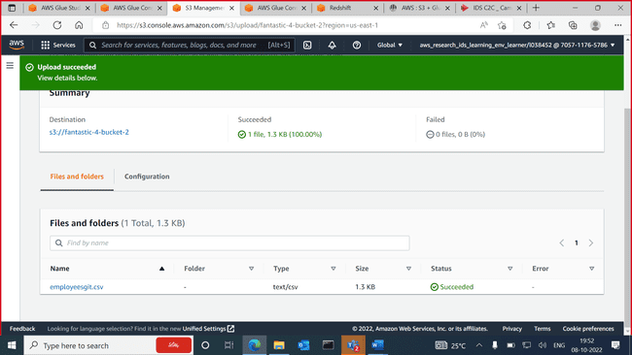

New database created under glue

Crawler

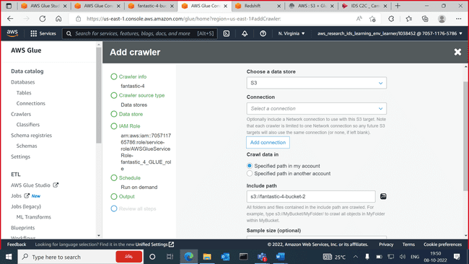

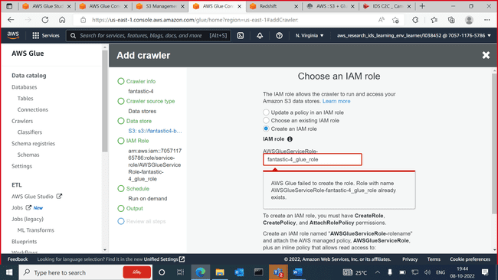

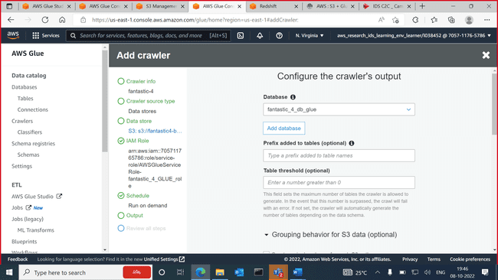

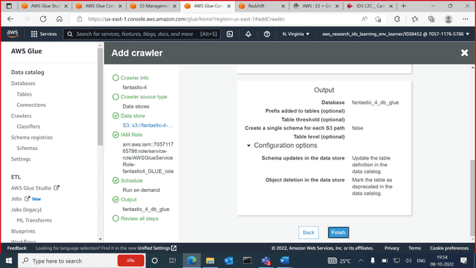

Crawler created for the new S3 bucket

Run crawler

Status 🡪 starting

Status 🡪 stopping

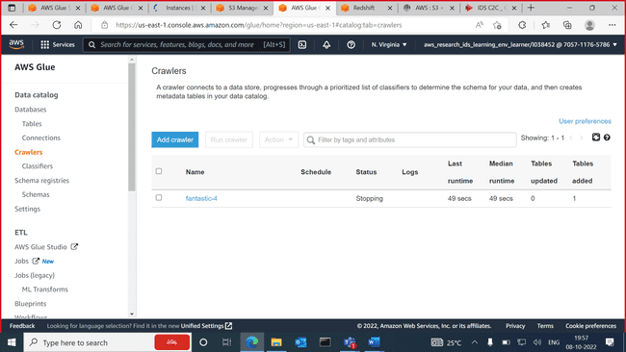

Under tables our bucket is visible

Csv file uploaded can be seen -

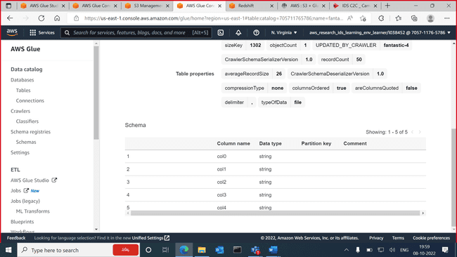

Edited the schema of the table

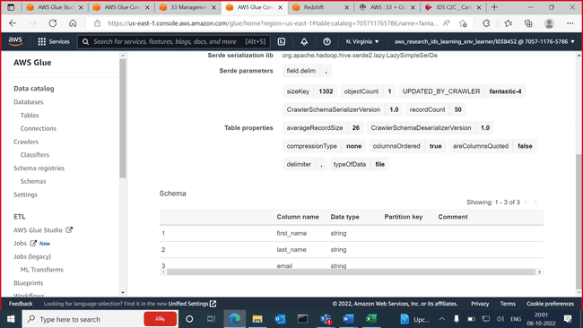

Athena – query editor

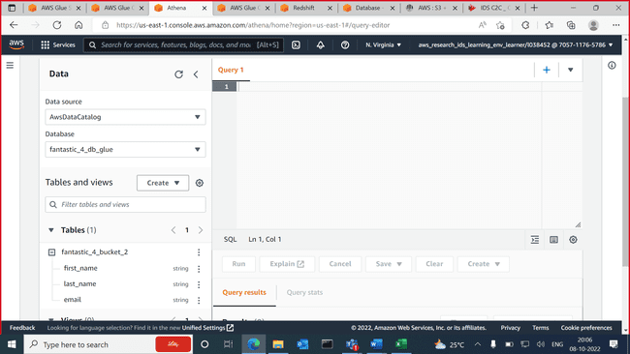

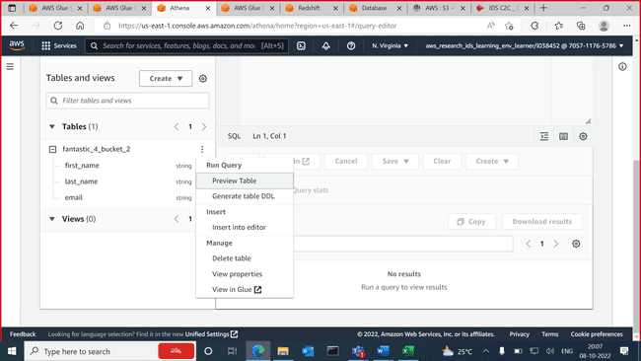

Edit settings 🡪 add the new bucket source

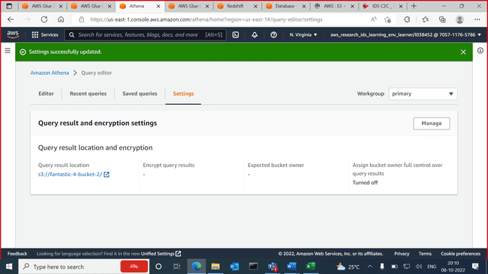

Query editor

Our table is displayed -

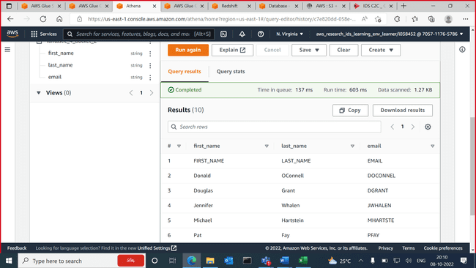

Redshift

Created new database

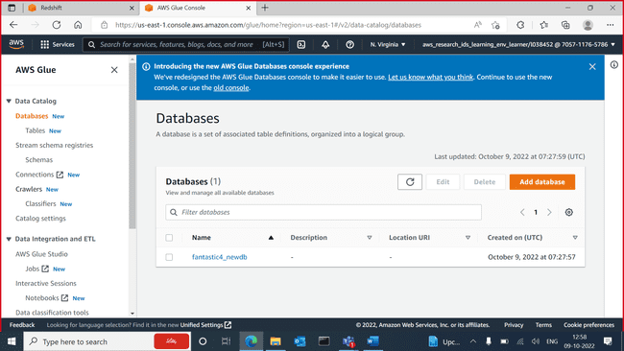

Data source for 1st crawler 🡪 S3

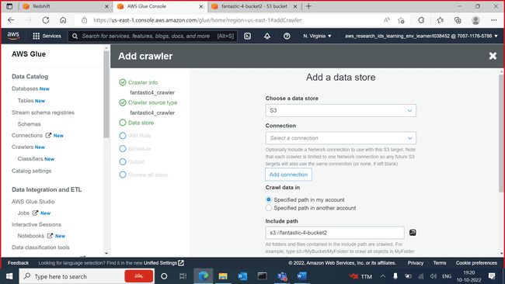

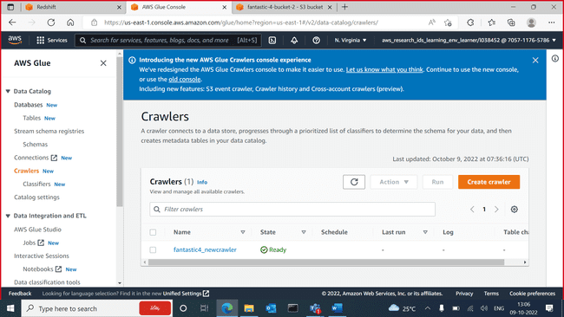

Run crawler

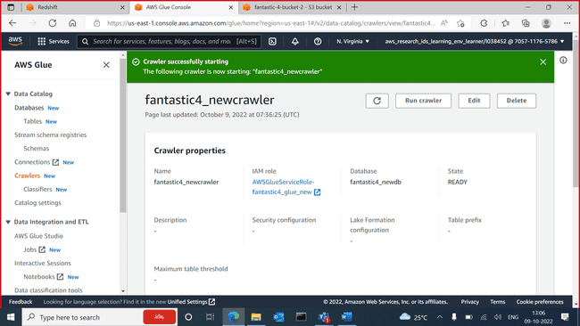

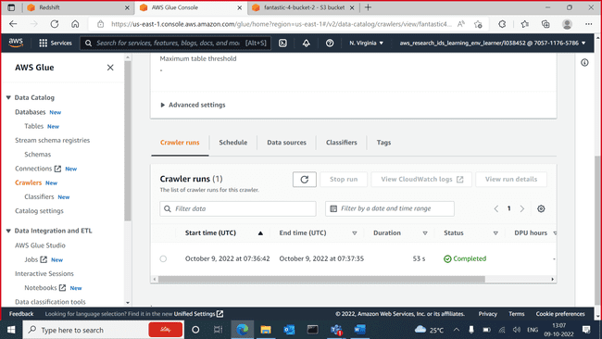

Table is displayed

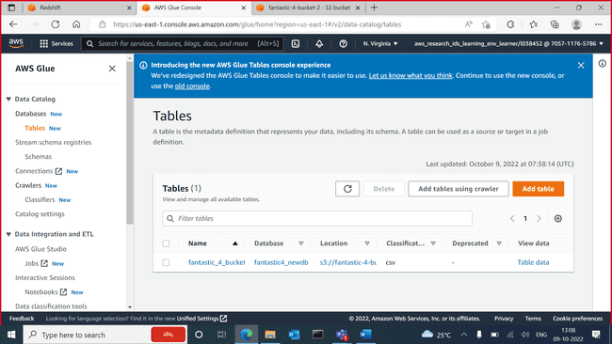

Edit the table

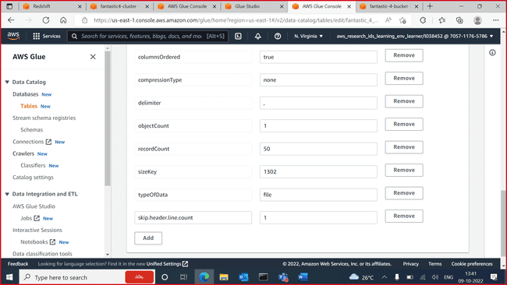

New endpoint created

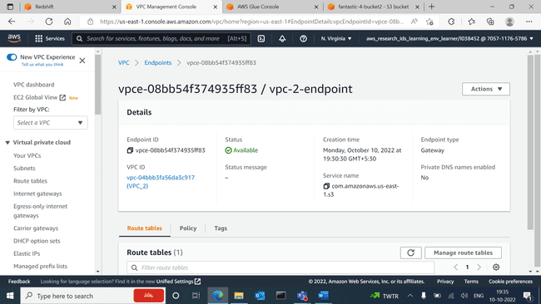

Cluster subnet group creation

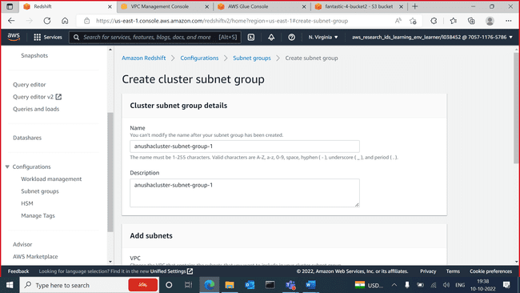

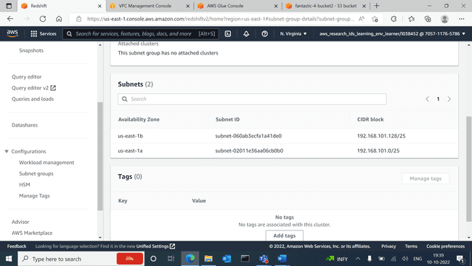

Redshift cluster created

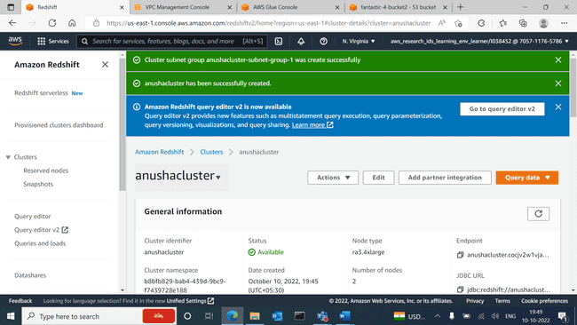

Connection created

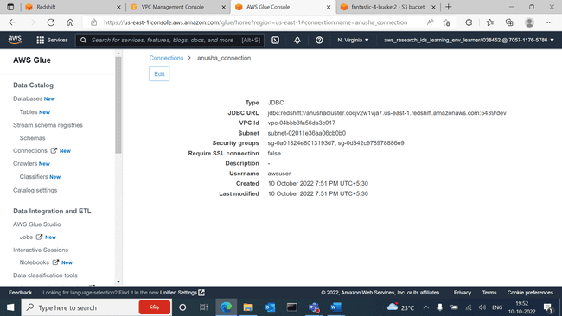

Redshift 🡪 change connection

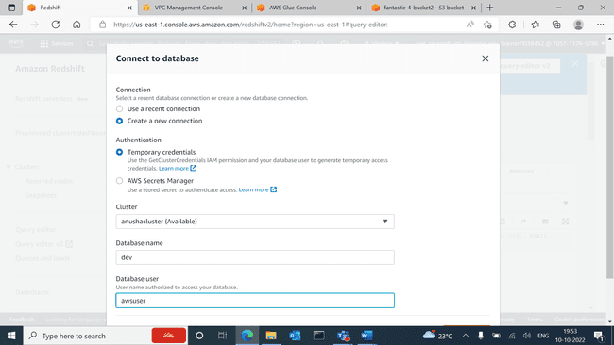

New crawler creation

New crawler created

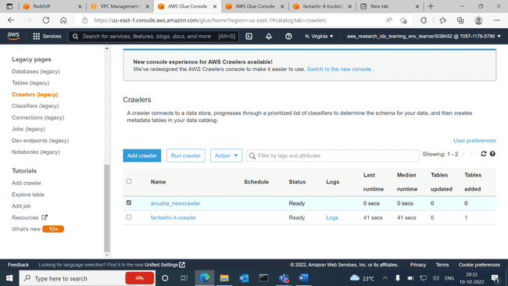

Redshift

Cluster created-

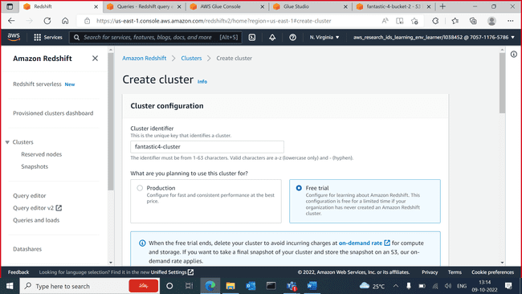

Cluster created

Cluster subnet creation

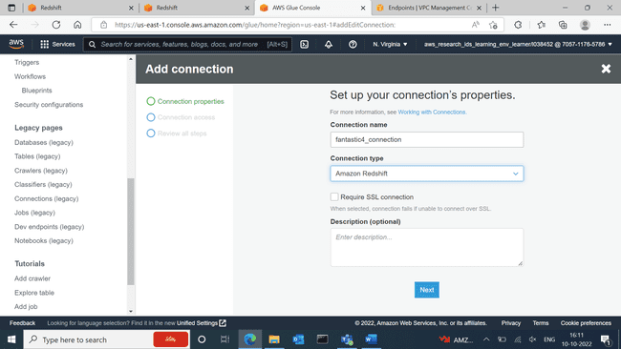

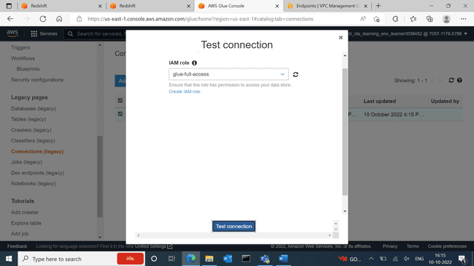

New endpoint

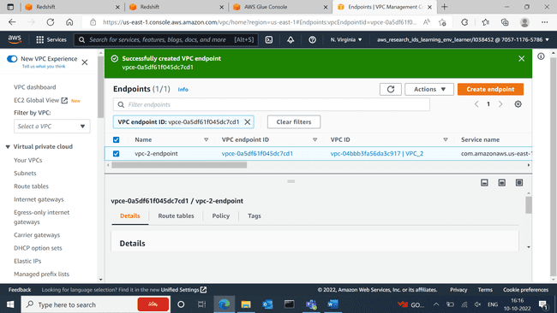

Connection created

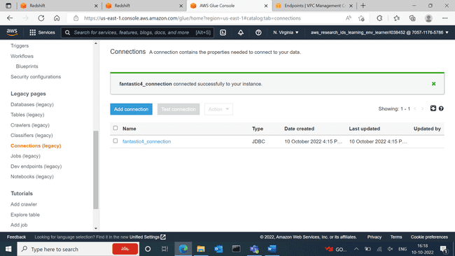

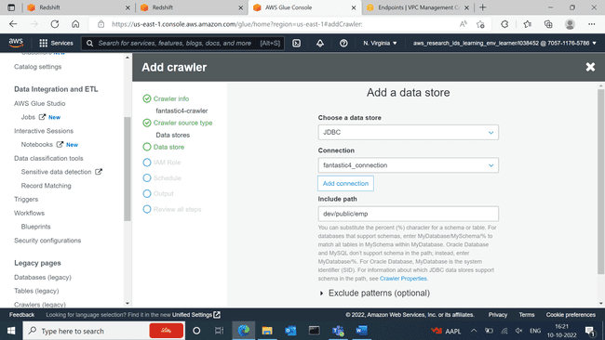

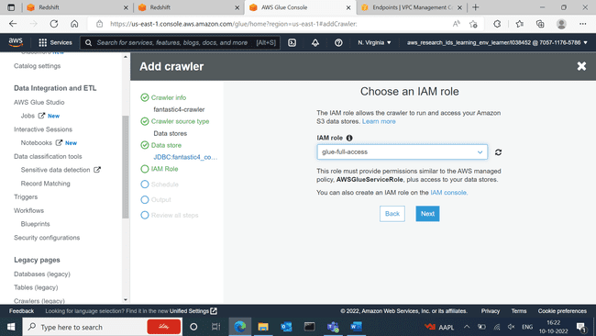

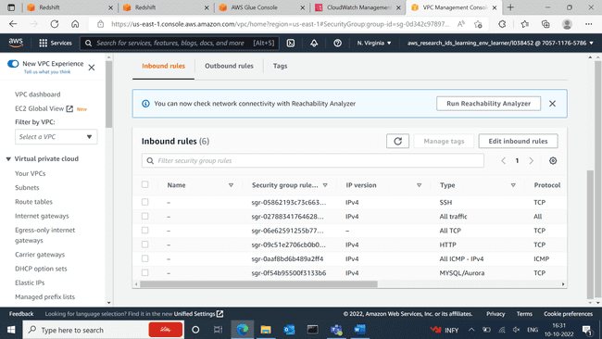

Glueservice role

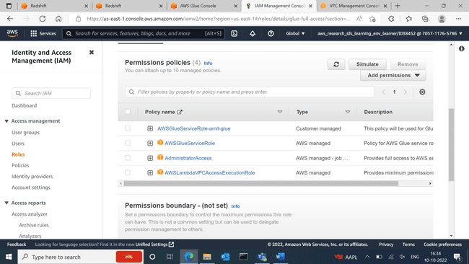

Cluster 🡪 VPC must be 2 – subnet grp 🡪

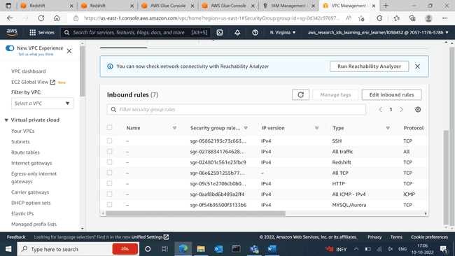

Created JOB

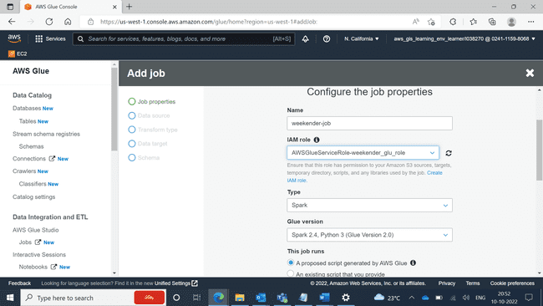

JOB created

