Created a AWS Lambda as shown below:

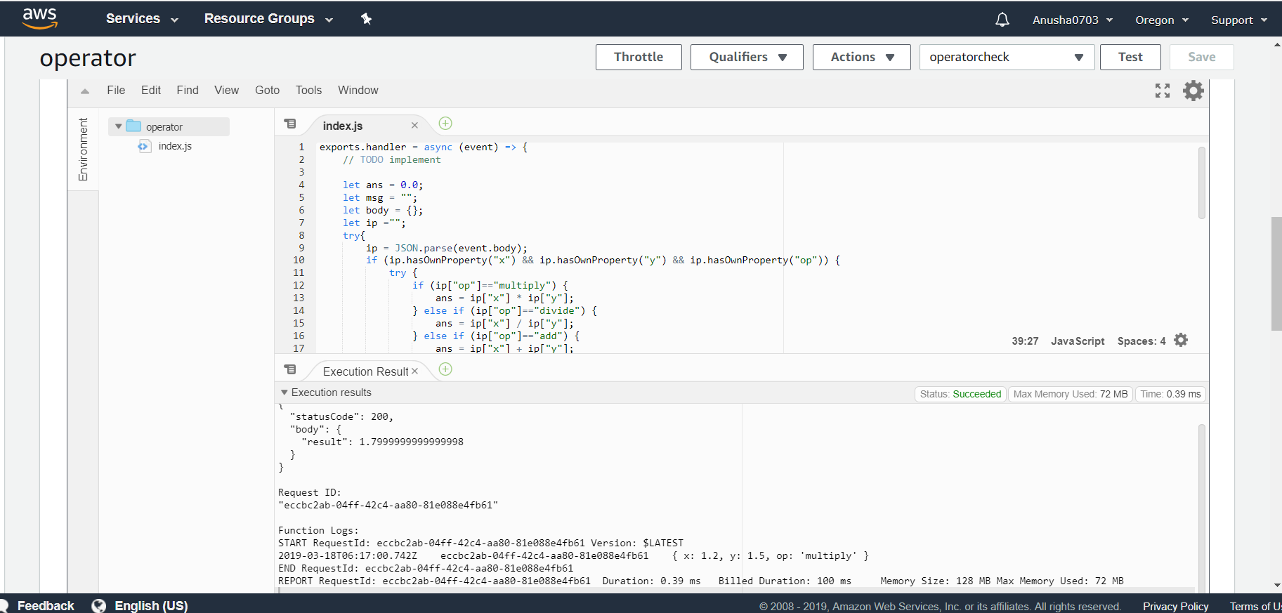

Code is provided at index.js in the hw_9 repo

The Lambda function is present at

<https://jrxgmt6ech.execute-api.us-west-2.amazonaws.com/default/operator>

Q2. I couldn’t finish writing the Q2, so I am submitting the Node JS code, Link for my lambda function, and test cases for Q1 as such.

Q3 and Q4 : Updated my project and ReadMe and is available at :

<https://github.com/AnushaKamat/AdaptiveCruiseControl>

I could curl into the Lambda and check for the functionality using

Test Cases are checked using PostMaster

1. Multiply:

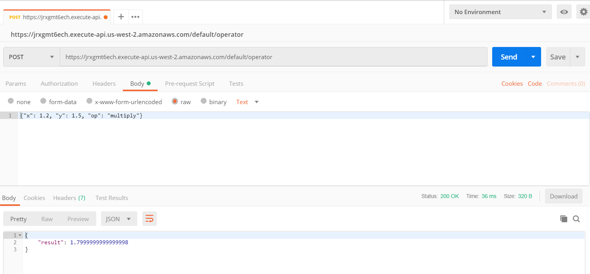

2. Add :

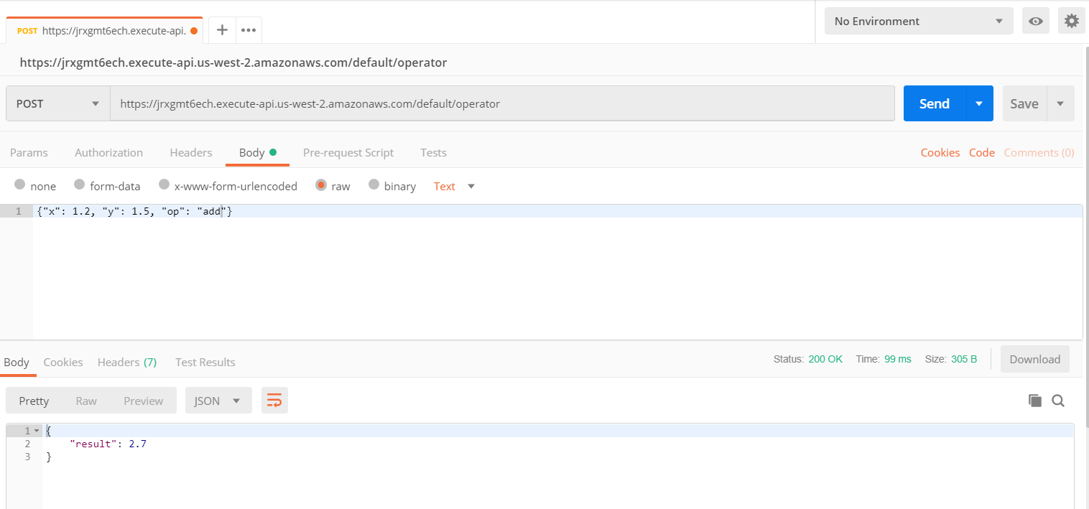

3. Divide:

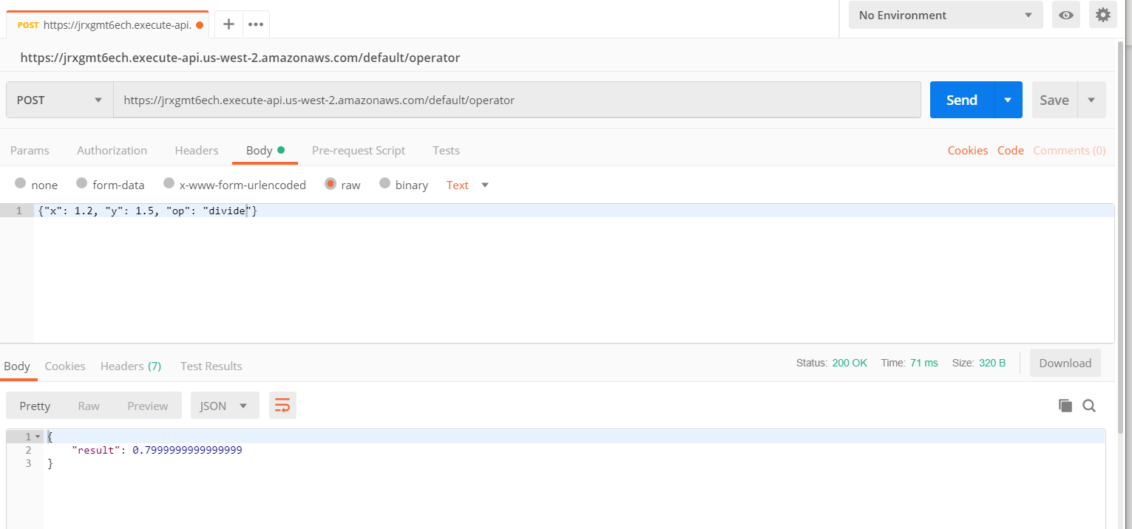

4. Divide by 0:

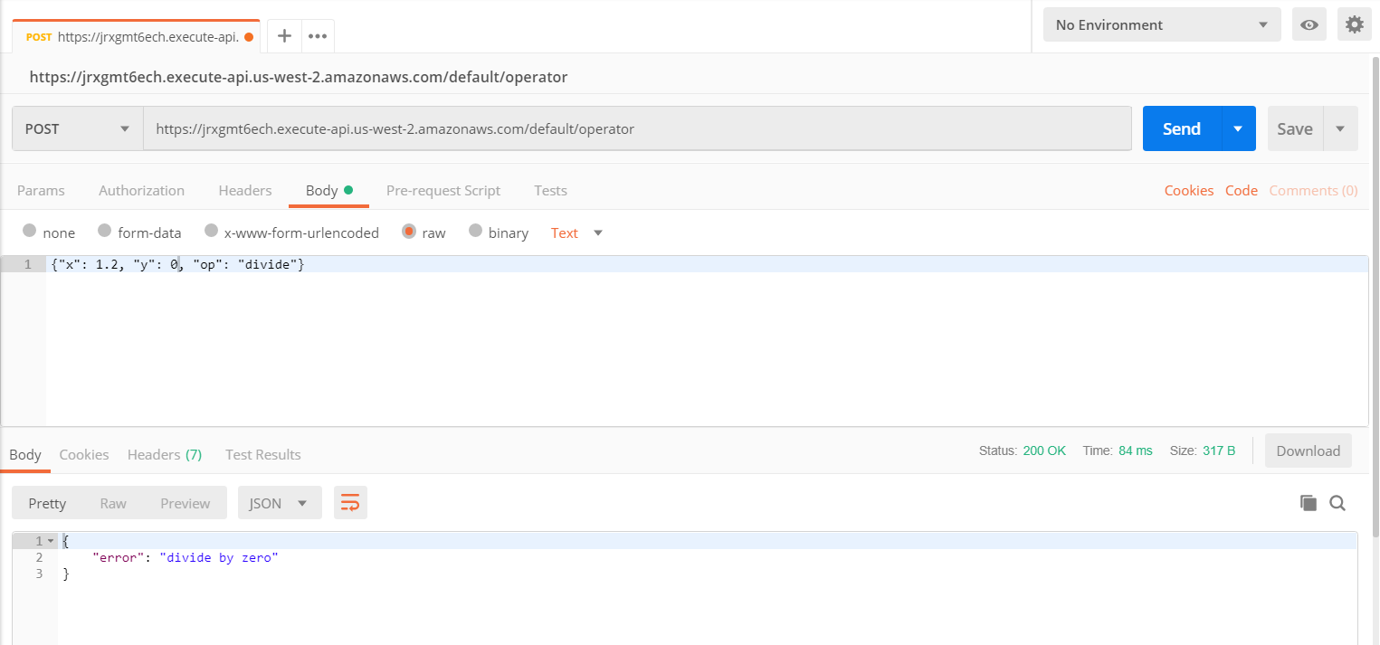

5.Subtract:

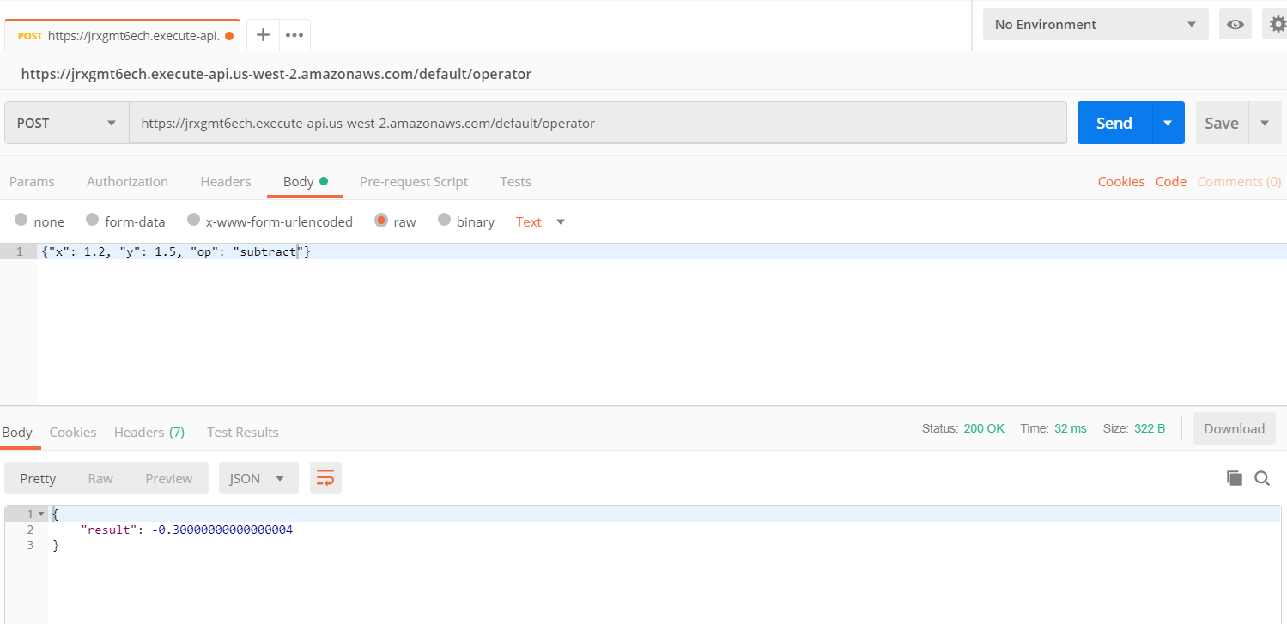

6. Improper JSON error:

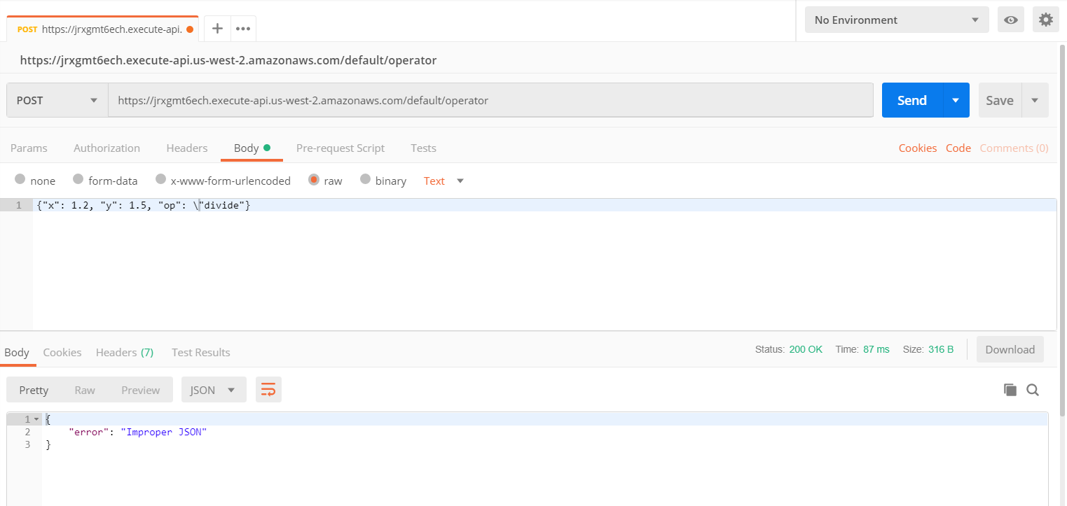

7. Missing Keys :

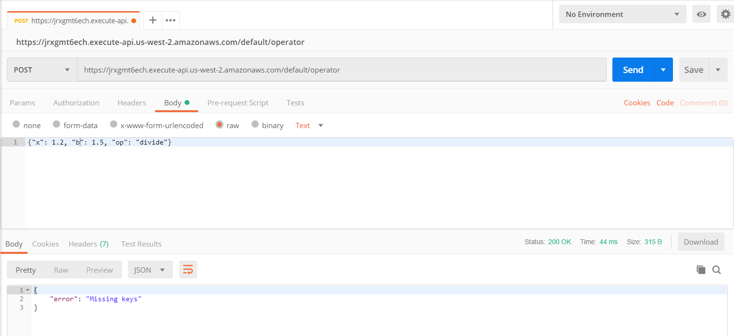

8. Unknown Operator:

