**BLOOD BANK MANAGEMENT SYSTEM.**

**BLOOD BANK DATABASE**:

BLOOD (BGType)

BLOODBANK (BBID, BBName)

BLOODBANK_AVAILABILITY (BGType, BBID, Availability)

HOSPITAL (HID, HName, Address, Contact, BBID)

DOCTOR (DID, DName, Phno, HID, Specialisation)

PATIENT (PID, PName, Age, Gender, Phoneno, Address, PBG, DID, HID)

DONOR (DOID, DonorName, Age, Weight, DPhoneno, DOBG, BBID)

**SCHEMA**:

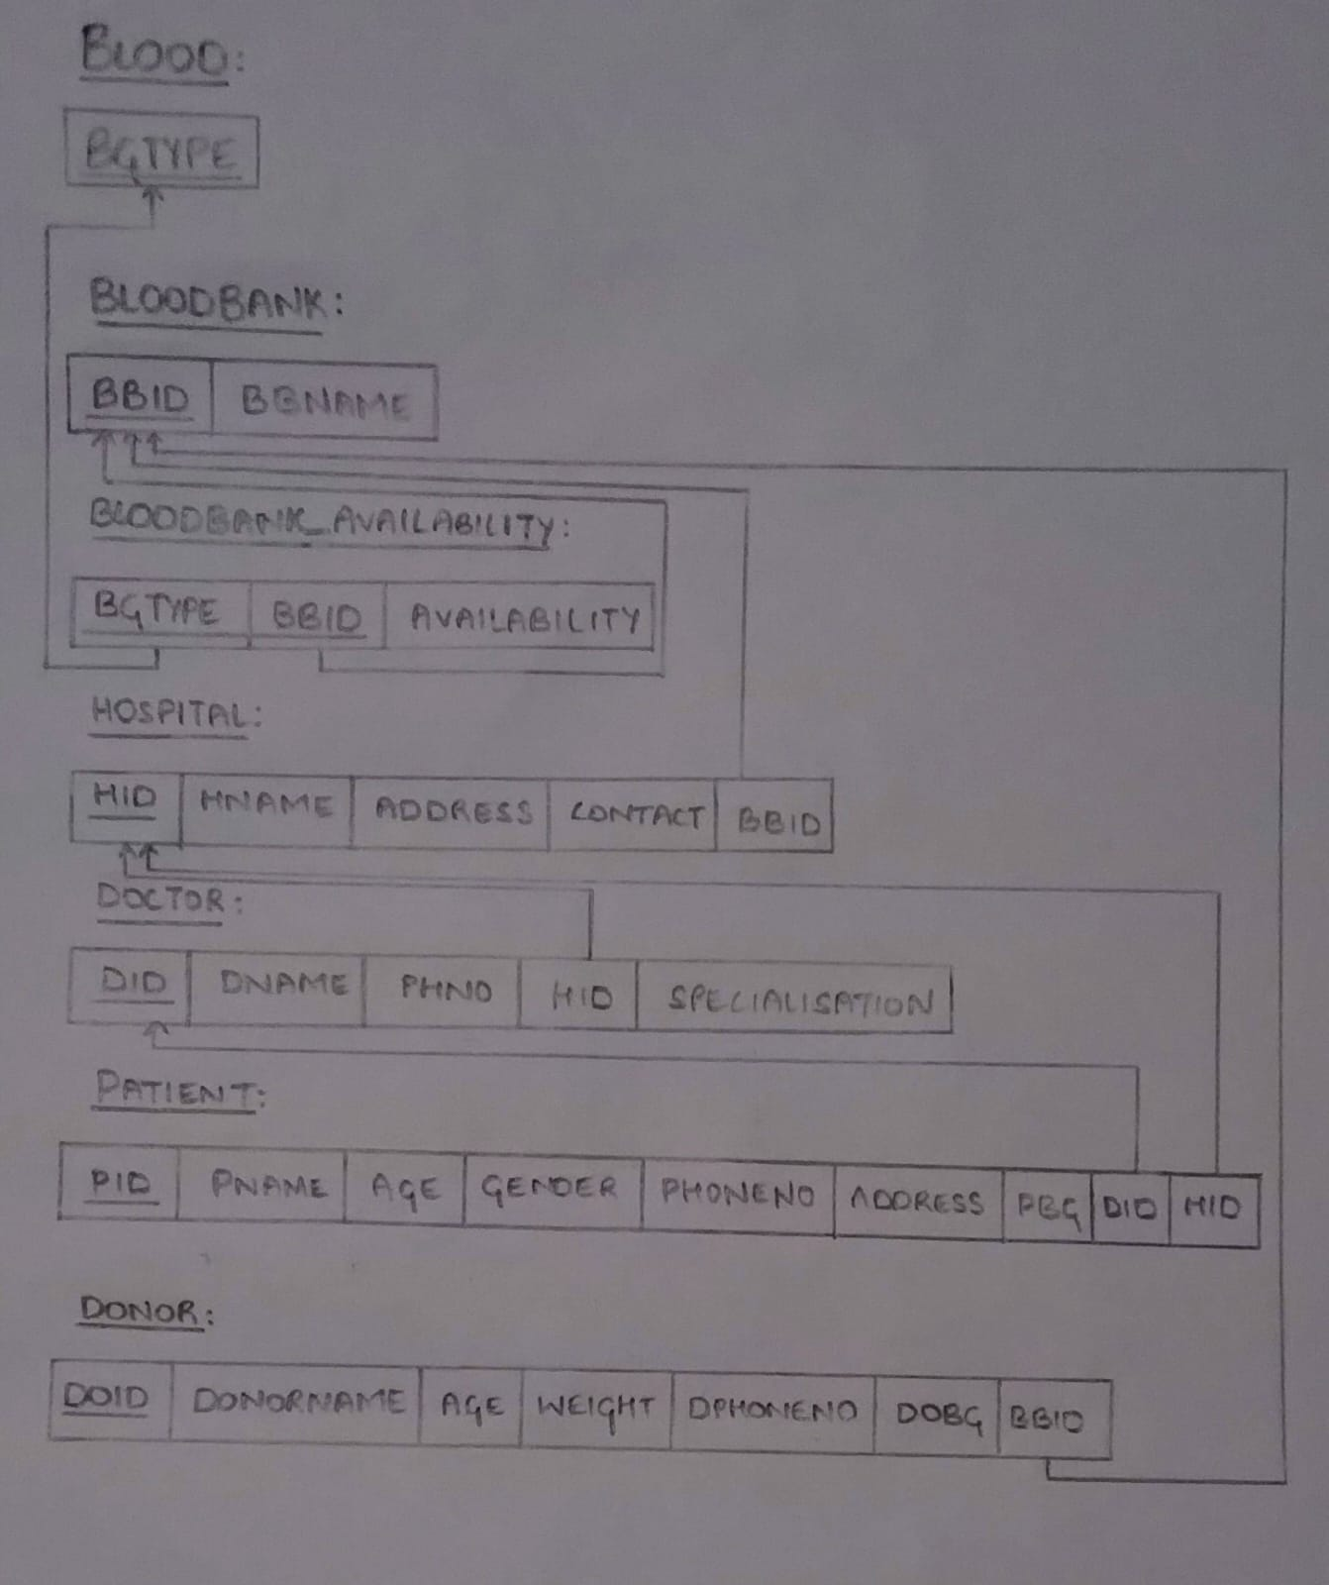

**ENTITY-RELATION DIAGRAM:**

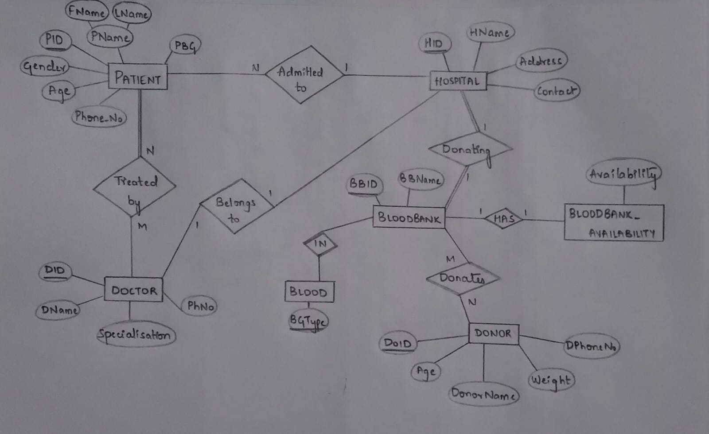

**CREATION TO TABLES:**

1) create table blood(

bgtype varchar(20) primary key);

2) create table bloodbank(

bbid varchar(10) primary key,

bbname varchar(20));

3) create table hospital(

hid varchar(10) primary key,

hname varchar(20),

address varchar(20),

contact varchar(10),

bbid varchar(10),

foreign key(bbid) references bloodbank(bbid) on delete set null);

4) create table doctor(

did varchar(10) primary key,

dname varchar(20),

phno varchar(10),

hid varchar(10),

specialisation varchar(25),

foreign key (hid) references hospital(hid) on delete set null);

5) create table bb_availablity(

bgtype varchar(10),

bbid varchar(10),

availability int,

primary key(bgtype, bbid),

foreign key(bgtype) references blood(bgtype),

foreign key(bbid) references bloodbank(bbid));

6) create table donor(

doid varchar(10) primary key,

donorname varchar(20),

age int,

weight varchar(10),

check(weight > 50),

dphno varchar(10),

dobg varchar(10),

bbid varchar(10),

foreign key(bbid) references bloodbank(bbid) on delete set null);

7) create table patient(

pid varchar(10) primary key,

pname varchar(20),

age int,

gender varchar(5),

pphno varchar(10),

address varchar(20),

pbg varchar(10),

did varchar(10),

hid varchar(10),

foreign key (did) references doctor (did) on delete set null,

foreign key (hid) references hospital(hid) on delete set null);

USE OF DEFAULT CONSTRAINT:

alter table donor

modify donorname varchar(20) default null;

**INSERTION OF VALUES TO TABLE:**

1) insert into blood values('0+');

insert into blood values('0-');

insert into blood values('A+');

insert into blood values('A-');

insert into blood values('B+');

insert into blood values('B-');

insert into blood values('AB+');

insert into blood values('AB+');

2) insert into bloodbank values('BB1','Victoria');

insert into bloodbank values('BB2','Lion');

insert into bloodbank values('BB3','BGS');

3) insert into bb_availablity values('AB+','BB1','4440');

insert into bb_availablity values('A+','BB1','5760');

insert into bb_availablity values('A-','BB1','7860');

insert into bb_availablity values('O+','BB1','3680');

insert into bb_availablity values('O-','BB1','2280');

insert into bb_availablity values('B+','BB1','2780');

insert into bb_availablity values('B-','BB1','3980');

insert into bb_availablity values('AB-','BB1','7640');

insert into bb_availablity values('B+','BB2','2900');

insert into bb_availablity values('O-','BB3','500');

insert into bb_availablity values('A-','BB2','5050');

4) insert into hospital values('H1','Victoria','Bangalore','6252121444','BB1');

insert into hospital values('H2','BGS','Bangalore','6468365735','BB2');

insert into hospital values('H3','Lotus','Hubli','5375297364','BB1');

insert into hospital values('H4','Ramaiah','Mangalore','5343745385','BB3');

insert into hospital values('H5','Sparse','Mysuru','4753797946','BB2');

5) insert into doctor values('D1','Udhay','3556643487','H2','Cardiologist');

insert into doctor values('D2','Akshara','7547534685','H5','Gynecologist');

insert into doctor values('D3','Vinay','5375873464','H3','Orthopedic');

insert into doctor values('D4','Vishwas','5353756527','H4','Neurologist');

insert into doctor values('D5','Chirag','5358570987','H1','Cardiologist');

6) insert into donor values('DO1','Keerthana','40','52','4357974537','AB+','BB1');

insert into donor values('DO2','Sowmya','20','59','5765893290','B+','BB2');

insert into donor values('DO3','Pallavi','38','68','4357832686','B+','BB2');

insert into donor values('DO4','Puneet','24','69','3568743567','O+','BB1');

insert into donor values('DO5','Praveen','32','72','4532665564','B+','BB1');

7) insert into patient values('P1','Akshay','21','M','4376983567','Bengaluru','O+','D5','H1');

insert into patient values('P2','Akash','34','M','5467586853','Bengaluru','A+','D5','H1');

insert into patient values('P3','Abhay','48','M','4735798635','Mangalore','AB-','D3','H4');

insert into patient values('P4','Sunil','27','M','4736580897','Mysuru','O-','D4','H5');

insert into patient values('P5','Sudha','17','F','4625788696','Hubli','B-','D2','H3');

CREATION OF VIEW:

create view v_bloodavailable as

(select availability, bgtype

from bloodbank);

**DESCRIPTION OF A TABLE:**

* desc patient;

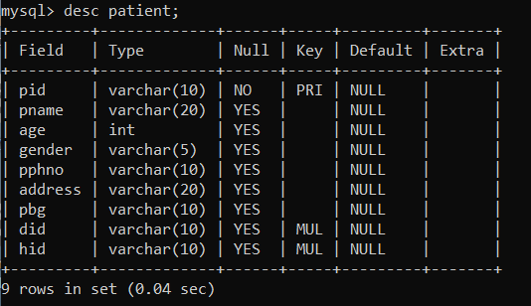

* desc donor;

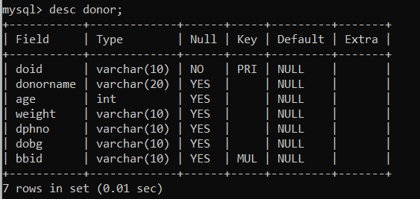

* desc bb_availablity;

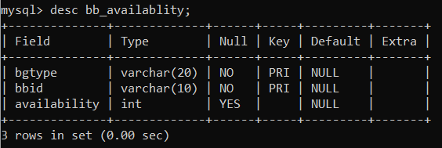

* desc blood;

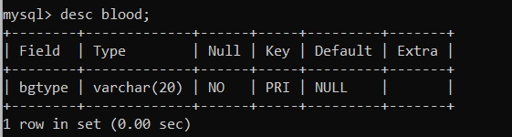

* desc bloodbank;

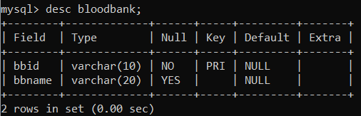

* desc doctor;

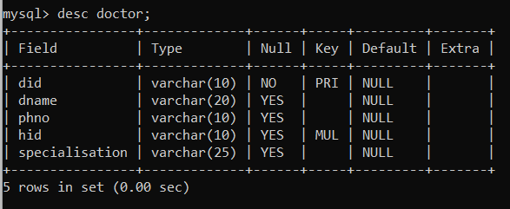

* desc hospital;

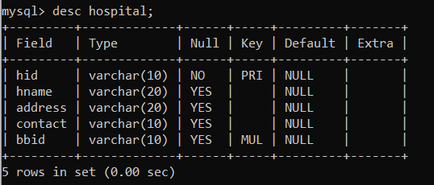

**TABLES WITH TUPLE VALUES:**

* select * from patient;

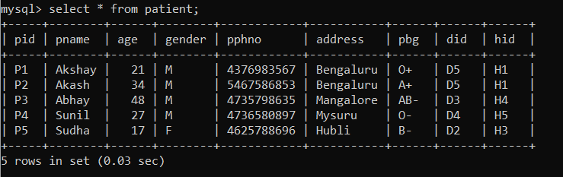

* select * from doctor;

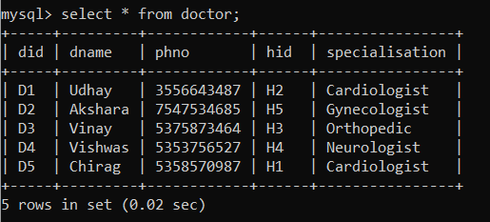

* select * from hospital;

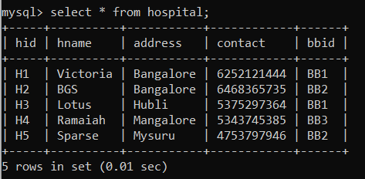

* select * from blood;

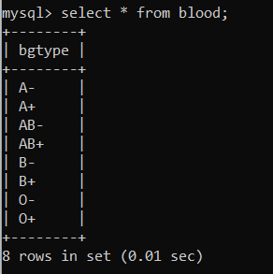

* select * from bloodbank;

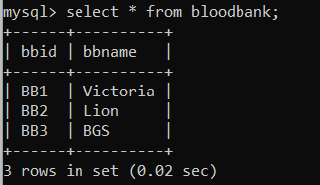

* select * from bb_availablity;

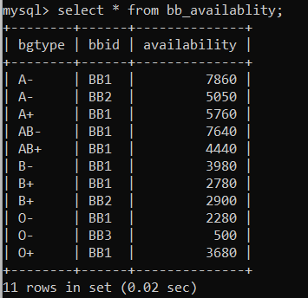

* select * from donor;

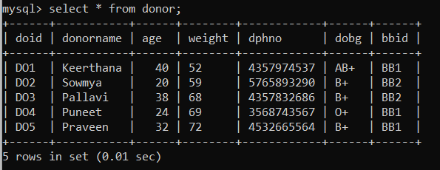

**QUERIES:**

**1) Write a query to retrieve patient details whose blood is available in the blood bank.**

select *

from patient

where pbg in(select p.pbg

from bb_availablity b, bloodbank bb, patient p, hospital h

where p.hid = h.hid

and h.bbid = bb.bbid

and bb.bbid = b.bbid

and p.pbg = b.bgtype);

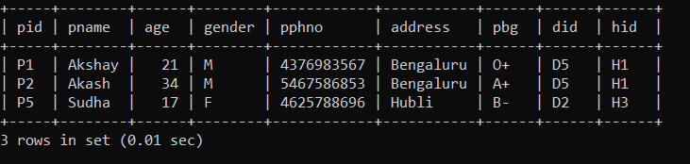

**2) Create an assertion to check if blood availability is less than 2000 units.**

create assertion bloodavailcnd

check(not exists (select *

from bb_availablity

where availability > 2000));

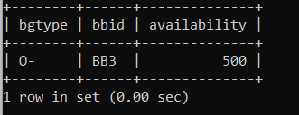

**3) Write a query to list the doctor details who treats more than one patient.**

select d.dname,count(distinct hid)

from doctor d

where 1<(select count(*)

from patient p

where p.did=d.did);

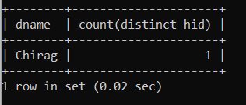

**4) Write a query to retrieve donor details whose age is above 20years.**

select doid, donorname, age

from donor

where age>20;

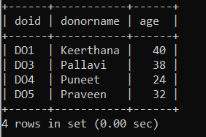

**5) Write a query to list the hospital where all blood types are available.**

select hid, hname

from hospital h

where h.bbid in (select ba.bbid

from bb_availablity ba, blood b, bloodbank bb

where bb.bbid = ba.bbid

and ba.bgtype = b.bgtype

and ba.bbid not in(select bbid

from bb_availablity

group by bbid

having count(bbid) < (select count(bgtype)

from blood)));

