Employee Attrition Prediction & Workforce Risk Analysis
Advanced Apex Project-2 | Week-9 Final Submission | Problem ID: P1
Student: Anusha Pala | Student ID: 2025EM1100155

1. Problem Statement & Objective
Employee attrition disrupts productivity, continuity and cost, replacing an employee typically costs half to twice their annual salary. The objective is to build a supervised ML model predicting whether an employee will leave (Attrition: 1=Yes, 0=No) from demographic, performance, compensation and engagement data, enabling proactive HR intervention. Because leavers are the minority class and a missed leaver is costlier than a false alarm, evaluation priorities were fixed in advance: (1) Recall on the "Yes" class, (2) F1-score, (3) ROC-AUC, with Accuracy reported but not used to select the final model.

2. Dataset Description
IBM HR Analytics Employee Attrition & Performance dataset (Kaggle, 1,470 employees, 39 columns), containing demographic, organisational, compensation and workplace variables. Target distribution: 1,233 stayed (83.9%), 237 left (16.1%) i.e., a moderate class imbalance that shapes the metric priorities, SMOTE usage, and evaluation strategy throughout.

3. Data Preparation & Feature Engineering
No missing values or duplicates were found. A column-by-column review (not a generic null check) removed six problematic columns: three zero-variance columns (Employee_Count, Standard_Hours, Over18), an ID column (Employee_Number), a noise column (Month), and critically Attrition_flag, which was found to be an exact copy of the target and would have caused target leakage. Five features were engineered: TenureRatio, IncomePerJobLevel, PromotionGap, IsFrequentTraveler, and AvgSatisfaction (composite of four satisfaction scores), designed to compress correlated tenure signals into interpretable ratios. Categorical variables were encoded after EDA: binary/ordinal mappings for Gender, Over_Time, Business_Travel; one-hot (drop_first=True) for remaining nominal columns yielding 54 numeric features.

4. Exploratory Data Analysis
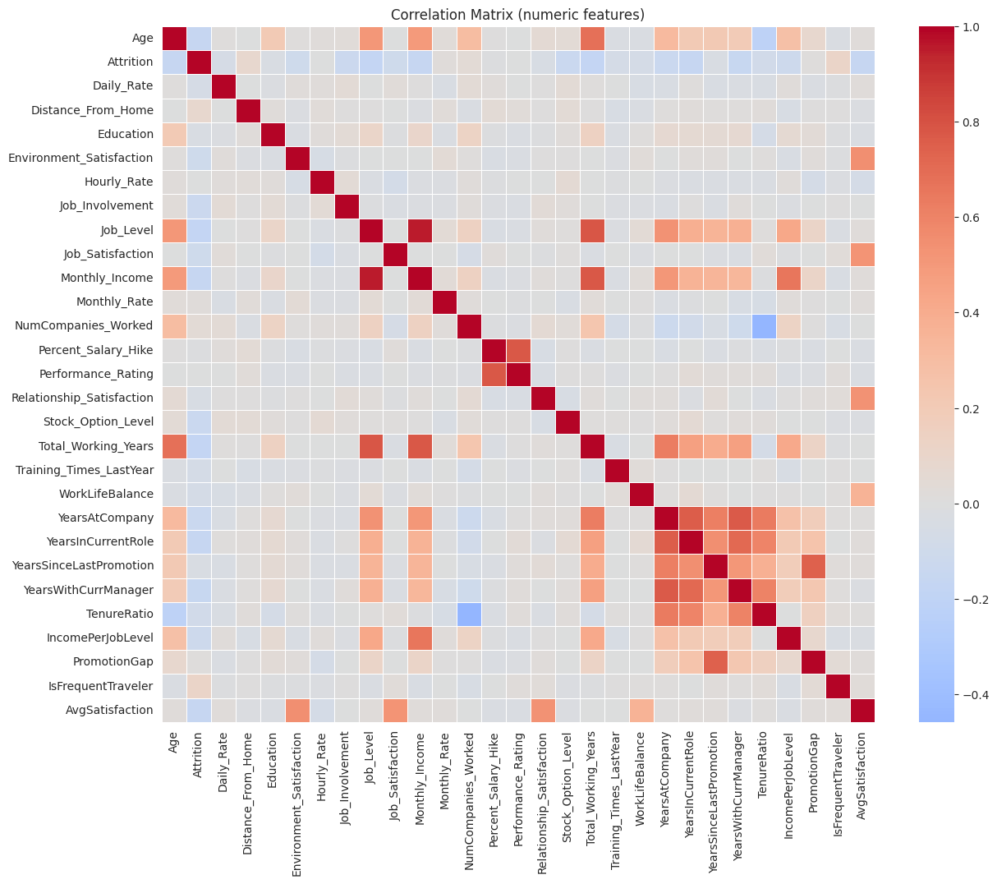
Correlation heatmap tenure, income and age show the strongest (negative) correlation with attrition; tenure columns are mutually correlated (multicollinearity).
- Leavers tend to be younger, lower-income, and shorter-tenured; OverTime is the single strongest categorical signal.
- Frequent travel and single marital status are associated with higher attrition; Sales dept. and Sales/Lab Technician roles show elevated rates.
- Engineered features TenureRatio and PromotionGap show visible separation between classes, an early sign of predictive value.

5. Baseline & Improved Models
Data was split 80:20 (stratified), scaled with StandardScaler (fit on train only), and SMOTE-balanced on the training set only (post-split) to 986:986; the test set retained the real 84:16 ratio throughout. Logistic Regression served as the interpretable linear baseline; Decision Tree, KNN, Random Forest and Gradient Boosting were trained at default settings as "improved" candidates.
Model | Role | Accuracy | Precision | Recall | F1 | ROC-AUC
Logistic Regression | Baseline | 0.789 | 0.407 | 0.702 | 0.516 | 0.809
Decision Tree | Improved (default) | 0.779 | 0.327 | 0.362 | 0.343 | 0.610
KNN | Improved (default) | 0.639 | 0.234 | 0.553 | 0.329 | 0.658
Random Forest | Improved (default) | 0.844 | 0.524 | 0.234 | 0.324 | 0.813
Gradient Boosting | Improved (default) | 0.847 | 0.536 | 0.319 | 0.400 | 0.798

Even at default settings, the baseline already leads on Recall and F1; the ensembles lead on Accuracy/Precision/ROC-AUC but miss more actual leavers the central tension explored through Sections 6–8. In brief: Logistic Regression is highly interpretable but linear-only; Decision Tree learns non-linear patterns but overfits easily; Random Forest generalises better than a single tree but is less interpretable; Gradient Boosting is the strongest raw predictor but slower to train; KNN is simple but sensitive to scaling and high dimensionality.

6. Hyperparameter Tuning
GridSearchCV (5-fold, scoring="f1", ranges centred on typical values for this dataset size) tuned all four non-linear models; a one-parameter sweep (train vs CV F1) additionally visualised overfitting for Random Forest (max_depth) and KNN (n_neighbors), both of which showed a widening train/CV gap as complexity increased (e.g., KNN at k=1 reaches ~1.0 training F1 while CV F1 is far lower).
Model | Best Parameters | Best CV F1 (SMOTE folds)
Decision Tree | max_depth=10, min_samples_split=2 | 0.862
KNN | n_neighbors=3, weights='distance' | 0.857
Random Forest | max_depth=15, min_samples_split=2, n_estimators=200 | 0.935
Gradient Boosting | learning_rate=0.05, max_depth=3, n_estimators=100 | 0.860

7. Model Comparison
On the real (untouched, imbalanced) test set, tuning helped Decision Tree substantially (F1 0.343→0.453) but left Random Forest, Gradient Boosting and KNN roughly flat or slightly worse, despite their much higher CV F1 during grid search:
Model | Variant | Recall | F1 | ROC-AUC
Logistic Regression | Default | 0.702 | 0.516 | 0.809
Decision Tree | Tuned | 0.511 | 0.453 | 0.651
Gradient Boosting | Tuned | 0.319 | 0.375 | 0.797
Random Forest | Tuned | 0.234 | 0.319 | 0.811
KNN | Tuned | 0.468 | 0.312 | 0.640

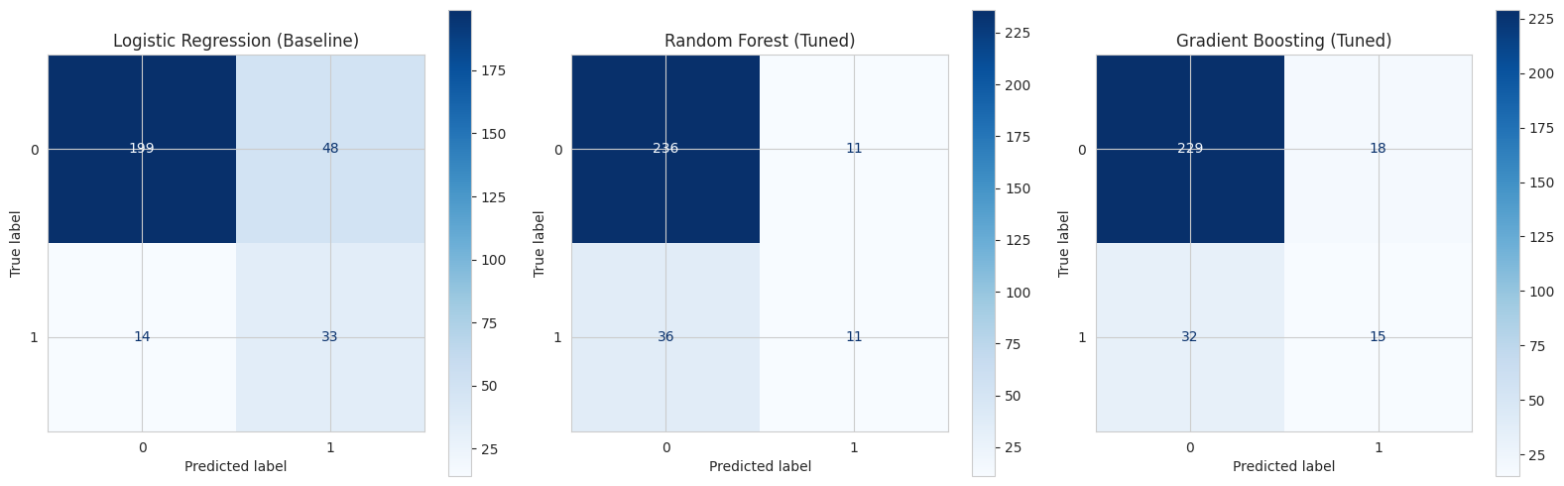
Confusion matrices (test set, n=47 leavers): Logistic Regression catches 33/47 leavers vs. 11/47 for tuned Random Forest and 15/47 for tuned Gradient Boosting.

8. Evaluation Metrics
Accuracy is misleading here (a majority-only model scores ~84%), so Recall, F1 and ROC-AUC were prioritised per Section 1. Against that order, Logistic Regression is the clear winner: highest Recall (0.702) and F1 (0.516) of any model/variant, and ROC-AUC (0.809) essentially tied with the ensembles (~0.81). The tuned ensembles trade Recall for Precision/Accuracy, a trade-off that is the wrong way round for this business problem, where a missed leaver (false negative) is costlier than an unnecessary retention conversation (false positive).

9. Generalization Discussion
Model | Train F1 (SMOTE) | Test F1 | Gap
Logistic Regression | 0.827 | 0.516 | 0.311
Decision Tree | 0.987 | 0.453 | 0.534
Gradient Boosting | 0.942 | 0.375 | 0.567
Random Forest | 1.000 | 0.319 | 0.681
KNN | 1.000 | 0.312 | 0.688

Logistic Regression has by far the smallest train-test gap, consistent with it also achieving the best real-world Recall/F1; Random Forest and KNN show the largest gaps (near-perfect training fit, weak test Recall), a textbook overfitting signature. This plus the high CV-F1-but-low-test-Recall pattern in Section 7 shows that optimising on SMOTE-resampled cross-validation folds does not guarantee generalisation to the true, imbalanced population, a key limitation of this pipeline worth flagging in any deployment.

10. Conclusion
The Logistic Regression baseline is the recommended final model: it best satisfies the pre-defined priority order (Recall → F1 → ROC-AUC), generalises best (smallest train-test gap), and remains fully interpretable via its coefficients (OverTime and IsFrequentTraveler increase risk; tenure/satisfaction reduce it), consistent with EDA and tree-based feature importances. Tuned Random Forest/Gradient Boosting remain reasonable alternatives only if minimising false alarms is prioritised over catching leavers.
Key learnings:
(1) column-by-column review is essential to catch target leakage that a null-check alone would miss;
(2) a high cross-validation F1-score does not guarantee real-world Recall;
(3) fixing evaluation priorities before seeing results prevents post-hoc, metric-shopping conclusions. As a practical decision-support tool, HR teams could use its predictions to complement, not replace, managerial judgement.
Future work: threshold tuning and class-weighting as SMOTE alternatives, SHAP-based per-employee explanations, and validation on real (non-synthetic) attrition data.
Reproducibility: RANDOM_STATE=42 fixed for the split, SMOTE and all models; pipeline is StandardScaler(fit on train)→SMOTE(train only)→model, so re-running the notebook (Python 3.12, scikit-learn, imbalanced-learn) on hr_dataset.csv reproduces identical results.

