Activity | Data Type
Number of beatings from Wife | Discrete
Results of rolling a dice | Discrete
Weight of a person | Continuous
Weight of Gold | Continuous
Distance between two places | Continuous
Length of a leaf | Continuous
Dog's weight | Continuous
Blue Color | Discrete
Number of kids | Discrete
Number of tickets in Indian railways | Discrete
Number of times married | Discrete
Gender (Male or Female) | Discrete
Q1) Identify the Data type for the Following:

Q2) Identify the Data types, which were among the following
Nominal, Ordinal, Interval, Ratio.
Data | Data Type
Gender | Nominal
High School Class Ranking | Ordinal
Celsius Temperature | Interval
Weight | Ratio
Hair Color | Nominal
Socioeconomic Status | Ordinal
Fahrenheit Temperature | Interval
Height | Ratio
Type of living accommodation | Nominal
Level of Agreement | Ordinal
IQ(Intelligence Scale) | Interval
Sales Figures | Ratio
Blood Group | Nominal
Time Of Day | Ordinal
Time on a Clock with Hands | Interval
Number of Children | Ratio
Religious Preference | Nominal
Barometer Pressure | Interval
SAT Scores | Interval
Years of Education | Ratio

Q3) Three Coins are tossed, find the probability that two heads and one tail are obtained?
Ans: Total number of outcomes possible are 8
P( 2 heads and 1 tail) = 3/8 = 0.375

Q4) Two Dice are rolled, find the probability that sum is
- Equal to 1
- Less than or equal to 4
- Sum is divisible by 2 and 3
Ans:

when two dice are rolled the total number of possibilities are 36
- When 2 dice are rolled the minimum sum possible is 2.(roll 1 and 1)
So the probability of sum equals to 1 is 0
P(sum Equal to 1) = 0

- P(sum <= 4) = p(sum = 2)+P(sum = 3)+P(sum = 4)
P(sum =2)= There is only 1 way out of 36 to get a sum of 2: (1+1) = 1/36
P(sum=3)=There are 2 ways out of 36 to get a sum of 3: (1+2), or (2+1)=2/36
P(sum=4)=There are 3 ways to get 4: (1+3), (2+2), (3+1)=3/36
P(sum Less than or equal to 4)=1/36+2/36+3/36=6/36 = 1/6=0.16

- P(Sum is divisible by 2 and 3) = P(sum = 6) +P(sum =12)
P(sum = 6) =There are 5 ways out of 36 to get a sum of 6: (2,4),(3,3),(4,2),(5,1),(1,5) = 5/36
P(sum =12)=There is only 1 way out of 36 to get a sum of 12: (6,6) = 1/36
P(sum divisible by 2 & 3)=1/36 + 5/36 = 6/36 = 1/6 = 0.16
Q5) A bag contains 2 red, 3 green and 2 blue balls. Two balls are drawn at random. What is the probability that none of the balls drawn is blue?
Ans: There are total 2® +2(G) +2(B) = 7 Balls.
Balls can be selected from 7 balls in 7C2 = 21 ways
Both the balls drawn are not blue = 5C2 (red+green)= 10 ways
P(Both the balls drawn are not blue) = 10/21 = 0.476
Q6) Calculate the Expected number of candies for a randomly selected child
Below are the probabilities of count of candies for children (ignoring the nature of the child-Generalized view)
CHILD | Candies count | Probability
A | 1 | 0.015
B | 4 | 0.20
C | 3 | 0.65
D | 5 | 0.005
E | 6 | 0.01
F | 2 | 0.120
Child A – probability of having 1 candy = 0.015.
Child B – probability of having 4 candies = 0.20
Ans:
E(x) = Σx.P(x)
E(x) = 1*0.015+4*0.20+3*0.65+5*0.005+6*0.01+2*0.120 = 3.09
Expected number of candies for a randomly selected child is 3.09
Q7) Calculate Mean, Median, Mode, Variance, Standard Deviation, Range & comment about the values / draw inferences, for the given dataset
- For Points,Score,Weigh>
Find Mean, Median, Mode, Variance, Standard Deviation, and Range and also Comment about the values/ Draw some inferences.
For Points:
Mean: 3.597
Median:3.695
Mode: 3.92,3.07

Variance: 0.2858814
Standard Deviation:0.5346787
Range:{2.76, 4.93}= 4.93 -2.76 = 2.17

As the difference b/w mean median and mode is very less we can conclude the data is normally distributed and as the standard deviation and variance are less we can conclude that most of the data lies symmetric around the mean.
For Score:
Mean:3.217
Median:3.325
Mode:3.44
Variance: 0.957379
Standard Deviation:0.9784574
Range:{1.513 ,5.424}=5.424 -1.513 = 3.911

As the difference b/w mean median and mode is very less we can conclude the data is normally distributed and as the standard deviation and variance are less we can conclude that most of the data lies symmetric around the mean.

For Weigh:
Mean:17.85
Median: 17.71
Mode:17.02,18.90
Variance:3.193166
Standard Deviation:1.786943
Range:{14.5, 22.9}=8.399

As mean median mode are very close we can consider the data is symmetric, as the standard deviation is around 1.7 few values are spread away from the mean

Use Q7.csv file
Q8) Calculate Expected Value for the problem below
- The weights (X) of patients at a clinic (in pounds), are
108, 110, 123, 134, 135, 145, 167, 187, 199
Assume one of the patients is chosen at random. What is the Expected Value of the Weight of that patient?
Mean value: 145.3333
Ans: E(x) = Σx.P(x)
Given there are 9 patients at a clinic. Probability of choosing each Patient is P(x) = 1/9
Expected value = 108*1/9 + 110*1/9 +123*1/9+134*1/9 +135*1/9+145*1/9 +167*1/9 + 187*1/9 +199*1/9 = 145.33
The Expected Value of the Weight of that patient chosen Randomly is : 145.33

Q9) Calculate Skewness, Kurtosis & draw inferences on the following data
Cars speed and distance
Use Q9_a.csv
Ans:
skewness of the speed dataset is: -0.1175
kurtosis of the given speed dataset is -0.5089
skewness of the dist dataset is: 0.8068
kurtosis of the dist dataset is 0.405

For speed values as the skewness value is negative we can conclude that the data is left skewed(I.e data is not distributed symmetrically around mean, most data is distributed on left side)
As the skewness for speed is < -0.5 we can conclude the data is fairly symmetrical.
As kurtosis for speed is negative, the distribution tends to be flatter with lighter tails with lack of outliers
For dist values as the skewness is positive and value >0.5, the distribution is moderately skewed and as the kurtosis is positive value the distribution tend to have heavy tails and outliers
SP and Weight(WT)
Use Q9_b.csv
Ans:
skewness of the SP dataset is: 1.611
kurtosis of the given SP dataset is 2.98
skewness of the WT dataset is: -0.614
kurtosis of the given WT dataset is 0.95

- As the skewness for SP dataset is greater than 1, we can conclude the data is highly skewed towards right and as the kurtosis is positive and high value, we can say data tends to have heavy tails and outliers. From both skewness and kurtosis for given SP dataset we can assume outliers are existing on right side.

- As the skewness for WT dataset is in b/w [-1,-0.5], we can conclude the data is moderately skewed towards left and as the kurtosis is positive , we can conclude data tends to have slightly heavy tails and outliers, from both the skewness and kurtosis values we can conclude that most of the outliers tend to exist on left side.

Q10) Draw inferences about the following boxplot & histogram

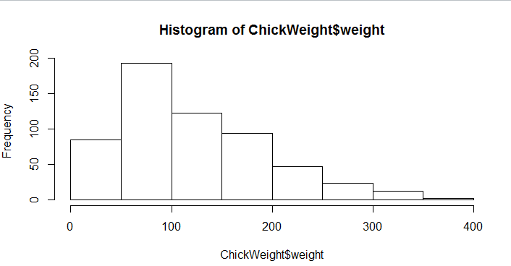

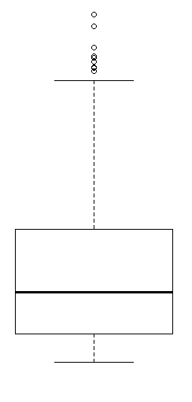

Ans:
Through the above histogram we can conclude the most common ChickenWeights(around 195) lies in range of 50-100, the mean and median values lies in this range
The weights are not spread out evenly on either sides of this range 50-100.( most of the data is spread on right side/positive side i.e most of chicken weights are >100 ). The given distribution is right skewed.
The few chicken weights lies in a range of 250-400(approx),which are very less in frequency can be considered as outliers, the same can be concluded using boxplot where outliers exist above upper fence

Q11) Suppose we want to estimate the average weight of an adult male in Mexico. We draw a random sample of 2,000 men from a population of 3,000,000 men and weigh them. We find that the average person in our sample weighs 200 pounds, and the standard deviation of the sample is 30 pounds. Calculate 94%,98%,96% confidence interval?
Ans:
Given: sample size( n) = 2000
Population size( N) = 3000000
Mean of sample weights = 200
Standard deviation of the sample(s) = 30
Though population standard deviation is not specified, as the population size is greater to calculate confidence interval we can calculate either t value or z value
t value = (s.mean - p.mean)/s/√n
In Python : stats.t.ppf(confidence,degreeoffreedom)
At 94%: t value = stats.t.ppf(0.97,1999) = 1.88

Confidence Interval = sampleMean +/- t*s/√n
= [200 - 1.88*(30/√2000),200 + 1.88*(30/√2000)]
= [198.738,201.261]

At 98%:t-value = stats.norm.ppf(0.99,1999)= 2.32
Confidence Interval = sampleMean +/- t*s/√n
= [200 - 2.32*(30/√2000),200 + 2.32*(30/√2000)]
= [198.443,201.556]
At 96%:t-value = stats.norm.ppf(0.98,1999)= 2.32
Confidence Interval = sampleMean +/- t*s/√n
= [200 - 2.32*(30/√2000),200 + 2.32*(30/√2000)]
= [198.62,201.378]

Q12) Below are the scores obtained by a student in tests
34,36,36,38,38,39,39,40,40,41,41,41,41,42,42,45,49,56
- Find mean, median, variance, standard deviation.
Ans:
Mean for the given data set is: 41.0
Median for the given data set is:40.5
variance for given data set is: 25.529412
standard deviation for given data set is:5.052664

- What can we say about the student marks?
Ans:
As mean value of the data set is very close to median, we can conclude that most of data is symmetrically Distributed, with outliers existing on right side.

And based on the data set we can conclude most of the data is distributed on left side and in the middle, very few students got high marks compared to mean marks(41)
Most of the students got marks less than avg and avg marks. Only few got high marks which can be considered as outliers

Q13) What is the nature of skewness when mean, median of data are equal?
Ans: The Distribution will be symmetric and unimodal,the skewness value will be Zero (0)
Q14) What is the nature of skewness when mean > median ?
Ans: If the mean >median, the distribution is positively skewed or right skewed
Q15) What is the nature of skewness when median > mean?
Ans: If the mean < median, the distribution is negatively skewed or left Skewed
Q16) What does positive kurtosis value indicates for a data ?
Ans: Positive kurtosis indicate that a distribution is peaked and possess thick tails.
An extreme positive kurtosis indicates a distribution where more of the values are located in the tails of the distribution rather than around the mean.
Q17) What does negative kurtosis value indicates for a data?
Ans: 1) A distribution with a negative kurtosis value indicates that the distribution is flat and possess lighter tails than the normal distribution
2)It is a less peaked flatter distribution
Q18) Answer the below questions using the below boxplot visualization.
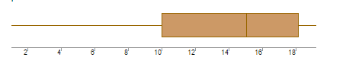
What can we say about the distribution of the data?
Ans: From the above box plot we can see that lower quartile and upper quartile of boxplot are not equal in size from which we can conclude that data is not Symmetrically distributed. As most of the data is consisted in lower quartile region and in left whisker we can expect outliers existing on left side(I.e values existing below lower extreme.
What is nature of skewness of the data?
The data is left skewed or negatively skewed as most of the data lies in lower quartile region
What will be the IQR of the data (approximately)?
IQR = Q3 - Q1 = (18.2 - 10) = 8.2(Approx)
Q19) Comment on the below Boxplot visualizations?
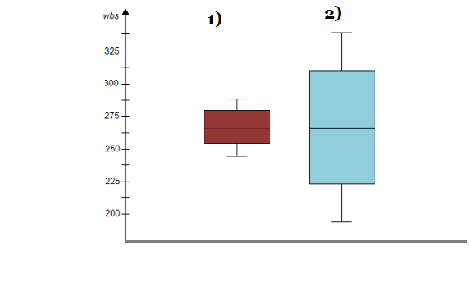
Draw an Inference from the distribution of data for Boxplot 1 with respect Boxplot 2.
Ans:
1)Median for Box plot 1 and Box Plot2 is nearly 262.5
2)There are no outliers existing in both data sets
3)It seems like Boxplot 2 is more normally distributed than boxplot1 as upper quartile and lower quartile are equal for boxplot2 and for box plot 1 the upper quartile is slightly greater than the lower quartile

Q 20) Calculate probability from the given dataset for the below cases

Data _set: Cars.csv
Calculate the probability of MPG of Cars for the below cases.
MPG <- Cars$MPG
  - P(MPG>38)
  - P(MPG<40)
  - P (20<MPG<50)
Ans:
- we give probability in terms of mean and standard deviation = N(x,μ,sigma)
- P(x<= 38 ) will be given as
In python
stats.norm.cdf( 38,34.42,9.13)

The probability of x<38 is 0.3475939251582705
- P(x>40) will be given as
In python
1-stats.norm.cdf( 40,34.42,9.13)
The Probabilty of mpg of x <40 is: 0.7293498762151616
- P (20<MPG<50) will be given as
= p(x<50) - p(x>20)
The probability of mpg between 20 and 50 is: 0.013116469610523374

Q 21) Check whether the data follows normal distribution
- Check whether the MPG of Cars follows Normal Distribution
Dataset: Cars.csv
Ans:
1)As mean, median, mode values are nearly same
mean is :34.422075728024666
median is :35.15272697
mode is: 29.629936
And skewness value is -0.17794674747025727 which is less than 1

2) Sum of all the probabilities or area under curve is
0.01+0.02+0.03+0.04 = 1
Based on the above properties we can consider the data set for MPG of cars
is mostly normal

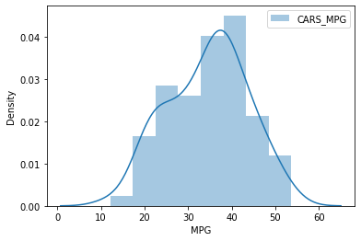

- Check Whether the Adipose Tissue (AT) and Waist Circumference(Waist) from wc-at data set follows Normal Distribution
Dataset: wc-at.csv

Ans: For Waist Circumference(Waist)

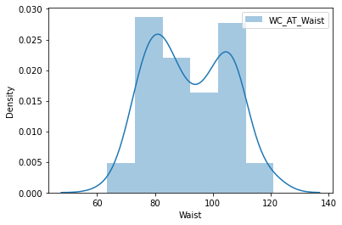
mean is :91.90183486238533
median is :90.8
mode is:
0 94.5
1 106.0
2 108.5
skewness is:0.1340560824786468

As mean, median, mode values are nearly same and skewness value is less than 1 we can consider this dataset tends to be normal
Ans: Adipose Tissue (AT)

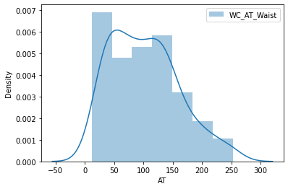

mean is :101.89403669724771
median is :96.54
mode is: 0 121.0
1 123.0
skewness is:0.584869324127853

As mean median and mode are slightly closr we can consider this data set as slightly symmetrically distributed, and as the skewness value is between [0.5,1] data is moderately skewed.

Q 22) Calculate the Z scores of 90% confidence interval,94% confidence interval, 60% confidence interval
Ans:
Z score value at 90% confidence interval is : 1.645
Z score value at 94% confidence interval is :1.881
Z score value at 60% confidence interval is :0.842

Q 23) Calculate the t scores of 95% confidence interval, 96% confidence interval, 99% confidence interval for sample size of 25
Ans:
Given: degrees of freedom = 25 -1 = 24
Formula : we can find the value in t table or using python
from scipy import stats
stats.t.ppf(confidencevalue , degrees of freedom)
The t score at 95% confidence is: 2.064
The t score at 96% confidence is: 2.172
The t score at 99% confidence is: 2.797

Q 24) A Government company claims that an average light bulb lasts 270 days. A researcher randomly selects 18 bulbs for testing. The sampled bulbs last an average of 260 days, with a standard deviation of 90 days. If the CEO's claim were true, what is the probability that 18 randomly selected bulbs would have an average life of no more than 260 days
Hint:
rcode pt(tscore,df)
df degrees of freedom
Ans:
Given:
μ = population mean = 270
x bar= mean of sample bulbs = 260
s = standard deviation of the sample = 90
n = no of randomly selected bulbs for sample = 18
Formula:
As the population standard deviation is not specified we do t test to find the probability
t = (x - μ)/(s/sqrt(n))
t = (260 - 270)/(90/sqrt(18)) = -0.47
Probablity using t value in python
stats.t.cdf(t-value,df = n-1)
stats.t.cdf(-0.47,17) = 0.32216

The probability of bulb avg life less than 260: 0.32216394448907903

