Association Rules Assignment

Question:

Prepare rules for the all the data sets
1) Try different values of support and confidence. Observe the change in number of rules for different support,confidence values
2) Change the minimum length in apriori algorithm
3) Visulize the obtained rules using different plots

Given Movies and Books Data set

To generate frequent item set rules we Implement logic in R as it is provided with more visualization pakages, and more number of parameter options used for filtering the rules compared to python.

1)Books DataSet

Books Data Set is represented in Binary format so we need not perform further transformations on this data to implement apriori

To find : Strong rules tells which books are bought together which helps us to genereate frequent itemsets

Steps
Step1: load the binary data into Books variable (Refer to the code in attached R file)
Step2: form initial set of rules using apriori algorithm(which is used for generating frequent item sets) with minimum Support and confidence parameters

# RULE 1

Lets Say min support = 0.05 and confidence=0.8
This means:
0.05 support says among all the transactions there are 5% of transactions which contains both antecedent and consequent and 0.8 confidence says among all the transactions which contains atecedent will contain consequent 80% of the time.

rule1 = apriori(as.matrix(Books),parameter = list(support=0.05, confidence=0.8))
Total number of rules generated = 62 rules
Top 5 transactions ordered by lift ratio
rule1_lift= sort(rule1,by='lift',decreasing = TRUE)
inspect(head(rule1_lift,5))

lhs rhs support confidence coverage lift count
[1] {ItalCook} => {CookBks} 0.1135 1 0.1135 2.320186 227
[2] {YouthBks,ItalCook} => {CookBks} 0.0590 1 0.0590 2.320186 118
[3] {ArtBks,ItalCook} => {CookBks} 0.0565 1 0.0565 2.320186 113
[4] {DoItYBks,ItalCook} => {CookBks} 0.0585 1 0.0585 2.320186 117
[5] {GeogBks,ItalCook} => {CookBks} 0.0640 1 0.0640 2.320186 128

Performing Visualizations for the above rule1

Scatter Plot:
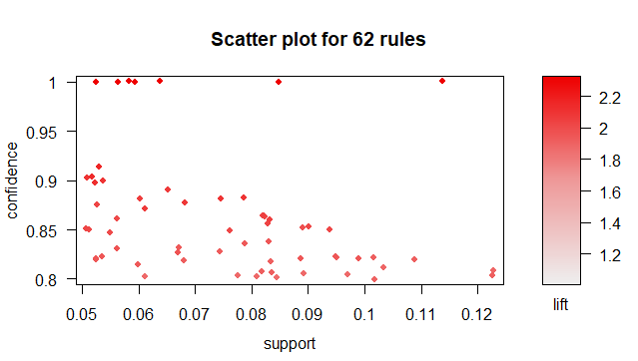

On x -axies support is plotted and on y-axies confidence is plotted and on heat map lift ratio is plotted
Note: Dark dots indicate high lift value
We can observe from the above scatter plot that dark red dots are observed for high support and confidence values, so we can conclude there are strong rules which are having high support,confidence and lift values

# Applying grouped matrix for above rules for detailed visualizations
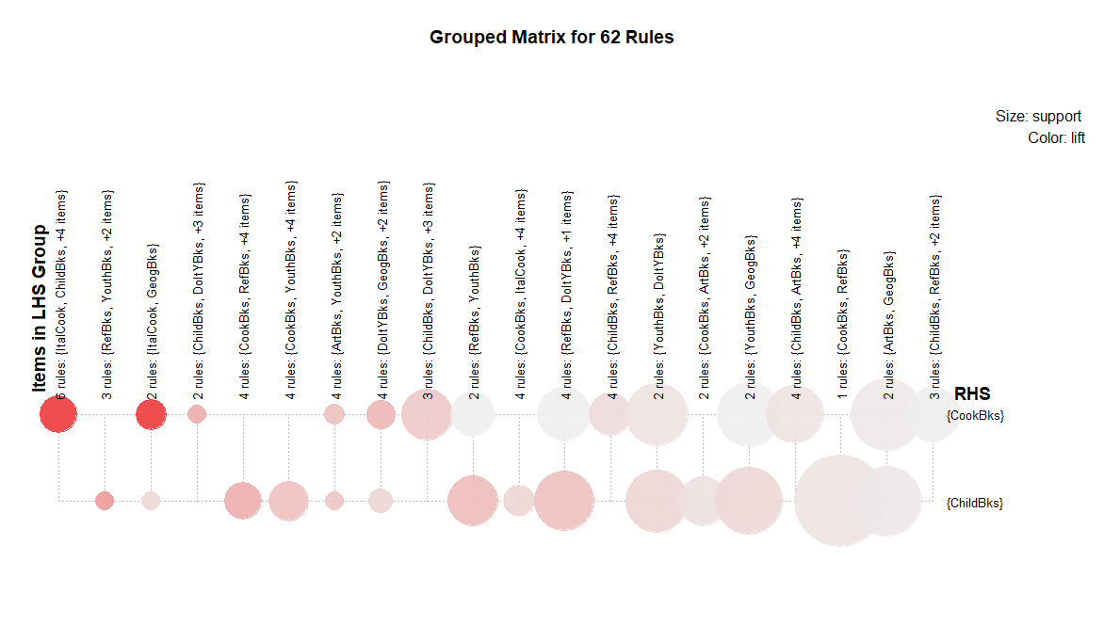
For the above visualizations items in LHS group indicate Antecedent items and RHS group indicate items in consequnt
Size of the bubble indicates the strength of support(if size is more support is high and if size is less support is low)
Color of the bubble indicates the strength of the lift value(darker the color, higher the lift value, lighter the color lower the lift value)

Rules having higher lift and support values are considered as strong rules
From the above visualizations we can conclude there are certain strong visualization as there are larger bubbles with thicker shades.

To get those rules apply filter again on the paramter values

# To filter the strong rules I have generated apriori rules using high support,confidence values

Rule 2
# consider minsupport = 0.1 , confidence = 0.8 from above visualization
Rule2 = apriori(as.matrix(Books),parameter = list(support=0.1, confidence=0.8))
Total number of rules generated = 7 rules
Top 5 transactions ordered by lift ratio
Rule2_lift= sort(rule2,by='lift',decreasing = TRUE)
inspect(head(rule2_lift,5))

lhs rhs support confidence coverage lift count
[1] {ItalCook} => {CookBks} 0.1135 1.0000000 0.1135 2.320186 227
[2] {DoItYBks,ArtBks} => {CookBks} 0.1015 0.8218623 0.1235 1.906873 203
[3] {DoItYBks,GeogBks} => {CookBks} 0.1085 0.8188679 0.1325 1.899926 217
[4] {CookBks,RefBks} => {ChildBks} 0.1225 0.8032787 0.1525 1.899004 245
[5] {ArtBks,GeogBks} => {ChildBks} 0.1020 0.8000000 0.1275 1.891253 204

Visualizations

Scatter Plot

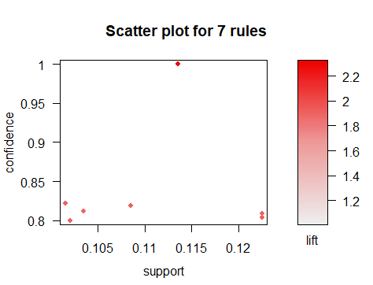
From above visualization we can conclude there is a strong rule at support 0.114 and confidence 1 with lift ratio 2.2

To get that rule we can apply grouped matrix visualization

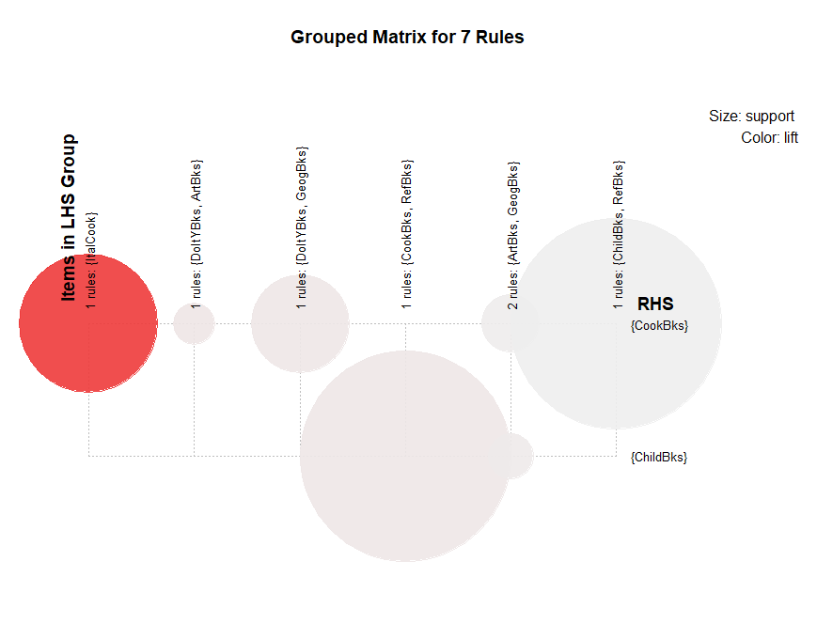
From the above visualizations we an conclude there are strong rules like

{ItalCook}-> {cookBks} I.e who ever reads italCook book also reads cookBks with high support and lift values

# filter rules based on min length => rules should contain atleast min 3 iteams in itemset

# Rule3- filter based on minlen
Rule3= apriori(as.matrix(Books),parameter = list(support=0.1, confidence=0.8,minlen=3))
Total number of rules generated = 6 rules
Top 5 transactions ordered by lift ratio
Rule3_lift= sort(rule3,by='lift',decreasing = TRUE)
inspect(head(rule3_lift,6))

lhs rhs support confidence coverage lift count
[1] {DoItYBks,ArtBks} => {CookBks} 0.1015 0.8218623 0.1235 1.906873 203
[2] {DoItYBks,GeogBks} => {CookBks} 0.1085 0.8188679 0.1325 1.899926 217
[3] {CookBks,RefBks} => {ChildBks} 0.1225 0.8032787 0.1525 1.899004 245
[4] {ArtBks,GeogBks} => {ChildBks} 0.1020 0.8000000 0.1275 1.891253 204
[5] {ArtBks,GeogBks} => {CookBks} 0.1035 0.8117647 0.1275 1.883445 207
[6] {ChildBks,RefBks} => {CookBks} 0.1225 0.8085809 0.1515 1.876058 245

Visualizations

Scatter Plot
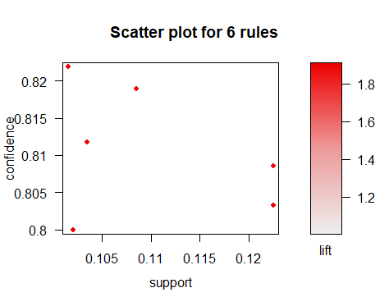

Grouped Plot
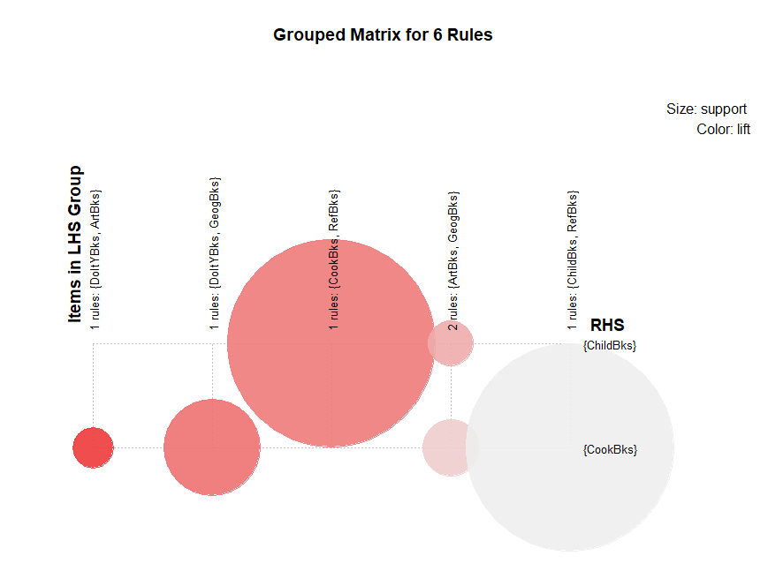
From the above visualizations we can conclude all most all the rules are strong enough to form frequent Itemsets
Ex:
{cookBks,RefBks}->{childBks} I.e whoever reads cookbks and refbks also reads childbks In most of the times
{DoltYBks,GeoBks}->{cookBks}
{DoltYBks,ArtBks}->{CookBks}

- Movie DataSet

Movie Data set is represented in Transaction as well as Binary Variables
we will consider the Binary Variables to prepare the Rules

To find : Strong rules tells which movies are frequently watched together.

Steps

Step1: load the binary data into movies variable (Refer to the code in attached R file)

Step2: form initial set of rules using apriori algorithm(which is used for generating frequent item sets) with minimum Support and confidence parameters

Lets Say min support = 0.05 and confidence=0.8
This means:
0.05 support says among all the transactions there are 5% of transactions which contains both antecedent and consequent and 0.8 confidence says among all the transactions which contains atecedent will contain consequent 80% of the time.

rule1 = apriori(as.matrix(movies[,6:15]),parameter = list(support = 0.05,
confidence = 0.8))

Top 5 transactions ordered by lift ratio
rule1_lift= sort(rule1,by='lift',decreasing = TRUE)
inspect(head(rule1_lift,5))

lhs rhs support confidence
[1] {Gladiator,Green.Mile} => {LOTR} 0.1 1
[2] {Sixth.Sense,Gladiator,Green.Mile} => {LOTR} 0.1 1
[3] {Harry.Potter2} => {Harry.Potter1} 0.1 1
[4] {LOTR} => {Green.Mile} 0.1 1
[5] {LOTR1} => {LOTR2} 0.2 1
coverage lift count
[1] 0.1 10 1
[2] 0.1 10 1
[3] 0.1 5 1
[4] 0.1 5 1
[5] 0.2 5 2

Performing Visualizations for the above rule1

Scatter Plot:
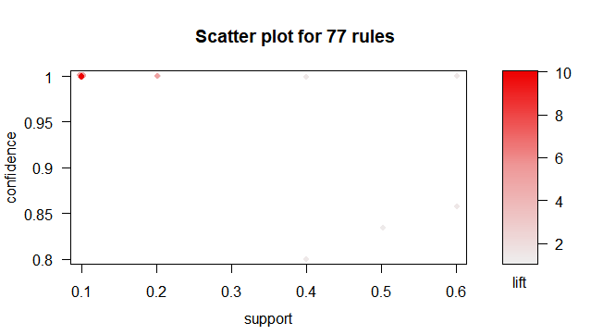

On x -axies support is plotted and on y-axies confidence is plotted and on heat map lift ratio is plotted
Note: Dark dots indicate high lift value
We can observe from the above scatter plot that dark red dots are observed for less support values, with very less support values and lift values, we can consider this patterns are occuring randomly and no standard frequency (I.e occuared randomly with out any logic behind them)

So we consider this rules as insignificant rules or not strong rules

# We can come to the same conclusions using another visualization plot - grouped Matrix Plot
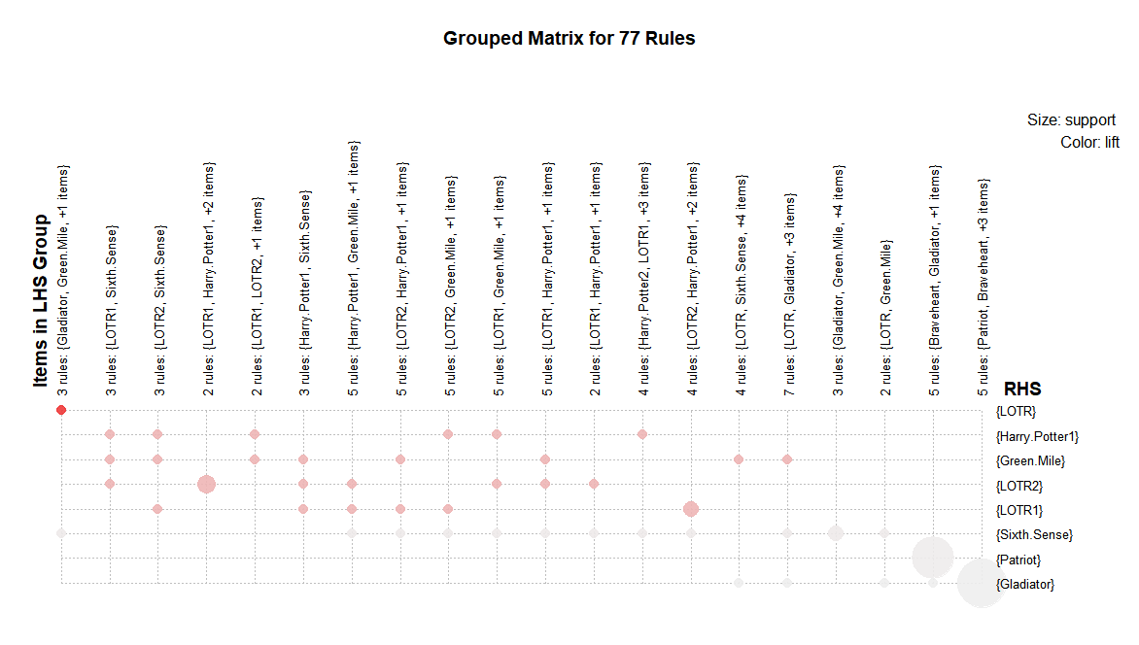From the above visualization we can see there is no dot which is having high support and lift at the same time . We can go further and create strong rules by changing the support and confidence valu,min len parameters

# creating rule 2 which takes different support and confidence parameters in apriori. Support = 0.8 and confidence = 1
rule2<- apriori(as.matrix(movies[,6:15],parameter= list(support = 0.8,confidence=1)))

lhs rhs support confidence
[1] {Gladiator,Green.Mile} => {LOTR} 0.1 1
[2] {Sixth.Sense,Gladiator,Green.Mile} => {LOTR} 0.1 1
[3] {Harry.Potter2} => {Harry.Potter1} 0.1 1
[4] {LOTR} => {Green.Mile} 0.1 1
[5] {LOTR1} => {LOTR2} 0.2 1
coverage lift count
[1] 0.1 10 1
[2] 0.1 10 1
[3] 0.1 5 1
[4] 0.1 5 1

By changing the min support and confidence values to 0.8 and 1 the rules are not changing much. But from both rule1 and rule2 we can conclude

#There is a standard rule which says whoever watches gladiator and green.mile moves watches LOTR with a lift ratio of 10(i.e 10% of times together with 100% confidence)

Grouped Matrix 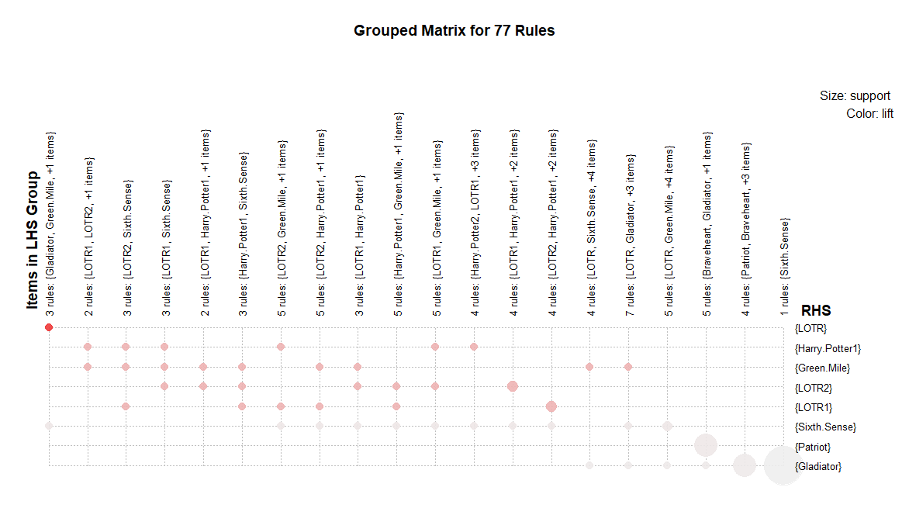

From the above visualization also we can say there are no strong rule as both support and lift values are not high for any dot.

# creating rule 3 which takes different support and confidence, minlen parameters in apriori. Support = 0.05 and confidence = 1
rule3<- apriori(as.matrix(movies[,6:15]),parameter= list(support = 0.05,confidence=0.8,minlen=3))

Here We are conidering support = 5% confidence = 80% minlen = 3(minimum items for item set should be atleast 3)

lhs rhs support confidence
[1] {Gladiator,Green.Mile} => {LOTR} 0.1 1
[2] {Sixth.Sense,Gladiator,Green.Mile} => {LOTR} 0.1 1
[3] {Gladiator,LOTR} => {Green.Mile} 0.1 1
[4] {Sixth.Sense,LOTR} => {Green.Mile} 0.1 1
[5] {LOTR1,Harry.Potter1} => {LOTR2} 0.1 1
coverage lift count
[1] 0.1 10 1
[2] 0.1 10 1
[3] 0.1 5 1
[4] 0.1 5 1
[5] 0.1 5 1
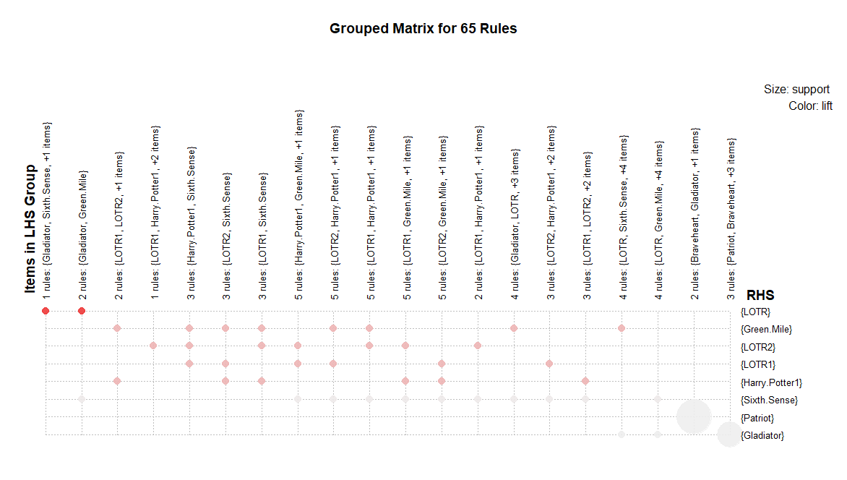

As per the filtered asociation rules based on different parameters we can conclude the below rules as strong rules
{Gladiator,Green.Mile} => {LOTR}
{Sixth.Sense,Gladiator,Green.Mile} => {LOTR}
{Gladiator,LOTR} => {Green.Mile}
{Sixth.Sense,LOTR} => {Green.Mile}
{LOTR1,Harry.Potter1} => {LOTR2}

