STATISTICS

**Consider a set S = {2, 4, 6, 8, x, y} with distinct elements. If x and y are both prime numbers and 0 < x < 40 and 0 < y < 40, which of the following MUST be true?  
I. The maximum possible range of the set is greater than 33.  
II. The median can never be an even number.  
III. If y = 37, the average of the set will be greater than the median.**

1. I only
2. I and II only
3. I and III only
4. III only
5. I, II, and III

**Three positive integers a, b, and c are such that their average is 20 and a ≤ b ≤ c. If the median is (a + 11), what is the least possible value of c?**A. 23  
B. 21  
C. 25  
D. 26  
E. 24

1. a ≤ b ≤ c
2. a, b, and c are positive integers.
3. Average of the three integers = 20
4. Sum of all the three integers = 60
5. Median = b = a + 11

**Check for the possible values of c**

Theoretically, the least value of c is when c = b.  
Therefore, a + (a + 11) + (a + 11) = 60 (b and c are equal and b, the median, is a + 11)  
Or 3a = 38 or a = 12.66  
So, b = c = 12.66 + 11 = 23.66

However, we know that these numbers are all integers.  
Therefore, a, b, and c cannot take these values.  
So, the least value for c with this constraint is NOT likely to be when c = b.

Let us increment c by 1. Let c = (b + 1)  
In this scenario, a + (a + 11) + (a + 12) = 60  
Or 3a = 37. The value of the numbers is not an integer in this scenario as well.

Let us increment c again by 1. i.e., c = b + 2  
Now, a + (a + 11) + (a + 13) = 60  
Or 3a = 36 or a = 12.  
If a = 12, b = 23 and c = 25.  
**The least value for c that satisfies all these conditions is 25**

Find the mean of the following distribution:  
  
Solution:  
Calculation of arithmetic mean  
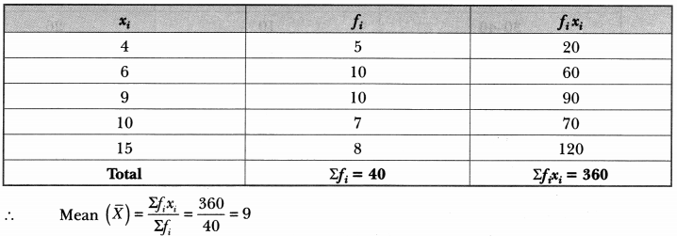

If the mean of the following distribution is 6, find the value of p.  
  
Solution:  
Calculation of mean  
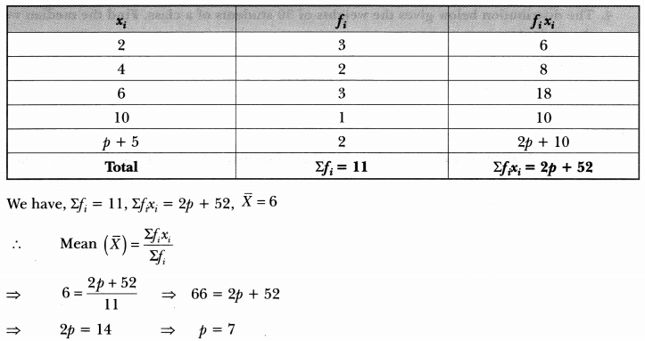

The mean of the following frequency distribution is 62.8. Find the missing frequency x.  
  
Solution:  
We have  
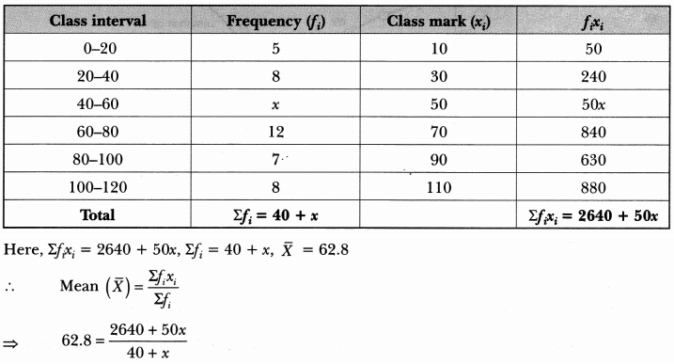  
⇒ 2512 + 62.8x = 2640 + 50x  
⇒ 62.8x – 50x = 2640 – 2512  
⇒ 12.8x = 128  
∴ x = 12812.8 = 10  
Hence, the missing frequency is 10.

Find mode, using an empirical relation, when it is given that mean and median are 10.5 and 9.6 respectively.  
**Solution:**  
Mean = 10.5 and median = 9.6  
Empirical relation: 3 Median = Mode + 2 Mean  
3(9.6) = Mode + 2(10.5)  
28.8 = Mode + 21  
Mode = 28.8 – 21 = 7.8

In a frequency distribution, if a = assumed mean = 55,∑ fi = 100, h = 10 and ∑ƒiμi = -30, then find the mean of the distribution  
**Solution:**  
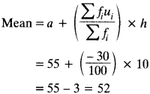

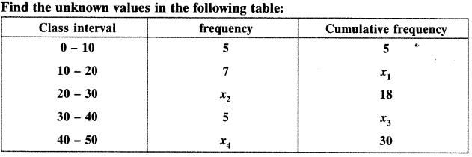  
**Solution:**  
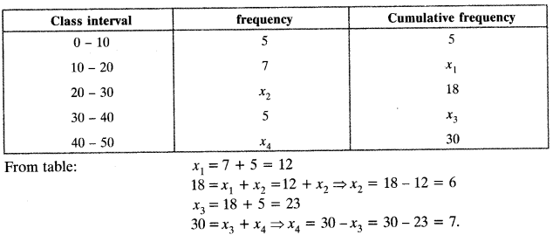

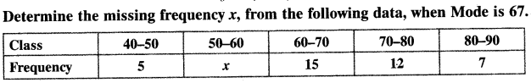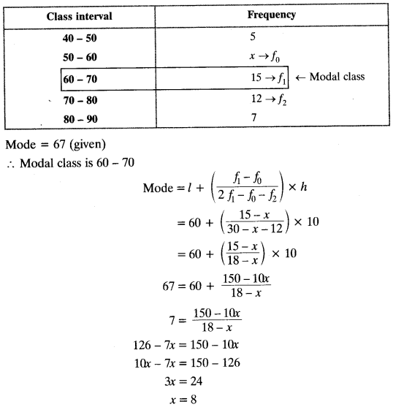

The average score of boys in the examination of a school is 71 and that of the the girls is 73. The average score of the school in the examination is 71.8. Find the ratio of the number of boys to the number of girls who appeared in the examination.  
**Solution:**  
Let number of boys in the school be x  
Average score of boys = 71  
Total score of boys in the examination of the school = 71xx = 71x  
Let number of girls in the school be y  
Average score of girls = 73  
Total score of girls in the examination of the school = 73 x y = 73y  
Now,  
average score of the school in examination = 71.8  
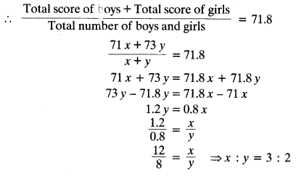

 If 35 is removed from the data, 30, 34, 35, 36, 37, 38, 39, 40 then the median increases by:

(A) 2

(B) 1.5

(C) 1

(D) 0.5

**Answer:  (D)**

**Explanation:** We have

30, 34, 35, 36, 37, 38, 39, 40

The data has 8 observations, so there are two middle terms, 4th and 5th term i.e. 36 and 37.

The median is the mean of both these terms.

Median = (36 + 37)/2

Median = 36.5

When 35 is removed from given data as 30, 35, 36, 37, 38, 39, 40 then the number of observations becomes 7.

Now the median is the middle most i.e 4th term which is equal to 37.

Therefore median is increased by 37 – 36.5 = 0.5

The Median when it is given that mode and mean are 8 and 9 respectively, is:

 (A) 8.57

(B) 8.67

 (C) 8.97

(D) 9.24

**Answer:  (B)**

**Explanation:**By Empirical formula:

Mode = 3median – 2 mean

8 = 3medain – 2 X 9

8 = 3median – 18

3median = 8 + 18

Median = 26/3

Median = 8.67

CBSE 10th Maths Exam 2020: Important MCQs from Chapter 14 Statistics with Answers

(A) 3

(B) 4

(C) 5

(D) 6

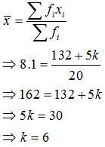

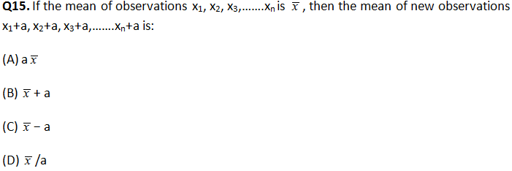

A national random sample of 20 ACT scores from 2010 is listed below. Calculate the sample mean and standard deviation. 29, 26, 13, 23, 23, 25, 17, 22, 17, 19, 12, 26, 30, 30, 18, 14, 12, 26, 17, 18 a. 20.50, 5.79 b. 20.50, 5.94 c. 20.85, 5.79 d. 20.85, 5.94

Example: 5, 7, 4, 4, 6, 2, 8

Put them in order: 2, 4, 4, 5, 6, 7, 8

And the result is:

* Quartile 1 (Q1) = **4**
* Quartile 2 (Q2), which is also the [Median](https://www.mathsisfun.com/median.html), = **5**
* Quartile 3 (Q3) = **7**

**Box and Whisker Plot and Interquartile Range** for

4, 17, 7, 14, 18, 12, 3, 16, 10, 4, 4, 11

Put them in order:

3, 4, 4, 4, 7, 10, 11, 12, 14, 16, 17, 18

Cut it into quarters:

3, 4, 4 | 4, 7, 10 | 11, 12, 14 | 16, 17, 18

In this case all the quartiles are between numbers:

* Quartile 1 (Q1) = (4+4)/2 = **4**
* Quartile 2 (Q2) = (10+11)/2 = **10.5**
* Quartile 3 (Q3) = (14+16)/2 = **15**

Also:

* The Lowest Value is **3**,
* The Highest Value is **18**

And the **Interquartile Range** is:

Q3 − Q1 = 15 − 4 = **11**

What are the quartiles for the following set of numbers?  
  
8, 11, 20, 10, 2, 17, 15, 5, 16, 15, 25, 6

First arrange the numbers in order: 2, 5, 6, 8, 10, 11, 15, 15, 16, 17, 20, 25  
This list can be split up into four equal groups of three:  
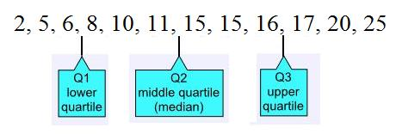

Therefore:  
Q1 is the mean of 6 and 8 = (6 + 8) ÷ 2 = 7  
Q2 is the mean of 11 and 15 = (11 + 15) ÷ 2 = 13  
Q3 is the mean of 16 and 17 = (16 + 17) ÷ 2 = 16.5

What are the quartiles for the following set of numbers?  
  
13, 18, 6, 20, 25, 11, 9, 18, 3, 30, 16, 9, 8, 23, 26, 17

First arrange the numbers in order: 3, 6, 8, 9, 9, 11, 13, 16, 17, 18, 18, 20, 23, 25, 26, 30  
This list can be split up into four equal groups of four:  
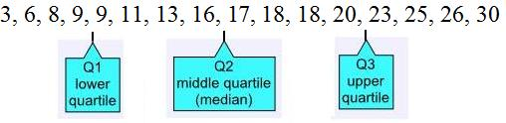  
Therefore:  
Q1 is the mean of 9 and 9 = (9 + 9) ÷ 2 = 9  
Q2 is the mean of 16 and 17 = (16 + 17) ÷ 2 = 16.5  
Q3 is the mean of 20 and 23 = (20 + 23) ÷ 2 = 21.5

What is the interquartile range for the following set of numbers?  
  
4, 5, 6, 8, 9, 11, 13, 16, 16, 18, 20, 21, 25, 30, 31, 33, 36, 37, 40, 41

This list can be split up into four equal groups of five:  
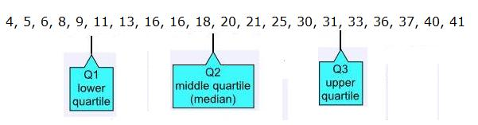  
Therefore:  
Q1 is the mean of 9 and 11 = (9 + 11) ÷ 2 = 10  
Q2 is the mean of 18 and 20 = (18 + 20) ÷ 2 = 19  
Q3 is the mean of 31 and 33 = (31 + 33) ÷ 2 = 32  
  
Therefore the interquartile range = Q3 - Q1 = 32 - 10 = 22

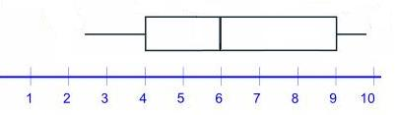

What is the interquartile range for the information shown in the above box and whisker plot,?

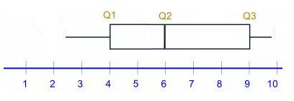  
  
The upper quartile, Q3 is 9  
The lower quartile, Q1 is 4  
  
Therefore, the interquartile range = 9 - 4 = 5

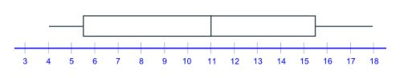

For the information shown in the above box and whisker plot, what is the range and what is the interquartile range?

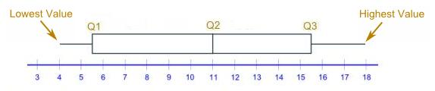

The highest value = 18  
The lowest value = 4  
Therefore the range = 18 - 4 = 14  
  
The upper quartile, Q3 is 15.5  
The lower quartile, Q1 is 5.5  
Therefore, the interquartile range = 15.5 - 5.5 = 10

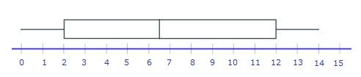

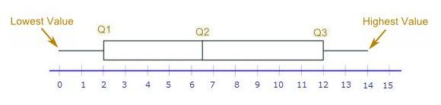

Median = Q2 = 6.5  
  
Range = Highest value - Lowest value = 14 - 0 = 14  
  
Interquartile range = Q3 - Q1 = 12 - 2 = 10

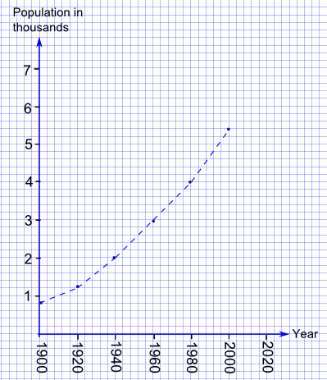

The population of a town was recorded every twenty years from 1900 to 2000. The results are shown in the line graph.  
Estimate the interquartile range over that period.

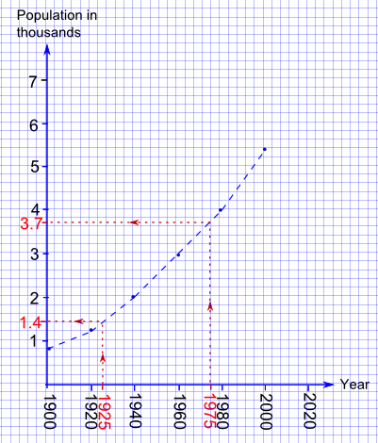

There are but 6 data points:  
  
1900, 800  
1920, 1200  
1940, 2000  
1960, 3000  
1980, 4000  
2000, 5400  
  
Dividing the list in quarters ends up at:

Q1: 1925, ≈ 1,400  
Q2: 1950  
Q3: 1975, ≈ 3,700  
  
∴ The interquartile range ≈ 3,700 - 1,400 = 2,300

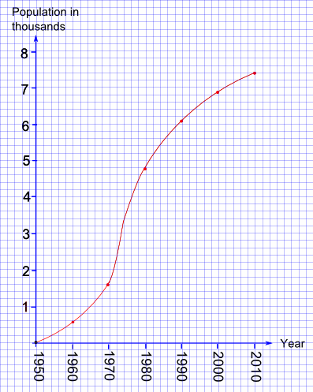

The graph shows how the population of rabbits on an island changed from 1950 to 2010.  
  
Estimate the interquartile range over that period.

The Range is 1950 to 2010, which is 60 years.  
  
And a quarter of 60 is 15, so 1965 and 1995 will be the lower and upper quartile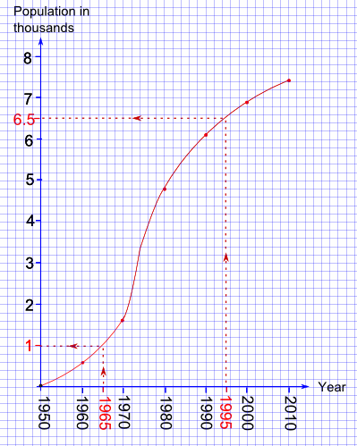

From the graph:  
The lower quartile (Q1) was the population in 1965 ≈ 1 × 1,000 = 1,000  
The upper quartile (Q3) was the population in 1995 ≈ 6.5 × 1,000 = 6,500

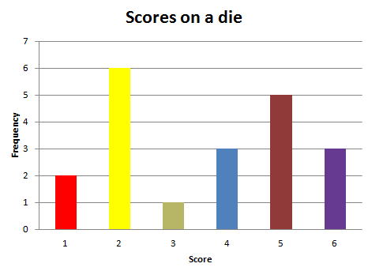

The bar graph shows the scores obtained from 20 throws of a die.  
  
What is the lower quartile

First write out the numbers in order: 1, 1, 2, 2, 2, 2, 2, 2, 3, 4, 4, 4, 5, 5, 5, 5, 5, 6, 6, 6  
This list can be split up into four equal groups of five:  
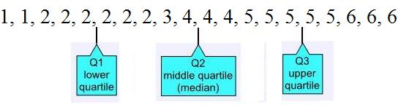  
  
So,  
Q1 is the mean of 2 and 2 = 2

Jake did a survey of the numbers of brothers and sisters of the children in his class.  
  
He recorded the results as follows:  
  
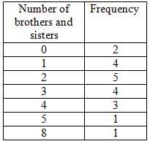  
  
What is the upper quartile?

First write out the numbers in order: 0, 0, 1, 1, 1, 1, 2, 2, 2, 2, 2, 3, 3, 3, 3, 4, 4, 4, 5, 8  
This list can be split up into four equal groups of five:  
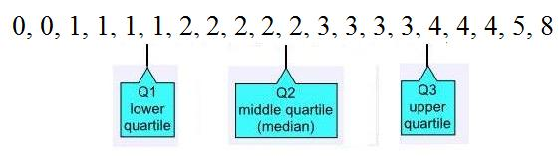  
  
So, Q3 is the mean of 3 and 4 = (3 + 4) ÷ 2 = 3.5.

Normal distribution

## **Standard Deviations**

The [Standard Deviation](https://www.mathsisfun.com/data/standard-deviation.html) is a measure of how spread out numbers are (read that page for details on how to calculate it).

When we [calculate the standard deviation](https://www.mathsisfun.com/data/standard-deviation-calculator.html) we find that **generally**:

|  |  |
| --- | --- |
|  | **68%** of values are within **1 standard deviation** of the mean      **95%** of values are within **2 standard deviations** of the mean      **99.7%** of values are within **3 standard deviations** of the mean |

95% of students at school are between **1.1m and 1.7m** tall.

Assuming this data is **normally distributed** can you calculate the mean and standard deviation?

The mean is halfway between 1.1m and 1.7m:

Mean = (1.1m + 1.7m) / 2 = **1.4m**

95% is 2 standard deviations either side of the mean (a total of 4 standard deviations) so:

|  |  |
| --- | --- |
| 1 standard deviation | = (1.7m-1.1m) / 4 |
|  | = 0.6m / 4 |
|  | = **0.15m** |

In that same school one of your friends is 1.85m tall

You can see on the bell curve that 1.85m is **3 standard deviations** from the mean of 1.4, so:

It is also possible to **calculate** how many standard deviations 1.85 is from the mean

*How far is 1.85 from the mean?*

It is 1.85 - 1.4 =**0.45m from the mean**

*How many standard deviations is that?* The standard deviation is 0.15m, so:

0.45m / 0.15m = **3 standard deviations**

95% of students at school weigh between 62 kg and 90 kg.  
Assuming this data is normally distributed, what are the mean and standard deviation?

The mean is halfway between 62 kg and 90 kg:  
Mean = (62 kg + 90 kg)/2 = 76 kg  
  
95% is 2 standard deviations either side of the mean (a total of 4 standard deviations) so:  
1 standard deviation = (90 kg - 62 kg)/4 = 28 kg/4 = 7 kg

A machine produces electrical components.  
99.7% of the components have lengths between 1.176 cm and 1.224 cm.  
Assuming this data is normally distributed, what are the mean and standard deviation?

The mean is halfway between 1.176 cm and 1.224 cm:  
Mean = (1.176 cm + 1.224 cm)/2 = 1.200 cm  
99.7% is 3 standard deviations either side of the mean (a total of 6 standard deviations) so:  
1 standard deviation = (1.224 cm - 1.176 cm)/6 = 0.048 cm/6 = 0.008 cm

The Fresha Tea Company pack tea in bags marked as 250 g  
A large number of packs of tea were weighed and the mean and standard deviation were calculated as 255 g and 2.5 g respectively.  
Assuming this data is normally distributed, what percentage of packs are underweight?

The following diagram shows 1, 2 and 3 standard deviations on either side of the mean:  
  
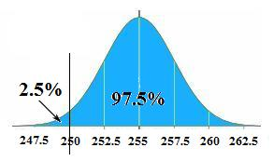  
  
250 g is two standard deviations below the mean  
Since 95% of packs are within 2 standard deviations of the mean, it follows that 5% ÷ 2 = 2.5% of packs were underweight.

Students pass a test if they score 50% or more.  
  
The marks of a large number of students were sampled and the mean and standard deviation were calculated as 42% and 8% respectively.  
  
Assuming this data is normally distributed, what percentage of students pass the test?

The following diagram shows 1, 2 and 3 standard deviations on either side of the mean:  
  
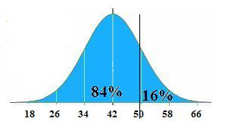  
50% is one standard deviation above the mean  
  
Since 68% of marks are within 1 standard deviation of the mean, it follows that 32% will be more than 1 standard deviation from the mean.  
  
And the half of those that are on the high side will pass.  
  
So 32% ÷ 2 = 16% of students pass.

A company makes parts for a machine. The lengths of the parts must be within certain limits or they will be rejected.  
  
A large number of parts were measured and the mean and standard deviation were calculated as 3.1 m and 0.005 m respectively.  
  
Assuming this data is normally distributed and 99.7% of the parts were accepted, what are the limits?

99.7% is 3 standard deviations on either side of the mean.  
  
The following diagram shows 1, 2 and 3 standard deviations on either side of the mean:  
  
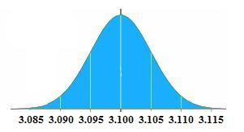  
  
So the lengths of the parts must be between 3.085 m and 3.115 m

The mean June midday temperature in Desertville is 36°C and the standard deviation is 3°C  
  
Assuming this data is normally distributed, how many days in June would you expect the midday temperature to be between 39°C and 42°C?

39°C is one standard deviation above the mean and 42°C is two standard deviations above the mean:  
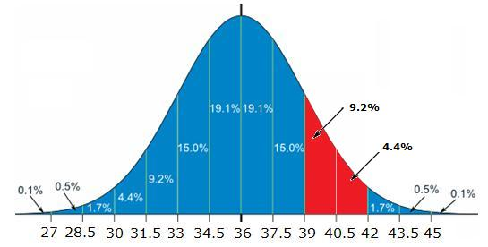  
  
Therefore we would expect the temperature to be between 39°C and 42°C on 13.6% of the days  
(9.2% + 4.4% = 13.6%)  
  
There are 30 days in June  
13.6% of 30 = 4.08 = 4 to the nearest day

The heights of male adults are Normally distributed with mean 1.7 m and standard deviation 0.2 m  
  
In a population of 400 male adults, how many would you expect to have a height between 1.4 m and 1.6 m?  
  
You can use this Standard Normal Distribution curve:  
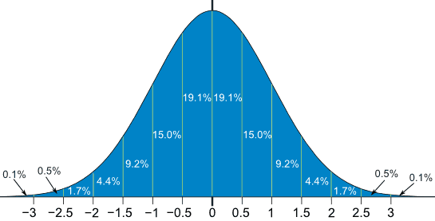

1.6 m is half a standard deviation below the mean and 1.4 m is one and a half standard deviations below the mean:  
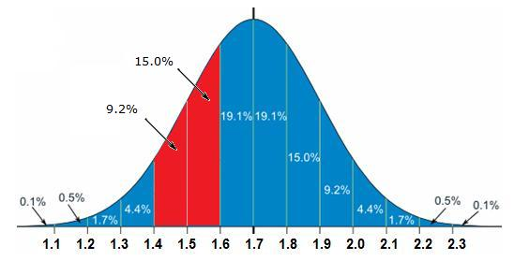  
  
Therefore the percentage of male adults with heights between 1.4 m and 1.6 m  
= 15.0% + 9.2% = 24.2%  
  
24.2% of 400 = 96.8  
  
Therefore we would expect 97 male adults with heights between 1.4 m and 1.6 m

The mean July daily rainfall in Waterville is 10 mm and the standard deviation is 1.5 mm  
  
Assume that this data is normally distributed.  
How many days in July would you expect the daily rainfall to be less than 8.5 mm?

8.5 mm is one standard deviation below the mean:  
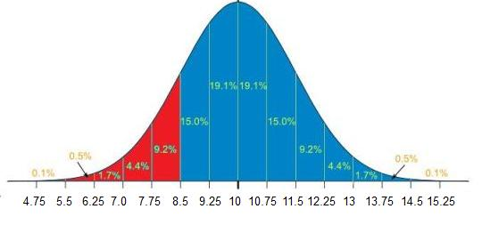  
  
Therefore we would expect the rainfall to be less than 8.5 mm on 15.9% of the days  
(9.2% + 4.4% + 1.7% + 0.5% + 0.1% = 15.9%)  
  
There are 31 days in July  
15.9% of 31 = 4.929 = 5 to the nearest day

The ages of the population of a town are Normally distributed with mean 43 and standard deviation 14  
  
The town has a population of 5,000.  
How many would you expect to be aged between 22 and 57?  
  
You can use this Standard Normal Distribution curve:  


22 is one and a half a standard deviation below the mean and 57 is one standard deviations above the mean:  
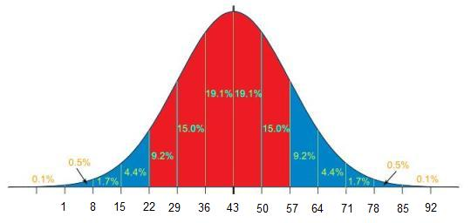  
  
So, the percentage of the population aged between 22 and 57  
= 9.2% + 15.0% + 19.1% + 19.1% + 15.0% = 77.4%  
  
77.4% of 5,000 = 3,870