EJB Application Execution and Results

The distributed application consists of 4 servers implementing Session, Entity and Message Driven Bean concepts using University as domain.

Running the Application:

1. Set up Net Beans IDE 8.0.1 version and Glassfish version 4.1
2. Extract the given Zip folder and move project to Net Beans workspace.
3. Open Projects CS441EJB and CS441EJBClient1 from IDE and check import required projects.
4. The database used is JavaDB which comes with glassfish server. The dabase is Sample and Schema is APP.
5. Create JMS resources in Glassfish Domain Admin Console for Message Driven Beans.

Steps involved in creating JMS resources are

1. Open the Admin Console and go to JMS resources.
2. Now click on Connection Factories and click new and enter JNDI name as “jms/queue” and select Resource Type as j”avax.jms.QueueConnectionFactory”
3. Again go to JMS Resources and then click on Destination Resources.
4. Click new and enter JNDI name as “jms/dest” and physical destination name as “cs441jms” and Resource Type as “javax.jms.Queue”.
5. Click OK
6. Now Clean and build CS441EJB project and deploy it in the server.
7. Clean and Build CS441EJBClient1 and then run the Project.

The Application has :

1. **Session_StatelessBean** Server which uses stateless bean concept. And acts like Server for CS441EJBClient1 and Client for Session_StatefulBean Server.

**2. Session_StatefulBean** Server which uses stateful bean concept and acts as Server for Session_StatelessBean and Client for Professor(Entity Bean) Server.

3. **Professor**(Entity Bean) Server which uses persistence entity bean concept and acts as Server for Session_StatefulBean and CS441EJBClient1.

4**. MsgBea**n Server which uses concept Message Driven bean of EJB and is used to send the messages.

5. **TestAccessTimeout** server to test the access timeout of the application if there are parallel invocations occurring. If there is a concurrent access to a single method and if there is no lock acquired within a time period then concurrency Access timeout exception occurs in the application.

Outputs by Selecting Different Options:

1. By selecting Session Bean we get:

Choose typeId below for bean you want to work with :

1 Session Bean

2 Entity Bean

3 Message Driven Bean

4 Access Timeout testing

1

Select department ID for which you want to check the list of courses offered

1.Computer Science

2.Biology

3.MIS

2

1.BioChemistry-2

2.Analysis of Biological Stuctures

1. By selecting Entity Bean we get:
2. if we choose to list the rows in database Professor then

Choose typeId below for bean you want to work with :

1 Session Bean

2 Entity Bean

3 Message Driven Bean

4 Access Timeout testing

2

Choose ID from the list of options provided below

1. List all professors and their courses available using entity bean

2. Insert professor name and course into database using entity bean

1

List of all Courses and Corresponding Professors are :

*******************************

Professor Name : Gyorgy Turan

Course Name : Algorithms-2

*******************************

Professor Name : Bhaskar DasGupta

Course Name : Algorithms-2

*******************************

Professor Name : Prasad Sistla

Course Name : Database Systems

*******************************

Professor Name : Ouir Wolfson

Course Name : Database Systems

*******************************

Professor Name : Constance Jeffery

Course Name : BioChemistry-2

*******************************

Professor Name : Hua Jin

Course Name : BioChemistry-2

*******************************

Professor Name : M Simonovic

Course Name : Analysis of Biological Structures

*******************************

Professor Name : A Lavie

Course Name : Analysis of Biological Structures

*******************************

Professor Name : Aris M Oulcsel

Course Name : Operations Management

*******************************

Professor Name : Doug E Lundquist

Course Name : Operations Management

*******************************

Professor Name : Siddharth BhattaCharyya

Course Name : DataMining for Business

*******************************

Professor Name : Fan Wang

Course Name : DataMining for Business

1. if we want to insert a row in database then

Choose typeId below for bean you want to work with :

1 Session Bean

2 Entity Bean

3 Message Driven Bean

4 Access Timeout testing

2

Choose ID from the list of options provided below

1. List all professors and their courses available using entity bean

2. Insert professor name and course into database using entity bean

2

Enter Professor name

Mark

Enter the course name taken

Cloud Computing

Check for record in java database...

The record is inserted into database.

1. If Message Driven Bean is Chosen then

Output is:

Choose typeId below for bean you want to work with :

1 Session Bean

2 Entity Bean

3 Message Driven Bean

4 Access Timeout testing

3

Enter the number of messages you want to send....

2

Enter the message 1:

Hello

Enter the message 2:

Good Morning

Messages sent to server. Check Server log for output

**GlassFish Server log output is:**

Info: Java Web Start services started for the app client CS441EJBClient1 (contextRoot: /CS441EJBClient1)

Info: CS441EJBClient1 was successfully deployed in 752 milliseconds.

Info: Message Driven Bean: Message received: Good Morning

Info: Message Driven Bean: Message received: Hello

1. If Concurrent Access Timeout is choose then output for two threads is :

Run1:

Choose typeId below for bean you want to work with :

1 Session Bean

2 Entity Bean

3 Message Driven Bean

4 Access Timeout testing

4

I am able to run

Run2:

Choose typeId below for bean you want to work with :

1 Session Bean

2 Entity Bean

3 Message Driven Bean

4 Access Timeout testing

4

Concurrent Access timeout exception occurred

Below are the screenshots:

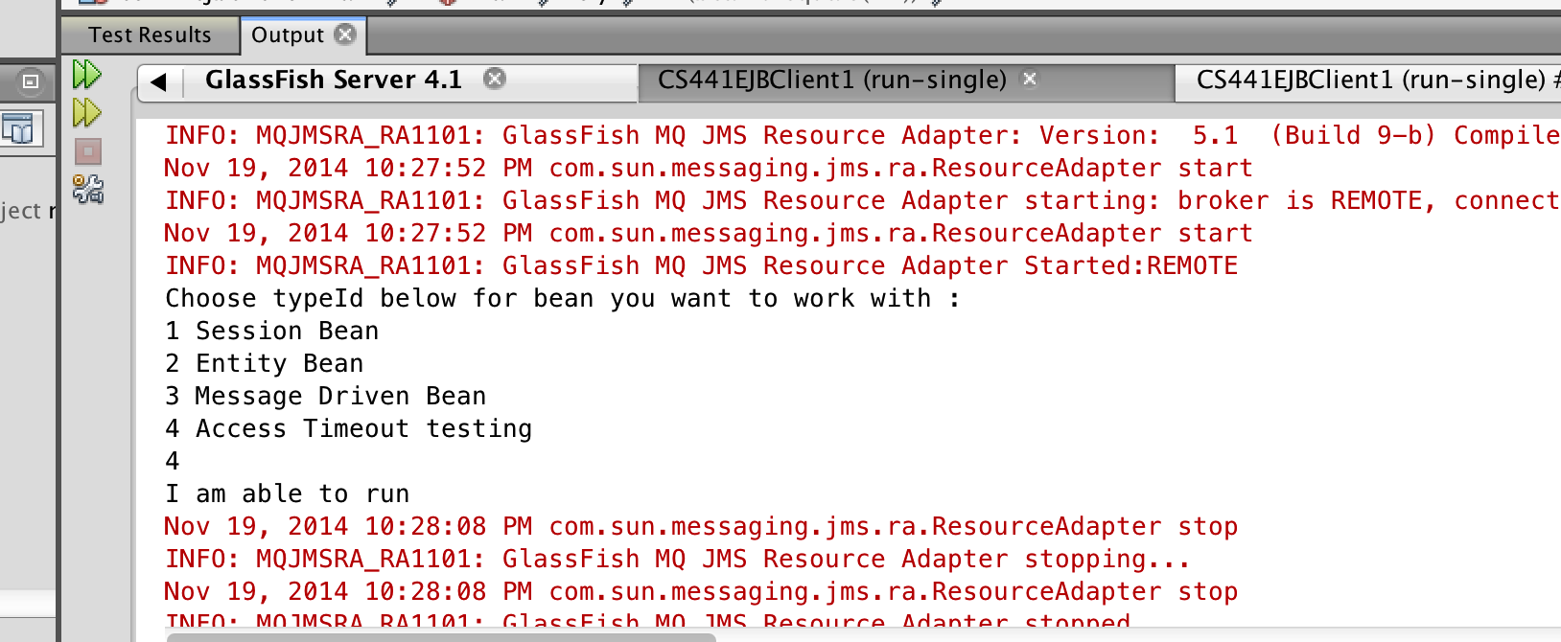

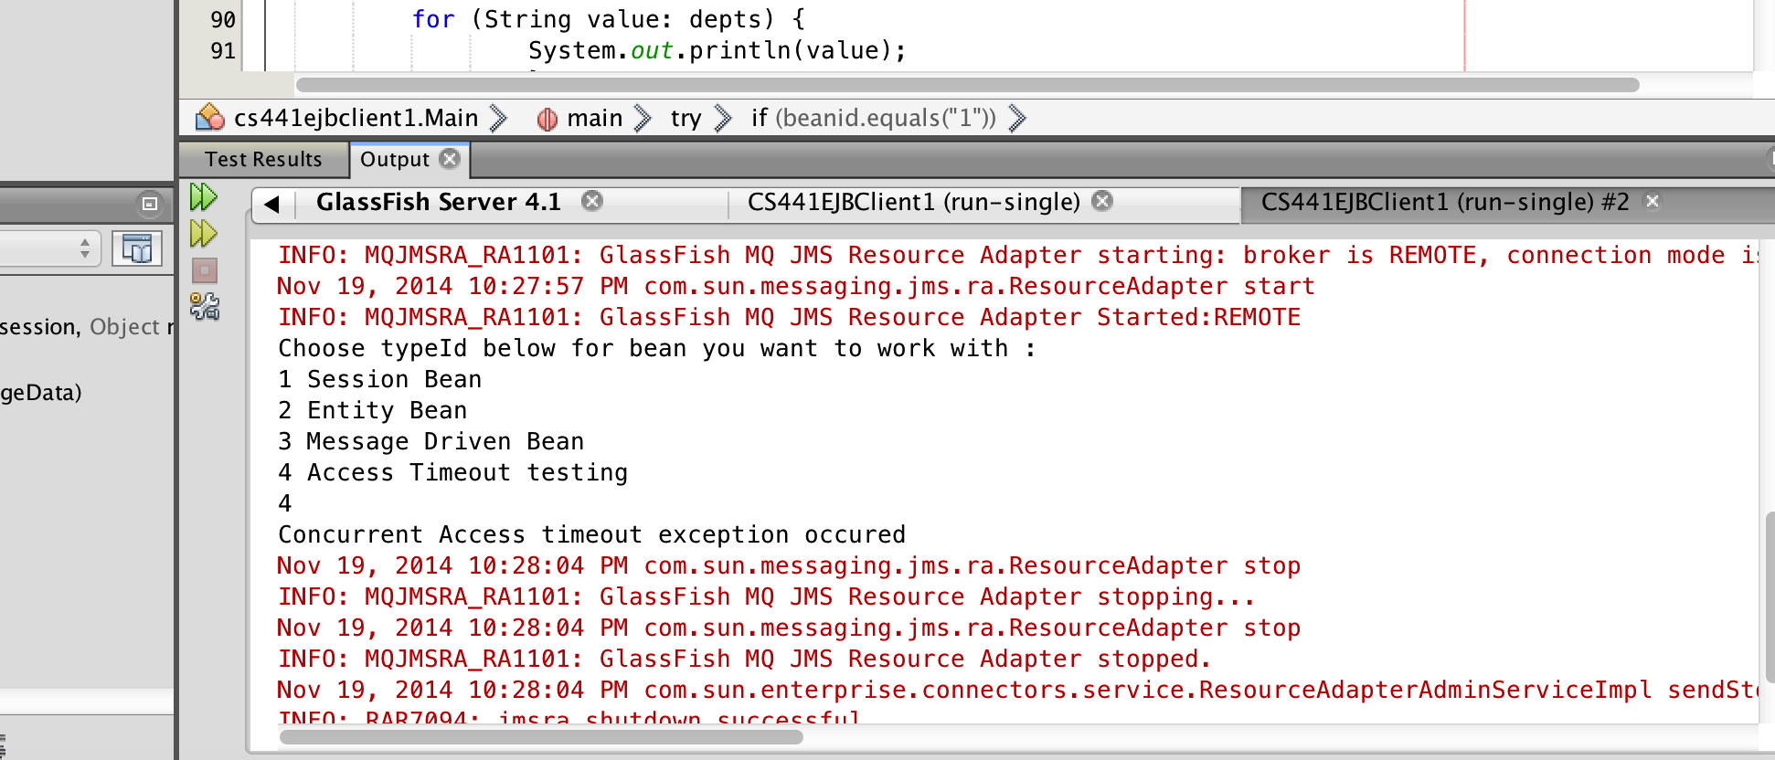

**JUnit Test Case:**

For Testing junit-4.10.jar is used.

Set the CLASSPATH first for this junit jar file

The JUnit test case is created for the Client Project. It is included in the Test Packages.

Run the file in Test Package for Testing.