VLABS NITK

BASE EXCITATION

Validation document

System:

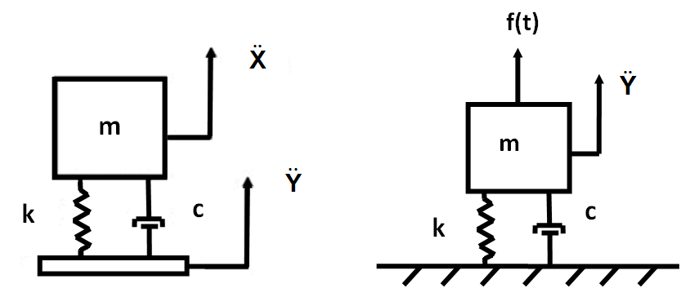

Equations used:



where 









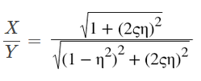

Initialized Parameters:

F0 = 20 N

M = 32 Kg

K = 20000 N/m

z = 0.07

Variable parameter:

ω = 50 rad/s

Calculated values:

ωn, η, X

|  |  |  |  |  |
| --- | --- | --- | --- | --- |
| Iteration No. | ω | ωn | η | X |
| 1 | 30 | 25.0000 | 1.2000 | 61.1488 |
| 2 | 40 | 25.0000 | 1.6000 | 32.4873 |
| 3 | 50 | 25.0000 | 2.0000 | 26.5513 |

Questions (Before simulation)

1. What is the phase difference between input and response for a system with 10kg mass 10N/m stiffness and 15Ns/m damping being operated at 0.5 rad/s

1. 90o
2. 60o
3. 30o
4. 45o

Ans: d. 45o

2. Amplification factor of a system was found to be 2 at resonance. What would be its damping ratio?

1. 0.5
2. 1
3. 0.25
4. 0.125

Ans: c. 0.25

3. A system with 10kg mass 10N/m stiffness and 2.5Ns/m damping is being operated at 1rad/s if Xst = 1cm what is the value of X0?

1. 2cm
2. 1cm
3. 4cm
4. None of these

Ans: c. 4cm

4. At resonance, for underdamped system increasing the value of damping would lead to?

1. Decrease then increase in steady state amplitude
2. Decrease in steady state amplitude
3. Increase in steady state amplitude
4. Increase then decrease in steady state amplitude

Ans: b. Decrease in steady state amplitude

5. Phase difference between input and response at resonance is 90o?

1. True
2. False

Ans: a. True