Title
Electric Vehicle Data Analysis
Submitted By:
Anusha Valishetty
Technology Used:
Python, Pandas, NumPy, Matplotlib, Seaborn, Folium, Scikit-learn
Submission Date:
19 July 2026
Introduction
This project analyzes Electric Vehicle (EV) registration data to identify trends in EV adoption, manufacturers, vehicle types, electric range, and geographic distribution. Python libraries were used for data cleaning, visualization, and predictive analysis.
Objectives
• Load and explore the EV dataset.
• Clean missing and duplicate data.
• Perform Exploratory Data Analysis (EDA).
• Create meaningful visualizations.
• Build a Linear Regression model.
• Export the cleaned dataset.
Dataset Information
Dataset Name: Washington Electric Vehicle Population Dataset
Rows: 289,564
Columns: 16

Data Cleaning
• Checked missing values.
• Removed duplicate records.
• Filled missing values using median and "Unknown".
• Verified the cleaned dataset.
Exploratory Data Analysis
The following analyses were performed:
• Top EV manufacturers
• Top EV models
• EV type distribution
• County-wise analysis
• City-wise analysis
• Model year analysis
• Electric range statistics
Data Visualizations
1.Top 10 Electric Vehicle Manufacturers
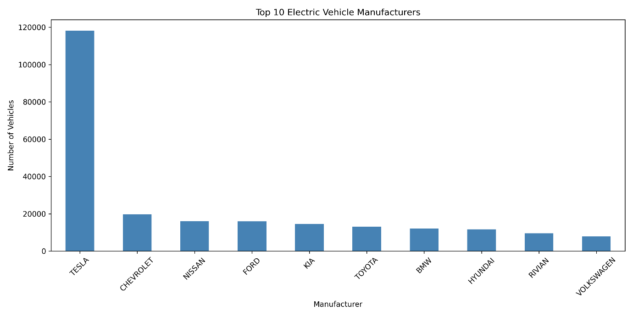
2 . EV Adoption by Model Year
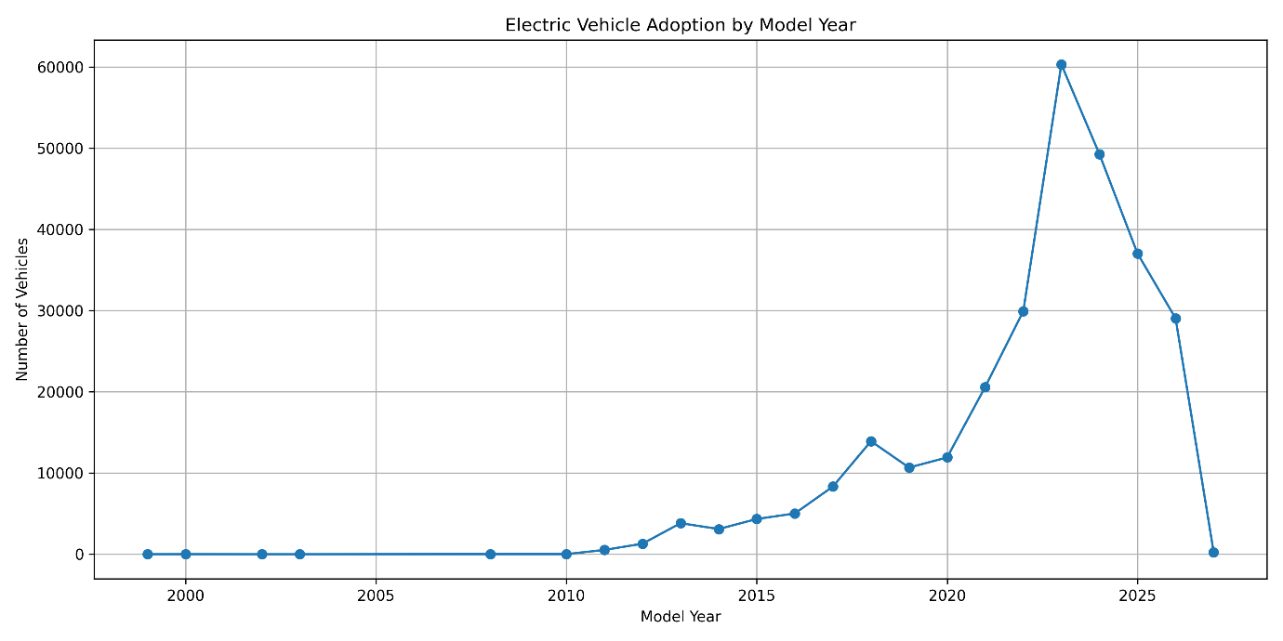
3. Electric Vehicle Type Distribution
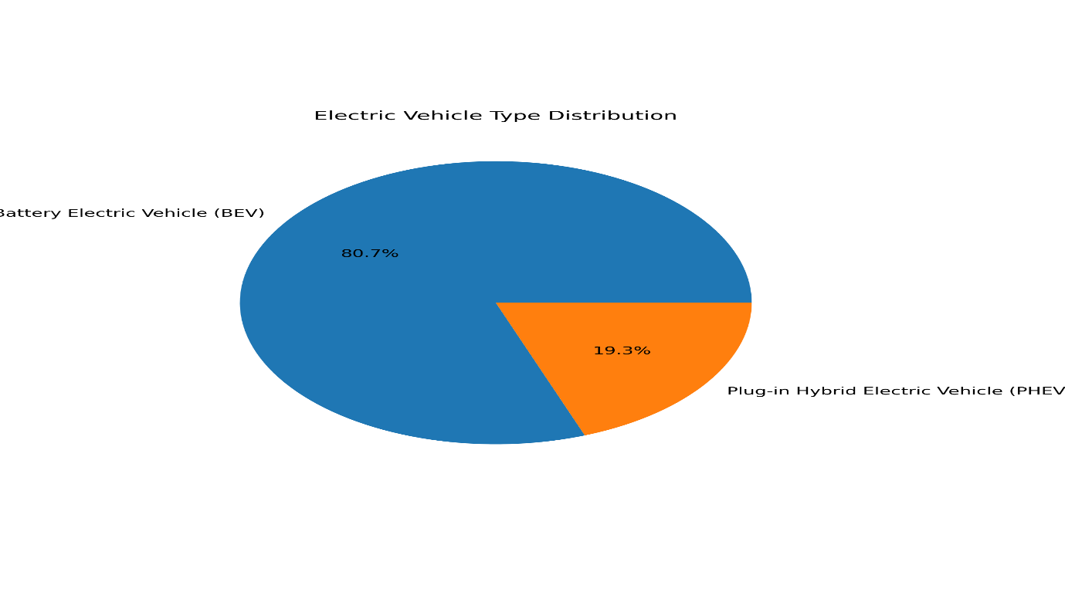
4 . Electric Range Distribution
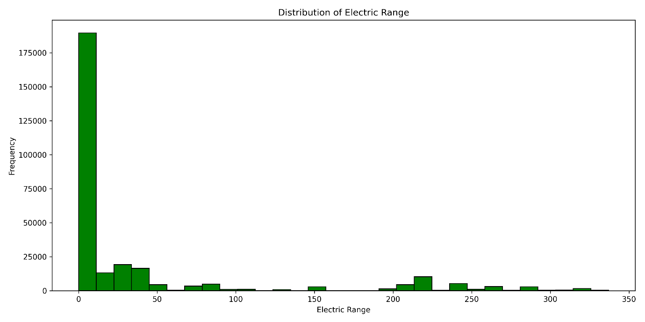
5. Top Counties
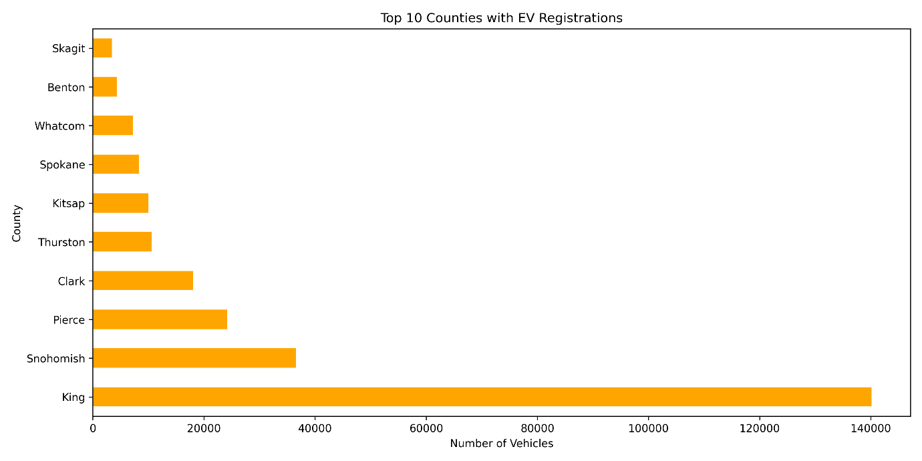
6 . Correlation Heatmap
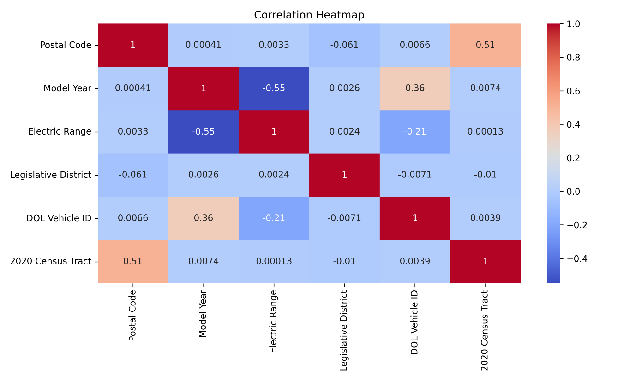
7 . Top Cities
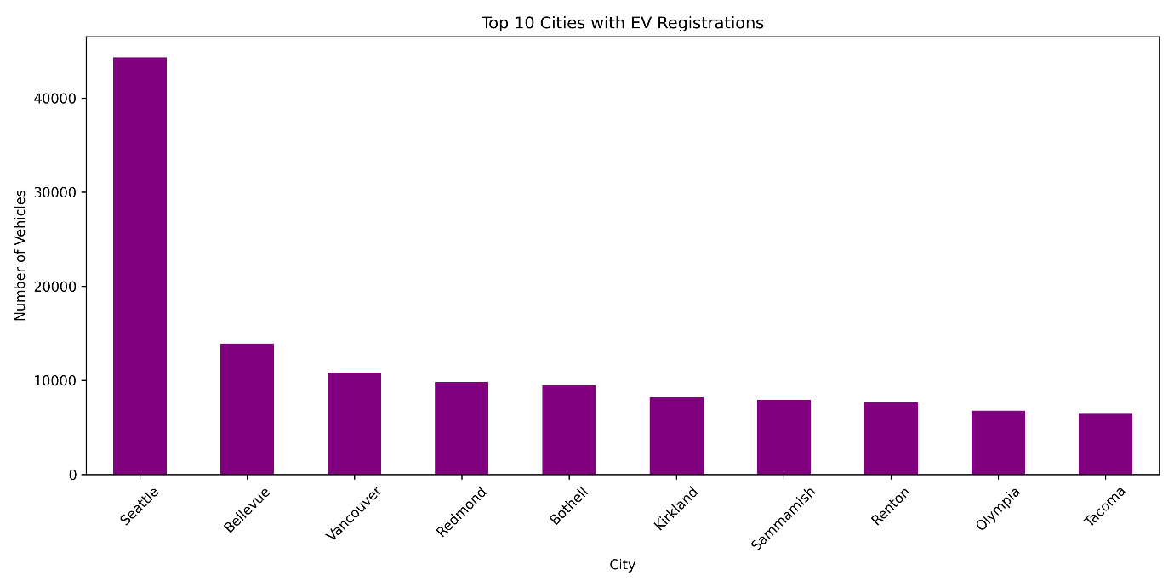
8. EV Map
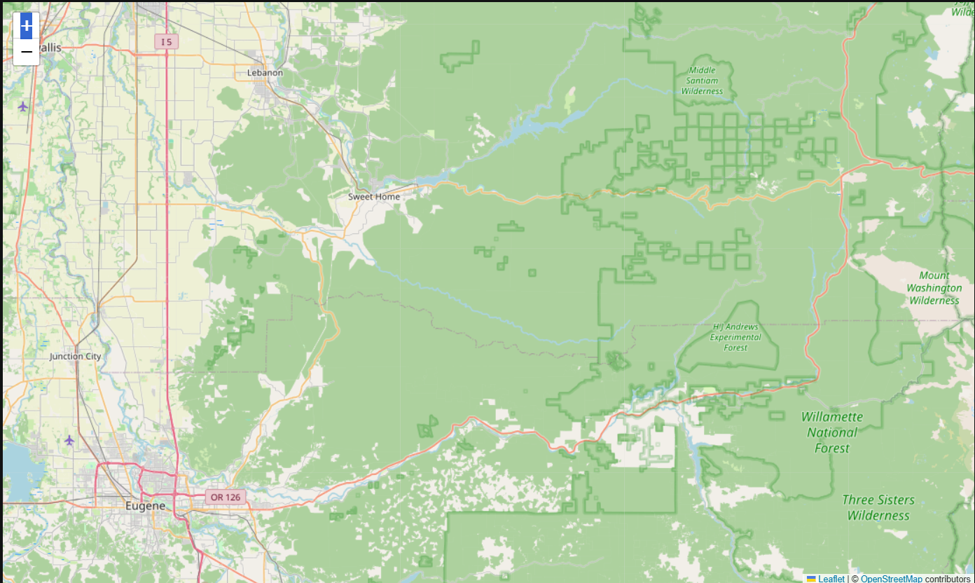

Machine Learning
A Linear Regression model was developed to predict Electric Range using Model Year.
The model was trained, tested, and evaluated using:
• Mean Squared Error (MSE)
• R² Score
Conclusion
This project demonstrates the complete workflow of data analysis using Python. The dataset was cleaned, analyzed, visualized, and used to build a predictive model. The project provides insights into EV adoption trends and showcases practical data analytics skills.

