**Data Base Assignment B6**

**Data collection and Requirement specification**

**CS 5332**

**Fall -2016**

**INSTRUCTOR: DR.C.J. HWANG**

**Submitted to: DR.C.J. HWANG**

**Submitted by: Anusha Vattam**

**Interview Report:**

Jones: Hi, How are you?

Me: Hi, I am good, How are you?

Jones: I am fine thank you!

Jones: Oh, I could see your Tours and Travels website while I was searching online, What is it about ?

Me: “Happy journey” – our Tours and Travels Management system is provide the online ticket booking and online payment facility for customers and to provide package details

Services provided. Like VIEW PACKAGE, SEARCH PACKAGE, BOOKING, CANCLE BOOKING, ONLINE PAYMENT

Jones: How many types of users will be using the system?

Me: Administrator and Customer, Traveler will be using the system, their roles differs based on their priorities to the system.

Jones: What is the role of Traveler?

Me: Traveler create the package and give to admin.

Jones: Why do you feel that you need a database?

Me: Most medium and large businesses rely on databases to store customer information. Because this information is accessible wherever Internet access is available, customers don't have to go to a local banking branch, for example, to access their account information.

Database management systems are important to businesses and organizations because they provide a highly efficient method for handling multiple types of data.

**Business Forms and Reports:**

1. **Login:**

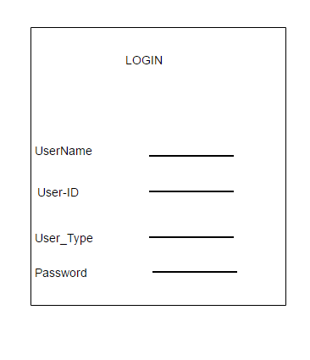

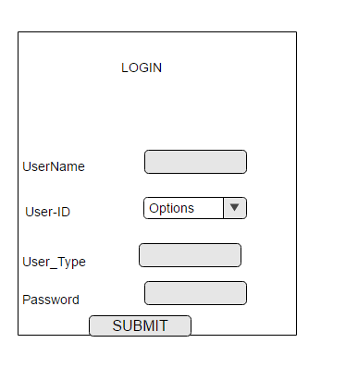

2)Registration**:**

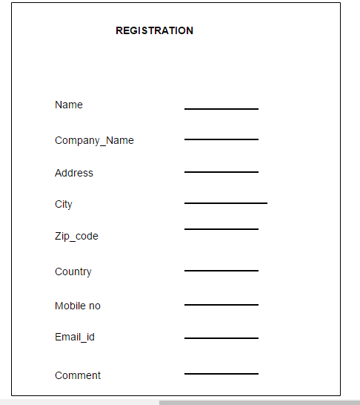

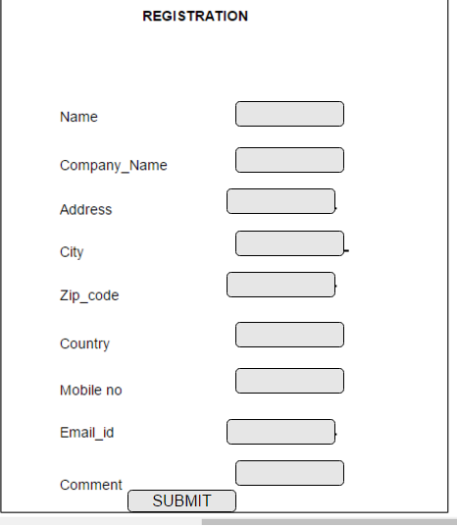

**3)Package**

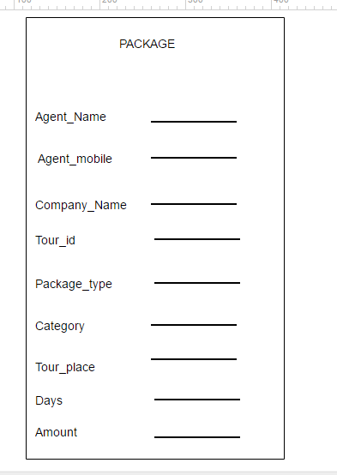

**4)BOOKING**

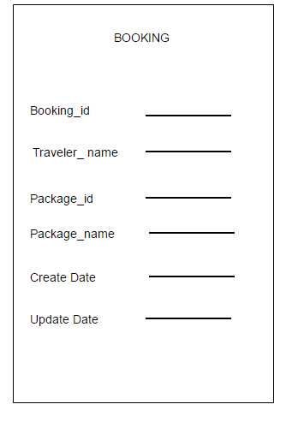

**5) Package Cateogry**

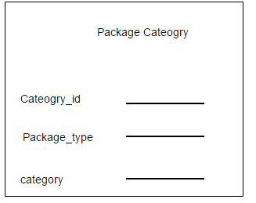

**6)Country:**

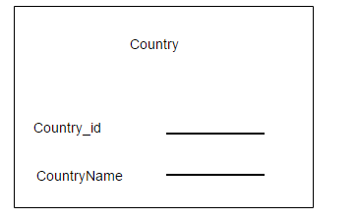

**7)**

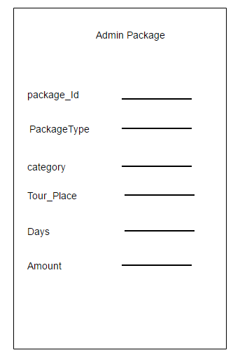

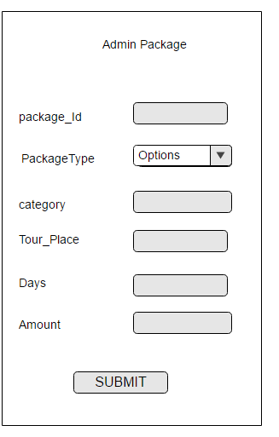

**8) Feed Back**

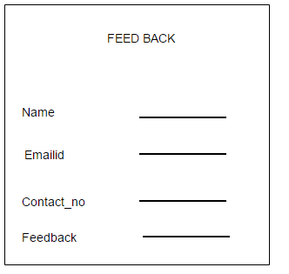

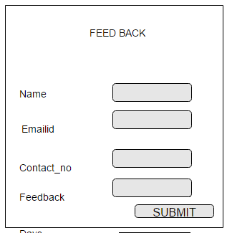

**Screen Shots:**

1. **Customer Form**

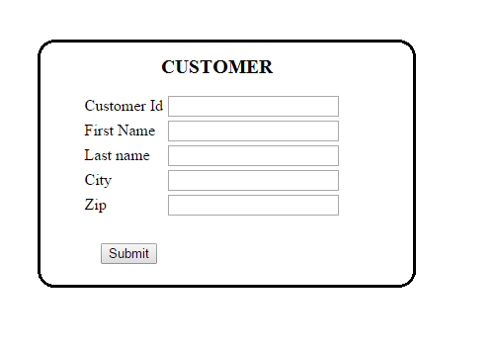

1. **Employee Form**

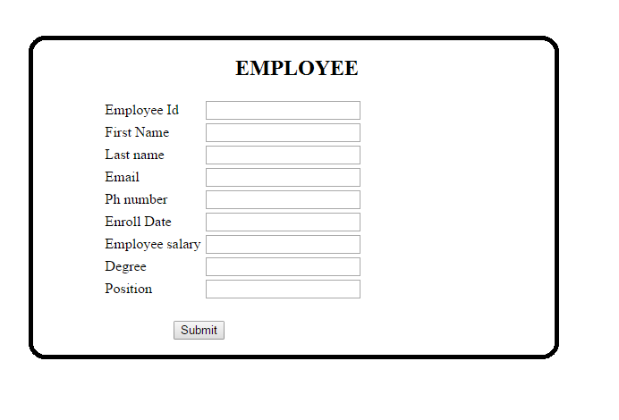

1. **Customer History Form**

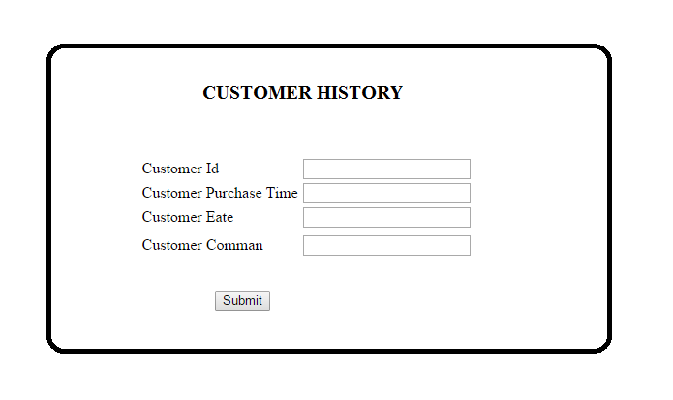

1. **Courier Company Form**



1. **Order Form**

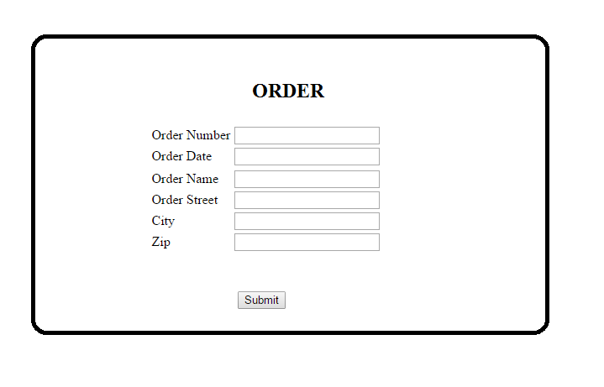

1. **Order Deatil Form**

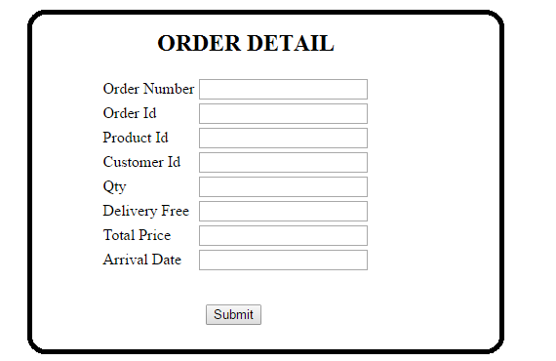

1. **Supplier Form**

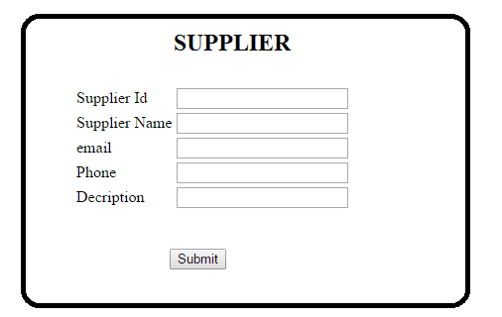

1. **Product Form**

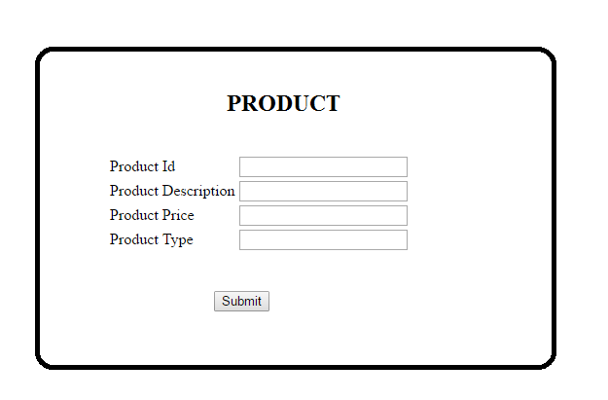

1. **Product Detail Form**