**DREAM HOME DATABASE ASSIGNMENT 2**

**CS 5332**

**FALL 2016**

**Instructor: PROF.DR.C.J.HWANG**

**DataBase: ORACLE 11G APPLICATION EXPRESS EDITION**

**SUBMITTED TO: PROF.DR.C.J.HWANG SUBMITTED BY: ANUSHA VATTAM**

**TEXAS STATE ID: A04701078**

**QUERIES:**

**1.List all staff members all who salaries > 20000**

**SELECT StaffNo,Fname,Lname,Position,Salary**

**FROM Staff**

**where Salary >=20000;**

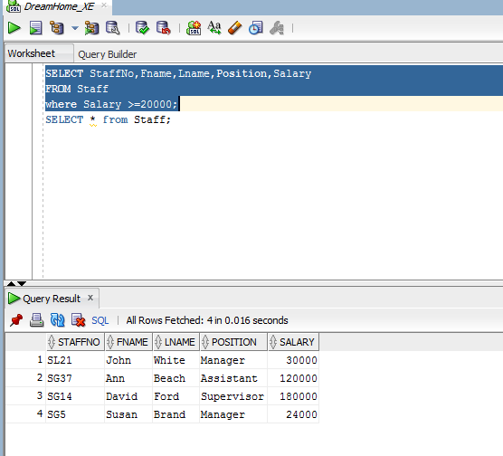

**2.List the Branches all which has city London.**

**SELECT * FROM Branch where city = 'London';**

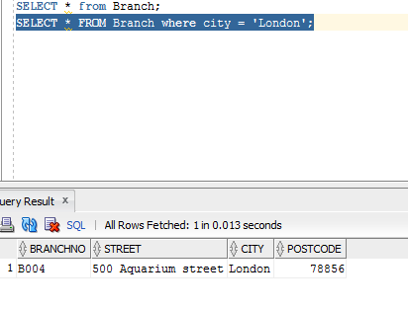

**3. List owerno and email from PrivateOwener who has Fname Tina and LName Murphy.**

**SELECT OwnerNo,email FROM PrivateOwner WHERE FName='Tina' AND LName='Murphy';**

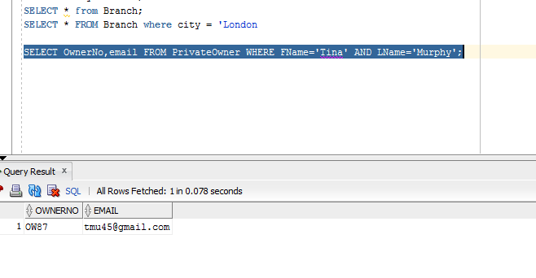

**4.List the details of all viewings on property PR4 where a comment has not supplied.**

**SELECT ClientNo,ViewDate from Viewing where PropertyNo ='PR4' AND Comments IS NULL;**

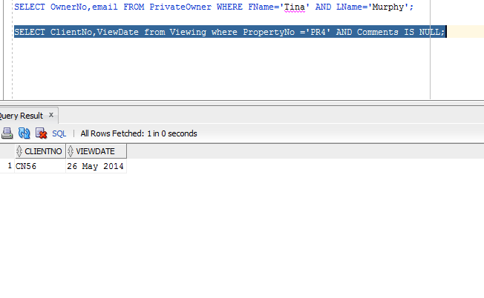

**5. Produce a list of salaries for all staff, arranged in descending order of salary;**

**SELECT StaffNo,Fname,Lname,Position,Salary**

**FROM Staff**

**ORDER BY Salary DESC;**

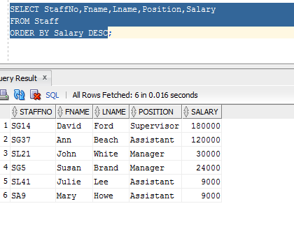

**6.Produce an abbreviated list of properties arranged in order of property type.**

**SELECT PropertyNo,Type,Rooms,Rent**

**FROM PropertyforRent**

**ORDER BY Type;**

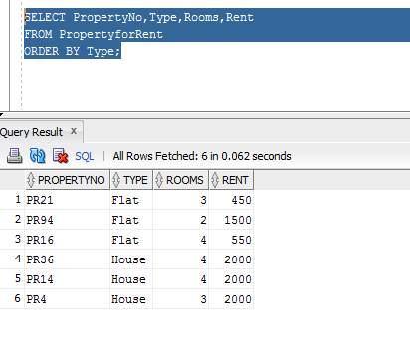

**7.List all Managers and Supervisors from staff table.**

**SELECT StaffNo,Fname,Lname,Position,Salary**

**FROM Staff**

**where Position IN('Manager','Supervisor');**

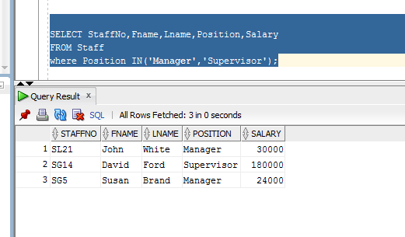

**8. Produce a list of ClientNo, PropertyNo, ViewDate for Viewing order by PropertyNo.**

**SELECT ClientNo,PropertyNo,ViewDate FROM Viewing ORDER BY PropertyNo;**

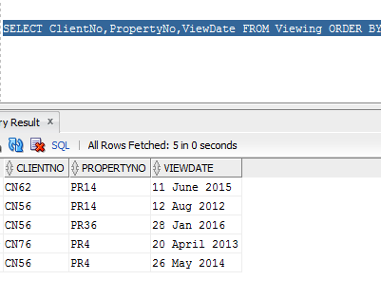

**9.How many properties cost more than $450 per month to rent?**

**SELECT COUNT(*) AS myCount**

**from PropertyforRent**

**where Rent > 450;**

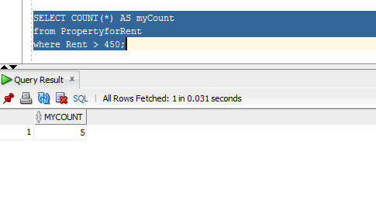

**10. Produce a list of dateofjoin for all client arranged in Ascending order of Dateofjoin.**

SELECT ClientNo,BranchNo,DateOfJoin FROM Registration ORDER BY DateOfJoin ASC;

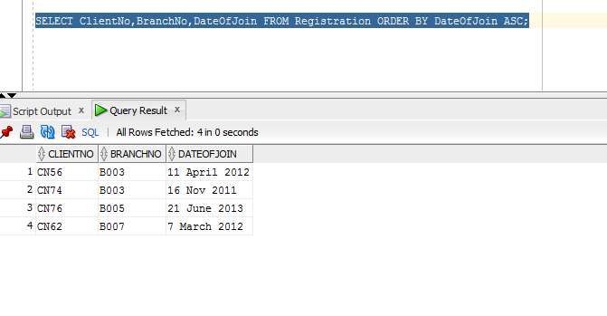

**11.List all The Staff whose sex are same.**

**SELECT StaffNo,FName,LName,Position,Sex FROM Staff where Sex='M';**

**SELECT StaffNo,FName,LName,Position,Sex FROM Staff where Sex='F';**

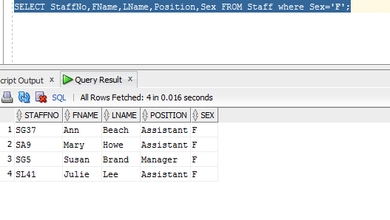

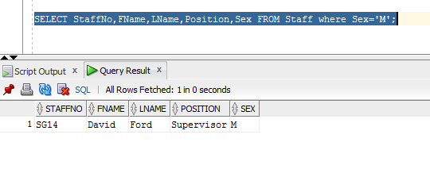

12. **List all the members of propertyForRent who has Owerno OW87 Or city Texas.**

**SELECT * FROM PropertyforRent WHERE OwnerNo='OW87' OR City='Texas';**

