**DREAM HOME DATABASE ASSIGNMENT 3**

**CS 5332**

**FALL 2016**

**Instructor: PROF.DR.C.J.HWANG**

**DataBase: ORACLE 11G APPLICATION EXPRESS EDITION**

**SUBMITTED TO: PROF.DR.C.J.HWANG SUBMITTED BY: ANUSHA VATTAM**

**TEXAS STATE ID: A04701078**

**QUERIES:**

**ENGLISH and SQL QUERIES:**

**1.List the clients who has Tel no, along with any comments supplied.**

**SELECT c.ClientNo, FName,LName,TelNo,Comments**

**FROM Client c, Viewing v**

**Where c.ClientNo = v.ClientNo;**

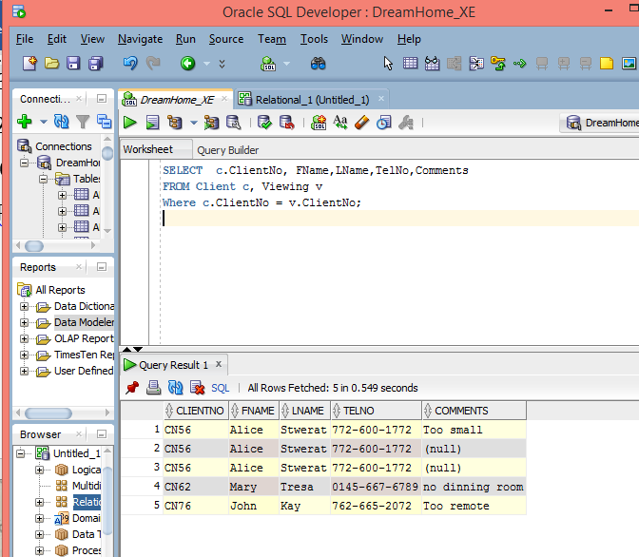

**2.For each branch office, list the staff numbers and names of staff who manage properties and the properties that they manage.**

**SELECT s.BranchNo, s.StaffNo, FName,LName,PropertyNo**

**FROM Staff s, PropertyForRent p**

**WHERE s.StaffNo = p.StaffNO**

**ORDER BY s.BranchNO,s.StaffNo,PropertyNo;**

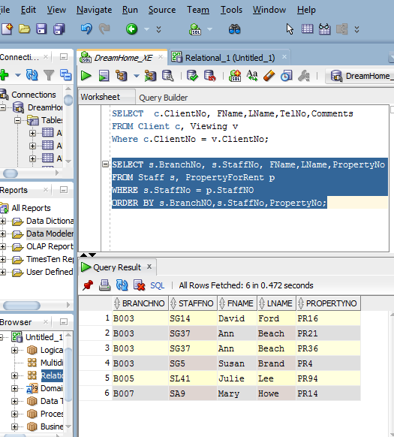

**3. List all the staff whose Postcode is 78666**

**SELECT * FROM Staff Natural Join Branch where Postcode = 78666;**

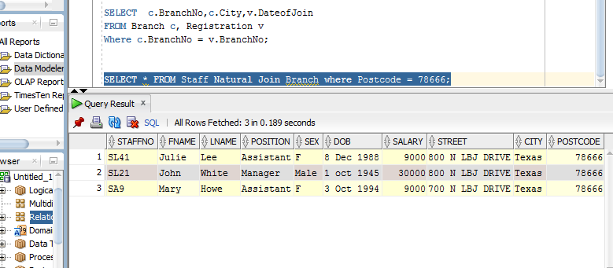

**4. Select PrivateOwner for all PropertyForRent where Rent >20.**

**SELECT * FROM PropertyforRent Natural Join privateOwner where Rent > 20;**

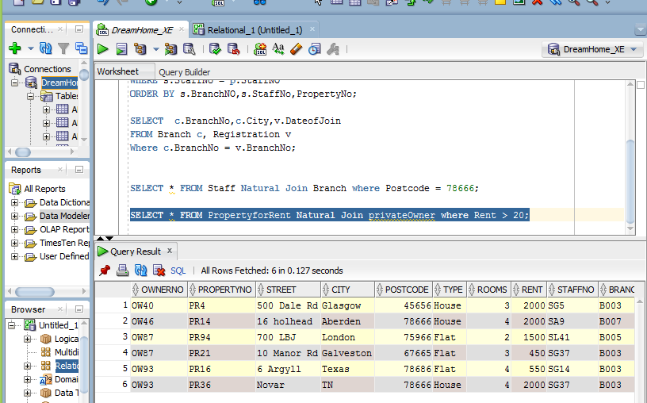

**5. Select Viewing for all PropertyForRent where Property number is PR4and Client Number is CN76.**

**SELECT * FROM PropertyforRent Natural Join Viewing where PropertyNo = 'PR4' or ClientNo ='CN76';**

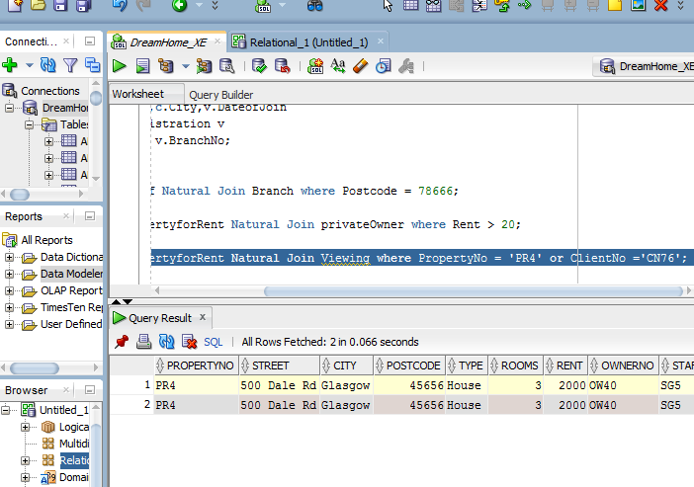

**6. PrivateOwner for all PropertyforRent who has type House.**

**Select * FROM PropertyforRent Natural Join PrivateOwner where Type = 'House';**

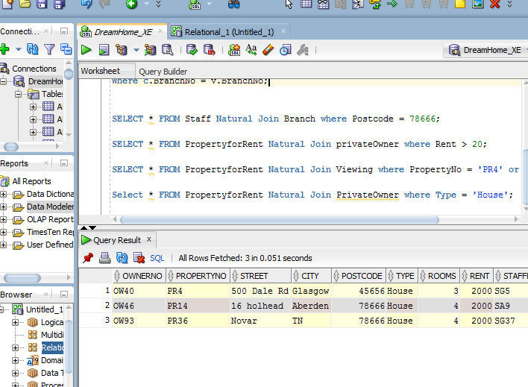

**ENTITY RELATIONAL DIAGRAM FOR DREAMHOME PROJECT**

