**Data Base Assignment B11**

**TRAVEL AGENCY PROJECT IMPLEMENTATION**

**USING SQL Server Using SQL Server Management Studio**

**CS 5332**

**Fall - 2016**

**INSTRUCTOR: DR.C.J. HWANG**

**Submitted to: DR.C.J. HWANG**

**Submitted by: Anusha Vattam**

**Project Name/ Data Base Name: Travel Agency**

**It consists of tables:**

Travel_Agency

Staff_Agency

Customers

Calendar

Booking Outcomes

BookingStatus

BookingServiceLevel

Services

Services Bookings

payments

Bookings

Creation of Tables:

**Table creation:**

CREATE TABLE Travel_Agency (travel_ID VARCHAR(50), Name VARCHAR (50) ,City VARCHAR (50),State VARCHAR (50),Zip INTEGER,CONSTRAINT PK_Travel PRIMARY KEY (travel_ID));

**Data Insertion:**

INSERT INTO Travel_Agency (travel_ID , Name, City ,State ,Zip )VALUES ('TA45', 'Money Makers', 'San Jose', 'CA', '198076');

INSERT INTO Travel_Agency (travel_ID , Name ,City ,State ,Zip)VALUES ('TA23', 'Makemytrip', 'San Marcos', 'SM', '165890');

INSERT INTO Travel_Agency (travel_ID , Name , City ,State ,Zip)VALUES ('TA12', 'Easygo', 'Dallas', 'TX', '177025');

INSERT INTO Travel_Agency (travel_ID , Name ,City ,State ,Zip)VALUES ('TA10', 'Anu Travels', 'Austin', 'TX', '178654');

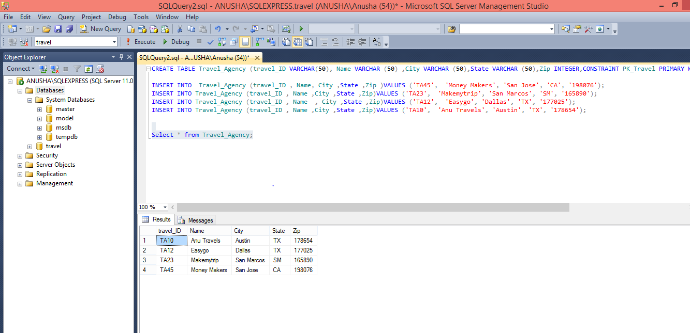

Staff_Agency :

CREATE TABLE Staff_Agency(StaffAID VARCHAR(50), FName VARCHAR (50), LName VARCHAR(50), Email VARCHAR (50), PhoneNo VARCHAR (50), EnrollDate VARCHAR(20), CONSTRAINT PK_Staff PRIMARY KEY (StaffAID));

INSERT INTO Staff_Agency(StaffAID , FName , LName, Email , PhoneNo , EnrollDate)VALUES ('ST76', 'Sowmya', 'Dose', 'xyz@gmail.com', '667-098-4567', '05-12-2003');

INSERT INTO Staff_Agency(StaffAID , FName , LName, Email , PhoneNo , EnrollDate)VALUES ('ST80', 'sanjay', 'mishra', 'goto@gmail.com', '667-098-4567', '05-10-2013');

INSERT INTO Staff_Agency(StaffAID , FName , LName, Email , PhoneNo , EnrollDate)VALUES ('ST90', 'Anusha', 'jones', 'homedays@gmail.com', '667-098-4567', '08-1-2053');

INSERT INTO Staff_Agency(StaffAID , FName , LName, Email , PhoneNo , EnrollDate)VALUES ('ST92', 'lekha', 'puppala', 'xyz123@gmail.com', '667-098-4567', '09-2-2063');

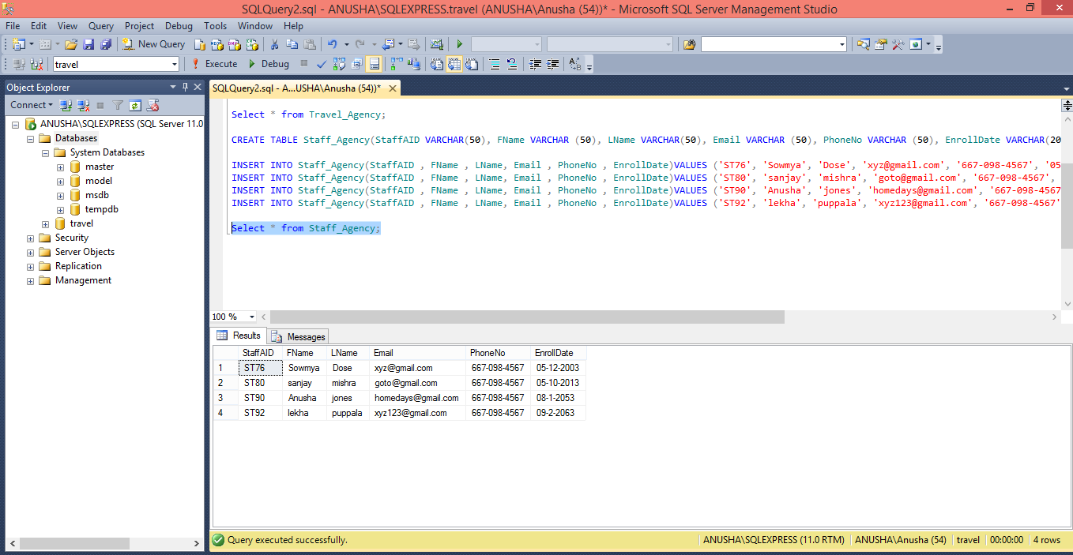

Customers :

CREATE TABLE Customers(CustID VARCHAR(50), FName VARCHAR (50) , LName VARCHAR (50),City VARCHAR (50),State VARCHAR (50),Zip INTEGER,CONSTRAINT PK_cust PRIMARY KEY (CustID));

INSERT INTO Customers (CustID , FName , LName ,City ,State ,Zip )VALUES ('CS45', 'John', 'Peters', 'San Jose', 'CA', '198076');

INSERT INTO Customers (CustID , FName , LName ,City ,State ,Zip)VALUES ('CS23', 'Tom', 'Edwards', 'New York', 'NY', '615890');

INSERT INTO Customers (CustID , FName , LName ,City ,State ,Zip)VALUES ('CS12', 'Ella', 'Jiang', 'Houston', 'TX', '771025');

INSERT INTO Customers (CustID , FName , LName ,City ,State ,Zip)VALUES ('CS10', 'Ann', 'Watsaon', 'Austin', 'TX', '718654');

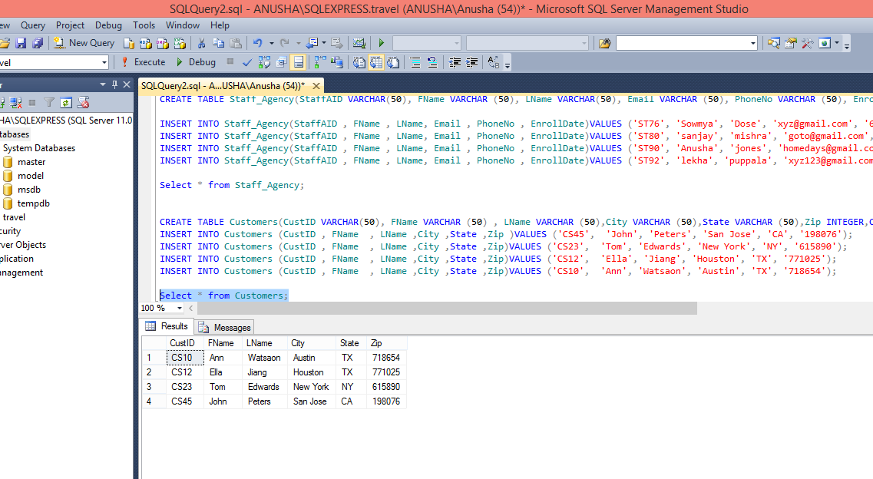

Calendar:

CREATE TABLE Calendar(CalID VARCHAR(50),Datecal VARCHAR (50),Daycal VARCHAR (50),comments VARCHAR(50),CONSTRAINT PK_cal PRIMARY KEY (CalID));

INSERT INTO Calendar(CalID,Datecal,Daycal,comments)VALUES ('CA11','05-12-2003','Monday','need new members');

INSERT INTO Calendar(CalID,Datecal,Daycal,comments)VALUES ('CA10','05-10-2013','Tuesday','comments');

INSERT INTO Calendar(CalID,Datecal,Daycal,comments)VALUES ('CA8','08-1-2053','Tuesday','No bookings');

INSERT INTO Calendar(CalID,Datecal,Daycal,comments)VALUES ('CA9','09-2-2063','Friday','No comments');

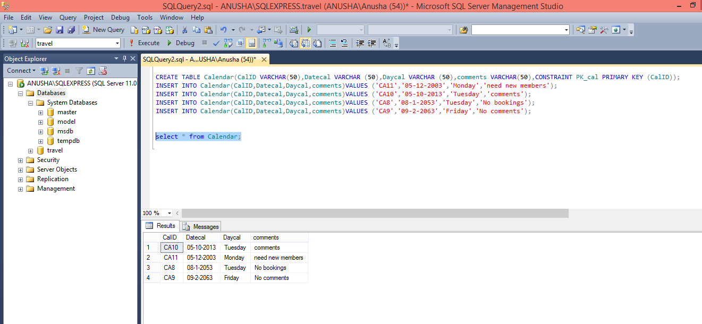

Booking Outcomes:

CREATE TABLE BookingOutcomes(OutComeCode VARCHAR(50),OutcomeDesc VARCHAR (50),CONSTRAINT PK_Out PRIMARY KEY (OutComeCode));

INSERT INTO BookingOutcomes(OutComeCode,OutcomeDesc )VALUES ('O2','Cancelled');

INSERT INTO BookingOutcomes(OutComeCode,OutcomeDesc )VALUES ('O3','OK');

INSERT INTO BookingOutcomes(OutComeCode,OutcomeDesc )VALUES ('O4','Processing');

INSERT INTO BookingOutcomes(OutComeCode,OutcomeDesc )VALUES ('O5','Cancelled');

select * from BookingOutcomes;

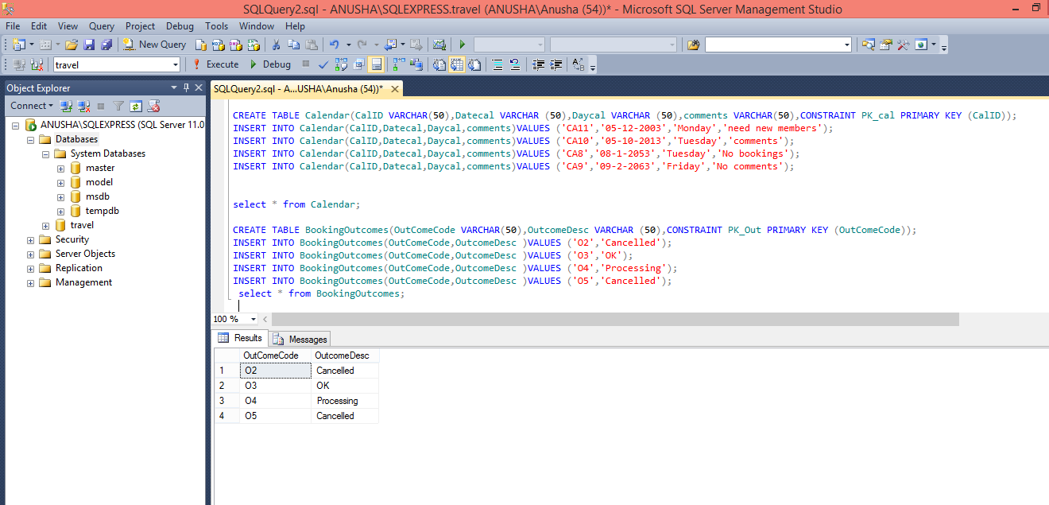

BookingStatus:

CREATE TABLE BookingStatus(StatusCode VARCHAR(50),StatusDesc VARCHAR (50),CONSTRAINT PK_Status PRIMARY KEY (StatusCode));

INSERT INTO BookingStatus(StatusCode,StatusDesc )VALUES ('S4','Provisional');

INSERT INTO BookingStatus(StatusCode,StatusDesc )VALUES ('S3','Processing');

INSERT INTO BookingStatus(StatusCode,StatusDesc )VALUES ('S5','waitingList');

INSERT INTO BookingStatus(StatusCode,StatusDesc )VALUES ('S2','Cancelled');

select * from BookingStatus;

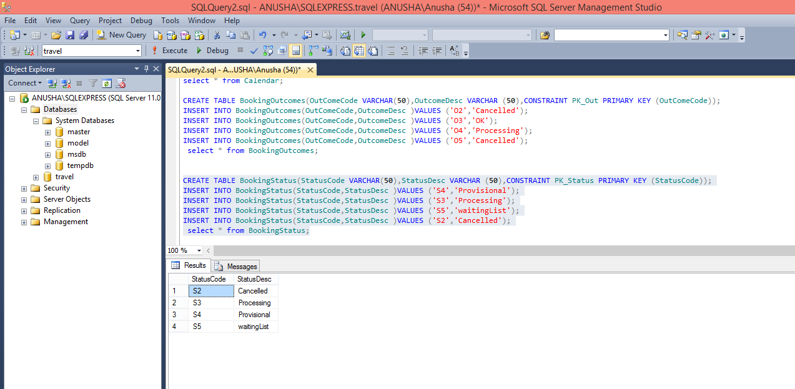

BookingServiceLevel:

CREATE TABLE BookingServiceLevel(LevelCode VARCHAR(50),LevelDesc VARCHAR (50),CONSTRAINT PK_Level PRIMARY KEY (LevelCode));

INSERT INTO BookingServiceLevel(LevelCode,LevelDesc )VALUES ('L4','Compact Car 5');

INSERT INTO BookingServiceLevel(LevelCode,LevelDesc )VALUES ('L3','Business class');

INSERT INTO BookingServiceLevel(LevelCode,LevelDesc )VALUES ('L2','Flight level');

INSERT INTO BookingServiceLevel(LevelCode,LevelDesc )VALUES ('L1','star hotel');

INSERT INTO BookingServiceLevel(LevelCode,LevelDesc )VALUES ('L5','Motels');

select * from BookingServiceLevel;

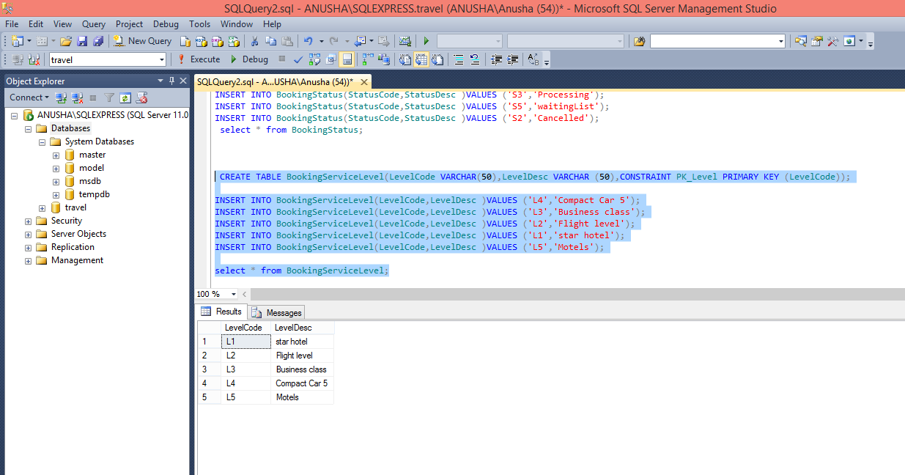

Services

CREATE TABLE Services(ServiceID VARCHAR(50),LevelCode VARCHAR(50),ServiceDetails VARCHAR (50),CONSTRAINT PK_Service PRIMARY KEY (ServiceID) ,CONSTRAINT fk_LevelCode FOREIGN KEY (LevelCode) REFERENCES BookingServiceLevel (LevelCode));

INSERT INTO Services(ServiceID, LevelCode, ServiceDetails)VALUES ('SL01','L4','Airways');

INSERT INTO Services(ServiceID, LevelCode, ServiceDetails)VALUES ('SL04','L2','Cars');

INSERT INTO Services(ServiceID, LevelCode, ServiceDetails)VALUES ('SL03','L1','Star Hotels');

INSERT INTO Services(ServiceID, LevelCode, ServiceDetails)VALUES ('SL05','L5','Motels');

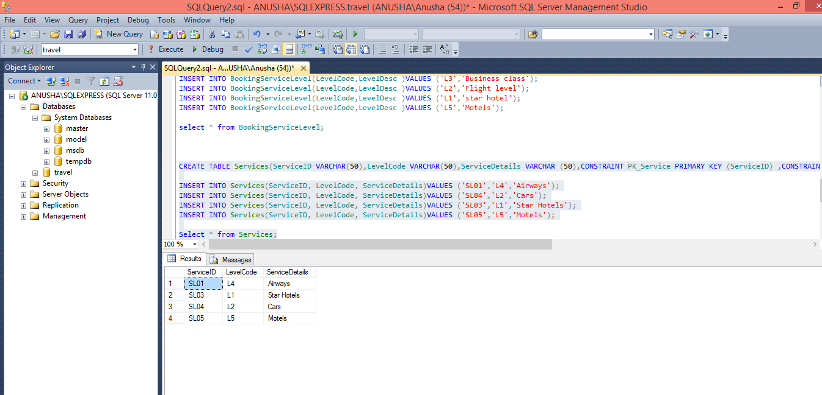

Services Bookings

CREATE TABLE ServiceBookings(BookingID VARCHAR(50),ServiceID VARCHAR(50),BookingStartDate VARCHAR (50),BookingendDate VARCHAR (50),CONSTRAINT PK_SerBook PRIMARY KEY (BookingID) ,CONSTRAINT fk_ServiceID FOREIGN KEY (ServiceID)

REFERENCES Services (ServiceID));

Select * from ServiceBookings;

INSERT INTO ServiceBookings(BookingID,ServiceID,BookingStartDate,BookingendDate)VALUES ('BK01','SL01','10-13-2016','11-12-2016');

INSERT INTO ServiceBookings(BookingID,ServiceID,BookingStartDate,BookingendDate)VALUES ('BK02','SL03','11-1-2016','10-2-2016');

INSERT INTO ServiceBookings(BookingID,ServiceID,BookingStartDate,BookingendDate)VALUES ('BK03','SL04','16-2-2016','11-3-2016');

INSERT INTO ServiceBookings(BookingID,ServiceID,BookingStartDate,BookingendDate)VALUES ('BK04','SL05','9-4-2016','11-5-2016');

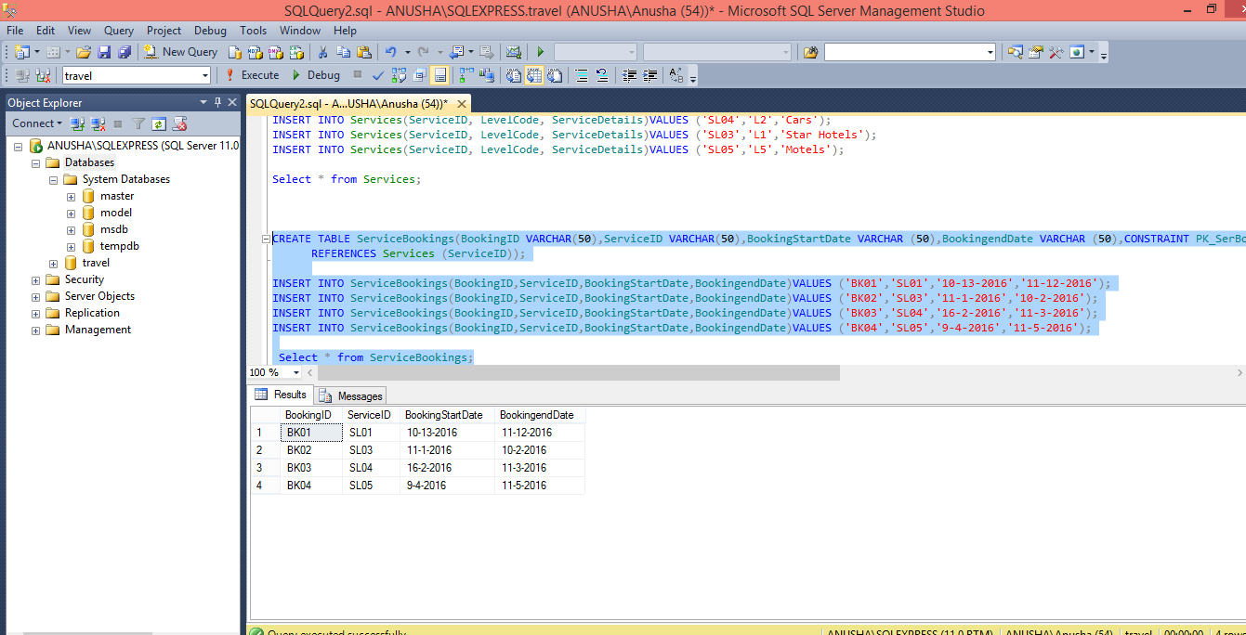

Payments

CREATE TABLE Payments(PaymentID VARCHAR(50),BookingID VARCHAR(50),PaymentAmount INTEGER, PaymentDate VARCHAR(50),CONSTRAINT PK_Payment PRIMARY KEY (PaymentID) ,CONSTRAINT fk_BookingID FOREIGN KEY (BookingID)

REFERENCES ServiceBookings (BookingID));

INSERT INTO Payments(PaymentID,BookingID,PaymentAmount,PaymentDate) VALUES ('P01','BK02',15000,'11-1-2016') ;

INSERT INTO Payments(PaymentID,BookingID,PaymentAmount,PaymentDate) VALUES ('P02','BK03',20000,'16-2-2016') ;

INSERT INTO Payments(PaymentID,BookingID,PaymentAmount,PaymentDate) VALUES ('P04','BK01',45000,'10-13-2016') ;

INSERT INTO Payments(PaymentID,BookingID,PaymentAmount,PaymentDate) VALUES ('P03','BK04',5000,'9-4-2016') ;

Select * from Payments;

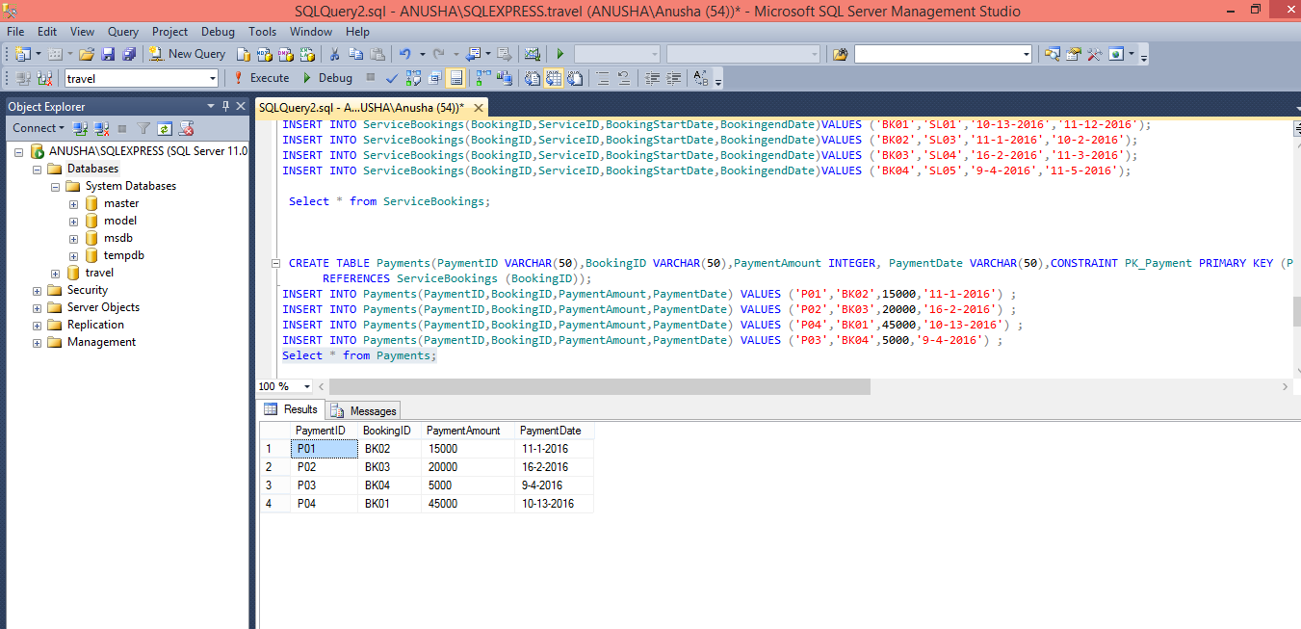

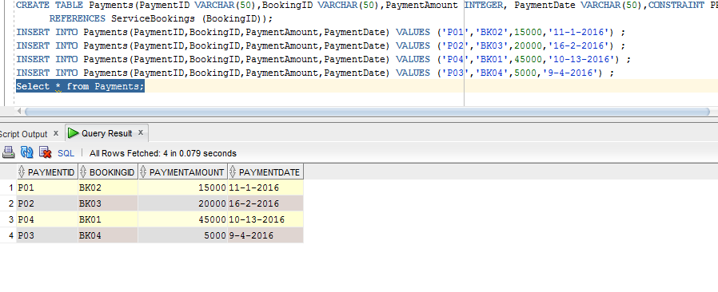

Bookings

CREATE TABLE Bookings(BookingFactID VARCHAR(50),travel_ID VARCHAR(50),StaffAID VARCHAR(50) , CustID VARCHAR(50),CalID VARCHAR(50),

OutComeCode VARCHAR(50),StatusCode VARCHAR(50),LevelCode VARCHAR(50),ServiceID VARCHAR(50),BookingID VARCHAR(50),PaymentID VARCHAR(50),

otherDetails VARCHAR(50), CONSTRAINT PK_BookingFactID PRIMARY KEY (BookingFactID),

CONSTRAINT fk_traveler_ID FOREIGN KEY (travel_ID)

REFERENCES Travel_Agency (travel_ID),

CONSTRAINT fk_StaffAsID FOREIGN KEY (StaffAID)

REFERENCES Staff_Agency (StaffAID),

CONSTRAINT fk_CustoID FOREIGN KEY (CustID)

REFERENCES Customers (CustID),

CONSTRAINT fk_CaleID FOREIGN KEY (CalID)

REFERENCES Calendar (CalID),

CONSTRAINT fk_OutComesCode FOREIGN KEY (OutComeCode)

REFERENCES BookingOutcomes (OutComeCode),

CONSTRAINT fk_StatussCode FOREIGN KEY (StatusCode)

REFERENCES BookingStatus (StatusCode),

CONSTRAINT fk_LevelsCode FOREIGN KEY (LevelCode)

REFERENCES BookingServiceLevel (LevelCode),

CONSTRAINT fk_ServicesID FOREIGN KEY (ServiceID)

REFERENCES Services (ServiceID),

CONSTRAINT fk_BookingsID FOREIGN KEY (BookingID)

REFERENCES ServiceBookings (BookingID),

CONSTRAINT fk_PaymenteID FOREIGN KEY (PaymentID)

REFERENCES Payments (PaymentID));

INSERT INTO Bookings(BookingFactID ,travel_ID ,StaffAID ,CustID ,CalID ,

OutComeCode ,StatusCode ,LevelCode ,ServiceID ,BookingID,PaymentID,otherDetails )VALUES

('BF01','TA45','ST76','CS45','CA11','O2','S4','L4','SL01','BK01','P02','any Concessions 10%');

INSERT INTO Bookings(BookingFactID ,travel_ID ,StaffAID ,CustID ,CalID ,

OutComeCode ,StatusCode ,LevelCode ,ServiceID ,BookingID,PaymentID,otherDetails )

VALUES('BF04','TA23','ST80','CS23','CA10','O3','S3','L1','SL03','BK02','P01','No Concessions');

INSERT INTO Bookings(BookingFactID ,travel_ID ,StaffAID ,CustID ,CalID ,

OutComeCode ,StatusCode ,LevelCode ,ServiceID ,BookingID,PaymentID,otherDetails )

VALUES('BF03','TA12','ST90','CS12','CA8','O4','S5','L5','SL04','BK03','P02','15% Concessions');

INSERT INTO Bookings(BookingFactID ,travel_ID ,StaffAID ,CustID ,CalID ,

OutComeCode ,StatusCode ,LevelCode ,ServiceID ,BookingID,PaymentID,otherDetails )

VALUES('BF02','TA10','ST92','CS10','CA9','O5','S2','L5','SL05','BK04','P03','2% Concessions');

select * from Bookings;

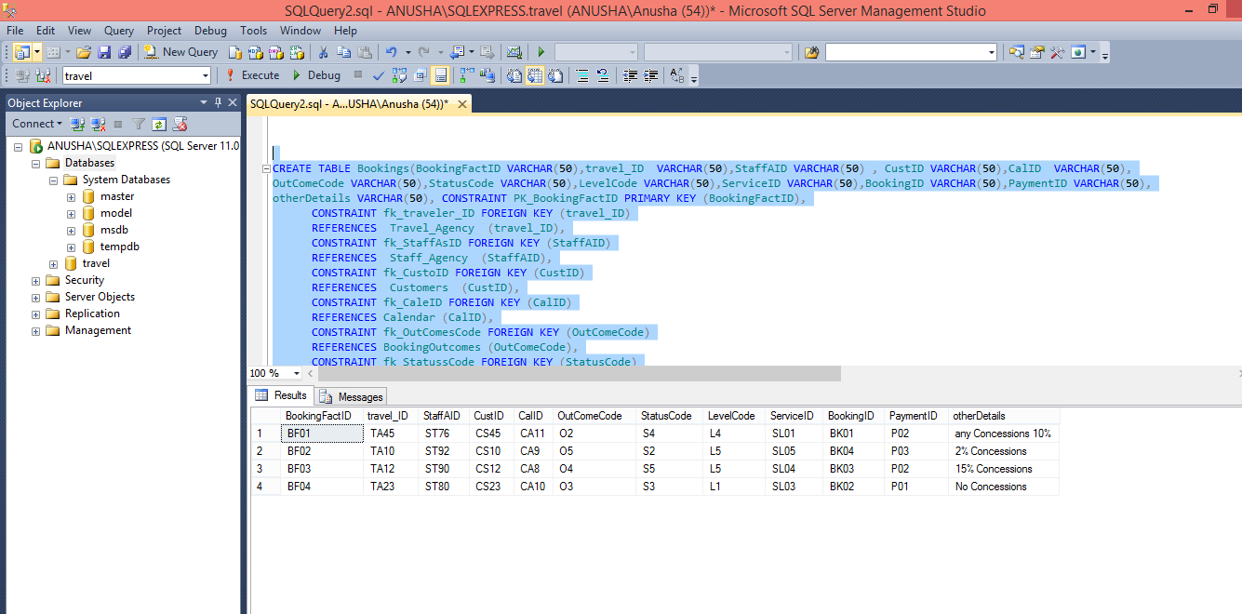

**Fifteen Queries in English sentences and SQL Queries for the project.**

1. Retrieve all staff members from staff table

Select * from Staff_Agency;

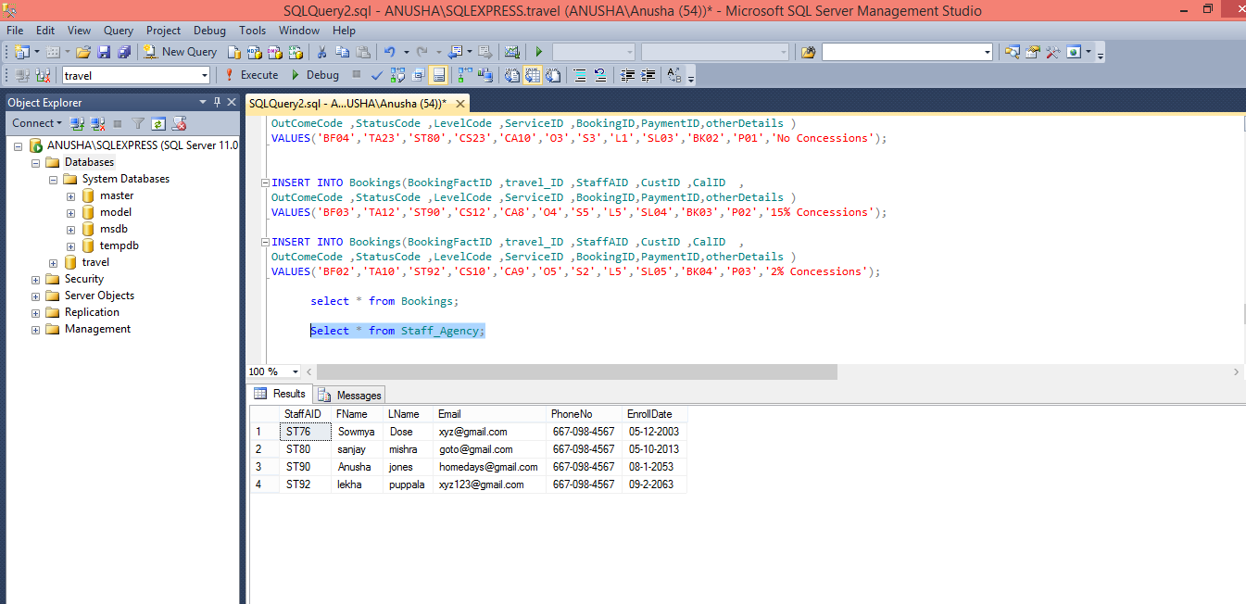

1. Insert a staff member in staff table

Select * from Staff_Agency;

INSERT INTO Staff_Agency(StaffAID , FName , LName, Email , PhoneNo , EnrollDate

)VALUES ('ST65', 'Anu', 'puppala', 'x123@gmail.com', '667-023-4867', '12-02-2017');

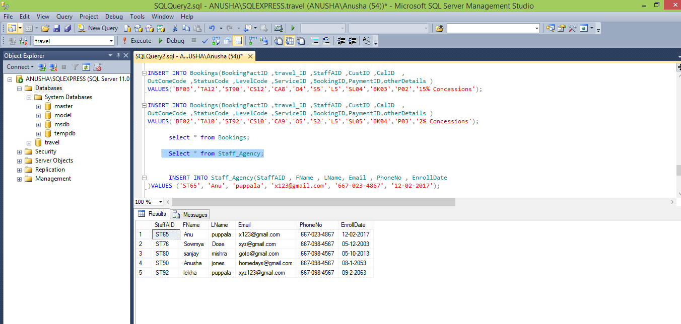

1. Retrieve a particular Booking details based on BookingID

SELECT * FROM ServiceBookings WHERE BookingID='BK03';

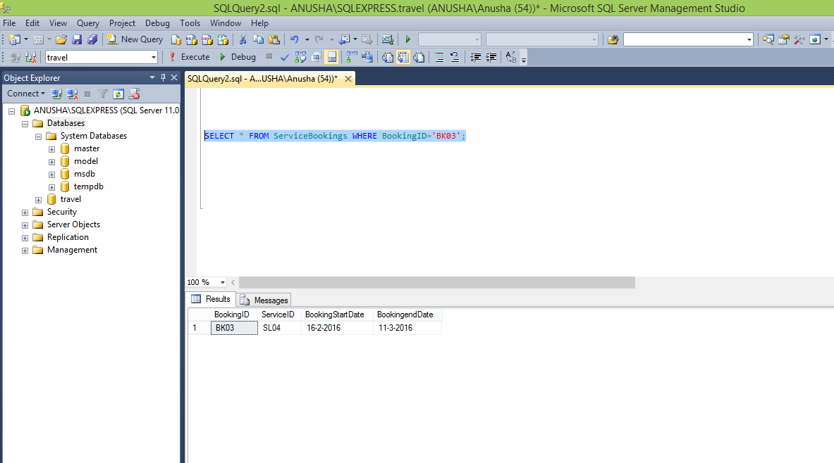

1. Retrieve all Level details based on LevelCode

SELECT * FROM BookingServiceLevel;

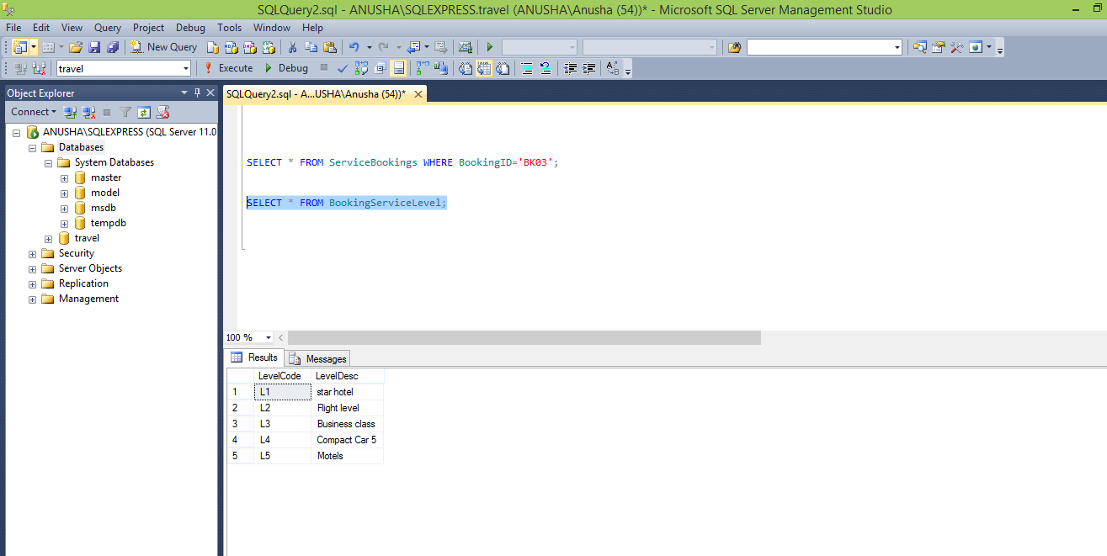

1. Retrieve all Customers data from customers table

SELECT * FROM Customers;

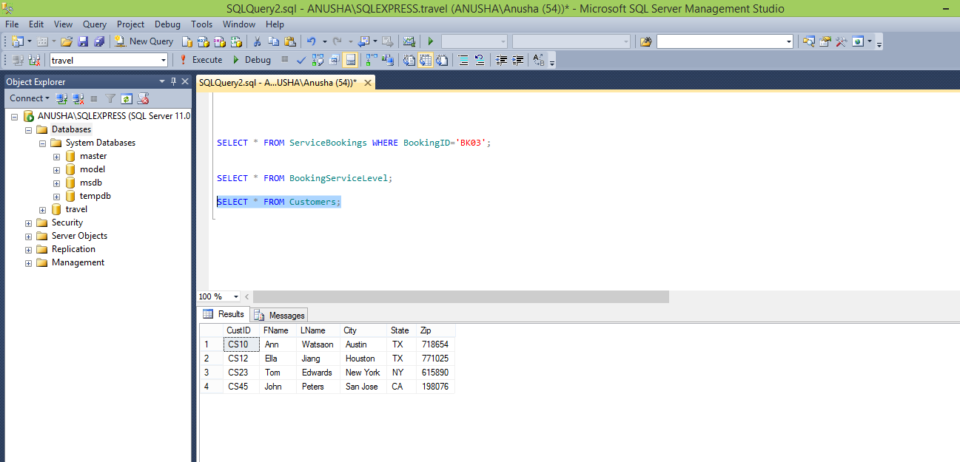

1. Retrieve all Booking status in Agency from Booking status Table

SELECT * FROM BookingStatus;

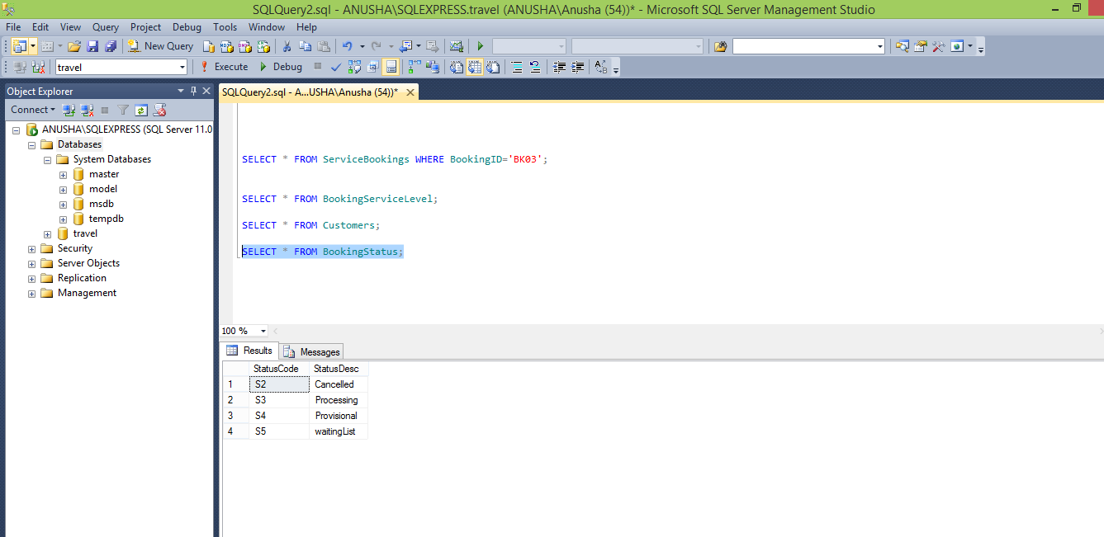

7.List the Payments details along with whose amount is below 10000

SELECT PaymentID,BookingID,PaymentAmount,PaymentDate FROM Payments

WHERE PaymentAmount < 10000;

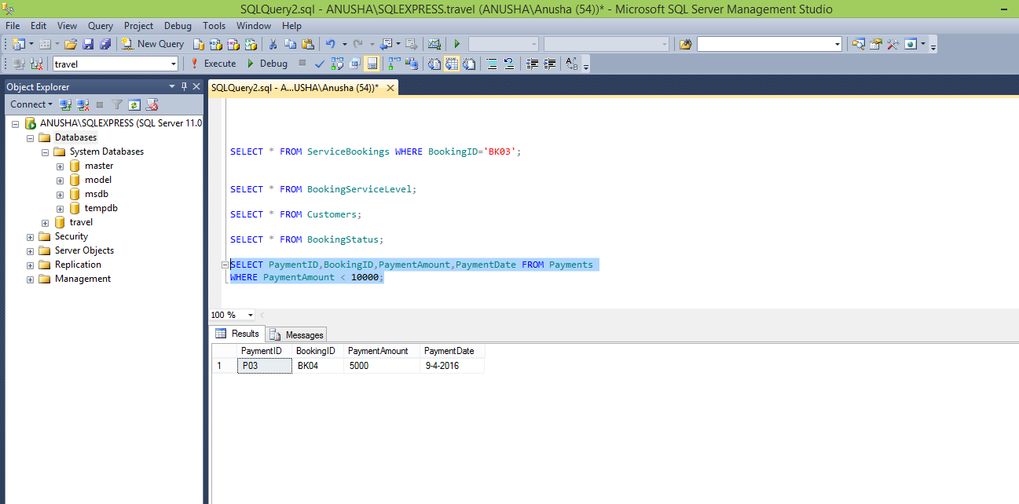

8. Order the Services by their ServiceID By descending order.

**SELECT * FROM Services ORDER BY ServiceID DESC;**

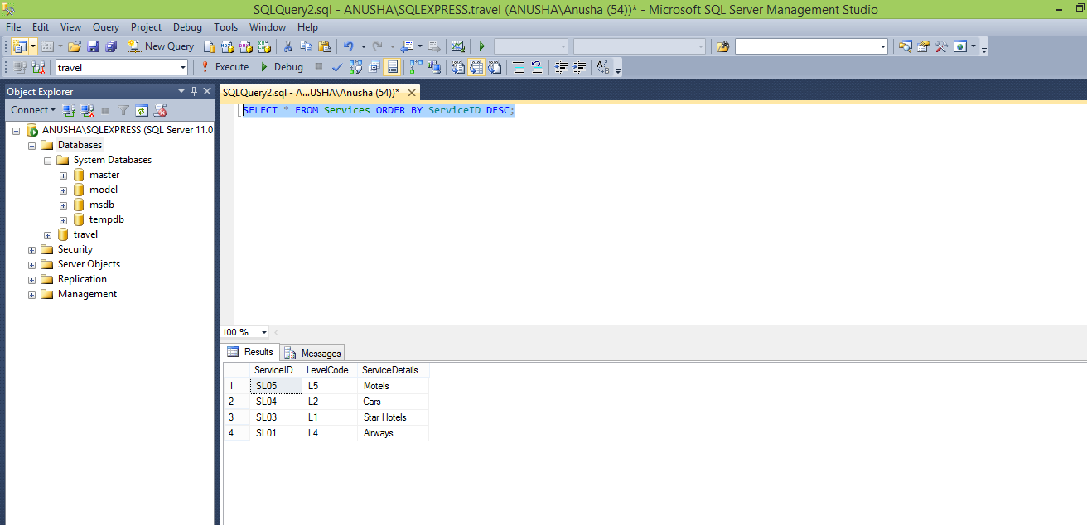

**9**. **Order BookingServiceLevel by their LevelCode By Ascending order**.

SELECT * FROM BookingServiceLevel ORDER BY LevelCode ASC;

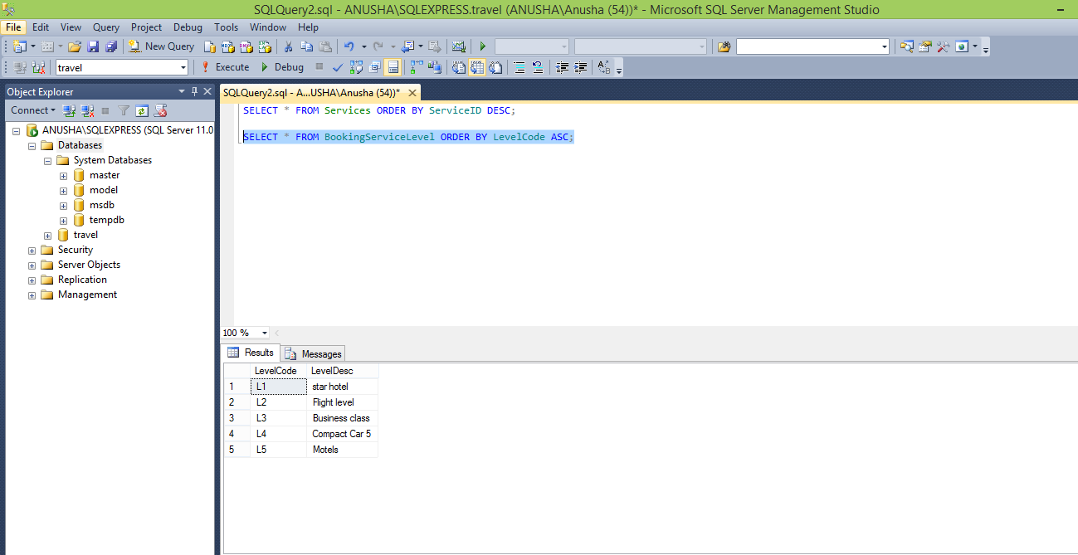

10.list the ServiceBookings who has BookingID as BK02 And ServiceID as SL03

SELECT * FROM ServiceBookings WHERE BookingID='BK02' AND ServiceID='SL03';

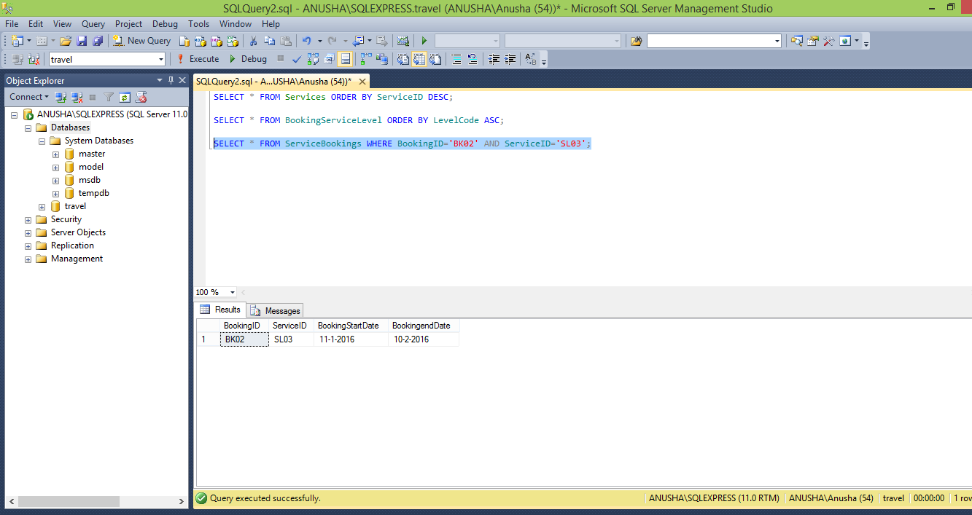11. Insert a new customer details in customer table

SELECT * FROM Customers;

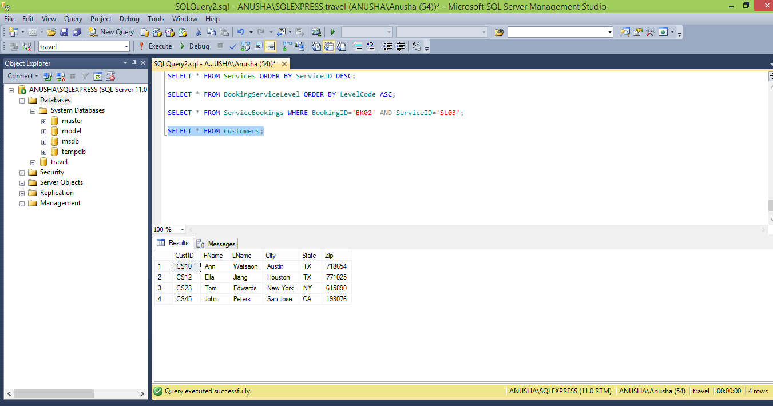

INSERT INTO Customers (CustID , FName , LName ,City ,State ,Zip)VALUES ('CS20', 'Allmu', 'Anng', 'Newyork', 'US', '700025');

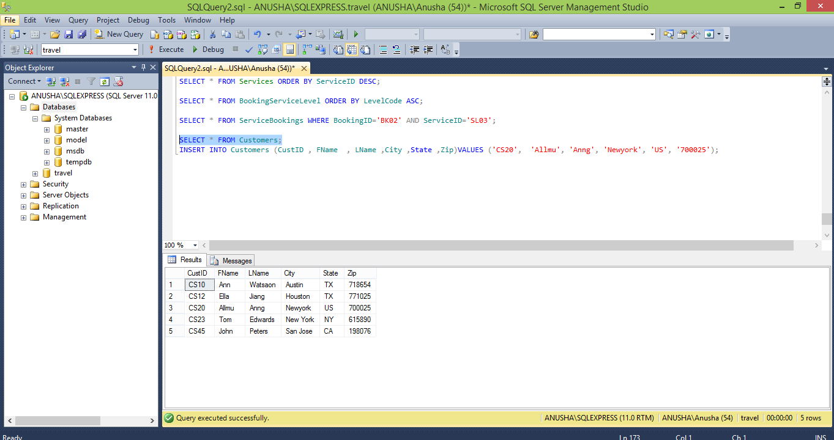

12. Insert new service item in to service Table.

INSERT INTO BookingServiceLevel(LevelCode,LevelDesc )VALUES ('L7','cartsNew');

INSERT INTO Services(ServiceID, LevelCode, ServiceDetails)VALUES ('SL07','L7','Carts');

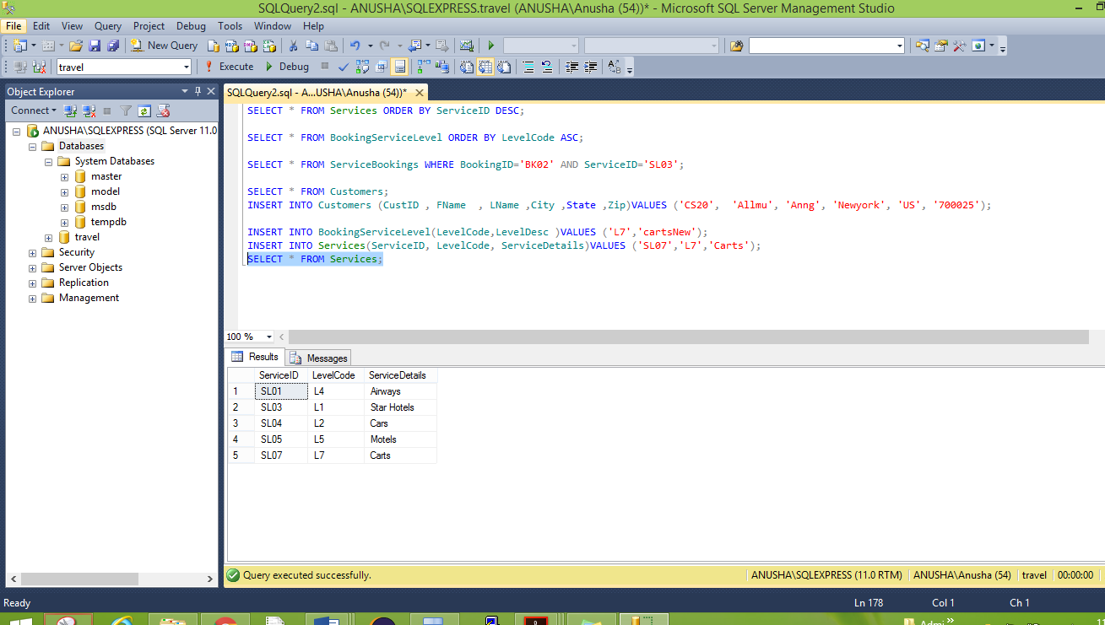

13.Find Staff who has StaffAID ST90 from staff

SELECT * FROM Staff_Agency WHERE StaffAId='ST90';

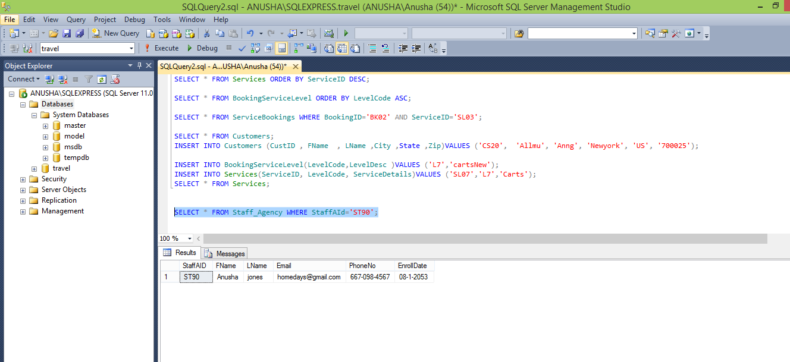

14. Retrieve all the data from Calendar Table

Select * from Calendar;

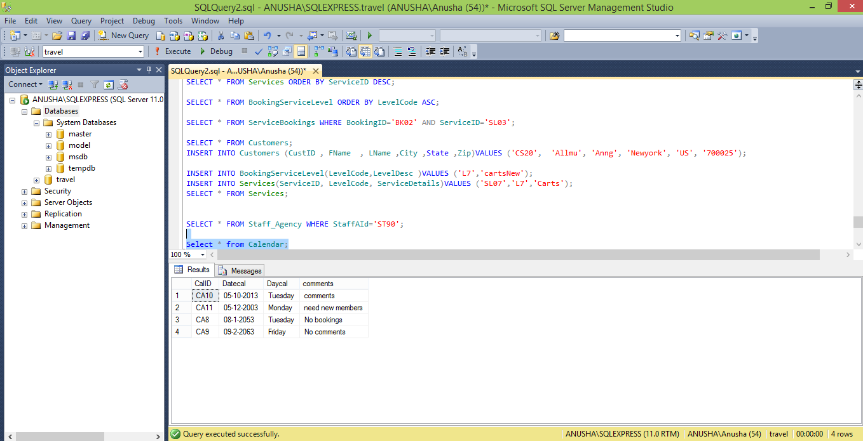

15. Retrieve all data from payments Table

Select * from Payments;

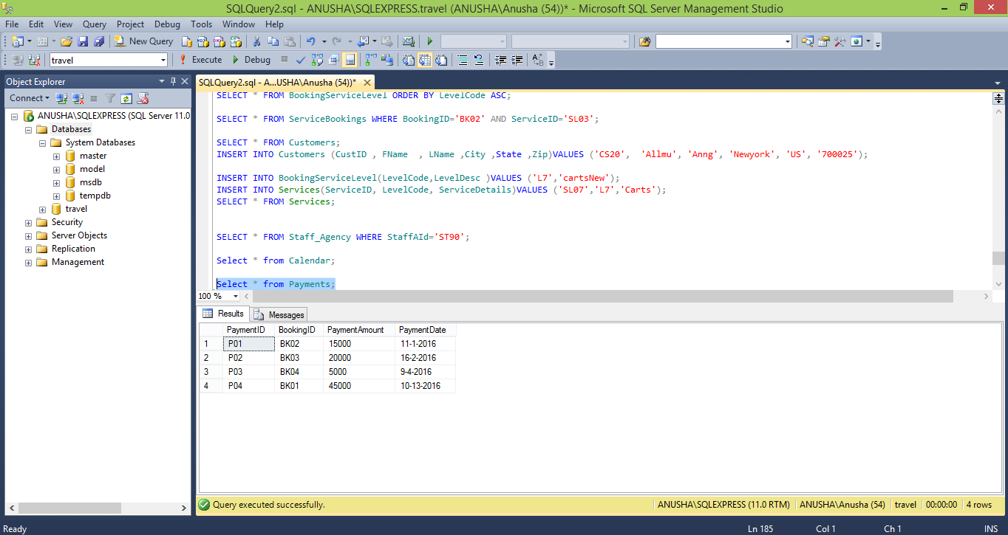

**ER DIAGRAM TRAVEL_AGENCY**

