ER Diagram Travel_Agency

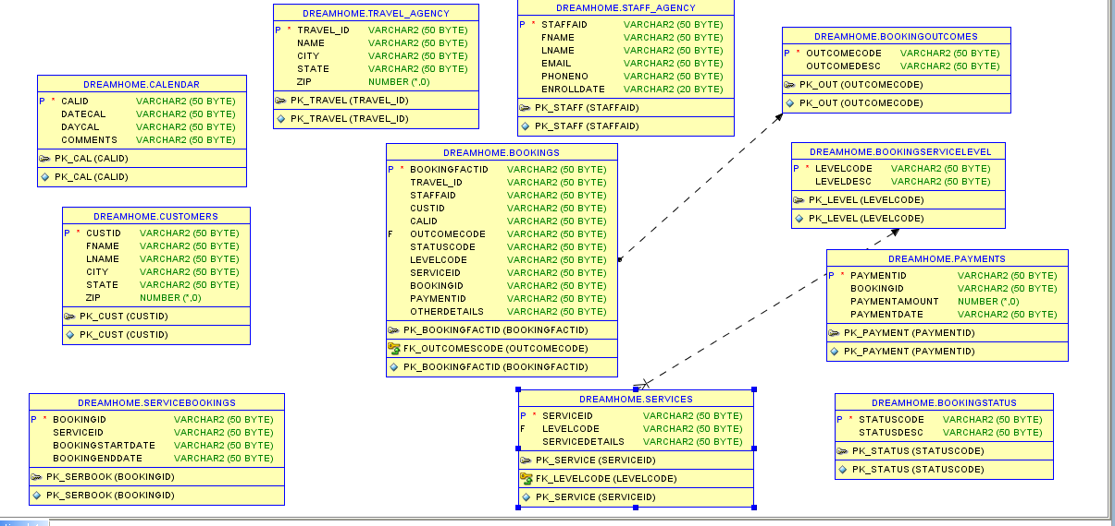

http://www.databaseanswers.org/data_models/travel_agencies/travel_agencies_data_mart.htm