**REPORT**

CAPM Explorer

**Team Members:**

T L Anusha – 20211ISD0028

Punitha Rani - 20211ISD0016

Bhavana H – 20211ISD0025

**Table of Contents:**

1. Introduction
2. Data
3. Key Points
4. Methodology
5. Results
6. Discussion
7. Conclusion

**Introduction**

The stock market is a complex and dynamic system presenting both opportunities and risks for investors. This report offers an analysis of stock market data utilizing Python programming language, including calculations of daily returns, beta, and expected returns based on the Capital Asset Pricing Model (CAPM) for various stocks and portfolios. Stock analysis is a process followed by traders to evaluate and understand the value of a security or the stock market. Stock analysis follows the idea that analysts can create methodologies to select stocks by studying past and present data.

The capital asset pricing model (CAPM) is a model used to determine a theoretically appropriate required rate of return of an asset, to make decisions about adding assets to a well-diversified portfolio. The Capital Asset Pricing Model (CAPM) describes the relationship between systematic risk, or the general perils of investing, and expected return for assets, particularly stocks. It is a finance model that establishes a linear relationship between the required return on an investment and risk. The model is based on the relationship between an asset's beta, the risk-free rate (typically the Treasury bill rate), and the equity risk premium, or the expected return on the market minus the risk-free rate.

**Data**

The data utilized in this analysis is a CSV file containing daily price data for various stocks such as Amazon, Google, and S&P 500, sourced from a reliable origin and subjected to cleaning and preprocessing before analysis.

**Key Points**

* The capital asset pricing model - or CAPM - is a financial model that calculates the expected rate of return for an asset or investment.
* CAPM does this by using the expected return on both the market and a risk-free asset, and the asset's correlation or sensitivity to the market (beta).
* There are some limitations to the CAPM, such as making unrealistic assumptions and relying on a linear interpretation of risk vs. return.
* Despite its issues, the CAPM formula is still widely used because it is simple and allows for easy comparisons of investment alternatives.
* For instance, it is used in conjunction with modern portfolio theory (MPT) to understand portfolio risk and expected return.

**Methodology**

The analysis was conducted using Python programming language and several libraries including Pandas, NumPy, Matplotlib, Seaborn, and Plotly. The following steps were undertaken:

1. I**mport Libraries/Datasets and Visualize Stocks Data:** Imports several Python libraries, including Pandas, NumPy, Matplotlib, Seaborn, and Plotly. It then reads in the stock dataset and visualizes the stock data using interactive plots.
2. **Calculate Daily Returns:** Daily returns are calculated as the percentage change in price from one day to the next.
3. **Calculate Beta for a Single Stock:** It calculates the beta for a single stock, which is a measure of the stock's volatility relative to the market. Beta is calculated by fitting a linear regression line to the scatter plot of the stock's daily returns against the market's daily returns.
4. **Apply the CAPM Formula to an Individual Stock:** The CAPM formula to an individual stock to calculate the stock's expected return. CAPM is a financial model that estimates the expected return on an investment based on its beta, the risk-free rate, and the expected return on the market.
5. **Calculate Beta for All Stocks:** It calculates the beta for all stocks in the dataset and stores the results in a dictionary.
6. **Calculate Expected Returns for All Stocks:** It calculates the expected returns for all stocks in the dataset using the CAPM formula and stores the results in a dictionary.
7. **Calculate Portfolio Returns:** It calculates the expected return for various portfolios consisting of different combinations of stocks. The portfolios are weighted equally.

Results

**Figure 1:** Apple vs S&P 500 Scatter Plot Figure 2 below shows the scatter plot of daily returns for Tesla and the S&P 500 index, with the regression line indicating a beta of 1.26.

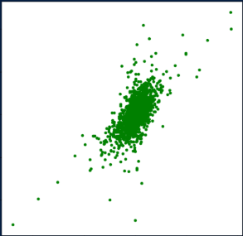

**Figure 2:** Tesla vs S&P 500 Scatter Plot

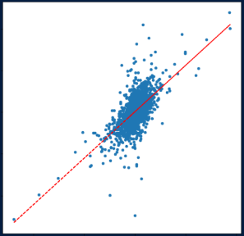

Discussion

The analysis presented in this report provides valuable insights into the expected returns on various stocks and portfolios. However, it is important to note that the analysis is based on historical data and does not guarantee future results.

Therefore, investors should perform their own due diligence before making investment decisions. Additionally, it is important to consider other factors such as the company's financial health, management team, and industry trends when making investment decisions.

Beta and expected returns are just two of many factors that investors should consider when analyzing stocks.

Conclusion

This report underscores the significance of data and analytics in investment decisions, emphasizing the importance of diversification for risk mitigation and enhanced returns. Recommendations include diversifying portfolios, prioritizing stocks with low beta and high expected returns, and maintaining regular monitoring and rebalancing.

The analysis of daily returns, beta, and expected returns highlighted significant disparities in risk and return characteristics among individual stocks. Portfolio analysis demonstrated the benefits of diversification, with constructed portfolios outperforming the S&P 500 in terms of expected returns.

Investors should diversify their portfolio to mitigate risk and increase returns, prioritizing stocks with low beta and high expected returns. Regular monitoring and rebalancing of the portfolio are essential to maintain desired risk-return profiles

This structured report offers a comprehensive overview of the stock market analysis, providing insights and recommendations for informed investment decisions.