Personal Finance Manager – Project Documentation

Project Overview
Project Name: Personal Finance Manager
Description:
A Python-based command-line application to manage personal finances, including income and expenses. Features include expense tracking, income tracking, category-wise summaries, monthly reports, net savings analysis, backup functionality, and optional data visualization.
Objectives:
- Track income and expenses efficiently.
- Generate reports for analysis and decision-making.
- Practice Python OOP, file handling, and data visualization.

Setup Instructions
- Install Python 3.x (preferably 3.12).
- Clone the repository:
git clone https://github.com/Anushage2/personal-finance-manager.git
cd personal-finance-manager
- Install dependencies:
pip install -r requirements.txt
- Run the program:
python main.py

Project Structure
personal-finance-manager/
├── main.py ← Main program entry point
├── expense.py ← Expense class
├── income.py ← Income class
├── file_manager.py ← CSV file operations
├── utils.py ← Utility functions
├── reports.py ← Reporting functions
├── data/ ← Sample and user data files
├── backup/ ← Backup data
├── docs/
│ ├── project_documentation.docx
│ └── user_manual.pdf
└── screenshots/
├── menu.png
├── add_expense.png
├── view_expense.png
├── category_summary.png
├── monthly_report.png
├── add_income.png
├── view_income.png
└── income_vs_expense.png

Features
- Add, view, and search expenses.
- Add and view income.
- Category-wise expense summary.
- Monthly report and net savings calculation.
- Backup and restore functionality.
- Optional charts for data visualization.

Code Explanation
- main.py: Handles menu and program flow.
- expense.py / income.py: Defines Expense and Income classes.
- file_manager.py: Reads/writes CSV data.
- utils.py: Validates user input.
- reports.py: Generates summaries and charts.

Screenshots
Figure 1: Main Menu
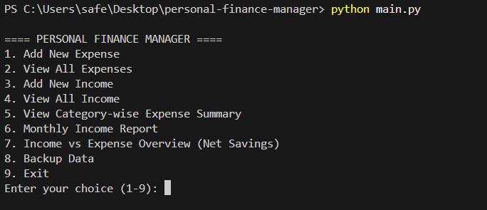
Figure 2: Add Expense
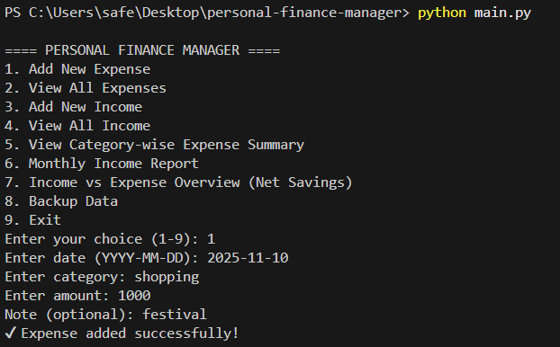
Figure 3: View All Expenses
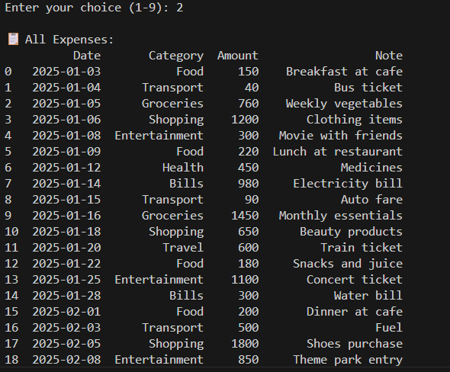
Figure 4: Category-wise Summary
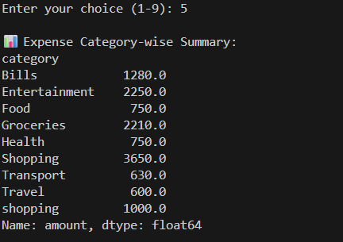
Figure 5: Monthly Report
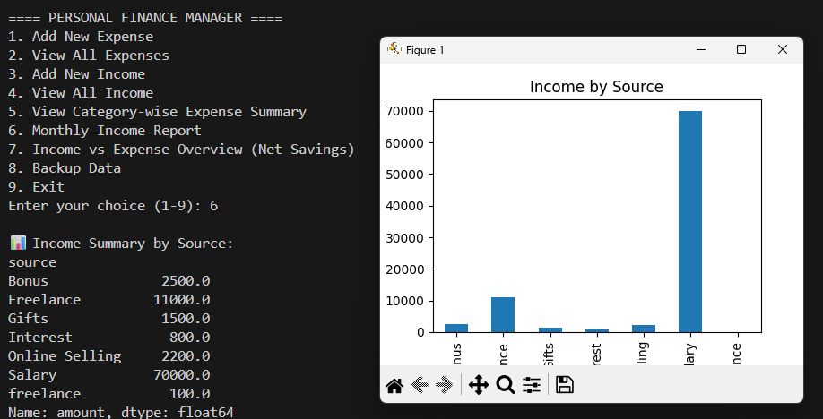
Figure 6: Add Income
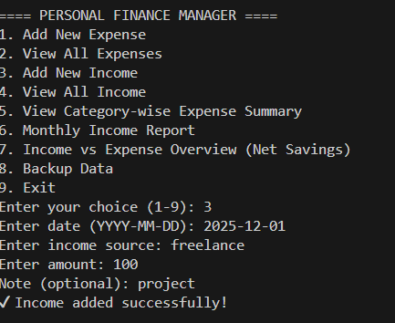
Figure 7: View All Income
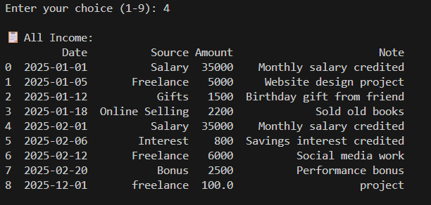
Figure 8: Income vs Expense Overview
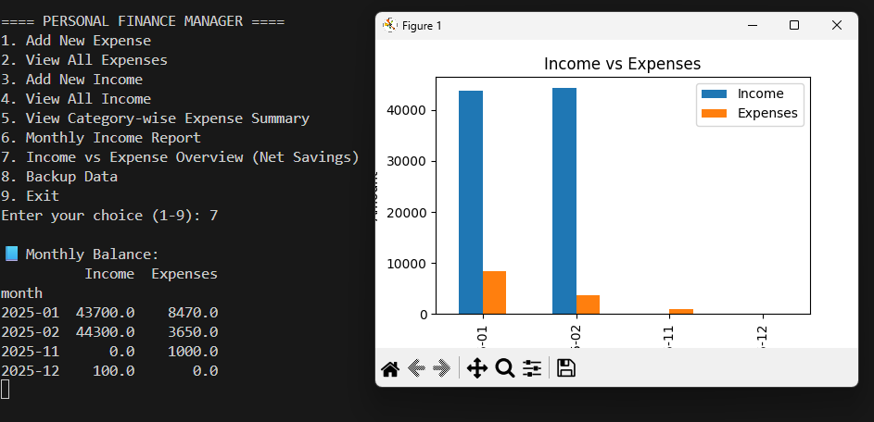

Technical Details
- Language: Python 3.x
- Libraries: pandas, matplotlib, numpy, csv
- Design: OOP (Expense and Income classes)
- File handling: CSV for data persistence
- Validation: User input validation for amount, date, and category

Testing & Validation
- Added multiple expenses and incomes to test CSV read/write.
- Verified reports match input data.
- Tested backup and restore functionality.
- Checked charts display correct data.

Conclusion
This project helps users manage finances effectively and demonstrates Python skills including OOP, file handling, data processing, and visualization.

