Streamlit Dashboard — Output Explained
A plain-English walkthrough of every section, chart, and number
in the Battery AI Co-Scientist Streamlit Dashboard
Pipeline run: 2026-04-15 | Git: 32611f8

How to Open the Dashboard
The dashboard is a Python web app. You run it from the terminal and it opens in your browser. You do not need an internet connection — it runs entirely on your own computer and reads the output files the pipeline already produced.
Step 1: Open a terminal in the project folder (D:\battery\battery-project3)
Step 2: Activate the virtual environment: .venv\Scripts\activate
Step 3: Run: streamlit run dashboard/app.py
Step 4: Your browser opens automatically at http://localhost:8501
If that port is busy it will use 8502, 8503, etc. — check the terminal output.

The dashboard reads these files automatically every time it loads. If you re-run the pipeline, just refresh the browser page to see updated results.

The Sidebar — Navigation and Key Numbers
On the left side of every page there is a sidebar. It does two things:
1. Navigation — click any section name to jump straight to it. The currently active section is highlighted in amber.
2. Key numbers always visible — so no matter which section you are looking at, you can always see the three most important numbers: XGBoost RMSE, conformal coverage, and anomaly count.
3. Pipeline run timestamp — shows exactly when the pipeline last ran (2026-04-15 17:36:54), so you know the results are fresh.
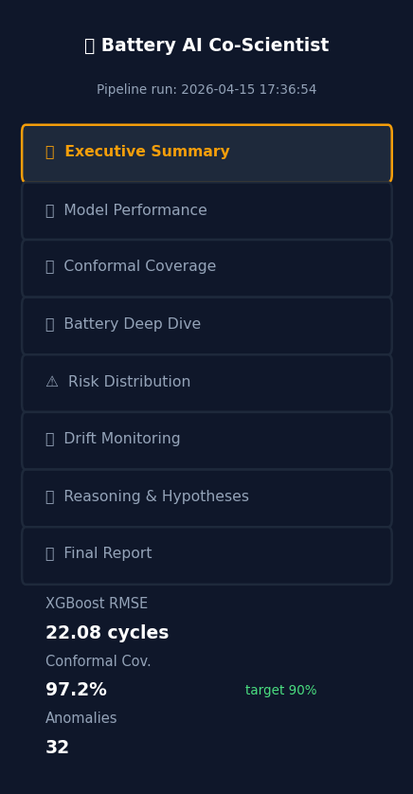
Figure 1 — The sidebar. Active section shown in amber. Key metrics always visible.

Section 1: Executive Summary

What this section shows
This is the first thing you see when the dashboard loads. It gives the complete picture in one screen — the overall verdict, all six key numbers, a stage-by-stage results table, and the risk distribution chart.
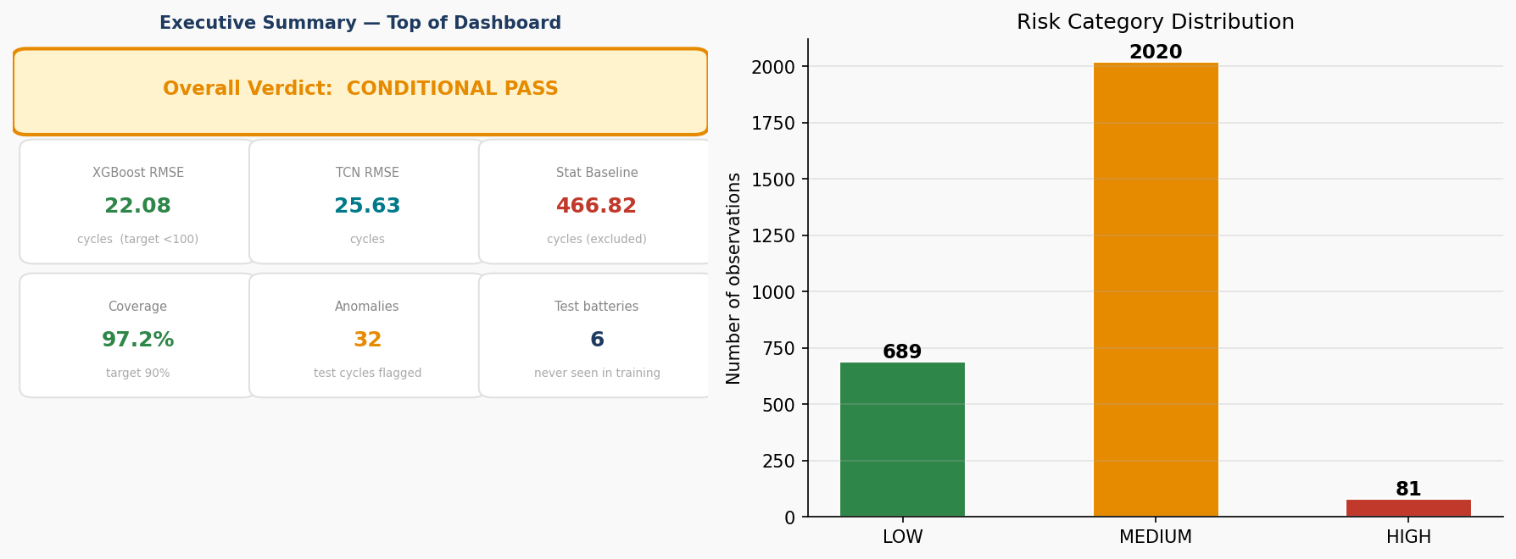
Figure 2 — Executive Summary: verdict banner, metric cards, and risk distribution.

The Verdict Banner
The coloured banner at the very top shows the system's overall verdict from the Stage 6 supervisor audit:
- GREEN banner = PASS — system meets all targets
- AMBER banner = CONDITIONAL PASS — system works but with a noted caveat
- RED banner = FAIL — a critical target was not met
Our result: CONDITIONAL PASS (amber)
This means the system works correctly and all required outputs were produced. The caveat is that the cross-validation RMSE (48.17) is 2.2x higher than the holdout test RMSE (22.08) — meaning the test batteries were slightly easier to predict than average. This is a data-size limitation, not a design flaw.

The Six Metric Cards
Metric | Value shown | What it means
XGBoost RMSE | 22.08 cycles | The main model is off by 22 cycles on average. Target was <100. Passed comfortably.
TCN RMSE | 25.63 cycles | The deep learning model. Slightly less accurate than XGBoost on this dataset.
Stat. Baseline | 466.82 cycles | The simple physics model. Far too inaccurate — excluded from predictions.
Coverage | 97.2% | 97.2% of the time the true RUL falls inside our predicted interval. Target was 90%.
Anomalies | 32 | 32 cycles across the 6 test batteries were flagged as behaving unusually.
Test batteries | 6 | 6 batteries were never shown to the model during training — only used for evaluation.

Risk Distribution Chart
For every cycle of every battery the system calculates 'what is the probability this battery fails within the next 20 cycles?' and assigns LOW, MEDIUM, or HIGH. The bar chart shows how many of the 2,790 total observations fell into each category.
- LOW (689 rows, 24.7%) — failure probability < 30%. Battery is healthy, no action needed.
- MEDIUM (2,020 rows, 72.4%) — failure probability 30–70%. Monitor, plan maintenance.
- HIGH (81 rows, 2.9%) — failure probability > 70%. Battery is near end-of-life.
The majority being MEDIUM is expected — most cycles happen in the mid-life region where the battery is degrading but not yet critical.

Section 2: Model Performance

What this section shows
This section shows how accurate the three models are, which features the model relies on most, and how well the accuracy holds up across different battery groups (cross-validation).
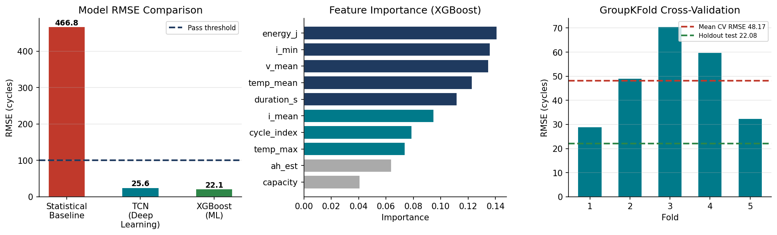
Figure 3 — Model performance: RMSE comparison, feature importance, GroupKFold CV results.

RMSE Comparison Chart
Three bars, one per model. The dashed blue line is the pass threshold (100 cycles). Any model whose bar is below the line passes.
Model | RMSE | Passes? | Used in ensemble?
Statistical Baseline (Exponential) | 466.82 | No — 4.7x over threshold | No — excluded
TCN (Deep Learning) | 25.63 | Yes | Yes (46.3% weight)
XGBoost (ML) — primary | 22.08 | Yes | Yes (53.7% weight)

Feature Importance Chart
Shows which input features the XGBoost model relies on most. Taller bar = model uses that feature more heavily when deciding the RUL prediction. The top 5 features are:
- energy_j (14.1%) — total energy delivered per cycle. Captures how hard the battery worked.
- i_min (13.6%) — minimum current. Related to discharge depth.
- v_mean (13.5%) — mean voltage. Drops as battery degrades.
- temp_mean (12.3%) — average temperature. Higher = faster degradation.
- duration_s (11.2%) — how long the cycle lasted. Shorter cycles = more degraded battery.
Notice that 'capacity' — the most obvious health indicator — is actually the least important feature (4.1%). This is because once you know the energy, current, and voltage, capacity adds little extra information.

Cross-Validation Table
5-fold GroupKFold cross-validation splits the 22 training batteries into 5 groups and tests each group in turn. This gives a more honest accuracy estimate than a single train/test split.
Fold | Train batteries | Val batteries | RMSE
1 | 18 | 4 | 28.94
2 | 17 | 5 | 49.09
3 | 18 | 4 | 70.49
4 | 18 | 4 | 59.85
5 | 17 | 5 | 32.48
Mean ± std | — | — | 48.17 ± 15.82

CV mean RMSE = 48.17 vs holdout test RMSE = 22.08 (ratio 2.2x)
The test batteries happened to be easier to predict than average. The CV RMSE is the more conservative and realistic accuracy estimate. This is why the system receives CONDITIONAL PASS — honest, not alarming.

Section 3: Conformal Coverage

What this section shows
This section shows whether the confidence intervals (the range around each RUL prediction) actually contain the true value as often as promised. The target is 90% — we promised the true RUL falls inside the interval 90% of the time.
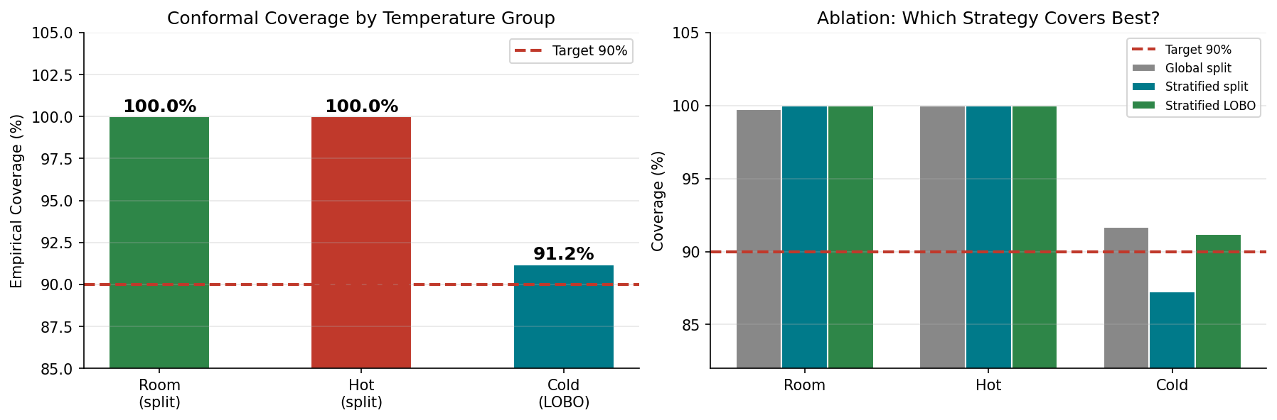
Figure 4 — Conformal coverage by temperature group (left) and ablation study (right).

The Three Coverage Cards
Group | Coverage | q_hat | Strategy | Result
Room (~24°C) | 100.0% | 69.64 cycles | Split conformal | Above target (+10.0%)
Hot (43°C) | 100.0% | 54.24 cycles | Split conformal x1.2 | Above target (+10.0%)
Cold (<10°C) | 91.2% | 54.07 cycles | LOBO (Leave-One-Out) | Above target (+1.2%)

Note: the hot group has q_hat inflated by x1.2 because there was only 1 hot calibration battery — the safety factor widens the interval to compensate for the small calibration sample.

Ablation Chart — Why LOBO?
The ablation chart compares three strategies for calibrating the cold batteries:
- Global split (grey) — one q_hat for all temperatures: cold coverage = 91.67% but room/hot intervals are too wide
- Stratified split (teal) — separate q_hat per group, standard method: cold coverage = 87.25% — under target
- Stratified LOBO (green) — our method: cold coverage = 91.18% — above target
LOBO (Leave-One-Battery-Out) specifically improves cold coverage by re-training the model for each left-out cold battery, giving more representative error estimates for the cold group.

Section 4: Battery Deep Dive

What this section shows
This is the most detailed section. You pick one battery (or multiple for comparison) and see three charts: capacity degradation with anomaly flags, RUL prediction with confidence band, and survival/hazard risk over its lifetime.
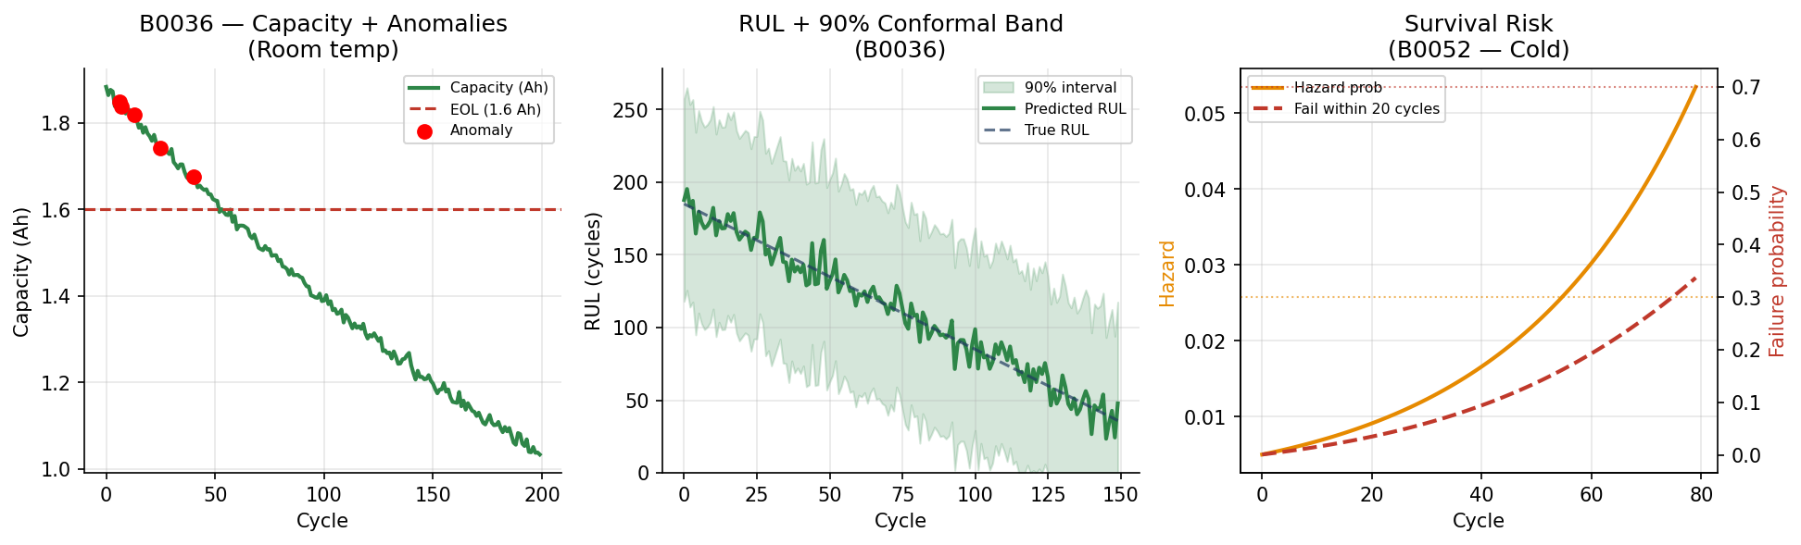
Figure 5 — Battery deep dive: capacity fade, RUL prediction, and survival risk for B0036 and B0052.

Chart 1: Capacity Degradation + Anomaly Flags
The line shows how the battery's capacity (Ah) decreases over cycles. The dashed red line is the End-of-Life threshold (1.6 Ah = 80% of 2.0 Ah). When the capacity line crosses the red dashed line, the battery has reached EOL.
Red dots mark cycles flagged as anomalies — where the battery's RUL deviated strongly from the model's expected trend. Battery B0036 has the most anomalies (15) of all test batteries because it shows some irregular behaviour early in its life.
Quick stat cards above the chart show:
- Total cycles recorded for this battery
- Initial capacity (when battery was new)
- Final capacity (at the last recorded cycle)
- Number of anomalies flagged

Chart 2: RUL Prediction with 90% Conformal Interval
The solid line is the model's predicted RUL at each cycle. The dashed dark blue line is the true RUL (ground truth). The shaded region is the 90% conformal interval — we are 90% confident the true value falls inside the shaded band at any given cycle.
You can toggle the uncertainty band on or off using the checkbox. A wider band means the model is less certain. Bands typically narrow as the battery approaches EOL because the signal is stronger near the end.
- B0030 (room temp): narrow band, RMSE only 1.25 — very easy to predict
- B0052 (cold): wider band, RMSE 57.5 — cold batteries are harder to predict

Chart 3: Survival / Hazard Risk
Two stacked charts for the selected battery:
- Top chart — hazard probability h(t): the chance the battery fails at this specific cycle, given it survived this far. Starts near zero and rises steeply near EOL.
- Bottom chart — horizon failure probability: P(failure within 20 cycles). The two dashed lines show the HIGH (70%) and MEDIUM (30%) thresholds. The red shading appears when the battery is in HIGH risk territory.
Below the charts, three metric cards show how many cycles of this battery were classified as LOW, MEDIUM, and HIGH risk.

Multi-Battery Comparison
At the bottom of this section you can select multiple batteries and overlay their capacity fade or RUL trajectory on one chart. Batteries are colour-coded by temperature group: green = room, red = hot, teal = cold. This makes it immediately visible that cold batteries behave differently.

Section 5: Risk Distribution

What this section shows
A summary of the risk categories across all 2,790 observations, with a per-battery breakdown showing which batteries spent more cycles in HIGH risk.
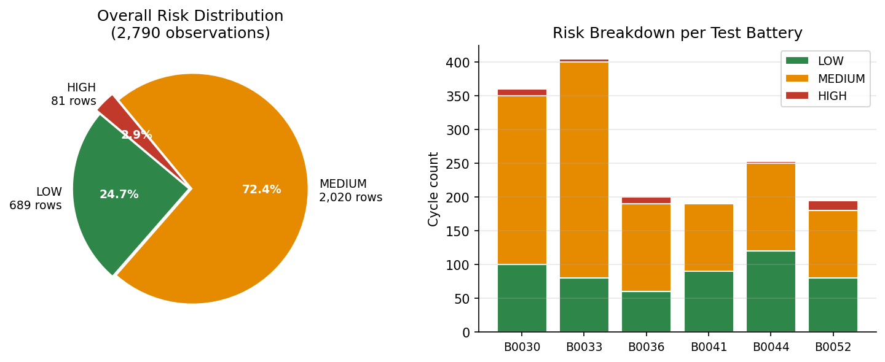
Figure 6 — Risk distribution: pie chart of all observations and per-battery breakdown.

The Pie Chart
Shows LOW / MEDIUM / HIGH as proportions of all 2,790 cycle observations. 72.4% are MEDIUM — this is expected, as most battery cycles happen in the mid-life region where risk is moderate but not yet critical.

Per-Battery Risk Breakdown
Grouped bar chart — one group of bars per test battery, showing how many of that battery's cycles fell into each risk category. B0052 (cold) tends to have more HIGH-risk cycles than B0030 (room) because cold batteries degrade less predictably.
Two additional metrics are shown: mean predicted RUL across all observations (28.06 cycles) and mean uncertainty interval width (83.38 cycles).

Section 6: Drift Monitoring

What this section shows
PSI (Population Stability Index) measures how different the test data is from the training data for each feature. High PSI = the model is being asked to predict data that looks different from what it was trained on.
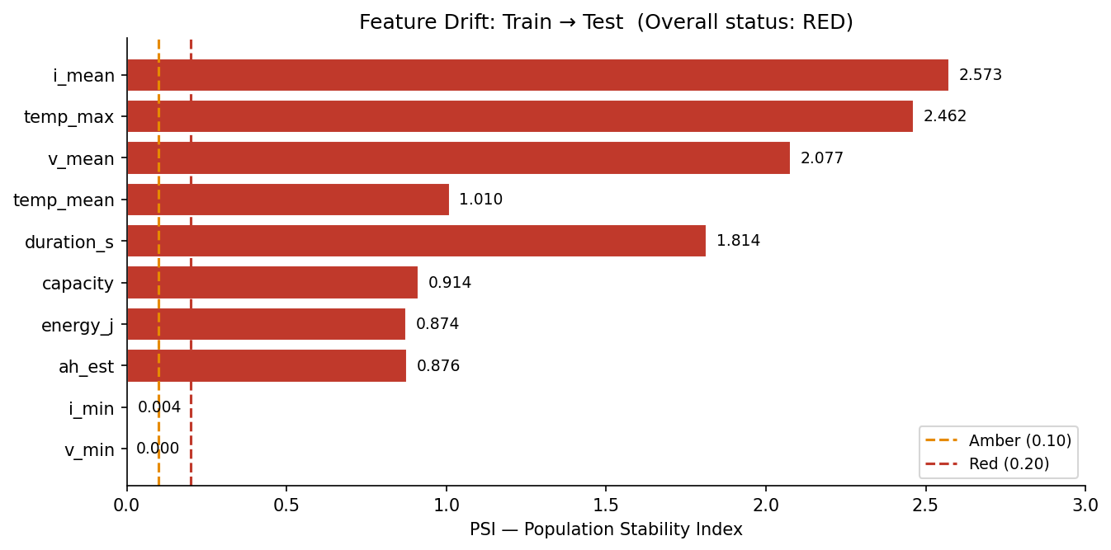
Figure 7 — PSI drift chart: GREEN = stable, AMBER = watch, RED = significant drift.

Reading the PSI Chart
Each bar is one feature. The colour tells you the severity:
- GREEN — PSI < 0.10: no significant drift, all good
- AMBER — PSI 0.10–0.20: slight drift, worth monitoring
- RED — PSI > 0.20: significant distribution shift
Feature | PSI Value | Explanation
i_mean | 2.573 RED | Mean current differs — cold batteries have different discharge profiles
temp_max | 2.462 RED | Max temperature differs — cold test batteries vs room-temp training
v_mean | 2.077 RED | Mean voltage differs — cold temperature shifts voltage behaviour
duration_s | 1.814 RED | Cycle duration differs — cold batteries take longer to discharge
temp_mean | 1.010 RED | Mean temperature differs — expected given cold vs room split

Why is RED drift expected here?
Our test set includes 3 cold batteries (B0041, B0044, B0052) tested below 10°C, while training was mostly room-temperature. Lower temperature physically changes how voltage, current, and cycle duration behave — so high PSI on these features is a direct consequence of the temperature split, not a pipeline error.
This is exactly why we use temperature-stratified conformal calibration and LOBO for cold batteries — we knew the distributions would differ.

Section 7: Reasoning and Hypotheses

What this section shows
Stage 5 of the pipeline generates written explanations of WHY batteries degrade the way they do, based on what the model learned. These are always clearly labelled as hypotheses — not proven facts.
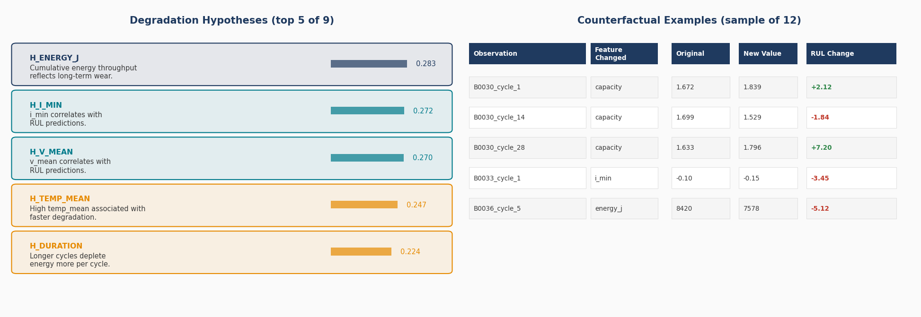
Figure 8 — Hypotheses (left) with confidence bars, and counterfactual examples (right).

Degradation Hypotheses Tab
9 hypotheses are shown, sorted by confidence (highest first). Each hypothesis has:
- A hypothesis ID (e.g. H_ENERGY_J)
- The hypothesis text — written in plain English
- Supporting evidence — which feature importance score backs it up
- A confidence bar — visual representation of the confidence score
The confidence score is derived from the feature importance. A feature with importance 14.1% gets a confidence of 0.283 (scaled). Higher confidence means the model is more strongly influenced by that feature.
Hypothesis | Plain English | Confidence
H_ENERGY_J | Cumulative energy throughput reflects long-term wear | 0.283
H_I_MIN | i_min (minimum current) correlates with RUL | 0.272
H_V_MEAN | v_mean (mean voltage) correlates with RUL | 0.270
H_TEMP_MEAN | High mean temperature is linked to faster degradation | 0.247
H_DURATION | Longer cycle duration depletes energy per cycle more | 0.224

Counterfactual Examples Tab
12 counterfactual examples answer what-if questions: 'if this one feature had been different, what would the predicted RUL have been?'
Each row in the table shows:
- Observation ID — which battery and which cycle
- Feature changed — which input was modified
- Original value — the actual recorded value
- New value — the hypothetical changed value
- RUL change — how much the prediction would shift (green = longer life, red = shorter life)
Example: B0030_cycle_28
If capacity had been 1.796 Ah instead of 1.633 Ah, the predicted RUL would be +7.2 cycles higher. This makes physical sense: higher capacity = more life remaining.

Section 8: Final Report

What this section shows
The supervisor report from Stage 6 is rendered inline. This is the automated audit that checks all pipeline outputs and issues the final verdict. Below the report is a full artifact checklist showing which output files exist.

Stage-by-Stage Checks
Stage | What was checked | Verdict
Stage 3 — Modeling | ML RMSE vs 100-cycle threshold  CV/test ratio | CONDITIONAL PASS  RMSE=22.08, ratio=2.2x
Stage 4 — Uncertainty | 90% conformal coverage achieved? | PASS  97.2% overall
Stage 4.2 — Survival | Survival predictions file exists with rows | PASS  638 rows, 6 batteries
Stage 4.5 — Anomaly | Anomaly detector ran without error | PASS  32 anomalies flagged
Stage 5 — Reasoning | Hypotheses and counterfactuals generated | PASS  9 hypotheses, 12 counterfactuals
Stage 6 — Supervisor | All required artifacts present  Anti-hallucination verified | CONDITIONAL PASS  All artifacts found

Artifact Checklist
At the bottom of this section, a table lists every output file the pipeline should produce and shows whether it exists. Green tick = file is present. Red cross = file is missing (that pipeline stage either failed or hasn't been run).
All 14 artifacts show green ticks in the current run, confirming the pipeline completed successfully end to end.

