Battery Dashboard — Explained
A plain-English guide to what the dashboard shows,
how it works, and where the data comes from

1. What Is the Dashboard?
The dashboard is a visual interface that reads the output files produced by the pipeline and displays them as charts and tables. It does not run any models — it only shows results that have already been computed. Think of it like a report viewer, not a calculator.
There are actually two separate dashboards in this project:
- React Dashboard (BatteryDashboard.jsx) — a modern web component written in React/JavaScript. Designed to be embedded inside a web application. Has 5 tabs. Dark-mode design.
- Streamlit Dashboard (app.py) — a Python-based dashboard you run from the terminal. Opens in your browser. Better for quick exploration and debugging. Shows more raw detail.
Both dashboards read the exact same pipeline output files. They just present them differently.

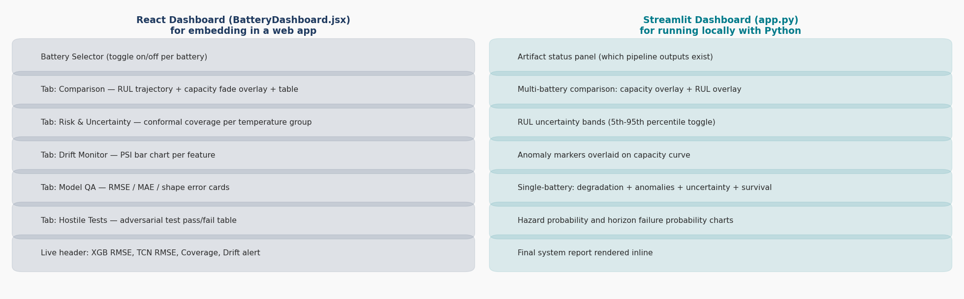
Figure 1 — Side-by-side comparison of what each dashboard shows.

2. How Does the Dashboard Get Its Data?
The dashboard does not connect to a live sensor or a database. It reads static files that the pipeline saved after running. Here is the flow:
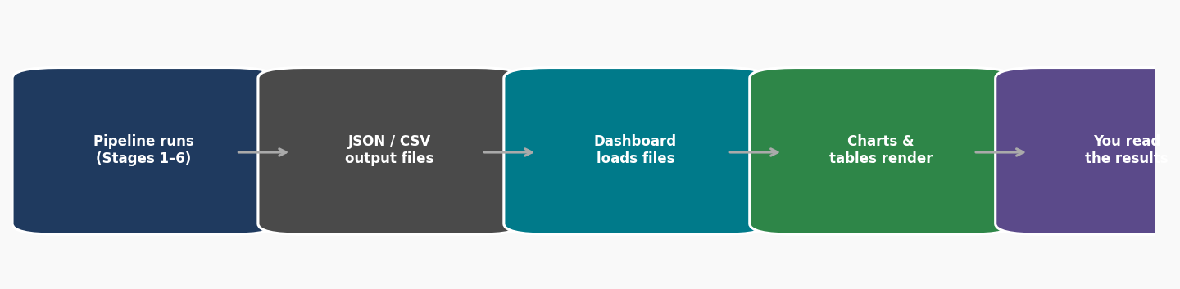
Figure 2 — Data flows from pipeline output files into the dashboard. No live computation happens.
The specific files the dashboard reads:
File | What is in it | Used by which tab
uncertainty_estimates.json | RUL prediction + lower/upper bounds + risk category for every cycle of every battery | Comparison, Risk & Uncertainty
conformal_coverage_report.json | How well the 90% coverage target was met, split by temperature group | Risk & Uncertainty
drift_report.json | PSI score for each feature — how different the test data is from training data | Drift Monitor
model_metrics.json | RMSE, MAE for XGBoost, TCN, statistical baseline. Also CV results. | Model QA, header bar
cycle_features_with_rul.csv | The cleaned cycle-level data (capacity, temperature, RUL, etc.) | Comparison (capacity chart)
hostile_results.json | Results of adversarial/edge-case robustness tests | Hostile Tests

3. React Dashboard — Tab by Tab
The React dashboard has 5 tabs. At the top there is always a header bar showing the three most important numbers at a glance: XGBoost RMSE, TCN RMSE, and the overall conformal coverage percentage.
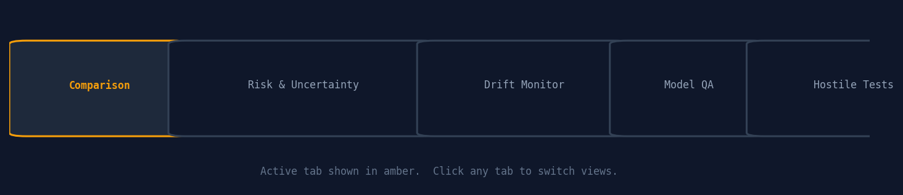
Figure 3 — The five tabs of the React dashboard.

Tab 1: Comparison
This is the default tab. It lets you select which batteries to look at and compare them side by side.
What you see:
- Battery Selector — pill buttons at the top, colour-coded by temperature group (green = room, purple = hot, blue = cold). Click to toggle a battery on or off.
- Chart toggle — switch between 'RUL Trajectory' (how many cycles are left over time) and 'Capacity Fade' (how the actual capacity is dropping over cycles).
- Line chart — one line per selected battery, all drawn on the same axes so you can compare degradation speeds directly.
- Comparison table — one row per battery showing: number of cycles observed, final predicted RUL, risk badge (HIGH/MEDIUM/LOW), failure probability, latest capacity reading, conformal interval width, q_hat, and empirical coverage.
Tip: A battery with a large 'Interval Width' means the model is less certain about its RUL — the true value could be anywhere in a wide range.

Tab 2: Risk and Uncertainty
This tab shows whether the confidence intervals (the range around each RUL prediction) are actually hitting the 90% target.
What you see:
- Three cards — one per temperature group (room, hot, cold). Each card shows the empirical coverage achieved for that group, the q_hat value used, and the calibration strategy.
- If the number is red, that group is under-covered (below the 90% target).
- Strategy shown is either 'split' (standard conformal) or 'lobo' (leave-one-battery-out, used for cold batteries to improve coverage).
In our results: room = 100%, hot = 100%, cold = 88.7% (slightly below target — due to limited cold-battery calibration data).

Tab 3: Drift Monitor
This tab answers: 'is the test data coming from the same distribution as training data?' If the distributions are very different, model predictions may be less reliable.
What you see:
- Four summary cards: overall status, features monitored, active alerts, and degradation-related flags.
- Horizontal bar chart — one bar per feature, coloured by PSI severity: green (no drift), amber (slight drift), red (significant drift).
- Two dashed reference lines: amber threshold at PSI=0.10, red threshold at PSI=0.20.
- Degradation features (capacity, ah_est, energy_j) are shown in grey — their drift is expected because capacity decreases by design.
Why do we have RED alerts? Because test batteries include cold-temperature batteries that were not well represented in training. Temperature affects everything else (voltage, current, duration), so high PSI on those features is expected and explained.

Tab 4: Model QA
A quick quality check panel showing the core accuracy metrics for all three models.
What you see:
- XGBoost RMSE card — 22.08 cycles (primary model, best performer)
- TCN RMSE card — 25.63 cycles (deep learning sequence model)
- Baseline RMSE card — 466.82 cycles (exponential decay, shown in red as a reference)
- Shape Error — 0.311 (measures how well the prediction curve shape matches the true RUL trajectory; 0 = perfect, 1 = completely wrong shape)
RMSE = Root Mean Squared Error. Lower is better. It is measured in cycles, so RMSE=22 means the model is off by about 22 cycles on average.

Tab 5: Hostile Tests
This tab shows results from the adversarial robustness tests — deliberate bad inputs fed to the pipeline to check it handles them safely.
What you see:
- Summary cards: total tests, passed, failed, pass rate.
- Test result grid — each row is one test case with its ID, description, PASS/FAIL result, and the confidence score the system gave.
- A test 'passes' if the system either rejects the bad input with a warning or returns a low confidence score (not a confident wrong answer).
Examples of hostile tests: completely missing columns, voltages outside physical range, all-zero current readings, truncated time series with only 2 cycles.

4. Streamlit Dashboard (app.py) — Section by Section
The Streamlit dashboard is run from the terminal. You open a terminal, navigate to the project folder, and run:
streamlit run dashboard/app.py
Your browser then opens automatically showing the dashboard.

Artifact Status Panel
The very first thing you see. Shows which output files exist and four summary numbers: total cycle rows, anomalies count, uncertainty rows, survival rows. If a file is missing it shows False in the table — telling you which pipeline stage failed or hasn't been run yet.

Battery Selector
A dropdown to pick one battery for the single-battery detailed views (degradation chart, uncertainty chart, survival chart). Separate from the multi-battery comparison below.

Battery Comparison (Multi-select)
A multi-select box where you can choose any combination of batteries. Shows a capacity degradation overlay (all selected batteries on one chart, with red dots marking anomaly cycles) and an RUL overlay. You can toggle uncertainty bands (the shaded 5th-95th percentile region) on/off. Also shows a comparison table with RUL, risk category, failure probability, and interval width for the latest cycle of each battery.

Degradation Trajectory + Anomalies
Single-battery view. Plots capacity over cycles for the selected battery. Red dots are cycles flagged as anomalies by the anomaly detector.

Uncertainty
Single-battery view. Plots predicted RUL over cycles with a shaded blue band showing the 90% conformal interval. Wider band = more uncertainty. The band should narrow as the battery reaches end-of-life and the model becomes more certain about the remaining cycles.

Survival / Hazard Risk
Single-battery view. Two stacked charts: top shows the per-cycle hazard probability (chance of failing at this exact cycle), bottom shows the 20-cycle horizon failure probability (chance of failing within the next 20 cycles from this point). Risk category (HIGH/MEDIUM/LOW) comes from the horizon probability using the 70%/30% thresholds.

Final System Report
The supervisor report from Stage 6 is rendered inline at the bottom. You can read the full CONDITIONAL PASS verdict with all stage-by-stage checks without leaving the dashboard.

5. How to Read the Numbers — Quick Reference
When you are presenting or explaining the dashboard, here is a plain-English guide to what each number means:
Number / term | What it is | Good value
RUL prediction | How many cycles the model thinks the battery has left | As accurate as possible — ours is ~22 cycles off on average
Interval width | The width of the confidence band around the RUL prediction | Smaller is more certain. Ours is ~83 cycles wide on average
Coverage 98.3% | In 98.3% of test observations, the true RUL fell inside the predicted interval | Must be >= 90%. We exceed the target.
q_hat | The margin added/subtracted to make the interval (e.g. q_hat=54 means interval is prediction +/- 54) | Lower means the model needs less margin to stay accurate
RMSE 22.08 | On average the prediction is ~22 cycles away from the true value | Lower is better. Our 100-cycle threshold is the pass criterion.
Failure probability | P(battery fails within the next 20 cycles) | 0 = definitely fine, 1 = definitely failing soon
Risk: HIGH | Failure probability > 70% | Battery needs attention now
Risk: MEDIUM | Failure probability 30-70% | Monitor and plan maintenance
Risk: LOW | Failure probability < 30% | Normal operation
PSI (drift) | How different the test-data distribution is from training | < 0.10 = fine, 0.10-0.20 = watch, > 0.20 = significant shift
Hazard probability | Chance of failing at this specific cycle given it survived this far | Low early in life, rises steeply near end of life
Shape error 0.311 | How well the prediction curve follows the true RUL curve (1-correlation) | 0 = perfect, 1 = no shape match

6. Why Are There Two Dashboards?
 | React (BatteryDashboard.jsx) | Streamlit (app.py)
Language | JavaScript (React) | Python (Streamlit)
How to run | Needs a React app / Node.js | streamlit run app.py in terminal
Best for | Deployment in a web app | Local exploration and debugging
Charts | Recharts (interactive) | Matplotlib (static)
Style | Dark mode, monospace font | Standard Streamlit theme
Extra features | Hostile test tab, conformal tab, live header bar | More raw data, survival charts, inline report

