# 1.SLICERS:

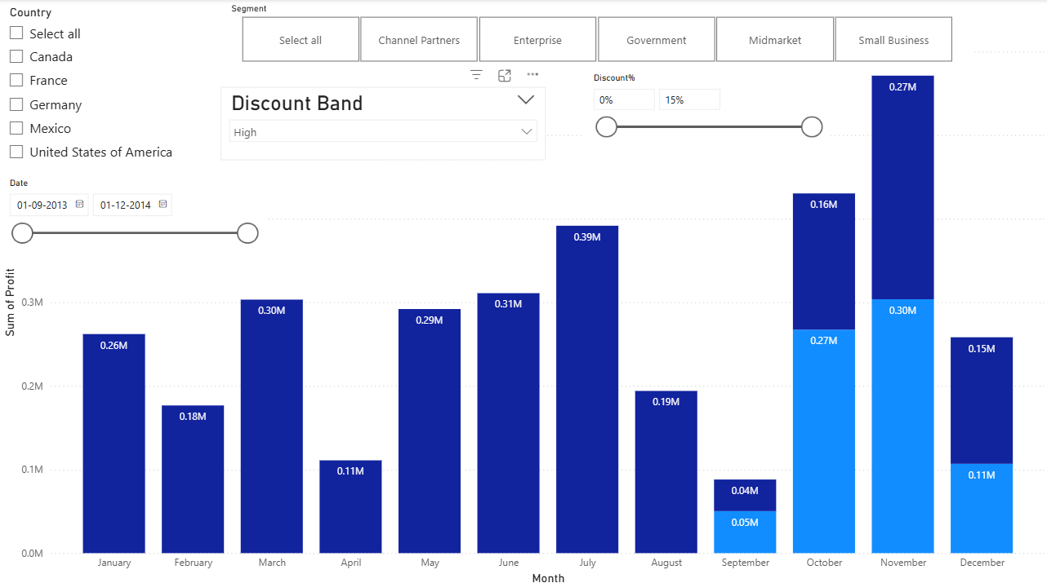

STEPS:

1.In visualization pane select the slicer visual, drag and drop discount band to the values. Format the slicer to be in single select mode and drop-down format in slicer settings.

2. In visualization pane select the slicer visual, drag and drop segment to the values. Format the slicer to be in select all options also with tile format in slicer settings.

3. In visualization pane select the slicer visual, drag and drop date to the values, format the values as between the values in slicer settings.

4.To create the slicer for the discount percentage, we need to calculate the discount percentage, to do that go to table view and add new column and calculate with the formula

discount% = financials[discounts]/financials [gross sales]

now go the report view and click on slicer drag and drop discount% to the values.

Now we have created all the slicers as specified and based on that we can answer the questions.

1. what is the profit of german government in the year 2014.

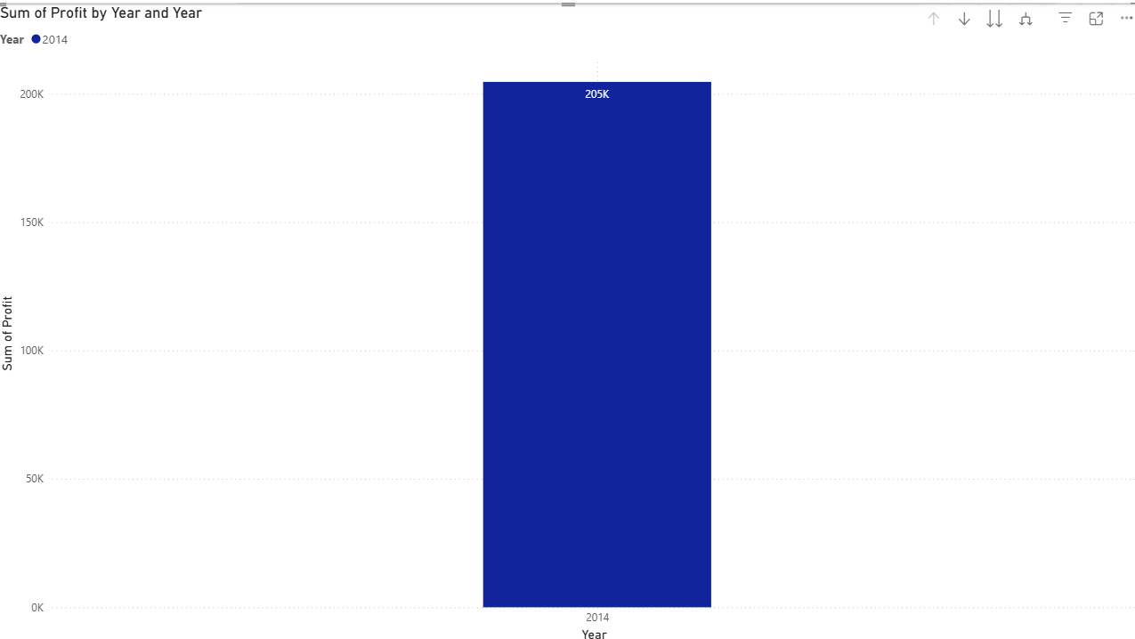

STEPS:

* Select Germany in the country slicer, in segment slicer select government and drag up to see the profit for the year 2014.
* The discount band is high in default keep it unchanged.

6.what is the profit of mexico and canada enterprise with low discount

band in December 2013

STEPS:

* Select Mexico and Canada in the country slicer, in segment slicer select enterprise and drag up to see the profit for the year 2013.
* The discount band is high in default change it to low.
* It does not have values in the scenario so the chart is empty.

