**SEPTEMBER 10**

* To make the connections we need one more categorical data, country can be grouped by continents.
* We can import the table consisting country and continent using web scrapping.
* In Home tab select import excel file, select the excel file consisting the continent.
* Select the table and transform data before importing.
* The data will be opened in power query use the first column as headers.
* Change the table name as Continent
* Now import to power BI
* Now we need to establish the relationships between the tables.
* Navigate to the model view, drag and drop country from WHR to country in Continent table.
* Now the connection is established.

**SCATTER PLOT WITH PLAY AXIS:**

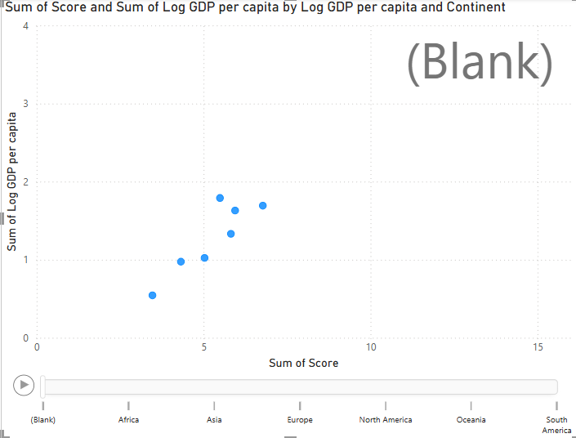

CHART TYPE: Scatter plot

INSIGHTS:

* We can see the score and GDP value in the scatter plot.
* The dots are log GDP values.
* To segregate the data we are using the continents in play axis.
* From the chart we can see the continent wise GDP and score.

STEPS:

* From visualization pane select a scatter plot.
* Drag and drop score to the x-axis and Log GDP per capita to the y-axis.
* Default the columns will be summarized.
* Now we can see the scatter plot.
* Now drag and drop Log GDP per capita into values.
* Drag and drop continents to the play axis.

**MAP:**

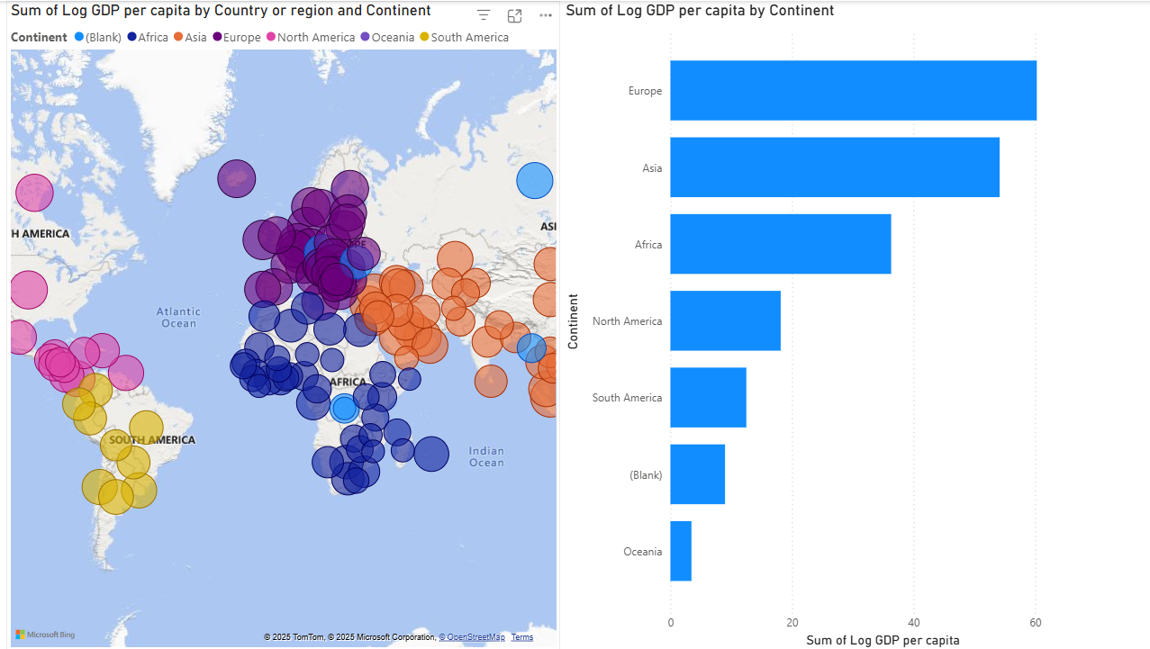

* North America and South America contribute less in total because of fewer countries compared to Europe/Asia.
* Oceania has the smallest contribution.
* The “(Blank)” category suggests missing continent data for some countries in the dataset.

STEPS:

* Insert a Map visual from the Visualizations pane.
* Drag Country/Region → *Location field*.
* Drag Log GDP per capita → *Size field*.
* Drag Continent → *Legend field* (to apply colours).
* Format options:
* Turn on bubble sizes scaling.
* Insert a **Clustered Bar Chart.**
* Drag **Continent** → Axis.
* Drag **Log GDP per capita** → Values (set aggregation as Sum).
* Sort by value (descending) for clarity.
* Format chart:
* Add data labels.
* Adjust bar colours for consistency.

FIELD MAP:

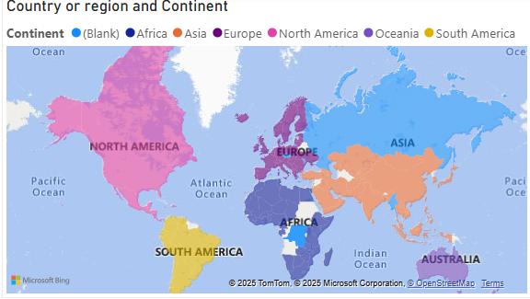

STEPS:

* Go to **Visualizations pane** → Select **Filled Map** (not bubble map).
* Drag **Country/Region** → Location field.
* Drag **Continent** → Legend field.
* If you want to color based on continent only:
* Leave Values field empty.
* Power BI will shade regions by continent.
* Set **Map Style**: Road/light theme for clarity.
* Enable **Category Colors** for consistent continent shading.
* Adjust **Data Colors** so each continent is visually distinct.