**PROJECT REPORT**

**EMPLOYEE MANAGEMENT**

**Submitted by Anusha Jiji (845512)**

**Batch-4**

**ABSTRACT**

Employees are the backbone of any company therefore their management plays a major role in deciding the success of an organization. Managing the employee information by just simply noting them in a diary is a tedious task to do. Employees Management System makes it easy for the employer to keep track of all records. This system uses proper authentication and authorization and then database administrator can perform CRUD operations on Employee dataset. This application allow database administrator to insert new employee, delete existing employee, update employee details and search employee using his/her employee ID. Each employee in the database is associated with a position can be added and edited when need arises. Employees can be transferred between positions easily without having to retype back their information in the database. A flexible and easy to use Employee Management software solution for small and medium sized companies provides modules for personnel information management thereby organization and companies are able to manage the crucial organization asset–people.

The technology stack used here is Spring-Hibernate combination ,more specifically Java Spring 5, Hibernate, MySQL and basic HTML with CSS. All the details are stored in a MySQL database. It is easy to update any employee details. All the employee records are integrated and so this makes it user-friendly and easy to use application.

**INTRODUCTION**

The strength of any organization depends on a large extent on its employees. The maintenance of employee records on a manual basis is a very hectic task especially in very large organizations. We have developed an Employee Management System which avoids all the ambiguities associated with these paper works. In our project, the well-developed application program and database are very important for the reliability, flexibility and functionality of the system.

The system can be accessed only by the concerned authorities in the department which maintains the employee records. The details of these authorities are stored into the database which is matched at the time of login, thereby increasing the security. Therefore only the admin has access rights to change or modify any records. It also provides error messages while providing invalid data. No formal knowledge is needed by the user to use this system. It is an application developed in Java and the database used is My SQL. It contains employee information like employee id, first name, last name, age etc. It is an easy to use application and has a user-friendly interface. The main aim of developing this application was to reduce the errors that occur in the manual system.

One can search the details easily by just entering employee id. In earlier systems, there was not such a facility to do so. All the details are stored in a My SQL database. It is easy to update any employee details. All the employee records are integrated and so this makes it user-friendly and easy to use application.

The goal of this project is to perform CRUD operations on employee data set. The admin/manager have the following authorities:

1. Add new employee
2. View complete employee details
3. Update an existing employee
4. Delete employee
5. Search employee by employee ID

**REQUIREMENT SPECIFICATION**

For building and executing this software, these requirements have to be followed.

**1.Java 1.8+**

JDK is the acronym for Java Development Kit. The Java Development Kit (JDK) is a software development environment which is used to develop java applications and applets. It physically exists. It contains JRE + development tools.JDK is an implementation of any one of the below given Java Platforms released by Oracle corporation: Standard Edition Java Platform, Enterprise Edition Java Platform, Micro Edition Java Platform. The JDK contains a private Java Virtual Machine (JVM) and a few other resources such as an interpreter/loader (Java), a compiler (javac), an archiver (jar), a documentation generator (Javadoc) etc. to complete the development of a Java Application.

**2.Tomcat Server 7.0 or above**

Apache Tomcat (sometimes simply "Tomcat") is an open-source implementation of the Java Servlet, JavaServer Pages, Java Expression Language and WebSocket technologies. Tomcat provides a "pure Java" HTTP web server environment in which Java code can runTomcat is developed and maintained by an open community of developers under the auspices of the Apache Software Foundation, released under the Apache License 2.0 license.

**3.MySQL database 5.0 or above**

MySQL tutorial provides basic and advanced concepts of MySQL. Our MySQL tutorial is designed for beginners and professionals. MySQL is a relational database management system based on the Structured Query Language, which is the popular language for accessing and managing the records in the database.

**4.Eclipse IDE / STS 2018-2019**

**5.Maven 3.0 or above**

**6.Junit 4**

JUnit is a unit testing framework for the Java programming language. JUnit has been important in the development of test-driven development, and is one of a family of unit testing frameworks. Its main use is to write repeatable tests for our application code units.

**ARCHITECTURE DESIGN**

The Web-UI provides presentation of content to the end user through GUI. This can be accessed through any type of client device like desktop, laptop, tablet, mobile, thin client, and so on. For the content to be displayed to the user, the relevant web pages should be fetched by the web browser or other presentation component which is running in the client device. To present the content, it is essential for Web-UI to interact with the other tiers that are present preceding it.

The middle tier is server. This is the tier in which the business logic of the application runs. Business logic is the set of rules that are required for running the application as per the guidelines laid down by the organization. The components of this tier typically run on one or more application servers.

The application data is typically stored in a database server, file server, or any other device or media that supports data access logic and provides the necessary steps to ensure that only the data is exposed without providing any access to the data storage and retrieval mechanisms.

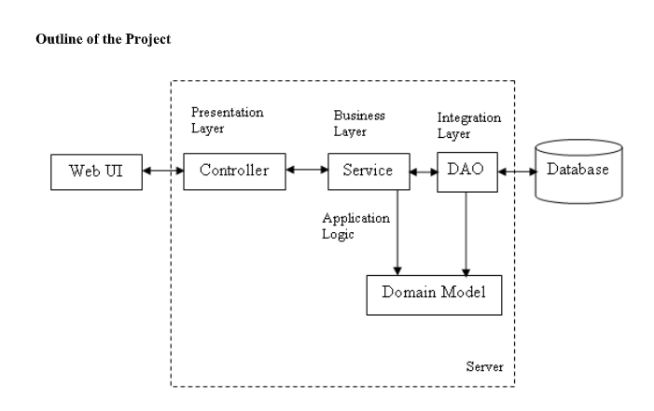

**SCREENSHOTS OF PROJECT**

1. **Employee List**

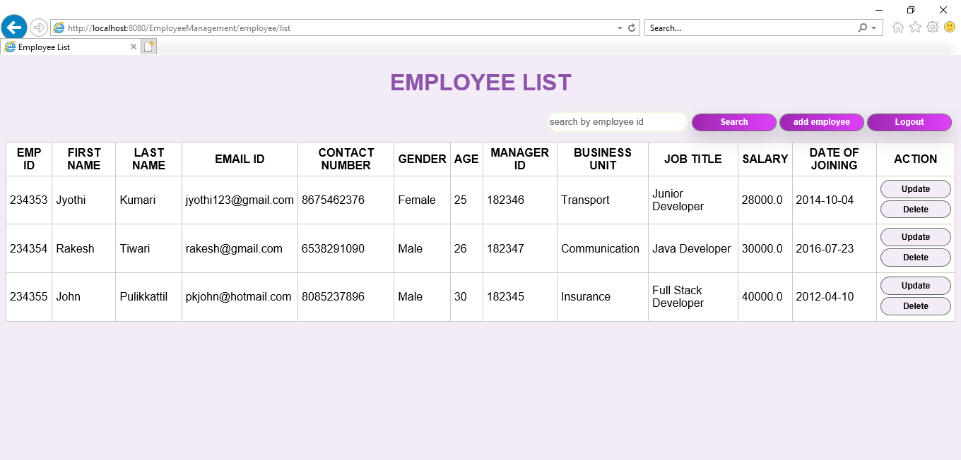

1. **Employee Form**

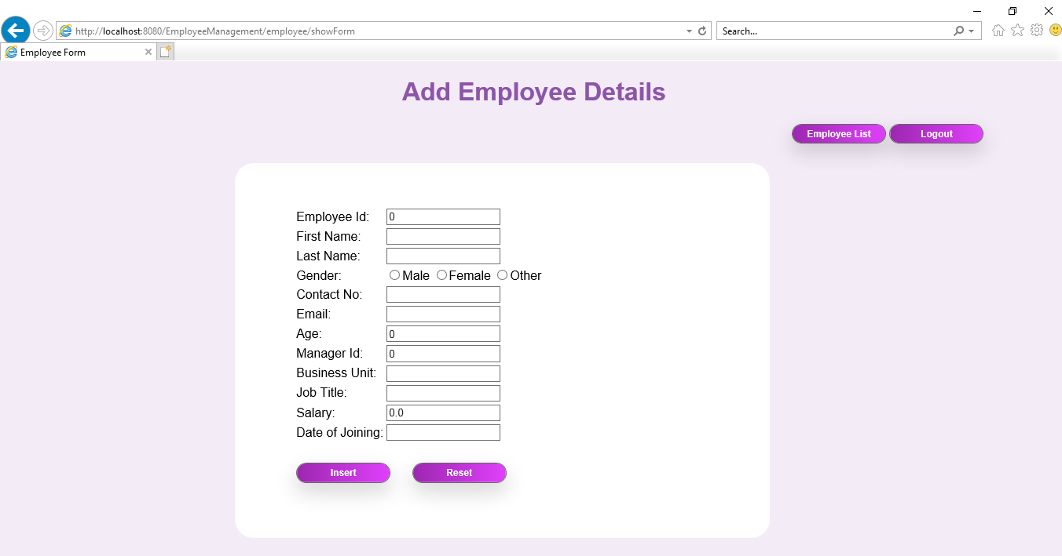

1. **Login**

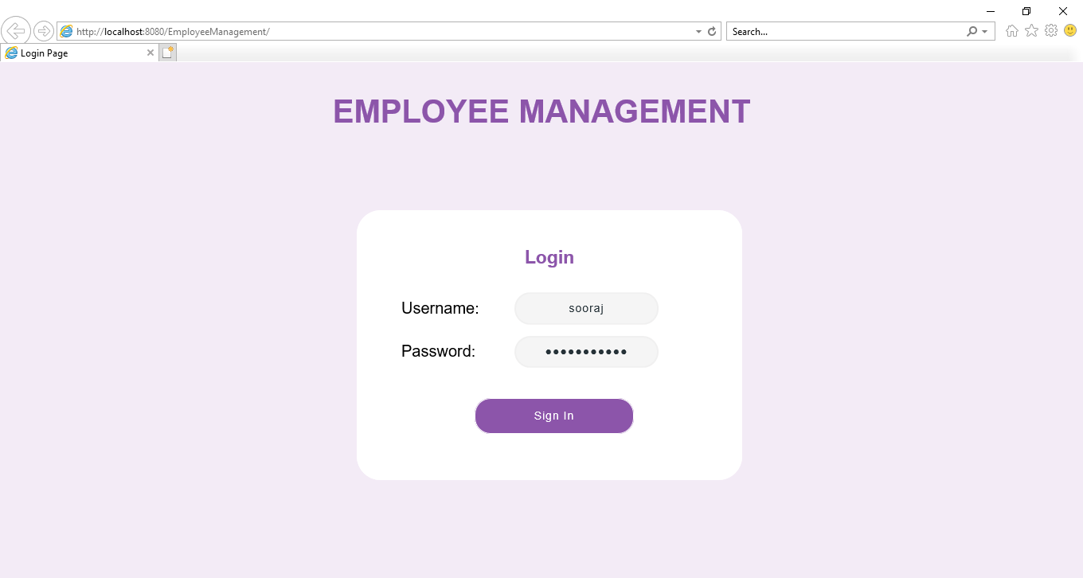

1. **Search Module**

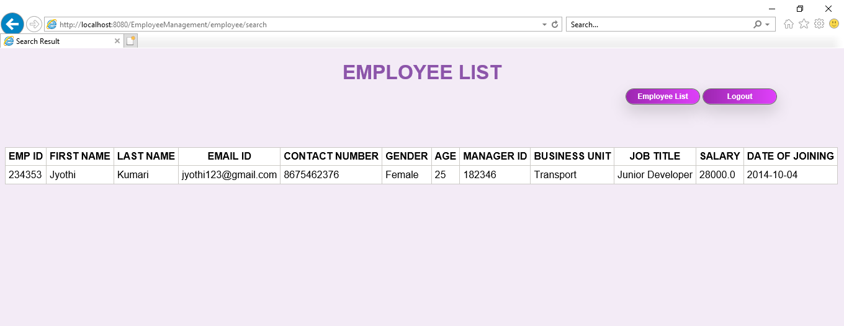

**5 .Logout**

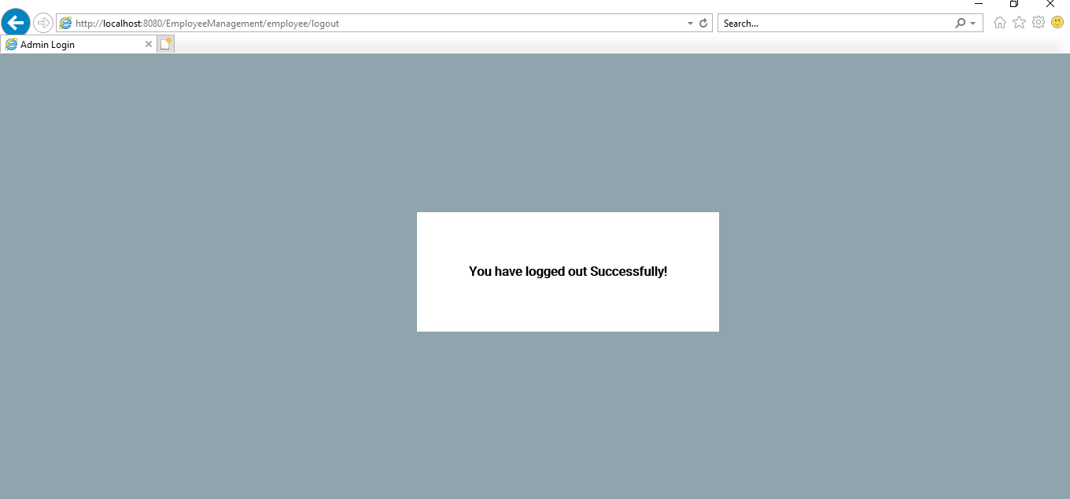

**CONCLUSION AND FUTURE WORK**

In this world of growing technologies everything has been computerized. With large number of work opportunities the Human workforce has increased. Thus there is a need of a system which can handle the data of a large number of employees in an organization. This project simplifies the task of maintain records because its users friendly nature.

The " Employee Management System " has been developed to override the problems prevailing in the practicing manual system. This Web Application is supported to eliminate and in some cases reduce the hardships faced by this existing system. Moreover this system is designed for the particular need of various companies to carry out the operations in a smooth and effective manner. This application is reduced as much as possible to avoid the errors while entering the data. It also provides error messages while entering the invalid data. No formal knowledge is needed for the user to use this system. Thus by this all it proves it is user friendly.

Currently only the administrators can enter the employee details. This may cause difficulties when the amount of data to be entered is large. So in future employees will be given separate user id’s and passwords to enter the data themselves. The data entered by the employees will be verified by the administrator later. Also database will be expanded to contain more employee details, and collected data will stored without any redundancies. The current UI can also be improved to make it more user friendly and attractive.

**REFERENCE**

1.https://docs.spring.io/spring/docs/current/spring-framework-reference/

2.https://docs.spring.io/spring/docs/current/spring-framework-reference/core.html#spring-core

3.https://docs.spring.io/spring/docs/current/spring-framework-reference/web.html

4.https://hibernate.org/orm/documentation/5.0/

5.https://maven.apache.org/guides/getting-started/index.html