

SOEN 6441: Advanced Programming Practice

**Winter 2019**

Build 1

Submitted To: **Amin Ranj Bar**

Submitted By: **Team 18**

|  |  |  |
| --- | --- | --- |
| Sr. No. | Name | Student ID |
| 1 | Nikitha Jayant Bangera | 40088393 |
| 2 | Shresthi Garg | 40105918 |
| 3 | Anusha Keralapura Thandavamurthy | 40102962 |
| 4 | Sumeetha kasulabad | 40078178 |
| 5 | Shiva Shamloo | 40052764 |

**Architecture for Risk Game – Model-View-Contoller**

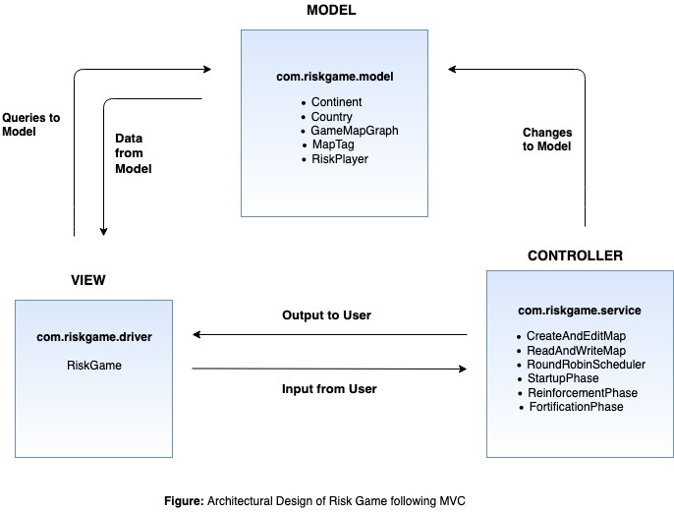

**Following are description for each layer**

1. Model – Has core classes for the game and related logic

2. View – Has classes related to view

3. Controller – Acts as a bridge between model and view .