Name**: Anusha Keralapura Thandavamurthy**

Email**: anushakt21@gmail.com**

Phone**: +1 4389248220**

Location**: Toronto, ON**

GitHub Link : <https://github.com/Anushakt/RTSP_Streaming_Module>

|  |  |  |  |  |
| --- | --- | --- | --- | --- |
| **Task Details** | **Solution Screen Shot** | **Time Taken & Time to repeat the same task again** | **Challenges faced and how it has been overcome** | **Notes and learned outcomes from this task** |
| **Motivation**  Build a RTSP streaming module  **Requirements**   * RTSP streaming module must take the below link and iterate it on the front end into the multiple of n. Link : rtsp://[freja.hiof.no:1935/rtplive/_definst_/hessdalen03.stream](http://freja.hiof.no:1935/rtplive/_definst_/hessdalen03.stream) * Dockerize the project as well as expose it to localhost. | Please Refer the below figures. | Time taken to complete this task was around 16 hours. | **Approach 1**: *Embedding an RTSP player in a web page*   * Import the flashphoner JavaScript API into the HTML page * Created JavaScript file to Initialize API and to Connect to the WCS server via WebSocket. * Created a method in JavaScript file to mount the stream into div element in HTML file. * With this approach I was unable to get Web call server address and the default WCS flashphoner server was not available to test my code. I successfully overcame this problem by following approach 2 mentioned below.   **Approach 2:** *Dynamic Iframe*  I came up with this approach by researching and reading content on the internet. In this approach I took input from the user and passed this value to the JavaScript method and created iframe object dynamically using a for loop and at the end of the loop the generated objects were appended to div tag.  Exposing to localhost:   1. Open a command prompt and enter the following: npm install -g http-server 2. Change to the directory containing the project 3. Start the server with this command: http-server   Dockerize:   1. Open the windows PowerShell and got the project directory 2. Enter below commands  * npm run * docker build . -t rtspstreaming (rtspstreaming is an image name) * docker run rtspstreaming * docker run -p 8080:8080 rtspstreaming  1. Open your browser and go to the address [http://localhost:8080](http://localhost:8080/) | Learned Outcome:   1. I learned how to create the HTML objects dynamically in JavaScript. 2. I learned how to use docker, how to define a container, how to build the image. 3. I also learned how to start a container based on new image. |

**Solution Screenshot:**

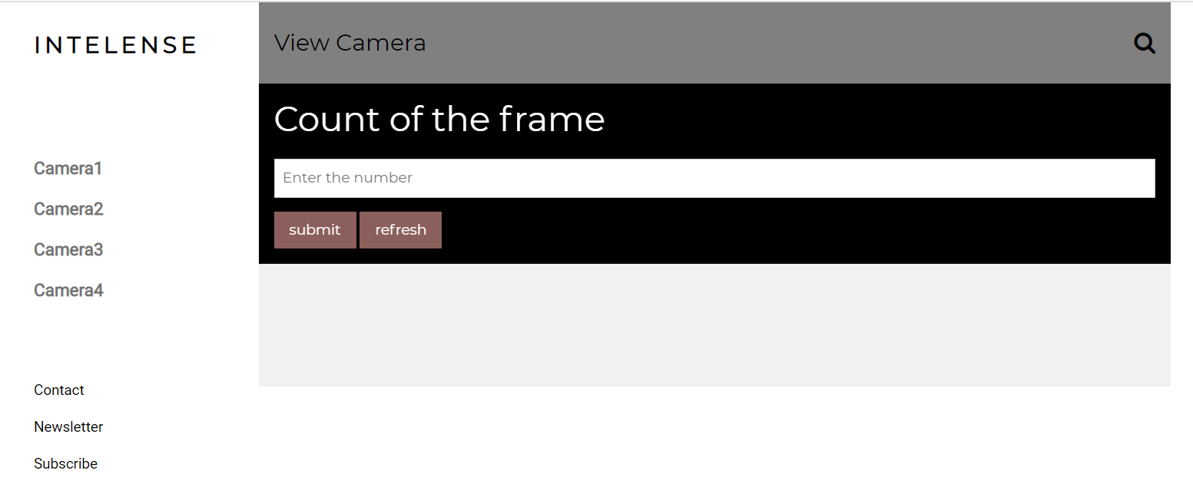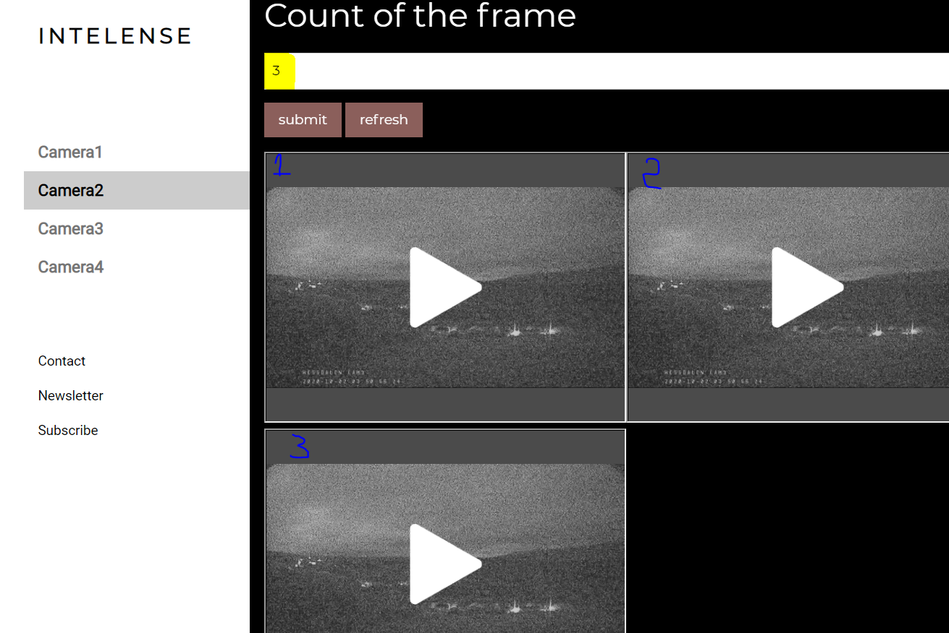

**Areas of Interest for future:**  Web technologies, Frontend and Backend development and Software development.

**What would you like to learn next in technology?**

I am a quick learner, having an inquisitiveness for trending technologies majorly across web and software development principles. I enjoy materializing concepts into reality. Learning is a continuous process and I am enthusiastically grasping new programming languages, frameworks, and principles.