**Project: ICare – Team D**

***Minutes of Meeting Log***

**Meeting - 1**

**Subject**: **Minutes of Kickoff Meeting 13/05/20**

**Venue**: **Teleconference**

**Minutes taken by: Anusha KT**

**Attendee**:

Anusha K T

Niralkumar

Moshood

Xiaofeng

Ahmad

|  |
| --- |
|  |

**Agenda**:

Team members introduction and understanding the project description.

**MOM**:

1. All team members introduced themselves.
2. Discussed about technical background of each team member.
3. Read and understood the project description.
4. Created shared google document.

**Meeting – 2**

**Subject**: **Minutes of Progress Meeting 15/05/20**

**Venue**: **Teleconference**

**Minutes taken by: Anusha K T**

**Attendee**:

Anusha K T

Niralkumar

Moshood

Xiaofeng

Ahmad

**Agenda**:

Decisions on technology to be used and other tools

Requirement elicitation.

**MOM**:

1. Discussed on which technology to be used for our project.
2. Discussed on specific UML version and UML modelling tool.
3. Discussed about the requirements of our project.
4. Created overleaf shared document and GitHub repository.
5. Everyone was asked to do research and come up we the design od our application.

**Meeting – 3**

**Subject**: **Minutes of Progress Meeting 18/05/20**

**Venue**: **Teleconference**

**Minutes taken by: Anusha K T**

**Attendee**:

Anusha K T

Niralkumar

Moshood

Xiaofeng

Ahmad

**Agenda**:

Project progress and any issues\concerns related to tasks

Discussion on design part.

**MOM:**

1. Discussed and finalised the design outline of our application.
2. Discussed on each deliverable.
3. Assigned task to every team member.

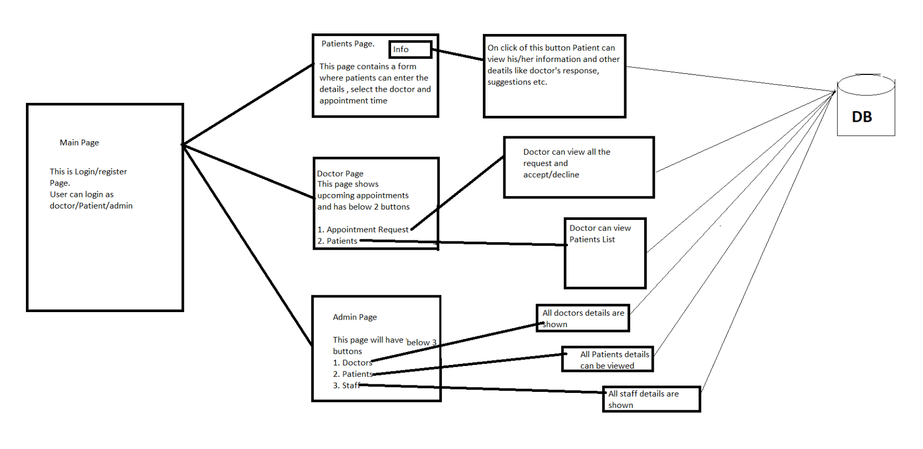

**Meeting – 4**

**Subject**: **Minutes of Progress Meeting 21/05/20**

**Venue**: **Teleconference**

**Minutes taken by: Anusha K T**

**Attendee**:

Anusha K T

Niralkumar

Moshood

Xiaofeng

Ahmad

**Agenda**:

Project progress and any issues\concerns related to tasks

Discussion on assigned task and changes.

**MOM:**

1. Discussed about the progress of each task
2. Looked for IEEE standards.
3. Discussed on modifications.
4. Asked everyone to update their task in shared document.

**Meeting – 5**

**Subject**: **Minutes of Progress Meeting 24/05/20**

**Venue**: **Teleconference**

**Minutes taken by: Anusha K T**

**Attendee**:

Anusha K T

Niralhlad

Moshood

Xiaofeng

Ahmad

**Agenda**:

**MOM:**