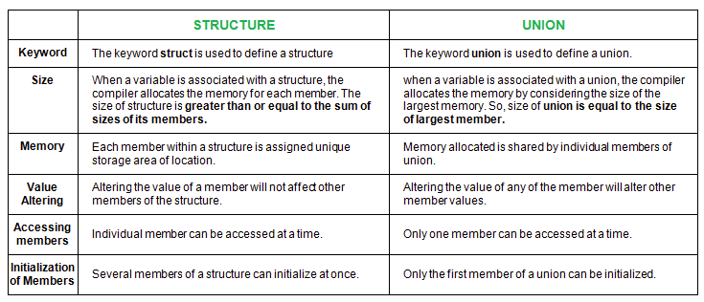

Difference between Array and Linked List

 | Array | Linked List
Define | Array is a collection of elements having same data type with common name. | Linked list is an ordered collection of elements which are connected by links/pointers.
Access | In array, elements can be accessed using index/subscript value, i.e. elements can be randomly accessed like arr[0], arr[3], etc. So array provides fast and random access. | In linked list, elements can’t be accessed randomly but can be accessed only sequentially and accessing element takes 0(n) time.
Memory Structure | In array, elements are stored in consecutive manner in memory. | In linked list, elements can be stored at any available place as address of node is stored in previous node.
Insertion & Deletion | Insertion & deletion takes more time in array as elements are stored in consecutive memory locations. | Insertion & deletion are fast & easy in linked list as only value of pointer is needed to change.
Memory Allocation | In array, memory is allocated at compile time i.e. Static Memory Allocation. | In linked list, memory is allocated at run time i.e. Dynamic Memory Allocation.
Types | Array can be single dimensional, two dimension or multidimensional. | Linked list can be singly, doubly or circular linked list.
Dependency | In array, each element is independent, no connection with previous element or with its location. | In Linked list, location or address of elements is stored in the link part of previous element/node.
Extra Space | In array, no pointers are used like linked list so no need of extra space in memory for pointer. | In linked list, adjacency between the elements are maintained using pointers or links, so pointers are used and for that extra memory space is needed.

malloc | calloc
The name malloc stands for memory allocation. | The name calloc stands for contiguous allocation.
void *malloc(size_t n) returns a pointer to n bytes of uninitialized storage, or NULL if the request cannot be satisfied. If the space assigned by malloc() is overrun, the results are undefined. | void *calloc(size_t n, size_t size) returns a pointer to enough free space for an array of n objects of the specified size, or NULL if the request cannot be satisfied. The storage is initialized to zero.
malloc() takes one argument that is, number of bytes. | calloc() take two arguments those are: number of blocks and size of each block.
syntax of malloc():  void *malloc(size_t n);  Allocates n bytes of memory. If the allocation succeeds, a void pointer to the allocated memory is returned. Otherwise NULL is returned. | syntax of calloc():  void *calloc(size_t n, size_t size);  Allocates a contiguous block of memory large enough to hold n elements of size bytes each. The allocated region is initialized to zero.
malloc is faster than calloc. | calloc takes little longer than malloc because of the extra step of initializing the allocated memory by zero. However, in practice the difference in speed is very tiny and not recognizable.

Callback:
A callback is any executable code that is passed as an argument to other code, which is expected to call back (execute) the argument at a given time [Source : Wiki]. In simple language, If a reference of a function is passed to another function as an argument to call it, then it it will be called as a Callback function.
In C, a callback function is a function that is called through a function pointer.
Below is a simple example in C to illustrate the above definition to make it more clear:
filter_none
edit
play_arrow
brightness_4
// A simple C program to demonstrate callback
#include<stdio.h>

void A()
{
printf("I am function A\n");
}

// callback function
void B(void (*ptr)())
{
(*ptr) (); // callback to A
}

int main()
{
void (*ptr)() = &A;

// calling function B and passing
// address of the function A as argument
B(ptr);

return 0;
}
I am function A

A cross compiler is a compiler capable of creating executable code for a platform other than the one on which the compiler is running.

Reduced Set Instruction Set Architecture (RISC) –
The main idea behind is to make hardware simpler by using an instruction set composed of a few basic steps for loading, evaluating and storing operations just like an addition command will be composed of loading data, evaluating and storing.
Complex Instruction Set Architecture (CISC) –
The main idea is to make hardware complex as a single instruction will do all loading, evaluating and storing operations just like a multiplication command will do stuff like loading data, evaluating and storing it.
Characteristic of RISC –
- Simpler instruction, hence simple instruction decoding.
- Instruction come under size of one word.
- Instruction take single clock cycle to get executed.
- More number of general purpose register.
- Simple Addressing Modes.
- Less Data types.
- Pipeling can be achieved.
Characteristic of CISC –
- Complex instruction, hence complex instruction decoding.
- Instruction are larger than one word size.
- Instruction may take more than single clock cycle to get executed.
- Less number of general purpose register as operation get performed in memory itself.
- Complex Addressing Modes.
- More Data types.

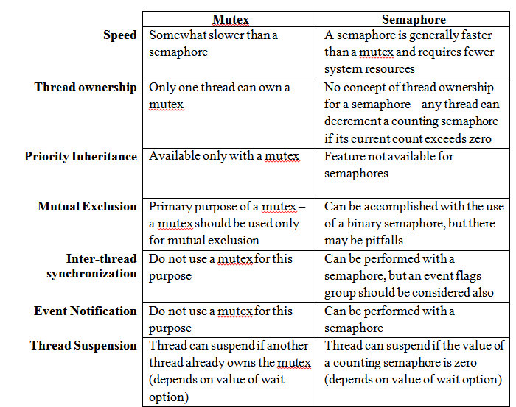

the volatile modifier indicates to the compiler that variables might change their value in main memory. This indicates to the compiler that this variable must be re-loaded from the main memory at any usage.
Volatile variables occur in multi-threaded programs, where they indicate that another thread might have changed the value of a variable in main memory. For example, the following spin loop does not work correctly without making flag volatile:
while(!flag) {}
A compiler might assign the non-volatile flag to a register, not re-loading it in every iteration of the spin loop.
Without multithreadin, volatile variables are still useful. For example, a volatile variable might be assigned to a memory location that might be changed by a hardware device or RDMA. In this case, the modification also occurs outside of the current instruction stream and might not be recognized if the compiler moves the variable into a register.
Difference between Stack and Queue Data Structures
STACKS | QUEUES
Stacks are based on the LIFO principle, i.e., the element inserted at the last, is the first element to come out of the list. | Queues are based on the FIFO principle, i.e., the element inserted at the first, is the first element to come out of the list.
Insertion and deletion in stacks takes place only from one end of the list called the top. | Insertion and deletion in queues takes place from the opposite ends of the list. The insertion takes place at the rear of the list and the deletion takes place from the front of the list.
Insert operation is called push operation. | Insert operation is called enqueue operation.
Delete operation is called pop operation. | Delete operation is called dequeue operation.
In stacks we maintain only one pointer to access the list, called the top, which always points to the last element present in the list. | In queues we maintain two pointers to access the list. The front pointer always points to the first element inserted in the list and is still present, and the rear pointer always points to the last inserted element.

Static Libraries : A Static library or statically-linked library is a set of routines, external functions and variables which are resolved in a caller at compile-time and copied into a target application by a compiler, linker, or binder, producing an object file and a stand-alone executable. This executable and the process of compiling it are both known as a static build of the program. Historically, libraries could only be static.
They are usually faster than the shared libraries because a set of commonly used object files is put into a single library executable file. One can build multiple executables without the need to recompile the file. Because it is a single file to be built, use of link commands are simpler than shared library link commands, because you specify the name of the static library.
Shared Libraries :
Shared libraries are .so (or in Windows .dll, or in OS X .dylib) files.
These are linked dynamically simply including the address of the library (whereas static linking is a waste of space). Dynamic linking links the libraries at the run-time. Thus, all the functions are in a special place in memory space, and every program can access them, without having multiple copies of them.
PROPERTIES | STATIC LIBRARY | SHARED LIBRARY
Linking time | It happens as the last step of the compilation process. After the program is placed in the memory | Shared libraries are added during linking process when executable file and libraries are added to the memory.
Means | Performed by linkers | Performed by operating System
Size | Static libraries are much bigger in size, because external programs are built in the executable file. | Dynamic libraries are much smaller, because there is only one copy of dynamic library that is kept in memory.
External file changes | Executable file will have to be recompiled if any changes were applied to external files. | In shared libraries, no need to recompile the executable.
Time | Takes longer to execute, because loading into the memory happens every time while executing. | It is faster because shared library code is already in the memory.
Compatibility | Never has compatibility issue, since all code is in one executable module. | Programs are dependent on having a compatible library. Dependent program will not work if library gets removed from the system .

