Differences between Deadlock and Starvation in OS :
- Deadlock occurs when none of the processes in the set is able to move ahead due to occupancy of the required resources by some other process as shown in the figure below, on the other hand Starvation occurs when a process waits for an indefinite period of time to get the resource it requires.
- Other name of deadlock is Circular Waiting. Other name of starvation is Lived lock.
- When deadlock occurs no process can make progress, while in starvation apart from the victim process other processes can progress or proceed.
Solution to Starvation : Aging
Aging is a technique of gradually increasing the priority of processes that wait in the system for a long time.For example, if priority range from 127(low) to 0(high), we could increase the priority of a waiting process by 1 Every 15 minutes. Eventually even a process with an initial priority of 127 would take no more than 32 hours for priority 127 process to age to a priority-0 process.
Priority inversion:
Let us first put ‘priority inversion’ in the context of the Big Picture i.e. where does this come from.
In Operating System, one of the important concepts is Task Scheduling. There are several Scheduling methods such as First Come First Serve, Round Robin, Priority based scheduling etc. Each scheduling method has its pros and cons. As you might have guessed, Priority Inversion comes under Priority based Scheduling. Basically, it’s a problem which arises sometimes when Priority based scheduling is used by OS. In Priority based scheduling, different tasks are given different priority so that higher priority tasks can intervene lower priority tasks if possible.
So, in a priority based scheduling, if lower priority task (L) is running and if a higher priority task (H) also needs to run, the lower priority task (L) would be preempted by higher priority task (H). Now, suppose both lower and higher priority tasks need to share a common resource (say access to the same file or device) to achieve their respective work. In this case, since there’s resource sharing and task synchronization is needed, several methods/techniques can be used for handling such scenarios. For for sake of our topic on Priority Inversion, let us mention a synchronization method say mutex. Just to recap on mutex, a task acquires mutex before entering critical section (CS) and releases mutex after exiting critical section (CS). While running in CS, a task access this common resource. More details on this can be referred here. Now, say both L and H shares a common Critical Section (CS) i.e. same mutex is needed for this CS.
Coming to our discussion of priority inversion, let us examine some scenarios.
1) L is running but not in CS ; H needs to run; H preempts L ; H starts running ; H relinquishes or releases control ; L resumes and starts running
2) L is running in CS ; H needs to run but not in CS; H preempts L ; H starts running ; H relinquishes control ; L resumes and starts running.
3) L is running in CS ; H also needs to run in CS ; H waits for L to come out of CS ; L comes out of CS ; H enters CS and starts running
Please note that the above scenarios don’t show the problem of any Priority Inversion (not even scenario 3). Basically, so long as lower priority task isn’t running in shared CS, higher priority task can preempt it. But if L is running in shared CS and H also needs to run in CS, H waits until L comes out of CS. The idea is that CS should be small enough so that it doesn’t result in H waiting for long time while L was in CS. That’s why writing CS code requires careful consideration. In any of the above scenarios, priority inversion (i.e. reversal of priority) didn’t occur because the tasks are running as per the design.

Now let us add another task of middle priority say M. Now the task priorities are in the order of L < M < H. In our example, M doesn’t share the same Critical Section (CS). In this case, the following sequence of task running would result in ‘Priority Inversion’ problem.
4) L is running in CS ; H also needs to run in CS ; H waits for L to come out of CS ; M interrupts L and starts running ; M runs till completion and relinquishes control ; L resumes and starts running till the end of CS ; H enters CS and starts running.
Note that neither L nor H share CS with M.
Here, we can see that running of M has delayed the running of both L and H. Precisely speaking, H is of higher priority and doesn’t share CS with M; but H had to wait for M. This is where Priority based scheduling didn’t work as expected because priorities of M and H got inverted in spite of not sharing any CS. This problem is called Priority Inversion. This is what the heck was Priority Inversion ! In a system with priority based scheduling, higher priority tasks can face this problem and it can result in unexpected behavior/result. In general purpose OS, it can result in slower performance. In RTOS, it can result in more severe outcomes. The most famous ‘Priority Inversion’ problem was what happened at Mars Pathfinder.
Priority Inheritance:
Priority Inversion is a problem while Priority Inheritance is a solution.
One of the solution for this problem is Priority Inheritance. In Priority Inheritance, when L is in critical section, L inherits priority of H at the time when H starts pending for critical section. By doing so, M doesn’t interrupt L and H doesn’t wait for M to finish. Please note that inheriting of priority is done temporarily i.e. L goes back to its old priority when L comes out of critical section.
Watchdog Timer (WDT):
A Watchdog Timer (WDT) is a hardware circuit that can reset the computer system in case of a software fault.

Mapping from page table to main memory
In operating systems, there is always a requirement of mapping from logical address to the physical address. However, this process involves various steps which are defined as follows.

1. Generation of logical address
CPU generates logical address for each page of the process. This contains two parts: page number and offset.

2. Scaling
To determine the actual page number of the process, CPU stores the page table base in a special register. Each time the address is generated, the value of the page table base is added to the page number to get the actual location of the page entry in the table. This process is called scaling.

3. Generation of physical Address
The frame number of the desired page is determined by its entry in the page table. A physical address is generated which also contains two parts : frame number and offset. The Offset will be similar to the offset of the logical address therefore it will be copied from the logical address.

4. Getting Actual Frame Number
The frame number and the offset from the physical address is mapped to the main memory in order to get the actual word address.
Link:https://www.javatpoint.com/os-mapping-from-page-table-to-main-memory

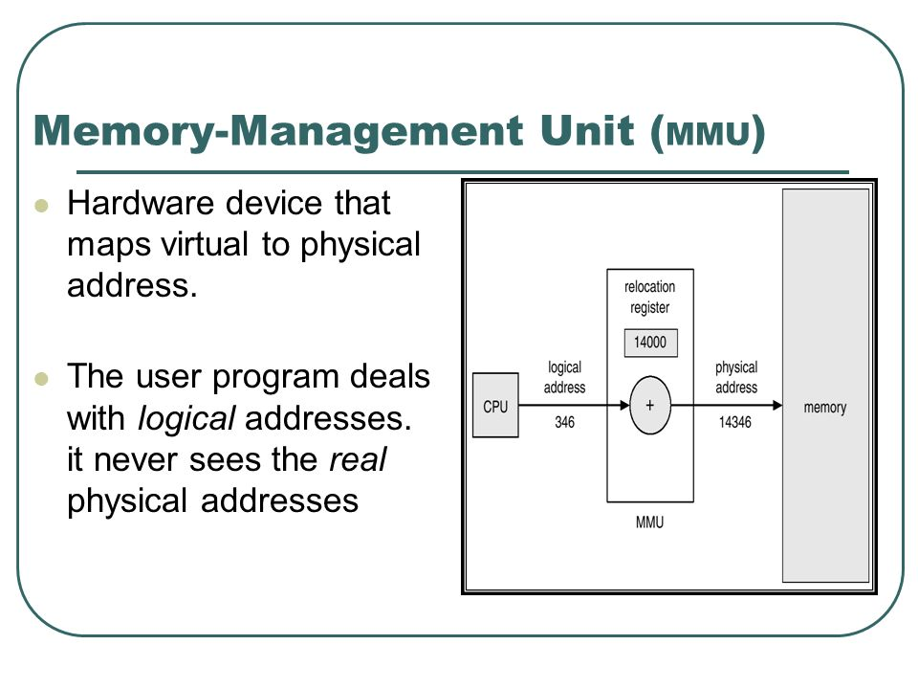
Deadlock:

Deadlock can arise if following four conditions hold simultaneously (Necessary Conditions)
Mutual Exclusion: One or more than one resource are non-sharable (Only one process can use at a time)
Hold and Wait: A process is holding at least one resource and waiting for resources.
No Preemption: A resource cannot be taken from a process unless the process releases the resource.
Circular Wait: A set of processes are waiting for each other in circular form.
Methods for handling deadlock
There are three ways to handle deadlock
1) Deadlock prevention or avoidance: The idea is to not let the system into deadlock state.
2) Deadlock detection and recovery: Let deadlock occur, then do preemption to handle it once occurred.
3) Ignore the problem all together: If deadlock is very rare, then let it happen and reboot the system. This is the approach that both Windows and UNIX take.

***********Deadlock Prevention And Avoidance:
Deadlock prevention:

Eliminate Mutual Exclusion
It is not possible to dis-satisfy the mutual exclusion because some resources, such as the tap drive and printer, are inherently non-shareable.

Eliminate Hold and wait
1. Allocate all required resources to the process before start of its execution, this way hold and wait condition is eliminated but it will lead to low device utilization. for example, if a process requires printer at a later time and we have allocated printer before the start of its execution printer will remained blocked till it has completed its execution.
2. Process will make new request for resources after releasing the current set of resources. This solution may lead to starvation.
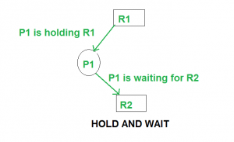
Eliminate No Preemption
Preempt resources from process when resources required by other high priority process.

Eliminate Circular Wait
Each resource will be assigned with a numerical number. A process can request for the resources only in increasing order of numbering.
For Example, if P1 process is allocated R5 resources, now next time if P1 ask for R4, R3 lesser than R5 such request will not be granted, only request for resources more than R5 will be granted.
Deadlock Avoidance
Deadlock avoidance can be done with Banker’s Algorithm.
Banker’s Algorithm
Bankers’s Algorithm is resource allocation and deadlock avoidance algorithm which test all the request made by processes for resources, it check for safe state, if after granting request system remains in the safe state it allows the request and if their is no safe state it don’t allow the request made by the process.
Inputs to Banker’s Algorithm
1. Max need of resources by each process.
2. Currently allocated resources by each process.
3. Max free available resources in the system.
Request will only be granted under below condition.
1. If request made by process is less than equal to max need to that process.
2. If request made by process is less than equal to freely availbale resource in the system.
Example
Total resources in system:
A B C D
6 5 7 6
Available system resources are:
A B C D
3 1 1 2
Processes (currently allocated resources):
A B C D
P1 1 2 2 1
P2 1 0 3 3
P3 1 2 1 0
Processes (maximum resources):
A B C D
P1 3 3 2 2
P2 1 2 3 4
P3 1 3 5 0
Need = maximum resources - currently allocated resources.
Processes (need resources):
A B C D
P1 2 1 0 1
P2 0 2 0 1
P3 0 1 4 0
******************Deadlock Detection:
1. If resources have single instance:
In this case for Deadlock detection we can run an algorithm to check for cycle in the Resource Allocation Graph. Presence of cycle in the graph is the sufficient condition for deadlock.
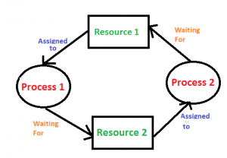
In the above diagram, resource 1 and resource 2 have single instances. There is a cycle R1–>P1–>R2–>P2. So Deadlock is Confirmed.
2. If there are multiple instances of resources:
Detection of cycle is necessary but not sufficient condition for deadlock detection, in this case system may or may not be in deadlock varies according to different situations.
Deadlock Recovery
Traditional operating system such as Windows doesn’t deal with deadlock recovery as it is time and space consuming process. Real time operating systems use Deadlock recovery.
Recovery method
1. Killing the process.
killing all the process involved in deadlock.

Killing process one by one. After killing each
process check for deadlock again keep repeating
process till system recover from deadlock.
2. Resource Preemption
Resources are preempted from the processes involved in deadlock, preempted resources are allocated to other processes, so that their is a possibility of recovering the system from deadlock. In this case system go into starvation.

