When an open system call is called it returns a file descriptor,which is an index to the file descriptor table,there base address of global file table is prasented.
Interaction between these tables with an example:
Example:
Process A:
fd1 = open("/var/file1", O_RDONLY);
fd2 = open("/var/file2", O_RDWR);
fd3 = open("/var/file1", O_WRONLY);

Process B:
fd1 = open("/var/file1", O_RDONLY);
fd2 = open("/var/file3", O_RDONLY);
The following figure represents the interaction between the three tables described above :
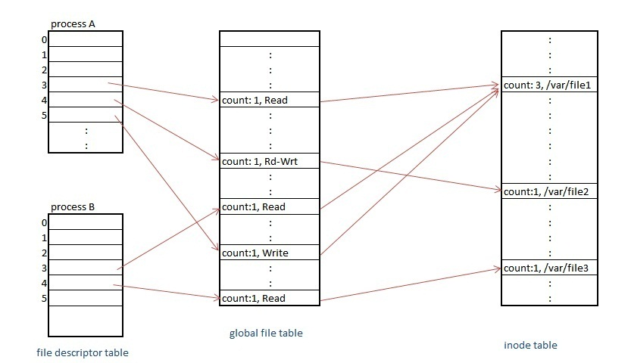
Each open() returns a file descriptor to the process, and the corresponding entry in the user file descriptor table points to a unique entry in the global file table even though a file(/var/file1) is opened more then once. These global file table entries map to the in-core inode table entry. Every opened file has a unique entry in the global file table and the user file descriptor table but kernel keeps only single entry per file in the in-core inode table.
Difference b/w dup(),open();
dup() system call doesnt create a separate entry in the global file table like the open() system call, instead it just increments the count field of the entry pointed to by the given input file descriptor in the global file table. Consider an example where fd 0, 1 and 2 are by default engaged to the standard input/output and error. Then if the user opens a file "/var/file1" (fd - 3), then he opens file "/var/file2" (fd - 4) and again he opened "/var/file1" (fd - 5). And now, if he does a dup(3), kernel would follow the pointer from the user file descriptive table for the fd entry '3', and increments the count value in the global file table. Then, it searches for the next avaialable free entry in file descriptor table and returns that value to the user (6 in this case).
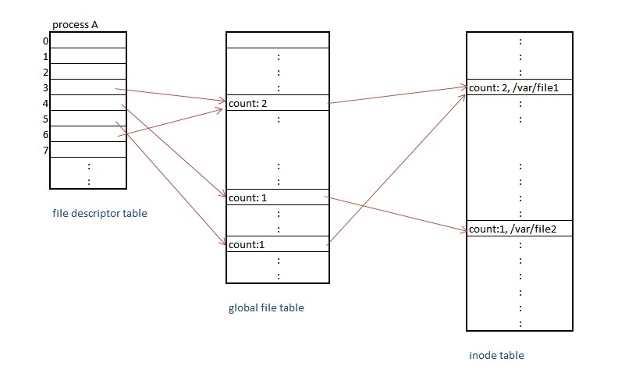
* Difference between open and dup system call
#include "fcntl.h"
int main()
{
int i,j;
char buf1[512],buf2[512];

i = open("/var/file1", O_RDONLY);
j = dup(i);

read(i, buf1, sizeof(buf1));
read(j, buf2, sizeof(buf2));
close(i);
read(j, buf2, sizeof(buf2));
return 0;
}
In the above program after doing the dup(i), both i and j point to the same entry in the global file table and thus share the same byte offset in the file. Thus the next two read operation will read different data and buf1 and buf2 will have different data. This is where the difference comes into picture when compared to the open() system call. If instead of dup(), we use open() call to open the same file again, it will create a separate entry in the global file table and thus separate byte offsets for the files opened. The effect is same content in bufferes buf1 and buf2. The user can close either of the file descriptors and continue using the other without any issue.

Module programming:
The system call init_module checks if the invoking process is authorized to load a module into the kernel.

#include <linux/init.h>
#include <linux/module.h>
MODULE_LICENSE("Dual BSD/GPL");
static int hello_init(void)
{
printk(KERN_ALERT "Hello, world\n");
return 0;
}
static void hello_exit(void)
{
printk(KERN_ALERT "Goodbye, cruel world\n");
}
module_init(hello_init);
module_exit(hello_exit);
This module defines two functions, one to be invoked when the module is loaded into the kernel (hello_init) and one for when the module is removed (hello_exit). The module_init and module_exit lines use special kernel macros to indicate the role of these two functions. Another special macro (MODULE_LICENSE) is used to tell the kernel that this module bears a free license; without such a declaration, the kernel complains when the module is loaded.The string KERN_ALERT is the priority of the message.
The printk function is defined in the Linux kernel and made available to modules; it behaves similarly to the standard C library function printf. The kernel needs its own printing function because it runs by itself, without the help of the C library. The module can call printk because, after insmod has loaded it, the module is linked to the kernel and can access the kernel’s public symbols (functions and variables, as detailed in the next section).
the following statement prints the process ID and the command name of the current
process by accessing certain fields in struct task_struct :
printk(KERN_INFO "The process is \"%s\" (pid %i)\n", current->comm, current->pid);
The command name stored in current->comm is the base name of the program file
(trimmed to 15 characters if need be) that is being executed by the current process.
Kernel code cannot do floating point arithmetic.
Makefile for module programming:
make -C ~/kernel-2.6 M=`pwd` modules
This command starts by changing its directory to the one provided with the -C option (that is, your kernel source directory). There it finds the kernel’s top-level makefile. The M= option causes that makefile to move back into your module source directory before trying to build the modules target. This target, in turn, refers to the list of modules found in the obj-m variable,
Loading and Unloading Modules:
insmod file.ko
modprobe file.ko
lsmod
modinfo file.ko
rmmod file
lsmod works by reading the /proc/modules virtual file. Informa-
tion on currently loaded modules can also be found in the sysfs virtual filesystem
under /sys/module.
Path to check list of modules:
lsmod
cat /proc/devices:maj num and dev name
/dev ls-l: contain maj and min num,device name
Special files for char drivers are identified by a “c” in the first column of the output of ls –l. Block devices appear in /dev as well, but they are identified by a “b.”

Major and Minor Numbers:
Major number identifies the driver associated with the device.The minor number is used by the kernel to determine exactly which device is being referred to.

The Internal Representation of Device Numbers:
Within the kernel, the dev_t type (defined in <linux/types.h>) is used to hold device numbers—both the major and minor parts. As of Version 2.6.0 of the kernel, dev_t is a 32-bit quantity with 12 bits set aside for the major number and 20 for the minor number. Your code should, of course, never make any assumptions about the inter- nal organization of device numbers; it should, instead, make use of a set of macros found in <linux/kdev_t.h>. To obtain the major or minor parts of a dev_t , use:
MAJOR(dev_t dev);
MINOR(dev_t dev);
If, instead, you have the major and minor numbers and need to turn them into a dev_t , use:
MKDEV(int major, int minor);

Allocating and Freeing Device Numbers:
The necessary function for this task is register_chrdev_region, which is declared in <linux/fs.h>:
int register_chrdev_region(dev_t first, unsigned int count, char *name);
Here, first is the beginning device number of the range you would like to allocate. The minor number portion of first is often 0 , but there is no requirement to that effect. count is the total number of contiguous device numbers you are requesting. Note that, if count is large, the range you request could spill over to the next major number; but everything will still work properly as long as the number range you request is available. Finally, name is the name of the device that should be associated with this number range; it will appear in /proc/devices and sysfs.
The kernel will happily allocate a major number for you on the fly, but you must request this
allocation by using a different function:
int alloc_chrdev_region(dev_t *dev, unsigned int firstminor, unsigned int count, char *name);
With this function, dev is an output-only parameter that will, on successful comple- tion, hold the first number in your allocated range. firstminor should be the requested first minor number to use; it is usually 0 . The count and name parameters work like those given to request_chrdev_region.
Regardless of how you allocate your device numbers, you should free them when
they are no longer in use. Device numbers are freed with:
void unregister_chrdev_region(dev_t first, unsigned int count);
The disadvantage of dynamic assignment is that you can’t create the device nodes in advance, because the major number assigned to your module will vary. For normal use of the driver, this is hardly a problem, because once the number has been
assigned, you can read it from /proc/devices. *

Most of the fundamental driver operations involve three important kernel data structures, called file_operations , file , and inode .
File operations:
The structure, defined in <linux/fs.h>, is a collection of function pointers.Conventionally, a file_operations structure or a pointer to one is called fops (or some variation thereof). Each field in the structure must point to the function in the driver that implements a specific operation, or be left NULL for unsupported operations.

struct file_operations {
struct module *owner;
loff_t (*llseek) (struct file *, loff_t, int);
ssize_t (*read) (struct file *, char __user *, size_t, loff_t *);
ssize_t (*write) (struct file *, const char __user *, size_t, loff_t *);
ssize_t (*aio_read) (struct kiocb *, const struct iovec *, unsigned long, loff_t);
ssize_t (*aio_write) (struct kiocb *, const struct iovec *, unsigned long, loff_t);
int (*iterate) (struct file *, struct dir_context *);
unsigned int (*poll) (struct file *, struct poll_table_struct *);
long (*unlocked_ioctl) (struct file *, unsigned int, unsigned long);
long (*compat_ioctl) (struct file *, unsigned int, unsigned long);
int (*mmap) (struct file *, struct vm_area_struct *);
int (*open) (struct inode *, struct file *);
int (*flush) (struct file *, fl_owner_t id);
int (*release) (struct inode *, struct file *);
int (*fsync) (struct file *, loff_t, loff_t, int datasync);
int (*aio_fsync) (struct kiocb *, int datasync);
int (*fasync) (int, struct file *, int);
int (*lock) (struct file *, int, struct file_lock *);
ssize_t (*sendpage) (struct file *, struct page *, int, size_t, loff_t *, int);
unsigned long (*get_unmapped_area)(struct file *, unsigned long, unsigned long, unsigned long, unsigned long);
int (*check_flags)(int);
int (*flock) (struct file *, int, struct file_lock *);
ssize_t (*splice_write)(struct pipe_inode_info *, struct file *, loff_t *, size_t, unsigned int);
ssize_t (*splice_read)(struct file *, loff_t *, struct pipe_inode_info *, size_t, unsigned int);
int (*setlease)(struct file *, long, struct file_lock **);
long (*fallocate)(struct file *file, int mode, loff_t offset,
loff_t len);
int (*show_fdinfo)(struct seq_file *m, struct file *f);
};
struct module *owner :
The first file_operations field is not an operation at all; it is a pointer to the
module that “owns” the structure. This field is used to prevent the module from
being unloaded while its operations are in use. Almost all the time, it is simply
initialized to THIS_MODULE , a macro defined in <linux/module.h>.
The file Structure:
Struct file , defined in <linux/fs.h>, is the second most important data structure used in device drivers. Note that a file has nothing to do with the FILE pointers of user-space programs. A FILE is defined in the C library and never appears in kernel code. A struct file , on the other hand, is a kernel structure that never appears in user programs.
The file structure represents an open file. (It is not specific to device drivers; every open file in the system has an associated struct file in kernel space.) It is created by the kernel on open and is passed to any function that operates on the file, until the last close. After all instances of the file are closed, the kernel releases the data structure.

struct file {
union {
struct llist_node fu_llist;
struct rcu_head fu_rcuhead;
} f_u;
struct path f_path;
#define f_dentry f_path.dentry
struct inode *f_inode; /* cached value */
const struct file_operations *f_op;

/*
* Protects f_ep_links, f_flags, f_pos vs i_size in lseek SEEK_CUR.
* Must not be taken from IRQ context.
*/
spinlock_t f_lock;
atomic_long_t f_count;
unsigned int f_flags;
fmode_t f_mode;
loff_t f_pos;
struct fown_struct f_owner;
const struct cred *f_cred;
struct file_ra_state f_ra;

u64 f_version;
#ifdef CONFIG_SECURITY
void *f_security;
#endif
/* needed for tty driver, and maybe others */
void *private_data;

#ifdef CONFIG_EPOLL
/* Used by fs/eventpoll.c to link all the hooks to this file */
struct list_head f_ep_links;
struct list_head f_tfile_llink;
#endif /* #ifdef CONFIG_EPOLL */
struct address_space *f_mapping;
#ifdef CONFIG_DEBUG_WRITECOUNT
unsigned long f_mnt_write_state;
#endif
};

Inode Structure:
The inode structure is used by the kernel internally to represent files.There can be numerous file structures representing multiple open descriptors on a single file, but they all point to a single inode structure.
dev_t i_rdev;
For inodes that represent device files, this field contains the actual device number.
struct cdev *i_cdev;
struct cdev is the kernel’s internal structure that represents char devices; this field contains a pointer to that structure when the inode refers to a char device file.
struct inode {
umode_t i_mode;
unsigned short i_opflags;
kuid_t i_uid;
kgid_t i_gid;
unsigned int i_flags;

#ifdef CONFIG_FS_POSIX_ACL
struct posix_acl *i_acl;
struct posix_acl *i_default_acl;
#endif

const struct inode_operations *i_op;
struct super_block *i_sb;
struct address_space *i_mapping;

#ifdef CONFIG_SECURITY
void *i_security;
#endif

/* Stat data, not accessed from path walking */
unsigned long i_ino;
/*
* Filesystems may only read i_nlink directly. They shall use the
* following functions for modification:
*
* (set|clear|inc|drop)_nlink
* inode_(inc|dec)_link_count
*/
union {
const unsigned int i_nlink;
unsigned int __i_nlink;
};
dev_t i_rdev;
loff_t i_size;
struct timespec i_atime;
struct timespec i_mtime;
struct timespec i_ctime;
spinlock_t i_lock; /* i_blocks, i_bytes, maybe i_size */
unsigned short i_bytes;
unsigned int i_blkbits;
blkcnt_t i_blocks;

#ifdef __NEED_I_SIZE_ORDERED
seqcount_t i_size_seqcount;
#endif

/* Misc */
unsigned long i_state;
struct mutex i_mutex;

unsigned long dirtied_when; /* jiffies of first dirtying */

struct hlist_node i_hash;
struct list_head i_wb_list; /* backing dev IO list */
struct list_head i_lru; /* inode LRU list */
struct list_head i_sb_list;
union {
struct hlist_head i_dentry;
struct rcu_head i_rcu;
};
u64 i_version;
atomic_t i_count;
atomic_t i_dio_count;
atomic_t i_writecount;
const struct file_operations *i_fop; /* former ->i_op->default_file_ops */
struct file_lock *i_flock;
struct address_space i_data;
#ifdef CONFIG_QUOTA
struct dquot *i_dquot[MAXQUOTAS];
#endif
struct list_head i_devices;
union {
struct pipe_inode_info *i_pipe;
struct block_device *i_bdev;
struct cdev *i_cdev;
};

__u32 i_generation;
#ifdef CONFIG_FSNOTIFY
__u32 i_fsnotify_mask; /* all events this inode cares about */
struct hlist_head i_fsnotify_marks;
#endif

#ifdef CONFIG_IMA
atomic_t i_readcount; /* struct files open RO */
#endif
void *i_private; /* fs or device private pointer */
};

struct cdev {
struct kobject kobj;
struct module *owner;
const struct file_operations *ops;
struct list_head list;
dev_t dev;
unsigned int count;
};

Release Method:
Not every close system call causes the release method to be invoked. Only the calls that actually release the device data structure invoke the method—hence its name. The kernel keeps a counter of how many times a file structure is being used. Neither fork nor dup creates a new file structure (only open does that); they just increment the counter in the existing structure. The close sys- tem call executes the release method only when the counter for the file structure drops to 0 , which happens when the structure is destroyed. This relationship between the release method and the close system call guarantees that your driver sees only one release call for each open.
scull’s Memory Usage:
The scull driver introduces two core functions used to manage memory in the Linux
kernel. These functions, defined in <linux/slab.h>, are:
void *kmalloc(size_t size, int flags);
void kfree(void *ptr);
read and write:
Therefore, their prototypes are pretty similar, and it’s worth introducing them at the same time:
ssize_t read(struct file *filp, char __user *buff, size_t count, loff_t *offp);
ssize_t write(struct file *filp, const char __user *buff, size_t count, loff_t *offp);
Depending on which architecture your driver is running on, and how the kernel was configured, the user-space pointer may not be valid while running in kernel mode at all. There may be no mapping for that address, or it could point to some other, random data.
The pointer in question has been supplied by a user program, which could be buggy or malicious. If your driver ever blindly dereferences a user-supplied pointer, it provides an open doorway allowing a user-space program to access or overwrite memory anywhere in the system. If you do not wish to be responsible for compromising the security of your users’ systems, you cannot ever dereference a user-space pointer directly.
your driver must be able to access the user-space buffer in order to get its job done. This access must always be performed by special, kernel-supplied functions, however, in order to be safe.We introduce some of those functions (which are
defined in <asm/uaccess.h>) here.
The code for read and write in scull needs to copy a whole segment of data to or from the user address space. This capability is offered by the following kernel functions, which copy an arbitrary array of bytes and sit at the heart of most read and write implementations:
unsigned long copy_to_user(void __user *to, const void *from, unsigned long count);
unsigned long copy_from_user(void *to, const void __user *from, unsigned long count);
The role of the two functions is not limited to copying data to and from user-space:
they also check whether the user space pointer is valid.
If you don’t need to check the user-space pointer you can invoke __copy_to_user and __copy_from_user instead.

Headers:
<linux/slab.h>/*kmalloc,kfree*/
<linux/fs.h>/*struct file struct inode struct file_operations*/
<linux/types.h>/*dev_t*/
<linux/kdev_t.h>/* macros MAJOR(dev_t dev),MINOR(dev_t dev)*/

