send some data(some text) from hardware(ex Raspberry with BT) to Android device.
Establishing bluetooth connection bittween Raspberry pi to Android device:
Manuallly:
on the buluetooth in the Raspberry pi and Android phone.
Click on Make Discovarable
click on add devices
select the device.then it will popup one window both in phone and Raspberry pi to conform key then press ok(here pairing is successfully done).but we got following error.

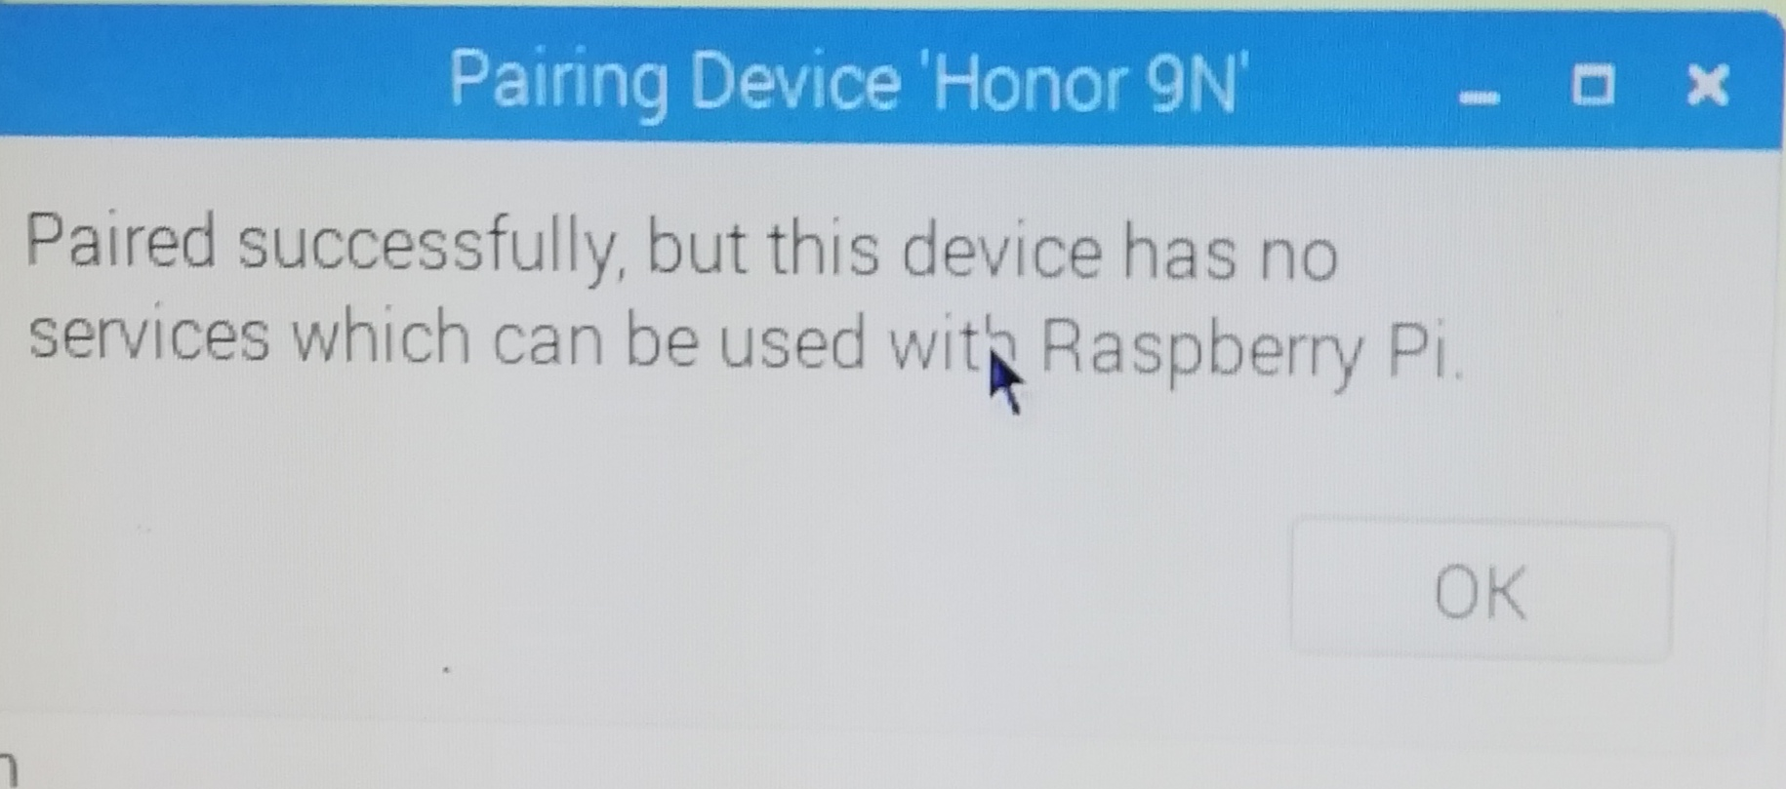

Then we solved that is by using below commands.
Start bluetoothctl
$ blutoothctl
Set the controller as discoverable:
[bluetooth]# discoverable on
Enable the agent and set it as default:
[bluetooth]# agent on
[bluetooth]#default-agent
Scan for devices:
[bluetooth]#scan on
Discover the device MAC address:
[bluetooth]#devices
Pair with the device:
[bluetooth]#pair device mac address
Enter the PIN if prompted:
[agent]PIN code:####
Allow the service authorization if requested:
[agent]Authorize service service uuid(yes/no):yes
Connect to the device:
[bluetooth]#connect device mac address
Now the connection is established bitween Android phone and Raspberry pi.

Transfer some text file from mobile to Raspberry pi through bluetooth:

The GUI package BlueMan provides a convenient front-end for several Bluetooth functions, but it's not clear how to use it to accept files from another Bluetooth device. One way of doing that, without BlueMan. We'll want to set up a OBEX push server, so download the software:
sudo apt-get install obexpushd
We'll need to add the compatibility flag on the Bluetooth daemon, so edit this file:
sudo nano /etc/systemd/system/dbus-org.bluez.service
Add the ' -C' flag to the end of the 'ExecStart=' line. It should look like this:
ExecStart=/usr/lib/bluetooth/bluetoothd -C
Save the file and reboot.
It's probably best to have a specific directory where received files are placed:
sudo mkdir /bluetooth
sudo obexpushd -B -o /bluetooth -n
It should respond with:
obexpushd 0.11.2 Copyright (C) 2006-2010 Hendrik Sattler
This software comes with ABSOLUTELY NO WARRANTY.
This is free software, and you are welcome to redistribute it
under certain conditions.
Listening on bluetooth/[00:00:00:00:00:00]:9
If that's not working, and you get:
obexpushd 0.11.2 Copyright (C) 2006-2010 Hendrik Sattler
This software comes with ABSOLUTELY NO WARRANTY.
This is free software, and you are welcome to redistribute it
under certain conditions.
BtOBEX_ServerRegister: Address already in use
net_init() failed
it could be because you have BlueMan running, which seems to take the rfcomm channel 9 that obexpushd uses by default. In this case change the channel to 23 like this:
sudo obexpushd -B23 -o /bluetooth -n
to use channel 23.
Once you get obexpushd running, open a second terminal window. You can verify that the OBEX service is registered with
sudo sdptool browse local
. It should list, among others, this.
Service Name: OBEX Object Push
Service Description: a free OBEX server
Service Provider: obexpushd
Service RecHandle: 0x10005
Service Class ID List:
"OBEX Object Push" (0x1105)
Protocol Descriptor List:
"L2CAP" (0x0100)
"RFCOMM" (0x0003)
Channel: 23
"OBEX" (0x0008)
Profile Descriptor List:
"OBEX Object Push" (0x1105)
Version: 0x0100
(with channel 23). In that window, while obexpushd is still running, use bluetoothctl to set 'discoverable on'.Now pair from your phone. Pairing MUST be done while obexpushd is running, or the phone wont recognize the service is available. If the phone is already paired, remove it from your phone, use bluetoothctl to remove it from the Pi, and re-pair.
You should now be able to send files from your phone (or other device) to the Pi, they will appear in the /bluetooth directory. Notice that they will be owned by root, so you'll need sudo to access them.
In order to automate the obexpushd command, create this file:
sudo nano /etc/systemd/system/obexpush.service
Add the following:
[Unit]
Description=OBEX Push service
After=bluetooth.service
Requires=bluetooth.service

[Service]
ExecStart=/usr/bin/obexpushd -B23 -o /bluetooth -n

[Install]
WantedBy=multi-user.target
Then, set that to autostart with
sudo systemctl enable obexpush
After a reboot, you should be able to send files from your phone to the Pi
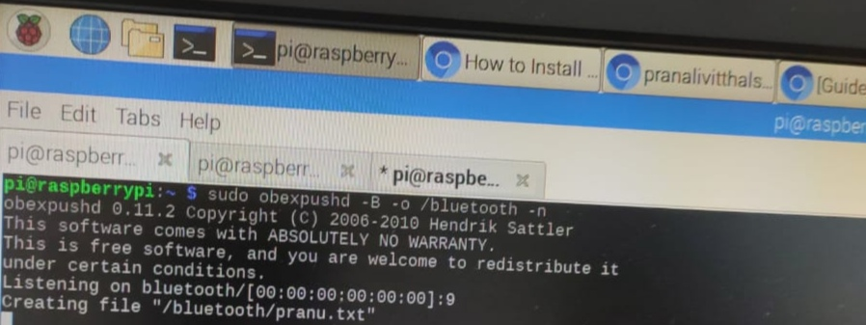

Bluetooth programming:
To run this programes you have to install the following packages
$apt-get install bluez libbluetooth-dev
Scan.c
#include<stdio.h>
#include<stdlib.h>
#include<unistd.h>
#include<sys/socket.h>
#include<bluetooth/bluetooth.h>
#include<bluetooth/hci.h>
#include<bluetooth/hci_lib.h>
int main(int argc, char **argv)
{
inquiry_info *ii = NULL;
int max_rsp, num_rsp;
int dev_id, sock, len, flags;
int i;
char addr[19] = { 0 };
char name[248] = { 0 };
dev_id = hci_get_route(NULL);
sock = hci_open_dev( dev_id );
if (dev_id < 0 || sock < 0) {
perror("opening socket");
exit(1);
}
len = 8;
max_rsp = 255;
flags = IREQ_CACHE_FLUSH;
ii = (inquiry_info*)malloc(max_rsp * sizeof(inquiry_info));
num_rsp = hci_inquiry(dev_id, len, max_rsp, NULL, &ii, flags);
if( num_rsp < 0 ) perror("hci_inquiry");
for (i = 0; i < num_rsp; i++) {
ba2str(&(ii+i)->bdaddr, addr);
memset(name, 0, sizeof(name));
if (hci_read_remote_name(sock, &(ii+i)->bdaddr, sizeof(name),
name, 0) < 0)
strcpy(name, "[unknown]");
printf("%s %s\n", addr, name);
}
free( ii );
close( sock );
return 0;
}
oupput:this program will scan all nearer bluetooth devices
$gcc -o scan scan.c -lbluetooth
$./scan

Send data from Raspberry pi to Android and vice versa through bluetooth:
server.c
#include<stdio.h>
#include<unistd.h>
#include<sys/socket.h>
#include<bluetooth/bluetooth.h>
#include<bluetooth/rfcomm.h>
int main(int argc, char **argv)
{
struct sockaddr_rc loc_addr = { 0 }, rem_addr = { 0 };
char buf[1024] = { 0 };
int s, client, bytes_read;
int opt = sizeof(rem_addr);
s = socket(AF_BLUETOOTH, SOCK_STREAM, BTPROTO_RFCOMM);
loc_addr.rc_family = AF_BLUETOOTH;
loc_addr.rc_bdaddr = *BDADDR_ANY;
loc_addr.rc_channel = (uint8_t) 1;
bind(s, (struct sockaddr *)&loc_addr, sizeof(loc_addr));
listen(s, 1);
client = accept(s, (struct sockaddr *)&rem_addr, &opt);
ba2str( &rem_addr.rc_bdaddr, buf );
fprintf(stderr, "accepted connection from %s\n", buf);
memset(buf, 0, sizeof(buf));
bytes_read = read(client, buf, sizeof(buf));
if( bytes_read > 0 ) {
printf("received [%s]\n", buf);
}
close(client);
close(s);
return 0;
}
How to run this code:
Terminal 1
$sudo rfcomm listen hci0&
Terminal 2
gcc -o server server.c -lbluetooth
./server
open BlueTerm app in mobile and on the bluetooth in raspberry pi.
Terminal 1
echo "heyyyy" > /dev/rfcomm0
this heyyy will display in Blue Term terminal.
Type anything in the Blue Term app
cat /dev/rfcomm0
what ever the messages typed in blueterm terminal that messages will display on Raspberry pi
output:
In Mobile blue term app terminal
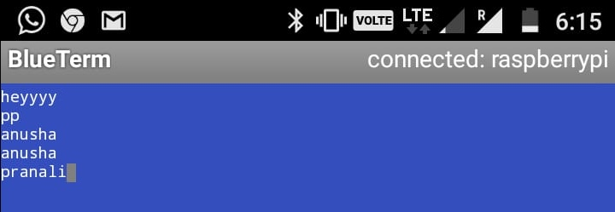

In Raspberry pi terminal

