CODEFORGE BUILDX 2026
SHAREPLATE
Share Food. Spread Kindness. Reduce Waste.
MINI PROJECT DOCUMENTATION

TEAM MEMBERS | ROLL NUMBER
Anusha Saladi | 25B11CS839
Ramoju Surya Venkata Sai Prakash | 25B11CS809
Santha Thanuja | 25B11CS855
Kosuri Teja Sampath Vinay | 25B11CS473

Department of Computer Science and Engineering
Second Year | CodeForge
Academic Year 2026–2027

ABSTRACT
SharePlate is a web-based food donation platform designed to connect people and organizations that have surplus food with individuals and communities that need it. The project addresses two related challenges: avoidable food wastage and difficulty in coordinating food donations. Through a single platform, donors can publish food details and recipients can discover available donations, submit quantity-based requests and follow request or collection status.
The application is designed with separate donor and recipient experiences. Its principal functions include account registration and login, role-specific dashboards, food listing management, food discovery, donation requests, request approval or rejection, status tracking and donation/request history. Food image uploads and a responsive interface support clearer communication and ease of use.
The technology stack documented for the project consists of React.js and Tailwind CSS for the frontend, Python FastAPI for backend services, PostgreSQL for persistent data storage, SQLAlchemy for object-relational mapping, JWT for authentication, Alembic for database migrations and Pytest for backend testing. The system follows a client-server structure in which the frontend communicates with backend API routes, and the backend manages validation, business logic and database operations.
SharePlate aims to make food redistribution more organized and accessible. The current project provides a foundation that can be extended with location-based discovery, real-time notifications, mapping, mobile access and intelligent recommendations.

PROJECT OVERVIEW

1.1 Introduction
Food waste occurs across households, restaurants, events and food businesses. At the same time, individuals and community groups may face difficulty accessing sufficient food. Surplus food that is still suitable for consumption can often be redirected, but the process requires donors and recipients to find one another and coordinate quantities and collection.
SharePlate proposes a digital platform to simplify this coordination. It allows donors to create food listings with relevant details and enables recipients to browse and request available food. Donors can review incoming requests and update their status, while both sides can follow the progress of donations through the platform.

1.2 Project Scope
The project scope covers the main digital workflow for food donation: user access, donor and recipient dashboards, food listing creation and management, browsing and searching, quantity-based requests, request decisions, status tracking and history. The system is intended as a coordination tool. Users must still ensure that donated food is safe, properly stored and suitable for consumption.

1.3 Intended Users
- Donors: individuals or entities that have surplus food and wish to share it.
- Recipients: individuals or community representatives who browse and request available food.
- Project administrators or maintainers: responsible for maintaining the application and its technical environment, where applicable.

PROBLEM STATEMENT & OBJECTIVES

2.1 Problem Statement
Surplus food may be discarded because donors do not have a convenient way to identify recipients or coordinate distribution. Manual communication can make it difficult to communicate food details, available quantities, request decisions and collection progress. Recipients may also lack a centralized place to discover available donations. SharePlate addresses this coordination gap through a role-based web application.

2.2 Proposed Solution
SharePlate provides a shared digital interface where donors can publish food listings and recipients can browse available items and submit requests. Donors can manage listings and approve or reject requests. The application records relevant statuses and history so that users can follow donation activity more clearly.

2.3 Objectives
- Provide a simple platform for publishing surplus-food donations.
- Allow recipients to discover available food and request required quantities.
- Separate donor and recipient functions through role-specific dashboards and access rules.
- Support request review, approval, rejection and status tracking.
- Maintain organized records of donations and requests.
- Promote awareness of food redistribution and responsible food use.

2.4 Expected Outcome
The expected outcome is a functional web application that makes the basic food donation workflow easier to coordinate and provides a foundation for additional community-focused features.

TECHNOLOGY STACK
The project uses a modern web application stack. Each technology has a defined role in the system.
Layer / Area | Technology | Purpose
Frontend | React.js | Builds reusable interface components and interactive pages.
UI styling | Tailwind CSS | Provides utility-based styling and responsive layouts.
Backend | Python, FastAPI | Implements server-side logic and REST API endpoints.
Database | PostgreSQL | Stores user, food listing and request records.
ORM | SQLAlchemy | Maps application objects to relational database tables.
Authentication | JWT | Supports token-based authentication for protected operations.
Migrations | Alembic | Manages database schema changes over time.
Testing | Pytest | Supports automated testing of backend functionality.
Version control | Git and GitHub | Tracks source-code changes and supports team collaboration.

3.1 Frontend
React.js is used to organize the user interface into reusable components and pages. Tailwind CSS is used to style the interface and support layouts across different screen sizes. The frontend presents the workflows available to donors and recipients and communicates with backend services.

3.2 Backend
FastAPI is used to implement backend routes and application logic in Python. It receives frontend requests, validates input, applies the relevant rules and coordinates database operations. FastAPI also provides interactive API documentation during development.

3.3 Database and Supporting Tools
PostgreSQL stores structured application data. SQLAlchemy provides the object-relational mapping layer, while Alembic supports controlled database migrations. JWT is used for token-based authentication, and Pytest is included for backend test execution.

SYSTEM ARCHITECTURE & WORKFLOW

4.1 Architecture Overview
SharePlate follows a client-server architecture with three principal layers: the React-based presentation layer, the FastAPI application layer and the PostgreSQL data layer. The browser presents the interface. When a user performs an action, the frontend sends an API request to the backend. The backend validates the request, checks the relevant access rules, performs application logic and reads or updates the database. A response is then returned to the frontend.
React.js  Tailwind CSS | Python FastAPI  Validation • API • Business Logic | PostgreSQL  SQLAlchemy • Alembic
CLIENT / PRESENTATION LAYER → APPLICATION LAYER → DATA LAYER

4.2 Main Workflow
1. A user registers and signs in to the platform.
2. The user accesses the dashboard associated with their role.
3. A donor creates a food listing containing details such as food name, description, quantity and availability information.
4. A recipient browses available listings and selects a food item.
5. The recipient submits a request with the required quantity.
6. The donor reviews the incoming request and approves or rejects it.
7. The users follow the request or donation status and relevant history.

4.3 Data Flow
The main data flow is : user action in the React interface → API request → FastAPI validation and business logic → SQLAlchemy database operation → PostgreSQL → API response → updated frontend view.

FEATURES & FUNCTIONAL MODULES

5.1 User Registration and Login
The authentication module provides account registration and login. Authentication establishes the identity of a user, while role information determines whether donor-oriented or recipient-oriented functions should be available. JWT is identified in the project stack for token-based authentication.

5.2 Donor Dashboard
The donor dashboard provides access to donation-related actions. Donors can create food listings, manage their own listings and review requests submitted by recipients. This dashboard centralizes the donor's primary activities.

5.3 Food Listing Management
Donors can add, edit and manage food donation details. Listings may include the food name, description, category, quantity, remaining quantity, unit, image and pickup-related information. Accurate listing details help recipients make informed requests.

5.4 Recipient Dashboard and Food Discovery
Recipients can access a separate dashboard to explore available donations. Browsing and search functions help recipients identify food listings relevant to their needs.

5.5 Food Request Management
Recipients can submit requests for a selected food listing and specify the required quantity. Donors can review incoming requests and approve or reject them. This workflow helps organize the distribution process.

5.6 Status Tracking and History
The application supports tracking of donation and request status. Donation and request history provide users with a record of previous activity and make the workflow easier to follow.

5.7 Food Image Uploads and Responsive UI
Food image uploads can provide additional context about a listing. The responsive interface is intended to make the platform usable on different screen sizes.

FRONTEND IMPLEMENTATION

6.1 Overview
The frontend is developed using React.js and Tailwind CSS. React organizes the application into reusable components and page-level views. Tailwind CSS is used to apply consistent spacing, typography, colors and responsive layout rules.

6.2 Main Interface Areas
- Public entry and account access pages for registration and login.
- Donor dashboard and food listing forms.
- Recipient dashboard and available-food browsing views.
- Food details and quantity-based request interface.
- Incoming request views for donor decisions.
- Donation and request history views.

6.3 User Experience Considerations
The interface separates donor and recipient activities to reduce confusion. Forms are used to collect structured food and request information. Listing cards and detail views help users review food information before taking action. Responsive styling supports use on both desktop and mobile-sized screens.

6.4 Frontend-to-Backend Communication
The frontend communicates with backend services through API requests. The backend response is used to update the interface, display records or provide feedback to the user. Protected actions require the appropriate authentication context.

BACKEND IMPLEMENTATION

7.1 Overview
The backend is implemented using Python and FastAPI. It provides the application interface between the React frontend and the PostgreSQL database. Backend responsibilities include processing requests, validating input, applying business rules, enforcing access restrictions and returning structured responses.

7.2 Core Backend Responsibilities
- Authentication: handle registration and login-related operations and identify authenticated users.
- User and role handling: distinguish donor and recipient permissions.
- Food listing operations: create, retrieve, update and manage donation records.
- Request operations: create requests and support donor decisions.
- Status management: maintain the state of donation and request workflows.
- Data access: use SQLAlchemy to interact with PostgreSQL.

7.3 API Design
The application uses an API-based communication approach. The project specification identifies API groups for authentication, user profiles, food listings, food requests and donation history. FastAPI's interactive documentation can be used during development to inspect available routes and request/response schemas.

7.4 Validation and Access Control
Incoming data should be validated before it is processed. Operations should be restricted according to the user's role and ownership of the relevant record. For example, donor-only listing management and recipient-owned request management should not be available to unrelated users.

DATABASE DESIGN

8.1 Database Overview
PostgreSQL is used as the relational database management system. The core data model described for SharePlate consists of users, food listings and food requests. SQLAlchemy is used to map application models to database records, and Alembic is used to manage schema migrations.
Table | Purpose | Important attributes
Users | Stores donor and recipient accounts. | user_id (PK), full_name, email, password_hash, phone, address, role, created_at
Food Listings | Stores surplus food published by donors. | food_id (PK), donor_id (FK), food_name, description, category, quantity, remaining_quantity, unit, image_url, pickup_location, available_until, listing_status
Food Requests | Stores requests made by recipients. | request_id (PK), food_id (FK), recipient_id (FK), requested_quantity, request_status, request_date, updated_at

USERS  user_id (PK)  role • email | FOOD LISTINGS  food_id (PK)  donor_id (FK) | FOOD REQUESTS  request_id (PK)  food_id / recipient_id (FK)
USERS → FOOD LISTINGS ← FOOD REQUESTS

8.2 Relationships
- One donor can create multiple food listings. Each listing belongs to one donor.
- One recipient can submit multiple food requests. Each request belongs to one recipient.
- One food listing can receive multiple requests. Each request refers to one food listing.

8.3 Data Integrity
Primary keys uniquely identify records, while foreign keys connect related tables. Unique email constraints help prevent duplicate accounts. Quantity validation should ensure that requested quantities are positive and do not exceed the available amount. Passwords should be stored as secure hashes rather than plain text.

APPLICATION SCREENSHOTS
1.Main Page:
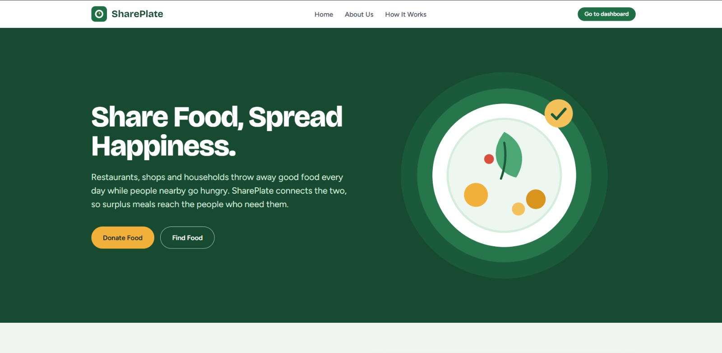

2.Login page:
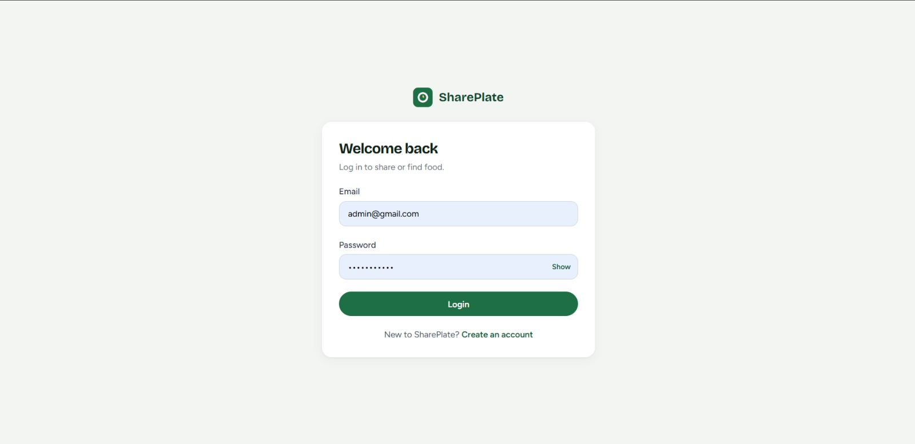

3.Adding food details as donor:

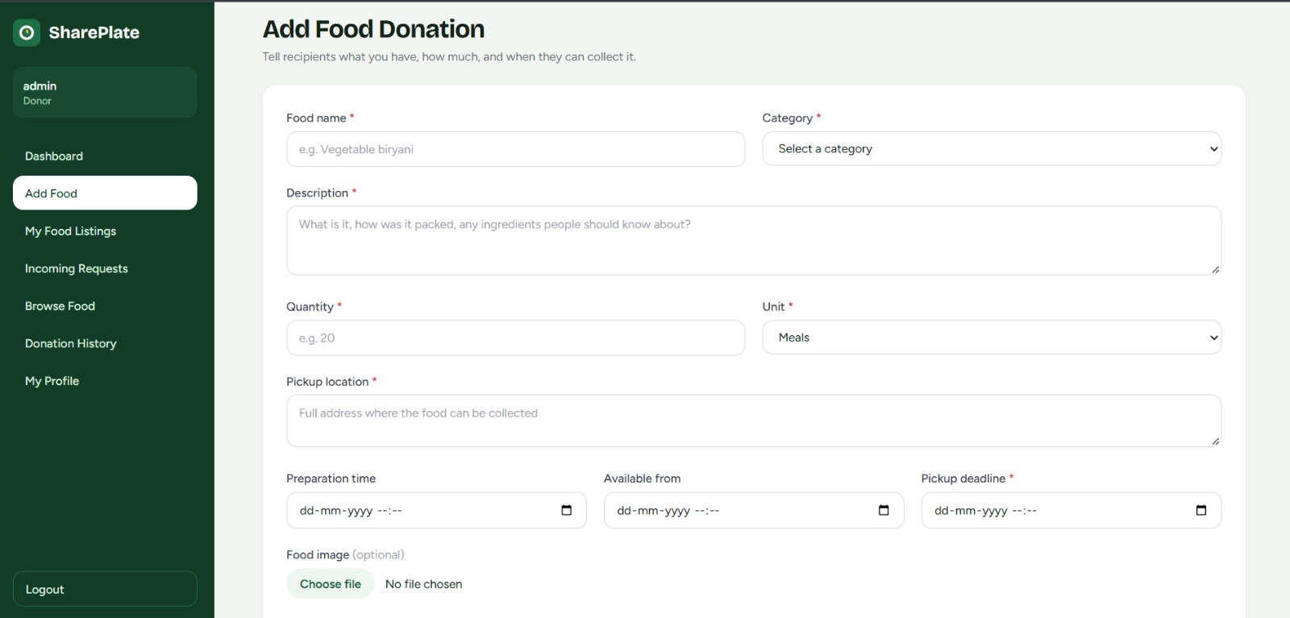

4. History of food donations:
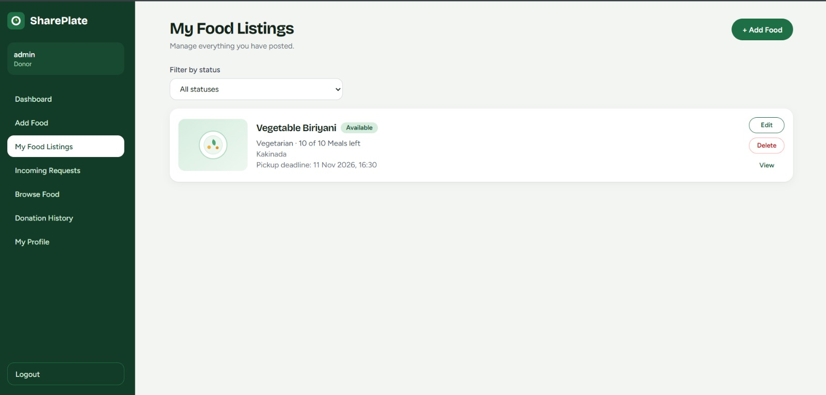

5. Available Food Listings:
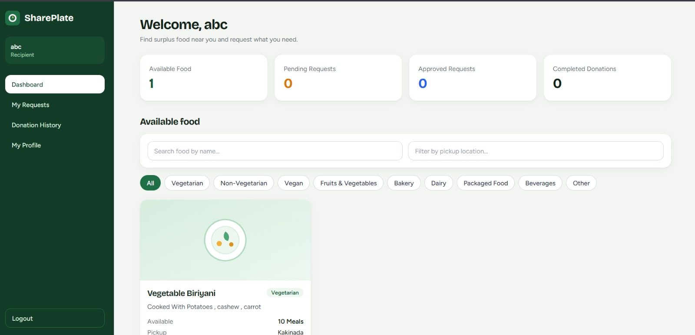

6.Details of Food:
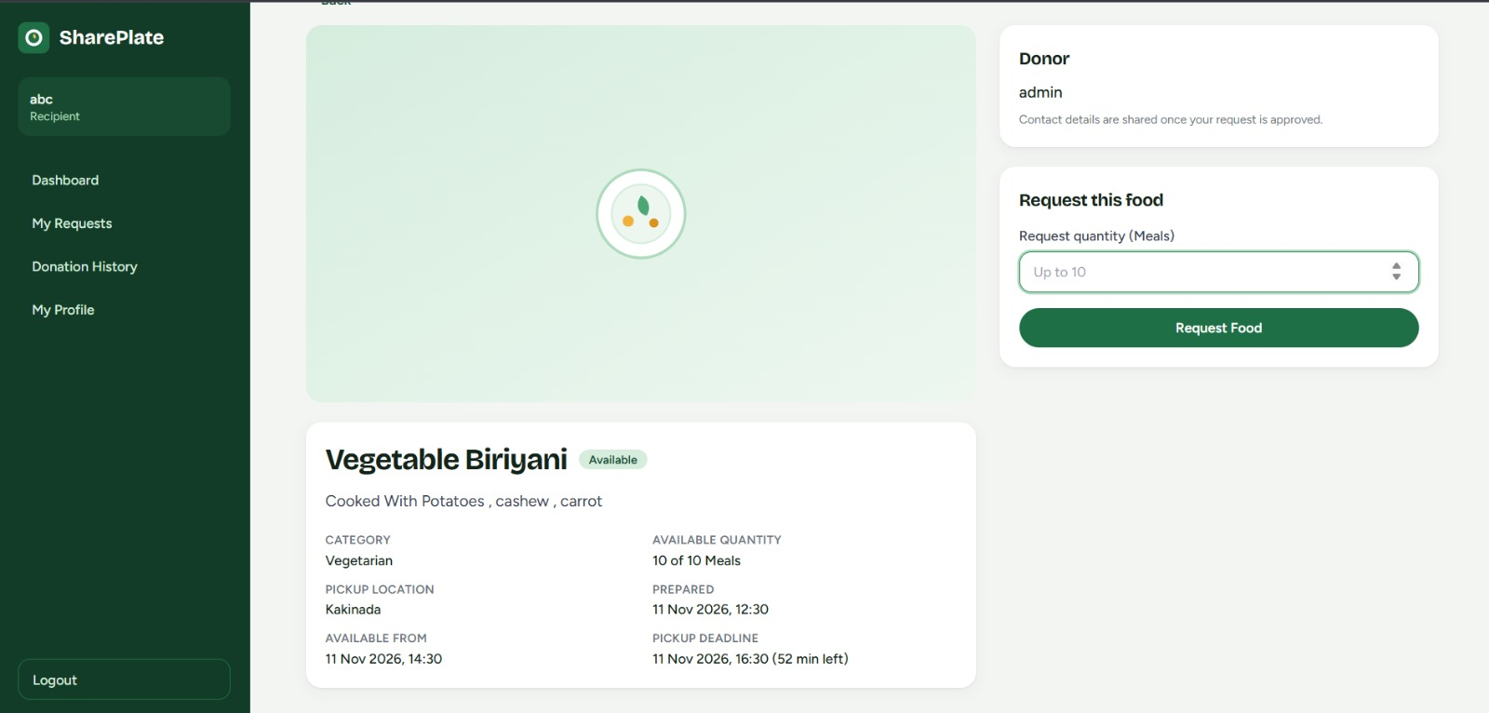

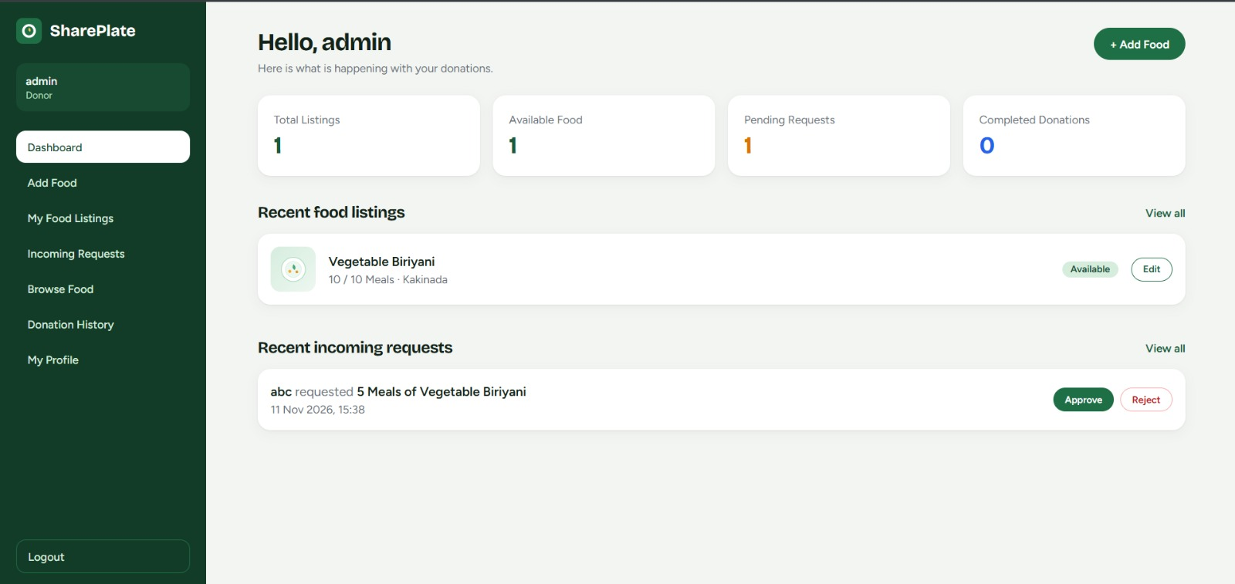
7.Donor Dashboard(Admin View):

8.Recipient Dashboard:
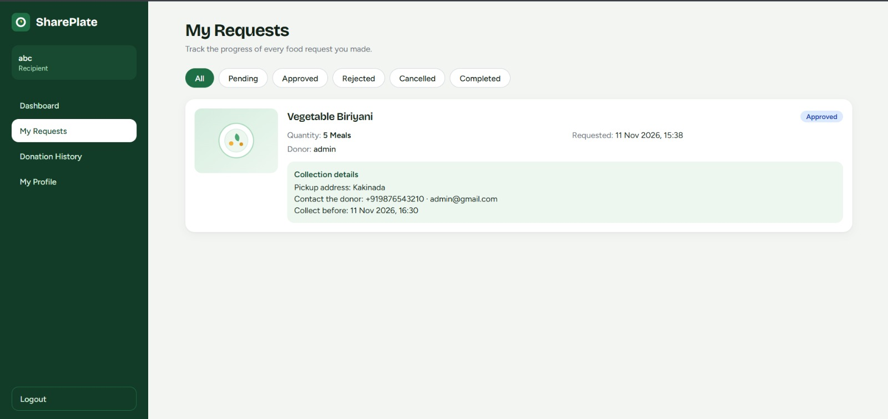

TESTING, RESULTS & LIMITATIONS

10.1 Testing Approach
Testing was performed to verify the functionality, reliability and integration of the SharePlate application. The major modules, including user authentication, role-based access, food listing management, food browsing, donation requests and request status management, were considered during testing.
The application was tested using different user scenarios to ensure that donors and recipients could perform their respective operations. Input validation, database interactions and the overall workflow were also checked to identify and resolve errors.
The testing process helped verify that the major functionalities of SharePlate work as intended.
Test case | Expected result | Status
User registration with valid details | Account is created and can be used to sign in. | Passed
Login with valid credentials | User is authenticated and reaches the correct dashboard. | Passed
Role-specific access | Donor and recipient functions are separated. | Passed
Create a food listing | Valid food details are saved and displayed. | Passed
Browse available food | Available listings are displayed to recipients. | Passed
Submit a food request | Request is recorded with the selected quantity. | Passed
Approve or reject a request | Request status changes appropriately. | Passed
View history/status | Relevant donation or request records are displayed. | Passed

10.2 Results
Final Results
The SharePlate application was successfully assembled and configured based on the requirements defined by our team. The application provides a centralized platform for managing food donations and connecting donors with recipients.
The final application includes the following features:
- Donor dashboard displaying donation statistics and recent activities.
- Food listing creation and management.
- Display of available food donations.
- Incoming donation request management with approval and rejection options.
- Donation history and profile sections.
- Separate navigation options for different application activities.
The dashboard displays key information such as total listings, available food, pending requests, and completed donations. It also provides a convenient way for donors to monitor their food listings and manage incoming requests.
Overall, the project demonstrates the implementation of a digital platform aimed at reducing food wastage and making surplus food more accessible to people in need.

10.3 Limitations
- Food safety, storage and transportation must be verified by the people handling each donation; the application cannot independently certify food safety.
- Real-time notifications, location-based discovery and map integration are identified as possible future additions.
- The usefulness of the platform depends on accurate listings and active participation by donors and recipients.
- The project should be treated as a coordination platform and not as a substitute for emergency food assistance or official food-safety processes.

AI USAGE, TEAM CONTRIBUTIONS & CONCLUSION

11.1 Use of AI Tools

Claude AI was used as the primary AI tool for SharePlate development. Our team provided detailed project documentation containing the requirements, features, workflows, and technical specifications. Claude generated the project files and code based on these instructions. The team then organized, connected, configured, and integrated the generated files to build the application.

11.2 Team Members
Name | Roll Number | Programme / Batch
Anusha Saladi | 25B11CS839 | CSE – Second Year, CodeForge
Ramoju Surya Venkata Sai Prakash | 25B11CS809 | CSE – Second Year, CodeForge
Santha Thanuja | 25B11CS855 | CSE – Second Year, CodeForge
Kosuri Teja Sampath Vinay | 25B11CS473 | CSE – Second Year, CodeForge

11.3 Team Contributions
The project was developed collaboratively by the three team members. Shared responsibilities include requirement discussion, planning, reviewing AI-assisted suggestions, implementation, debugging, integration, testing, version control and preparation of the project submission.
Team member | Contribution
Anusha Saladi | Requirement analysis, project documentation, AI prompting, feature planning, and application development.
Ramoju Surya Venkata Sai Prakash | Application setup, frontend development, generated file organization, feature integration, and testing.
Santha Thanuja | Backend development, database configuration, requirement preparation, application testing, and documentation.
Kosuri Teja Sampath Vinay | UI/UX design, frontend and backend integration, application configuration, debugging, and final testing.

11.4 Conclusion

Conclusion

SharePlate is a food donation platform developed to reduce food wastage by connecting food donors with people in need. It provides a centralized platform for sharing surplus food, browsing available donations, and managing food requests. The project demonstrates how technology and AI-assisted development can be used to address a real-world social problem and encourage responsible food utilization.

11.5 Future Enhancements
The following features can be considered for future development:
- Location-Based Food Discovery: Help users find available food donations in nearby locations.
- Real-Time Notifications: Notify users about new food listings, requests, and status updates.
- AI-Based Food Matching: Recommend suitable food donations to recipients based on their requirements and location.
- Mobile Application: Develop an Android and iOS application for easier access.
- Impact Tracking: Display statistics on food donations, meals distributed, and food waste reduced.
- Volunteer Coordination: Introduce volunteer support for collecting and delivering food donations.

Project Repository
GitHub: https://github.com/Anushasaladi/Shareplate

