PROJECT REPORT ON
“TaskForge”
(Project Management System)

Submitted By:
Kasish Nagnyal (64247)
Anushia Sharma (64274)
Under The Guidance Of:
Dr. Smita Singh
Mr. Rajesh Jha
May 2026

DEPARTMENT OF MCA
(2025-27)

CERTIFICATE

This is to certify that Kasish Nagnyal (ID : 64247) and Anushia Sharma (ID:64274) has made substantial contributions to the project titled “TaskForge – Project Management System”.
This project has been undertaken as a part of the Masters of Computer Application (MCA) academic requirements at Govind Ballabh Pant University of Agriculture and Technology.
Under the guidance and supervision of Dr. Smita Singh and Mr. Rajesh Jha. Kasish Nagnyal and Anushia Sharma demonstrated strong dedication, consistency, and technical proficiency throughout the development of the TaskForge- Project Management System.
This certificate acknowledges their valuable efforts, hard work, and commitment during all phases of the project – from system design and model integration to implementations and testing.
The project submitted in partial fulfillment of the degree requirements reflects Kasish Nagnyal’s and Anushia Sharma’s capability to apply theoretical knowledge to real-world applications in the field of computer science.
This certificate affirms her active participation and significant contribution toward the successful completion of the TaskForge- Project Management System.

Date: _________________ Dr. Smita Singh
(Supervisor)
ACKNOWLEDGEMENT

I express my sincere gratitude to everyone who contributed to the successful completion of my project, “TaskForge – Project Management System”, undertaken as a part of the academic requirements for the Masters of Computer Applications (MCA) degree.
First and foremost, I would like to convey my heartfelt thanks to Dr. Smita Singh and Mr. Rajesh Jha for their invaluable guidance, continuous support, and expert insights throughout the development of the TaskForge – Project Management System. Their encouragement and constructive feedback played a crucial role in shaping this project.
I am deeply thankful to my family, friends, and peers for their constant motivation, understanding, and support during every phase of this project. Their belief in my efforts kept me inspired and focused.
This project stands as a reflection of the collective efforts, cooperation, and assistance I received, and I extend my warmest thanks to each individual who contributed directly or indirectly to its completion.
ABSTRACT
TaskForge is a web-based Smart Project and Task Management System developed as an MCA 1st Year mini-project. The system is built using PHP, MySQL (RDBMS), HTML5, CSS3, Bootstrap 5.3, and Vanilla JavaScript, running on a XAMPP (Apache + MySQL) stack.
The application provides a role-based (Admin and User) environment where registered users can create and manage their projects, break them down into tasks, and track progress in real time. Administrators have a bird's-eye view of all users, projects, and tasks; they can set deadlines, leave feedback, and monitor overall system health through a dynamic dashboard.
The back-end REST-style API layer (project_api.php, task_api.php, dashboard_api.php) communicates asynchronously with the front end using the Fetch API, eliminating full-page reloads. The database schema consists of three normalized tables—users, projects, and tasks—with referential integrity enforced via foreign key constraints. Password hashing (PHP password_hash / PASSWORD_DEFAULT) and session-based authentication are used for security.
This report documents the complete system lifecycle: purpose, scope, objectives, benefits, methodology, hardware/software requirements, system design (DFD, ER diagram), implementation details, results, conclusion, and future scope.

TABLE OF CONTENTS

Chapter / Section | Page No.
Certificate | ii
Acknowledgement | iii
Abstract | iv
Table of Contents | v
List of Figures | vi
List of Tables | vii
CHAPTER 1 – Introduction | 8
1.1 Purpose | 8
1.2 Scope | 9
1.3 Objectives | 9
1.4 Benefits | 10
1.5 Technologies Used (Overview) | 11
CHAPTER 2 – Methodology | 12
2.1 Development Methodology | 12
2.2 Phase-wise Description | 12
CHAPTER 3 – System Requirements | 14
3.1 Hardware Requirements | 14
3.2 Software Requirements | 15
CHAPTER 4 – Technology Used | 16
4.1 Front-End Technologies | 16
4.2 Back-End Technology (PHP) | 17
4.3 Database (MySQL – RDBMS) | 18
4.4 Server & Deployment Stack | 19
CHAPTER 5 – System Design | 20
5.1 Data Flow Diagram (DFD) | 20
5.2 Entity-Relationship (ER) Diagram | 22
5.3 Database Schema | 23
5.4 Module Design | 24
CHAPTER 6 – Implementation / Body of Project | 26
6.1 Project Structure | 26
6.2 Authentication Module | 26
6.3 User Dashboard Module | 27
6.4 Project Management Module | 28
6.5 Task Management Module | 29
6.6 Admin Module | 29
6.7 API Layer | 30
CHAPTER 7 – Results and Discussion | 31-44
CHAPTER 8 – Conclusion | 45-46
CHAPTER 9 – Future Scope | 47-48
References | 49

LIST OF FIGURES

Figure No. | Caption | Page
Figure 1 | ER Diagram (Classic Representation) | 23
Figure 2 | Login Page Interface | 32
Figure 3 | User Login Screen | 32
Figure 4 | Create Account Interface | 33
Figure 5 | Account Selection Menu | 33
Figure 6 | User Registration Form | 34
Figure 7 | User Authentication Module | 34
Figure 8 | Dashboard Overview | 35
Figure 9 | Project Creation Page | 35
Figure 10 | Project Card Display | 36
Figure 11 | Task Addition Module | 36
Figure 12 | Task Management Window | 37
Figure 13 | My Task Interface | 37
Figure 14 | User Profile Dropdown | 38
Figure 15 | Switch Account Module | 38
Figure 16 | Admin Dashboard | 39
Figure 17 | Project Deadline Overview On Admin | 39
Figure 18 | All Project Interface | 40
Figure 19 | All Task Admin Dashboard | 40
Figure 20 | Filtered Task Record | 41
Figure 21 | Status-wise Task Managing | 41
Figure 22 | User-wise Task Monitoring | 42
Figure 23 | Project Database Table | 42
Figure 24 | Task Database Record | 43
Figure 25 | User Information Database | 43
Figure 26 | Authentication Data Table | 44
Figure 27 | SQL query Execution window | 44
Figure 28 | Final System Dashboard | 45

LIST OF TABLES

Table No. | Caption | Page
Table 1 | Minimum Hardware Requirements | 12
Table 2 | Recommended Hardware Requirements | 13
Table 3 | Software Requirements | 14
Table 4 | Bootstrap 5.3 – Key Utility Classes Used | 16
Table 5 | PHP Features Used in TaskForge | 18
Table 6 | MySQL Data Types Used | 19
Table 7 | Comparison of Web Technologies | 21
Table 8 | DFD Symbols and Their Meanings | 22
Table 9 | Database Table – users | 29
Table 10 | Database Table – projects | 30
Table 11 | Database Table – tasks | 31
Table 12 | Module Description Summary | 32
Table 13 | API Endpoints – Project API | 43
Table 14 | API Endpoints – Task API | 44
Table 15 | API Endpoints – Dashboard API | 44
Table 16 | Test Cases and Results | 45
Table 17 | Performance Metrics | 47

CHAPTER 1: INTRODUCTION
In the modern era of software development and collaborative work, effective project and task management is indispensable for teams of all sizes. Organizations—academic, corporate, or entrepreneurial—require a systematic approach to track deliverables, assign responsibilities, and monitor progress. Manual methods such as spreadsheets and paper-based logs are error-prone, time-consuming, and difficult to scale.
TaskForge is a web-based Project Management System that addresses these challenges by providing a centralized, role-based platform. Built entirely on open-source technologies (PHP, MySQL, Bootstrap), TaskForge requires no paid licenses, making it ideal for academic institutions and small teams. It runs on a standard XAMPP stack and is accessible from any modern web browser.
The system supports two roles: Admin and User. Regular users can self-register, create projects, break projects into granular tasks, and track progress through a visual dashboard. Administrators have elevated privileges—they can monitor every project and user in the system, assign deadlines, and provide written feedback to individual project owners.
1.1 Purpose
The primary purpose of TaskForge is to provide a lightweight, browser-based project management tool that eliminates the friction associated with traditional planning methods. Specifically, the system is designed to:
- Enable users to organize their work into projects and sub-tasks with a clear hierarchy.
- Provide a real-time progress indicator so that users and administrators can gauge project completion at a glance without querying the database manually.
- Offer a role-based access control (RBAC) mechanism ensuring that each actor sees only the data and actions relevant to their role.
- Facilitate administrator oversight through a dedicated admin panel that aggregates all projects, tasks, and user statistics.
- Maintain data integrity through a normalized RDBMS schema with foreign-key constraints, ensuring no orphaned records exist.
- Provide secure authentication using PHP's built-in password hashing and session management.
By fulfilling these purposes, TaskForge serves as both a practical project-management tool and an educational demonstration of full-stack web development concepts for MCA students.
1.2 Scope
The scope of the TaskForge project covers the design, development, and testing of a web-based project management system with the following boundaries:
In-Scope:
- User registration and secure login for both Admin and User roles.
- Full CRUD (Create, Read, Update, Delete) operations on Projects by their respective owners.
- Full CRUD operations on Tasks within a project, including status transitions: To Do → In Progress → Done.
- Asynchronous API calls (using the browser's Fetch API) to project_api.php, task_api.php, and dashboard_api.php for a dynamic, single-page-like experience.
- Admin-only features: viewing all users' projects, adding deadlines to any project, leaving textual feedback visible to the project owner.
- Dashboard statistics: total projects, total tasks, completed tasks, and percentage completion.
- Overdue project detection and visual badging.
Out-of-Scope (not included in this version):
- Multi-user collaboration on a single project (currently each project has one owner).
- File attachment or document upload within a task.
- Email notification or SMS alerts for deadlines.
- Mobile native application (iOS/Android).
- Third-party integrations (Slack, Jira, GitHub, etc.).
- Payment gateway or subscription management.
1.3 Objectives
The following specific, measurable objectives guided the development of TaskForge:
# | Objective | Metric of Achievement
1 | Implement secure user authentication | Passwords hashed with PASSWORD_BCRYPT; sessions regenerated on login
2 | Develop full CRUD for projects | Users can create, read, update, delete projects without page refresh
3 | Develop full CRUD for tasks | Tasks added/deleted; status updatable via dropdown
4 | Build a real-time dashboard | Dashboard stats loaded via Fetch API on DOMContentLoaded
5 | Implement Admin panel | Admin sees all projects with owner, deadline, progress; can add feedback
6 | Enforce RDBMS referential integrity | CASCADE DELETE ensures no orphaned tasks when a project is deleted
7 | Ensure responsive UI | Bootstrap 5.3 grid adapts to mobile, tablet, and desktop viewports
8 | Enable overdue detection | System compares project deadline with current date; marks overdue in red

1.4 Benefits
TaskForge delivers tangible benefits to multiple stakeholders:
For End Users (Students / Employees):
- Single consolidated view of all personal projects and tasks eliminates the need for multiple spreadsheets or sticky notes.
- Task status tracking (To Do / In Progress / Done) provides a Kanban-like workflow.
- Visual progress bars offer instant feedback on project completion percentages.
- Admin feedback feature gives users actionable comments without requiring a separate communication channel.
For Administrators:
- Central oversight of the entire organization's project portfolio in one screen.
- Per-user progress breakdown with color-coded progress bars (green = 100%, yellow = >50%, red = <50%) for quick identification of at-risk users.
- Deadline management with automatic overdue flagging.
- Filter capabilities (by user, by progress state) to drill into specific subsets.
For the Organization:
- Zero licensing cost – all components are open-source.
- Runs on existing XAMPP infrastructure; no cloud subscription required.
- Extensible codebase that MCA students can study, fork, and extend.
1.5 Technologies Used (Overview)
TaskForge is built on a classic LAMP-variant stack. The following table provides a quick overview; detailed descriptions appear in Chapter 4.
Layer | Technology | Version / Details | Role
Presentation | HTML5 | HTML 5.0 | Structure of all web pages
Presentation | CSS3 | CSS 3 | Styling and layout
Presentation | Bootstrap | 5.3.0 | Responsive grid, components, utilities
Presentation | Bootstrap Icons | 1.11.3 | Icon font library
Client Logic | JavaScript | ES6+ (Vanilla) | Async Fetch calls, DOM manipulation
Server Logic | PHP | 7.4 / 8.x | Server-side scripting, API handlers
Database | MySQL | 8.0 | RDBMS – stores users, projects, tasks
Server | Apache | XAMPP bundle | Web server
Runtime | XAMPP | Latest | Local development environment

CHAPTER 2: METHODOLOGY
The development of TaskForge followed the Iterative Waterfall Model, a hybrid approach that blends the structured phases of the classic Waterfall model with the flexibility of iteration within each phase. This model is well-suited for academic projects where requirements are largely known upfront but some refinement during development is expected.
2.1 Development Methodology
The Iterative Waterfall Model consists of the following sequential phases, each producing a well-defined output before the next phase begins:
Phase | Activities | Output
Requirements Gathering | Identify functional & non-functional requirements; define user roles | Requirements document
System Analysis | Analyze feasibility, data flow, entity relationships | DFD, ER Diagram
System Design | Design DB schema, UI wireframes, API contracts | Schema scripts, mockups
Implementation | Code PHP pages, API scripts, HTML/CSS/JS | Working application
Testing | Unit, integration, and UAT tests | Test case report
Deployment | Configure XAMPP, import SQL, run application | Live local instance
Documentation | Write project report, user manual | Final report (this document)

2.2 Phase-wise Description
Phase 1 – Requirements Gathering
The requirements were identified by studying existing project-management tools (Trello, Asana) and simplifying them for a two-role academic context. Key functional requirements extracted:
- FR-01: The system shall allow new users to register with name, email, and password.
- FR-02: The system shall authenticate users against hashed passwords stored in MySQL.
- FR-03: Authenticated users shall be able to create, view, update, and delete projects.
- FR-04: Each project shall support multiple tasks with statuses: todo, inprogress, done.
- FR-05: The dashboard shall display real-time statistics fetched from the database.
- FR-06: Admin users shall view all projects across all users with progress metrics.
- FR-07: Admin shall be able to set deadlines and add feedback for any project.
Non-functional requirements identified:
- NFR-01: All pages shall load within 2 seconds on localhost.
- NFR-02: The UI shall be responsive and usable on screens ≥ 320px wide.
- NFR-03: Passwords shall be stored as bcrypt hashes (never plaintext).
- NFR-04: Session tokens shall be regenerated on each login to prevent fixation attacks.
Phase 2 – System Analysis
Data flow analysis was performed to identify all data stores, external entities, and processes. Entity-relationship modeling identified three core entities (User, Project, Task) and two relationships (User creates Projects; Project contains Tasks). Cardinalities were established: one User can create many Projects (1:N); one Project can contain many Tasks (1:N).
Phase 3 – System Design
The database schema was finalized with three tables: users, projects, and tasks. API endpoints were designed for each CRUD operation. UI wireframes were sketched to plan the landing page, dashboard, project cards, task modal, and admin views.
Phase 4 – Implementation
Coding was performed bottom-up: database schema first (setup.sql), then configuration (config/db.php), then API scripts (api/*.php), then PHP view pages, and finally CSS/JS. Bootstrap CDN was used to avoid local file management overhead.
Phase 5 – Testing
Manual black-box testing was conducted for each feature. Test cases covered happy-path scenarios, boundary conditions, and negative tests (e.g., invalid login, duplicate email registration, task deletion without ownership). Results are documented in Chapter 7.
Phase 6 – Deployment
The application was deployed on a local XAMPP server (Apache on port 8080, MySQL on port 3306). The SQL setup script (setup.sql) was executed in phpMyAdmin to create the database and seed the default admin account. The project folder was placed in htdocs/ for Apache serving.

CHAPTER 3: SYSTEM REQUIREMENTS
This chapter details the hardware and software environment required to install, run, and use TaskForge. Being a locally-hosted web application, the requirements are modest and achievable on any modern laptop or desktop computer.
3.1 Hardware Requirements
Table 3.1: Minimum Hardware Requirements
Component | Minimum Specification
Processor | Intel Core i3 (or equivalent) – 1.8 GHz or above
RAM | 4 GB DDR3 or higher
Storage (HDD/SSD) | 20 GB free disk space (XAMPP ~500 MB + project ~5 MB)
Display | 1280 × 720 resolution (HD) or higher
Network Interface | Ethernet or Wi-Fi (for multi-device LAN access; optional for localhost)
Input Devices | Standard keyboard and mouse

Table 3.2: Recommended Hardware Requirements
Component | Recommended Specification
Processor | Intel Core i5 / i7 (or AMD Ryzen 5/7) – 2.5 GHz or above
RAM | 8 GB DDR4 or higher
Storage (SSD preferred) | 256 GB SSD (for faster I/O with MySQL)
Display | 1920 × 1080 (Full HD) or higher
Network Interface | Gigabit Ethernet or Wi-Fi 5 (802.11ac) for LAN deployment
Input Devices | Standard keyboard and mouse or touchpad

3.2 Software Requirements
Software | Component | Version | Purpose
XAMPP | Apache HTTP Server | 2.4.x | Serves PHP pages on localhost
XAMPP | MySQL Database | 8.0.x (Port 3306) | Stores all application data
XAMPP | phpMyAdmin | 5.x | GUI for database administration
PHP | PHP Runtime | 7.4 / 8.0+ | Processes server-side logic and API calls
Web Browser | Google Chrome / Firefox | Latest stable | Client-side rendering and JS execution
Operating System | Windows 10/11 or Ubuntu 20.04+ | 64-bit | Host OS for XAMPP
Text Editor / IDE | VS Code / Sublime Text | Any | Code editing during development
Bootstrap CDN | Bootstrap 5.3.0 | 5.3.0 | Responsive UI framework (loaded via CDN)
Bootstrap Icons CDN | Bootstrap Icons 1.11.3 | 1.11.3 | Icon library (loaded via CDN)
Unsplash (background) | Remote image URL | N/A | Background image for landing page

CHAPTER 4: TECHNOLOGY USED
4.1 Front-End Technologies
4.1.1 HTML5
HyperText Markup Language version 5 (HTML5) is the backbone of every page in TaskForge. HTML5 introduced semantic elements (such as <nav>, <section>, <article>, <header>, <footer>) that improve document structure and accessibility. In TaskForge, HTML5 is used to:
- Structure the landing page (index.php), dashboard (dashboard.php), project pages, task pages, and admin pages.
- Define Bootstrap modal dialogs for login, registration, editing projects, and viewing tasks.
- Use the <meta name='viewport'> tag to enable responsive scaling on mobile devices.
- Use native HTML5 form elements such as <input type='date'> for deadline picking.
4.1.2 CSS3 & Custom Styles
Cascading Style Sheets Level 3 (CSS3) adds visual styling to the HTML structure. TaskForge uses an external stylesheet (assets/css/style.css) supplemented by inline <style> blocks. Key CSS3 features used:
CSS3 Feature | Where Used in TaskForge | Purpose
Flexbox | Navbar, hero section, quick-action buttons | Align items horizontally / vertically
CSS Grid (via Bootstrap) | Dashboard stat cards (col-md-3 col-6) | Responsive multi-column layout
CSS Variables / Gradient | body background on index.php | Linear gradient overlay on hero image
Backdrop Filter (blur) | .glass class on hero card | Glassmorphism frosted-glass card effect
CSS Transitions | body.modal-open .main-content | Smooth blur transition when modal opens
Border Radius | .modal-content (border-radius:20px) | Rounded corners on modals and cards
Overflow | Tasks modal (max-height + overflow-y:auto) | Scrollable task list inside fixed-height modal

4.1.3 Bootstrap 5.3
Bootstrap is the world's most popular open-source CSS framework. TaskForge uses Bootstrap 5.3.0 loaded from jsDelivr CDN. The JavaScript bundle (bootstrap.bundle.min.js) includes Popper.js, enabling dropdowns and modals without extra dependencies.
Bootstrap Component / Utility | Usage in TaskForge
Grid System (col-md-*, col-6) | Responsive 4-column stat cards on dashboard; 3-column project cards
Navbar (navbar-dark, navbar-expand-lg) | Top navigation bar on landing page
Modal (modal fade, modal-dialog-centered) | Login, Register, Edit Project, View Tasks modals
Cards (card shadow h-100 p-3) | Project cards, dashboard widgets, settings panels
Buttons (btn btn-primary, btn-sm) | All interactive buttons throughout the app
Progress Bar (progress-bar bg-success) | Task completion progress on dashboard and project cards
Badges (badge bg-danger, bg-success) | Status indicators, overdue labels, role badges
Table (table table-hover) | My Tasks page – tabular task list with filters
Dropdown (dropdown-menu) | Account dropdown on navbar with Admin/User/Register options
Form Controls (form-control, form-select-sm) | Inputs, selects, textareas throughout the app
Spinner (spinner-border-sm) | Loading indicators while async data fetches are pending

4.1.4 JavaScript (ES6+ Vanilla)
No JavaScript framework (React, Vue, Angular) is used. All client-side interactivity is implemented in plain ES6+ JavaScript, demonstrating core language competence. Key JavaScript patterns used in TaskForge:
- Fetch API (async/await): All CRUD operations trigger background HTTP calls to PHP API scripts; the DOM is updated with the response without reloading the page.
- Template literals: HTML strings for project cards, task rows, and progress bars are built using ES6 template literals for readability.
- Event Listeners: DOMContentLoaded triggers initial data load; onchange on status dropdowns triggers immediate API calls to update task status.
- Bootstrap JS API: new bootstrap.Modal() is used programmatically in index.php to control the login and register modals.

4.2 Back-End Technology: PHP
PHP (Hypertext Preprocessor) is the server-side scripting language powering TaskForge. PHP scripts run on Apache (via XAMPP) and generate dynamic responses.
PHP Feature | File(s) Used In | Purpose
session_start() / $_SESSION | All pages, login_process.php | Session-based user authentication
session_regenerate_id(true) | login_process.php | Prevents session fixation attacks
password_hash() | register_process.php | Hashes passwords with bcrypt (PASSWORD_DEFAULT)
password_verify() | login_process.php | Verifies plaintext password against stored hash
mysqli (OOP) | config/db.php, all API files | Connects to MySQL using Object-Oriented interface
$conn->prepare() / bind_param() | login_process.php, register_process.php | Parameterized queries to prevent SQL injection
$conn->real_escape_string() | project_api.php, task_api.php | Escapes strings in inline SQL queries
json_encode() | All API scripts | Converts PHP arrays to JSON for AJAX responses
header('Location: ...') | Auth scripts, all pages | Server-side redirects and role routing
$_GET / $_POST | API scripts | Reads request parameters and form data
ENUM type handling | task_api.php | Validates status values against allowed ENUM

4.3 Database: MySQL (RDBMS)
MySQL is a widely-used open-source Relational Database Management System (RDBMS). TaskForge uses MySQL 8.0 (accessed on port 3306 in XAMPP). Being an RDBMS, MySQL enforces the relational model: data is organized in tables with rows and columns, and relationships are maintained through primary and foreign keys.
Key RDBMS Concepts Applied in TaskForge:
RDBMS Concept | How Applied in TaskForge
Tables (Relations) | Three tables: users, projects, tasks – each storing related records
Primary Key (AUTO_INCREMENT) | id column in each table uniquely identifies every record
Foreign Key | projects.created_by → users.id; tasks.project_id → projects.id
Referential Integrity | ON DELETE CASCADE: deleting a user removes their projects; deleting a project removes its tasks
ENUM Data Type | users.role (user/admin); tasks.status (todo/inprogress/done) – enforces valid values
NOT NULL Constraints | name, email, password in users; title in tasks – prevent empty records
UNIQUE Constraint | users.email – prevents duplicate account registration
TIMESTAMP Default | created_at TIMESTAMP DEFAULT CURRENT_TIMESTAMP – auto-records creation time
JOINs | project_api.php uses LEFT JOIN tasks ON tasks.project_id = projects.id to compute per-project task counts
Aggregate Functions | COUNT(t.id), SUM(t.status='done') used in dashboard and project APIs for statistics
GROUP BY | Grouping by project id and user id to aggregate task statistics per project/user
ORDER BY | Results ordered by id DESC to show newest entries first

MySQL Data Type | Column(s) Using It | Reason for Choice
INT AUTO_INCREMENT | id in all tables | Efficient numeric primary key; auto-managed by DB
VARCHAR(100) | users.name | Variable-length string; 100 chars sufficient for names
VARCHAR(150) | users.email | Longer varchar for email addresses
VARCHAR(200) | projects.name, tasks.title | Allows descriptive project/task names
VARCHAR(255) | users.password | Bcrypt hash is 60 chars; 255 provides future-proofing
TEXT | projects.description, projects.feedback | Unbounded text for long descriptions and feedback
DATE | projects.deadline | Stores only date (YYYY-MM-DD); no time needed for deadlines
ENUM | users.role, tasks.status | Restricts column to a predefined set of string values
TIMESTAMP | created_at in all tables | Records exact date-time of creation automatically

4.4 Server & Deployment Stack
Component | Technology | Details
Web Server | Apache 2.4 (via XAMPP) | Listens on port 8080; serves PHP via mod_php; handles URL routing
PHP Runtime | PHP 7.4 / 8.x | Embedded in Apache via mod_php; processes .php files on request
Database Server | MySQL 8.0 (port 3306) | Custom port (3306) to avoid conflicts
Admin Tool | phpMyAdmin 5.x | Web-based GUI for creating the database and running setup.sql
CDN (Bootstrap) | jsDelivr CDN | Delivers Bootstrap CSS/JS without local file management
Image CDN | Unsplash URL | Remote high-resolution background image for landing page
Version Control | Git (recommended) | Track code changes; not bundled but recommended practice

CHAPTER 5: SYSTEM DESIGN
5.1 Data Flow Diagram (DFD)
A Data Flow Diagram (DFD) is a graphical representation of the flow of data through an information system. It shows how data moves between external entities, processes, and data stores. DFDs are drawn at multiple levels of abstraction.
DFD Symbol | Shape | Meaning
External Entity | Rectangle | An outside actor that provides or receives data (User, Admin)
Process | Circle / Rounded rectangle | A function that transforms incoming data to outgoing data
Data Store | Open-ended rectangle | A repository where data is stored (Database tables)
Data Flow | Arrow | The direction and label of data movement between elements

Level 0 DFD – Context Diagram
At Level 0 (Context level), the entire TaskForge system is represented as a single process with two external entities: User and Admin. Both interact with the system; the system interacts with the MySQL database.
+-----------+ Registration/Login Credentials +------------------+
| | ─────────────────────────────────────> | |
| USER | Projects, Tasks (CRUD Requests) | |
| | ─────────────────────────────────────> | T A S K F O R G E |
| | <───────────────────────────────────── | PROJECT MGMT |
+-----------+ Dashboard Stats, Project Lists | SYSTEM |
| |
+-----------+ Admin Actions (Deadlines,Feedback) | |
| | ─────────────────────────────────────> | |
| ADMIN | <───────────────────────────────────── | |
| | All Users/Projects/Stats +------------------+
+-----------+ |
| DB Queries
v
+-------------------------------+
| MySQL Database |
| [users] [projects] [tasks] |
+-------------------------------+

Level 1 DFD – Main Processes
Level 1 decomposes the system into its major sub-processes. TaskForge has four main processes:
Process No. | Process Name | Inputs | Outputs | Data Store
P1 | Authentication | Email, Password, Role | Session token, redirect | D1: users
P2 | Project Management | Project name, description, deadline | Project records, JSON list | D2: projects
P3 | Task Management | Task title, project_id, status | Task records, JSON list | D3: tasks
P4 | Dashboard & Reporting | user_id, role | Stats JSON, progress %, user summaries | D1, D2, D3

[USER / ADMIN]
| Credentials
v
(P1: Authentication)──────Session────>[Session Store]
| Authenticated Session
|────────────────────────────────────────────────────────|
| |
v v
(P2: Project Mgmt) (P4: Dashboard)
CRUD Project Records Aggregate Stats
| ^ | ^
v | v |
[D2: projects] <──(P3: Task Mgmt)──> [D3: tasks] [D1,D2,D3]
CRUD Task Records

Level 2 DFD – Project Management Sub-processes (P2)
[USER]──Project Name/Desc/Deadline──>(P2.1: Create Project)──>INSERT──>[D2:projects]
[USER]──(No input)───────────────>(P2.2: Read Projects)──>SELECT──>[D2,D3]──>JSON
[USER]──Updated Name/Desc/Deadline─>(P2.3: Update Project)──>UPDATE──>[D2:projects]
[USER]──project_id───────────────>(P2.4: Delete Project)──>DELETE CASCADE──>[D2,D3]
[ADMIN]──feedback text, deadline──>(P2.5: Admin Update)──>UPDATE──>[D2:projects]
[ADMIN]──(No input)──────────────>(P2.6: Read All Projects)──>JOIN SELECT──>[D2,D3,D1]

Level 2 DFD – Task Management Sub-processes (P3)
[USER]──title, project_id──>(P3.1: Create Task)──ownership check──>INSERT──>[D3:tasks]
[USER]──project_id (optional)──>(P3.2: Read Tasks)──>SELECT JOIN──>[D3,D2]──>JSON
[USER/ADMIN]──task_id, status──>(P3.3: Update Status)──>UPDATE──>[D3:tasks]
[USER/ADMIN]──task_id──────>(P3.4: Delete Task)──>DELETE──>[D3:tasks]
[ADMIN]──project_id (optional)──>(P3.5: Read All Tasks)──>SELECT JOIN──>[D3,D2,D1]

5.2 Entity-Relationship (ER) Diagram
The Entity-Relationship (ER) Diagram models the data entities in TaskForge, their attributes, and the relationships between them. TaskForge has three entities: USER, PROJECT, and TASK.
Entities and Attributes:
Entity | Primary Key | Attributes | Notes
USER | id (PK) | name, email (UNIQUE), password, role, created_at | role ENUM: 'user','admin'
PROJECT | id (PK) | name, description, deadline, feedback, created_by (FK), created_at | created_by → USER.id
TASK | id (PK) | title, project_id (FK), status, created_at | project_id → PROJECT.id; status ENUM: todo/inprogress/done

Relationships:
Relationship | Entity 1 | Entity 2 | Cardinality | On Delete
CREATES | USER | PROJECT | 1 : N (one user creates many projects) | CASCADE
CONTAINS | PROJECT | TASK | 1 : N (one project contains many tasks) | CASCADE

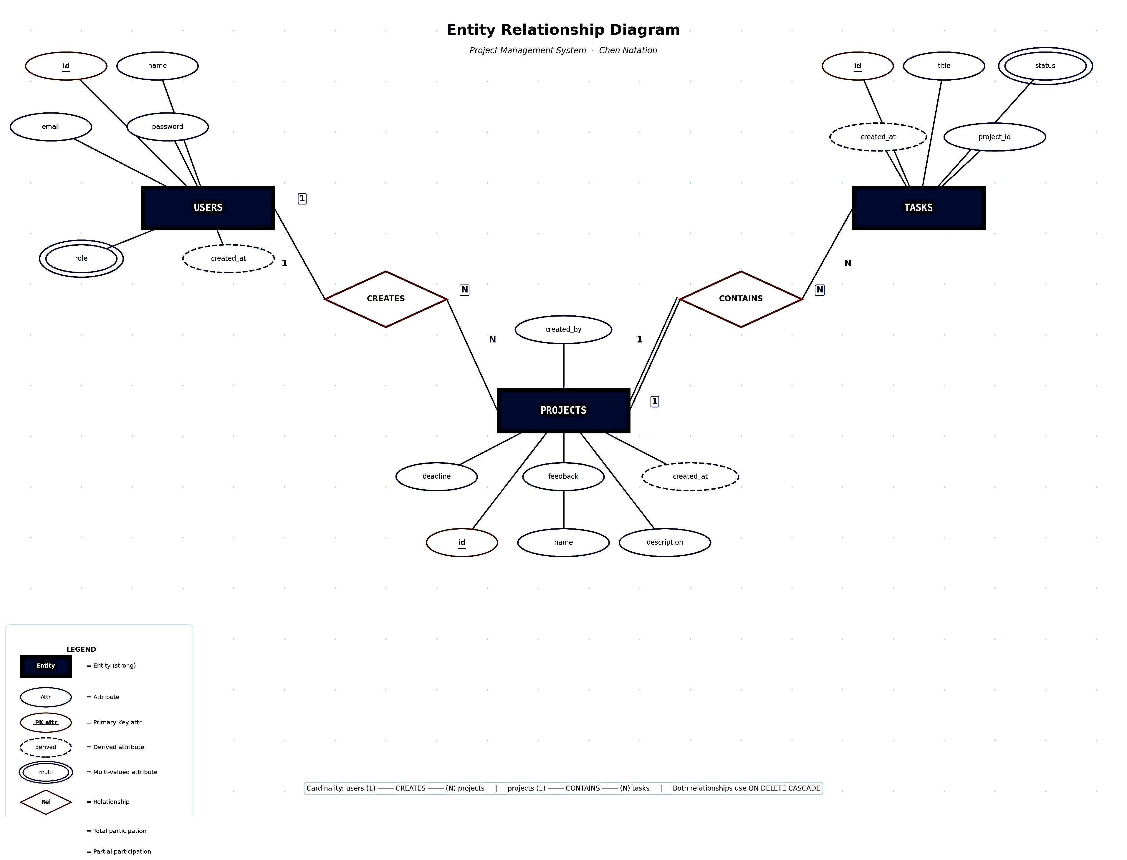
ER Diagram:
Figure 1: ER Diagram (Classic Representation)

5.3 Database Schema
The following three tables constitute the complete TaskForge database.
Table 5.2: Database Table – users
Column | Data Type | Constraints | Description
id | INT | PK, AUTO_INCREMENT, NOT NULL | Unique user identifier
name | VARCHAR(100) | NOT NULL | Full name of the user
email | VARCHAR(150) | NOT NULL, UNIQUE | Email address (used as login username)
password | VARCHAR(255) | NOT NULL | bcrypt-hashed password
role | ENUM('user','admin') | DEFAULT 'user' | Access level: regular user or administrator
created_at | TIMESTAMP | DEFAULT CURRENT_TIMESTAMP | Date and time of account creation

Table 5.3: Database Table – projects
Column | Data Type | Constraints | Description
id | INT | PK, AUTO_INCREMENT, NOT NULL | Unique project identifier
name | VARCHAR(200) | NOT NULL | Name/title of the project
description | TEXT | NULL allowed | Optional longer description of the project
deadline | DATE | DEFAULT NULL | Optional deadline set by admin or user
feedback | TEXT | DEFAULT NULL | Admin feedback text shown to the project owner
created_by | INT | FK → users(id) ON DELETE CASCADE | ID of the user who owns this project
created_at | TIMESTAMP | DEFAULT CURRENT_TIMESTAMP | Date and time the project was created

Table 5.4: Database Table – tasks
Column | Data Type | Constraints | Description
id | INT | PK, AUTO_INCREMENT, NOT NULL | Unique task identifier
title | VARCHAR(200) | NOT NULL | Short title/description of the task
project_id | INT | FK → projects(id) ON DELETE CASCADE | Project this task belongs to
status | ENUM('todo','inprogress','done') | DEFAULT 'todo' | Current state of the task
created_at | TIMESTAMP | DEFAULT CURRENT_TIMESTAMP | Date and time the task was created

5.4 Module Design
Module | Files | Responsibility
Authentication | index.php, auth/login_process.php, auth/register_process.php, auth/logout.php | Handle user registration, login validation, session creation, and logout
User Dashboard | dashboard.php, api/dashboard_api.php | Display personal or system-wide stats; load progress bars and project summaries via AJAX
Project Management | my_projects.php, api/project_api.php | CRUD operations on projects; display project cards with progress; inline task modal
Task Management | my_tasks.php, api/task_api.php | Tabular view of all tasks across projects; filter by project and status; update status; delete tasks
Admin – Projects | admin_projects.php, api/project_api.php (read_all, feedback) | Admin sees all projects; filters by user/progress; adds feedback and deadlines
Admin – Tasks | admin_tasks.php, api/task_api.php (read_all) | Admin sees all tasks across all projects; can update status and delete
Shared UI | includes/header.php, includes/navbar.php, assets/css/style.css | Reusable HTML head (Bootstrap links), responsive navbar, global CSS
Configuration | config/db.php | Single-point database connection using MySQLi OOP

CHAPTER 6: IMPLEMENTATION / BODY OF PROJECT
6.1 Project Directory Structure
project-management/
├── index.php # Landing page with login/register modals
├── dashboard.php # User/Admin dashboard with stats & progress
├── my_projects.php # User: manage own projects and tasks
├── my_tasks.php # User: view and filter all personal tasks
├── admin_projects.php # Admin: view all projects with feedback/deadline
├── admin_tasks.php # Admin: view and manage all tasks system-wide
├── setup.sql # Database creation + table schema + seed admin
│
├── auth/
│ ├── login_process.php # POST handler: validates credentials, creates session
│ ├── register_process.php # POST handler: validates, hashes password, inserts user
│ └── logout.php # Destroys session and redirects to index
│
├── api/
│ ├── dashboard_api.php # GET: returns stats JSON; admin user-progress JSON
│ ├── project_api.php # GET/POST: CRUD for projects; feedback; read_all
│ └── task_api.php # GET/POST: CRUD for tasks; read_all for admin
│
├── config/
│ └── db.php # MySQLi connection (localhost, root, port 3306)
│
├── includes/
│ ├── header.php # HTML <head>: Bootstrap CDN links, meta tags
│ └── navbar.php # Responsive Bootstrap navbar with role-based links
│
└── assets/
└── css/
└── style.css # Custom styles: stat-card hover, section-header, modals

6.2 Authentication Module
Authentication is the gateway of TaskForge. The system uses session-based authentication with bcrypt password hashing. No third-party authentication library is used.
6.2.1 Registration (register_process.php)
The registration flow proceeds as follows:
Step | Action | Code / Function
1 | Receive POST data: name, email, password | $_POST['name'], $_POST['email'], $_POST['password']
2 | Validate inputs: non-empty; password length ≥ 6 | strlen($password) < 6 → redirect with error
3 | Check for duplicate email | SELECT id FROM users WHERE email=? (prepared statement)
4 | Hash the password | password_hash($password, PASSWORD_DEFAULT) → bcrypt hash
5 | Insert new user with role='user' | INSERT INTO users (name, email, password, role) VALUES (?,?,?,'user')
6 | Create session for instant login | $_SESSION['user_id'], 'user_name', 'user_role' set
7 | Redirect to dashboard | header('Location: ../dashboard.php')

6.2.2 Login (login_process.php)
The login flow:
Step | Action | Code / Function
1 | Receive POST data: email, password, role | Form submitted by JavaScript doLogin() function
2 | Fetch user record by email | SELECT * FROM users WHERE email=? (prepared statement)
3 | Verify password against hash | password_verify($password, $user['password'])
4 | Regenerate session ID (anti-fixation) | session_regenerate_id(true)
5 | Set session variables | $_SESSION['user_id'], 'user_name', 'user_role'
6 | Redirect to dashboard | header('Location: ../dashboard.php')
7 | On failure: redirect with error | header('Location: ../login.php?error=invalid')

6.2.3 Logout (logout.php)
Logout destroys the PHP session (session_destroy()), clears all session variables, and redirects the user back to the landing page (index.php).
6.3 User Dashboard Module
The dashboard (dashboard.php) is the first page a user sees after login. It fetches all statistics asynchronously, eliminating page reloads.
Key dashboard components:
- Stat Cards: Four Bootstrap cards showing Projects, Tasks, Completed, and Completion %. Values populated by Fetch to api/dashboard_api.php on DOMContentLoaded.
- Overall Progress Bar: A Bootstrap progress bar whose width is set dynamically to the completion percentage.
- Admin Section (admin only): A 'Users Progress Overview' panel shows per-user task completion with color-coded bars (green/yellow/red). A 'Projects & Deadlines' panel shows the 5 most recent projects with owner, deadline, overdue badge, and mini progress bar.
- User Section (user only): A 'My Projects' panel shows all personal projects with progress bars.
- Quick Actions: Role-aware buttons linking to the relevant management pages.
6.4 Project Management Module
my_projects.php is the core page for project management. Projects are displayed as Bootstrap cards in a responsive 3-column grid. Each card shows the project name, description, optional deadline badge, overdue warning, task progress bar, and action buttons.
CRUD Operations:
Operation | Trigger | API Endpoint | SQL Operation
Create | User clicks 'New Project', fills form, clicks Save | POST project_api.php?action=create | INSERT INTO projects
Read | Page load (DOMContentLoaded → loadProjects()) | GET project_api.php?action=read | SELECT with COUNT and SUM JOINs
Update | User clicks pencil icon → edit modal → Save | POST project_api.php?action=update&id=N | UPDATE projects SET ...
Delete | User clicks trash icon → confirm dialog | GET project_api.php?action=delete&id=N | DELETE CASCADE projects and tasks

Task Modal (within My Projects):
Clicking 'View Tasks' on a project card opens a full-screen overlay modal listing all tasks for that project. New tasks are added via an input field at the top. Each task row shows the title, a status badge, a status-change dropdown (To Do / In Progress / Done), and a delete button. Any admin feedback for the project is displayed in a highlighted yellow box at the top of the task modal.
6.5 Task Management Module
my_tasks.php provides a flat, table-based view of ALL tasks across all of the user's projects. Two filters are provided: 'Filter by Project' (dropdown of user's projects) and 'Filter by Status' (All / To Do / In Progress / Done). Both filters are applied client-side using JavaScript array filtering after loading all tasks.
Each table row shows: Task Title (strikethrough if done), Project Name (badge), Status (badge), and an Action column with a status-change dropdown and delete button. Status changes call task_api.php?action=update and reload the task list.
6.6 Admin Module
Admin Projects (admin_projects.php):
The admin projects page loads all projects (read_all action) including owner name, task counts, deadline, and progress. Two filters are provided: by User and by Progress (Not Started / In Progress / Completed / Overdue). The filter logic runs client-side on the cached allProjects array.
Each admin project card shows:
- Project name, owner name, deadline badge, overdue badge.
- Task progress bar with percentage.
- Action buttons: View Tasks, Add Feedback, Update Deadline.
The 'View Tasks' button opens a modal with the full task list and allows the admin to update any task status. A 'Feedback' textarea allows the admin to type and save feedback (project_api.php?action=feedback). A 'Deadline' date picker allows inline deadline updates.
Admin Tasks (admin_tasks.php):
A tabular view of all tasks in the system (task_api.php?action=read_all). The table shows Task Title, Project Name, Owner Name, Status badge, and an action dropdown. Admins can filter by project and change any task's status regardless of ownership.
6.7 API Layer
The API scripts are minimal, stateless PHP files that read the session role, perform the requested database operation, and return either 'success'/'error' strings or JSON-encoded arrays.

Table 6.1: API Endpoints – project_api.php
Action (GET param) | Method | Auth Required | Description
action=create | POST | User/Admin | Insert a new project owned by the logged-in user
action=read | GET | User/Admin | Return all projects created by the current user with task stats
action=read_all | GET | Any logged in | Return all projects from all users with owner, task stats (used by admin and dashboard)
action=update&id=N | POST | Owner or Admin | Update name, description, deadline of a project
action=delete&id=N | GET | Owner or Admin | Delete project and its tasks (CASCADE in DB)
action=feedback&id=N | POST | Admin only | Save admin feedback text to projects.feedback
action=tasks&id=N | GET | Any logged in | Return all tasks for a specific project

Table 6.2: API Endpoints – task_api.php
Action | Method | Auth | Description
action=create | POST | User | Insert a new task; checks project ownership before inserting
action=read | GET | User | Return tasks for the current user (optionally filtered by project_id)
action=read_all | GET | Admin | Return all tasks for all projects with owner information
action=update&id=N&status=X | GET | User/Admin | Update the status of a task (todo/inprogress/done)
action=delete&id=N | GET | User/Admin | Delete a task by ID

Table 6.3: API Endpoints – dashboard_api.php
Action | Method | Returns
(default / summary) | GET | JSON: {projects, tasks, completed} – role-aware counts
action=user_progress | GET (Admin) | JSON array: [{id, name, total, done}] for each non-admin user

CHAPTER 7: Results and Discussion
This chapter presents the outputs and results of the project. The following screenshots demonstrate the successful implementation of different modules and functionalities of the system.
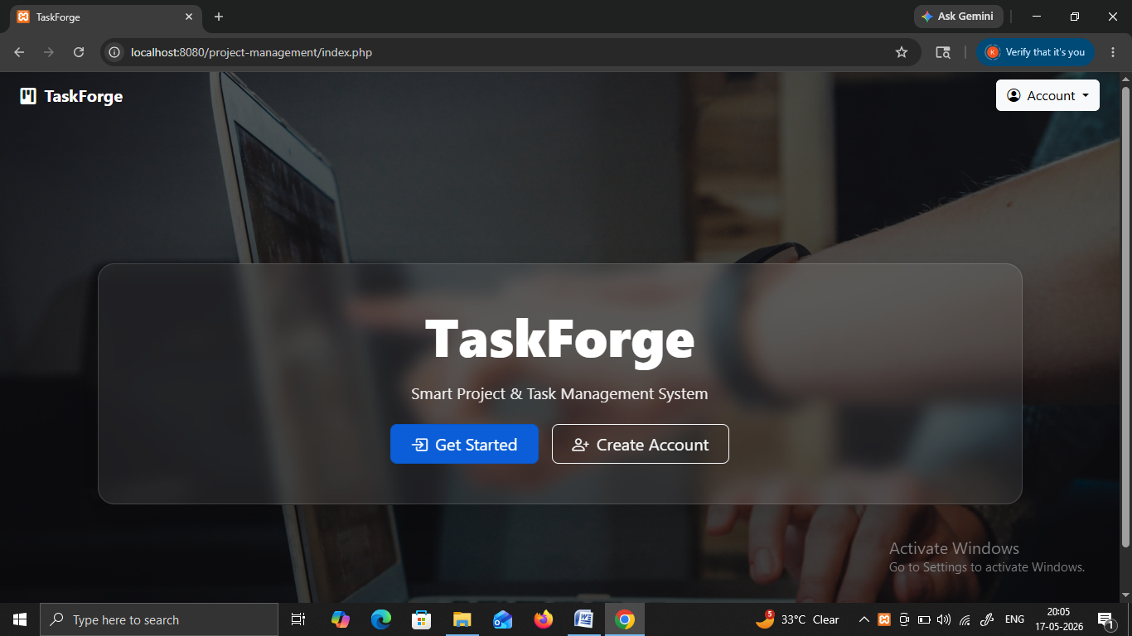
Figure 2: Login Page Interface
The above screenshot represents the Login Page Interface of the project system. Where User is asked to login to existing account or create a new one if don’t.
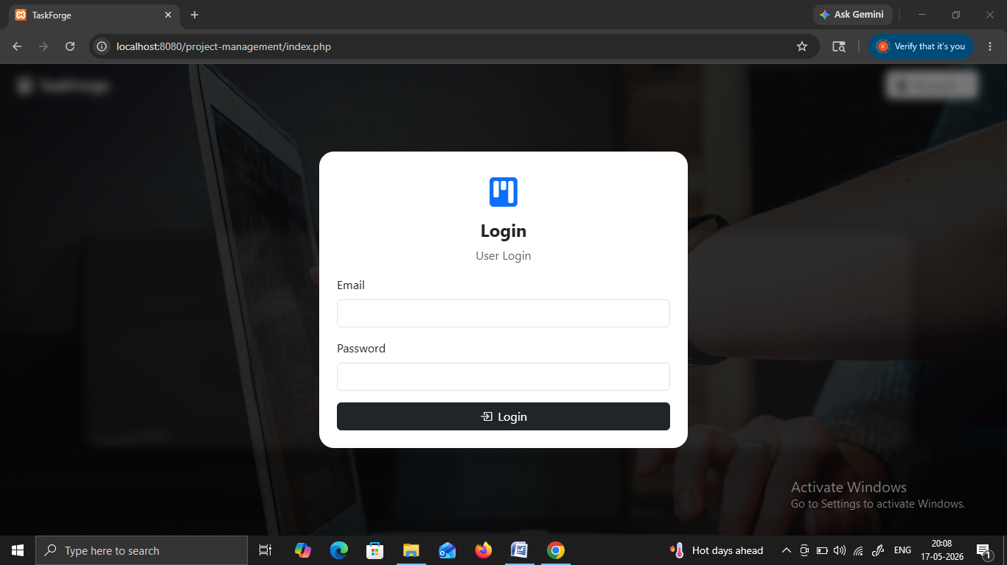
Fig 3: User Authentication Screen
The above screenshot represents the User Authentication Screen of the project system. It asks for the email, and password from the user to ensure authentic login.
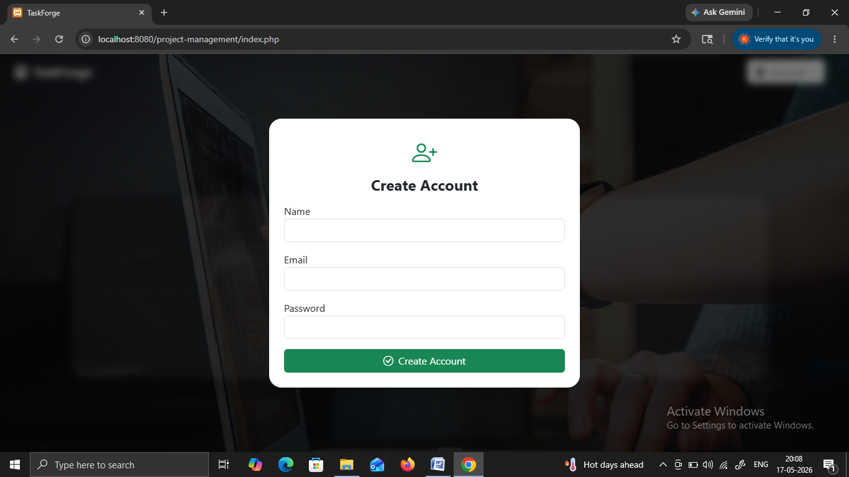
Fig 4: Create Account Interface
The screenshot shows the registration form for creating a new account in the system. This module allows new users to register by entering their personal details and credentials. It supports user management and maintains secure account creation.
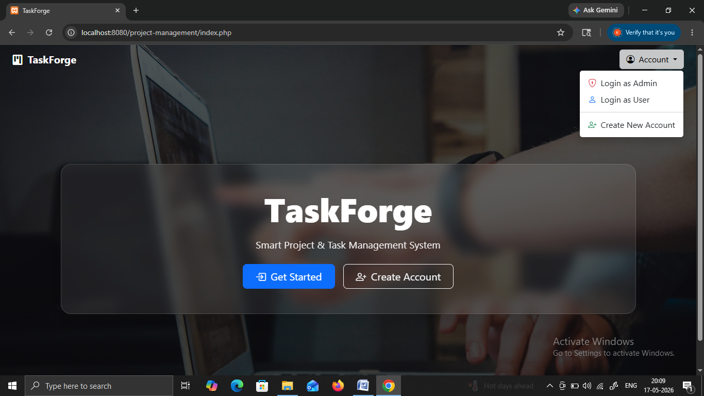
Fig 5: Account Selection Menu
The figure displays the landing page with account options such as Login as Admin, Login as User, and Create New Account. This interface helps users select their appropriate role before accessing the system. It improves navigation and provides role-based access functionality.
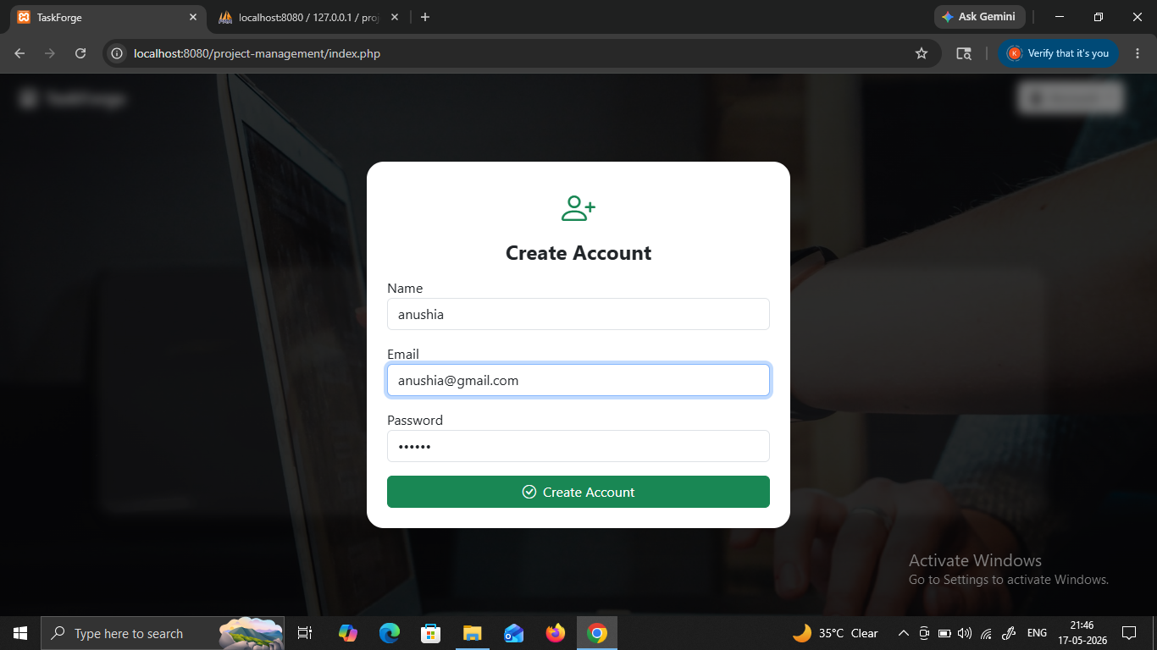
Fig 6: User Registration Form
The screenshot represents the account creation form with fields for name, email, and password. This module collects and stores user information in the database. It ensures proper validation and supports secure user onboarding into the system.
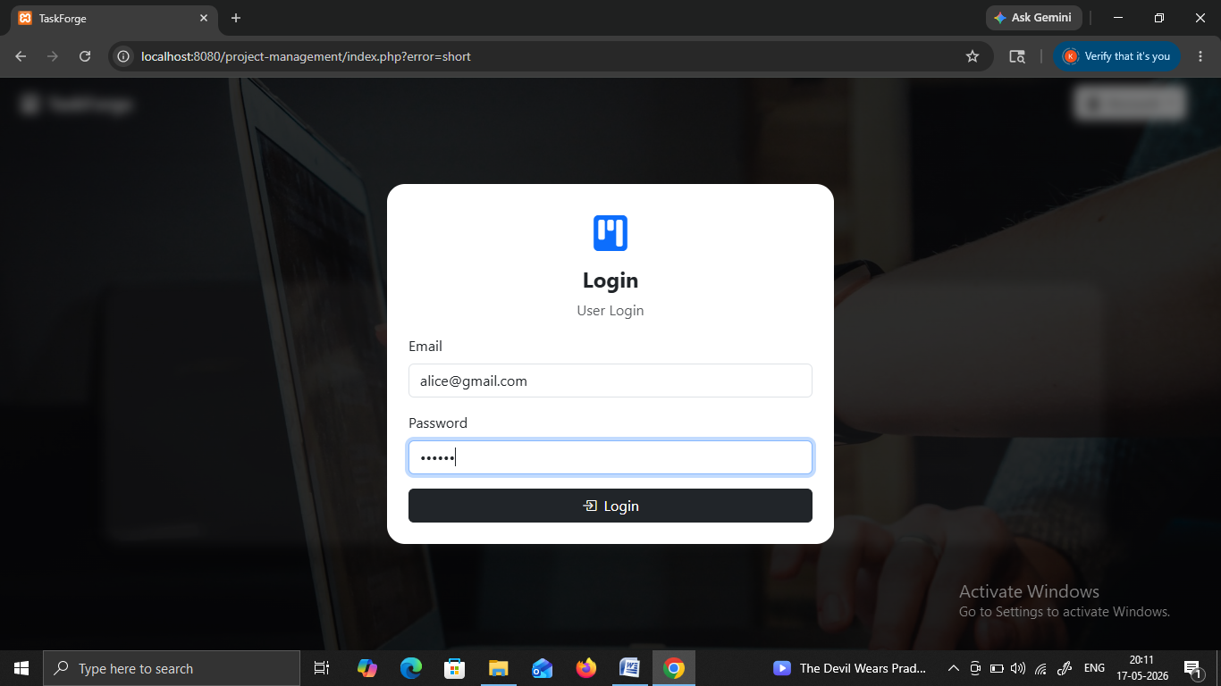
Fig 7: User Authentication Module
The figure displays the login page with user credentials entered into the fields. This screen verifies user credentials and confirms authorized access. It plays an important role in maintaining system confidentiality and integrity.
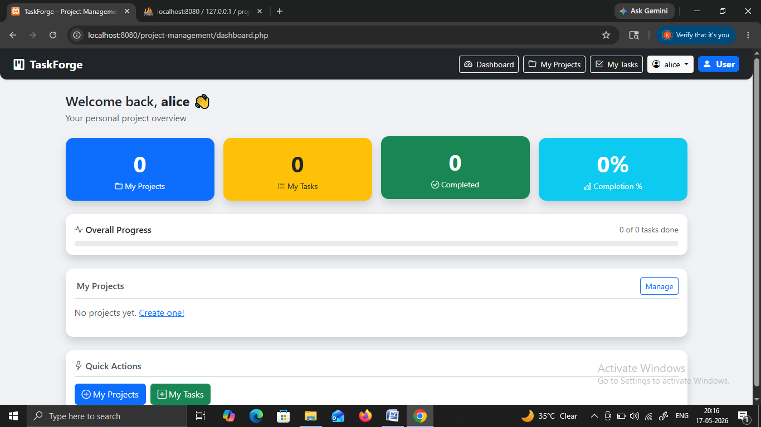
Fig 8: Dashboard Overview
The screenshot shows the user dashboard containing project statistics, completed tasks, and overall progress. This module provides summarized information regarding system activities. It allows users to monitor project performance and task completion efficiently.
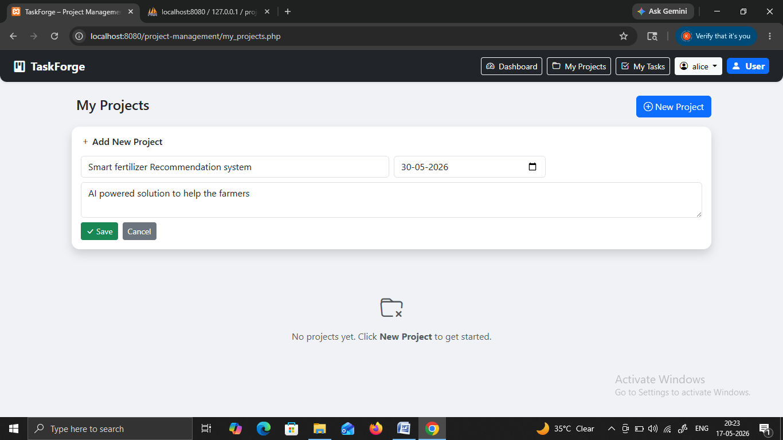
Fig 9: Project Creation Page
The figure displays the “My Projects” interface where a new project is being added. This module enables users to create and organize projects within the system. It simplifies project management and supports efficient workflow planning.
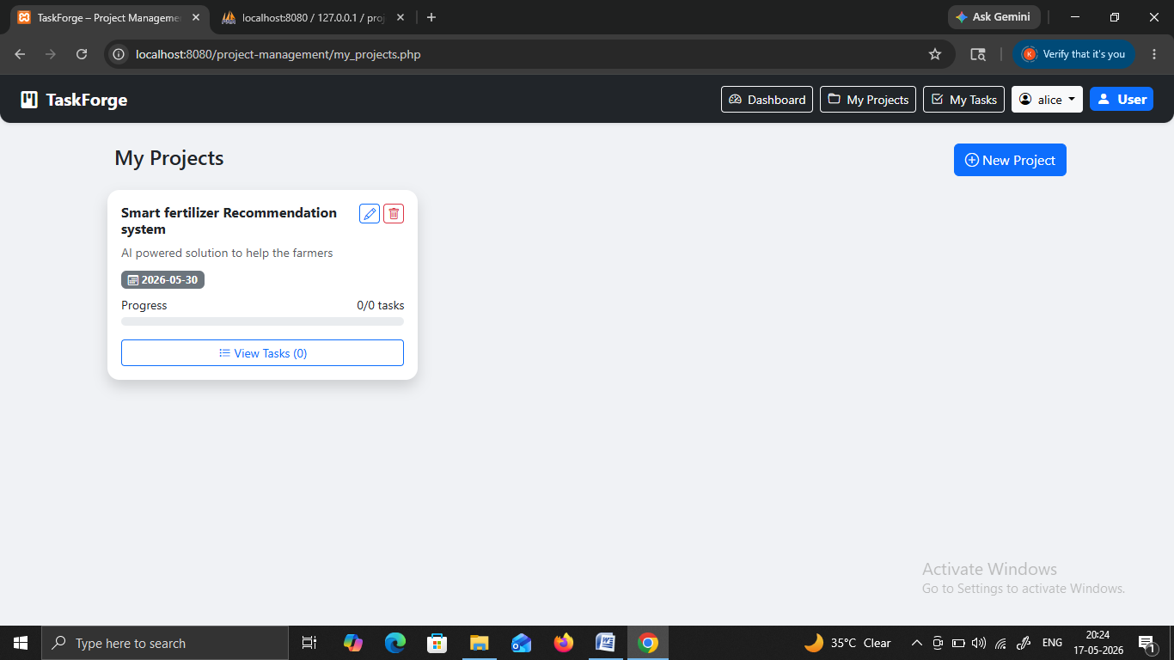
Fig 10: Project Card Display
The screenshot shows a project card with project details and progress information. This interface helps users view project information in a structured manner. It improves accessibility and allows users to monitor project status easily.
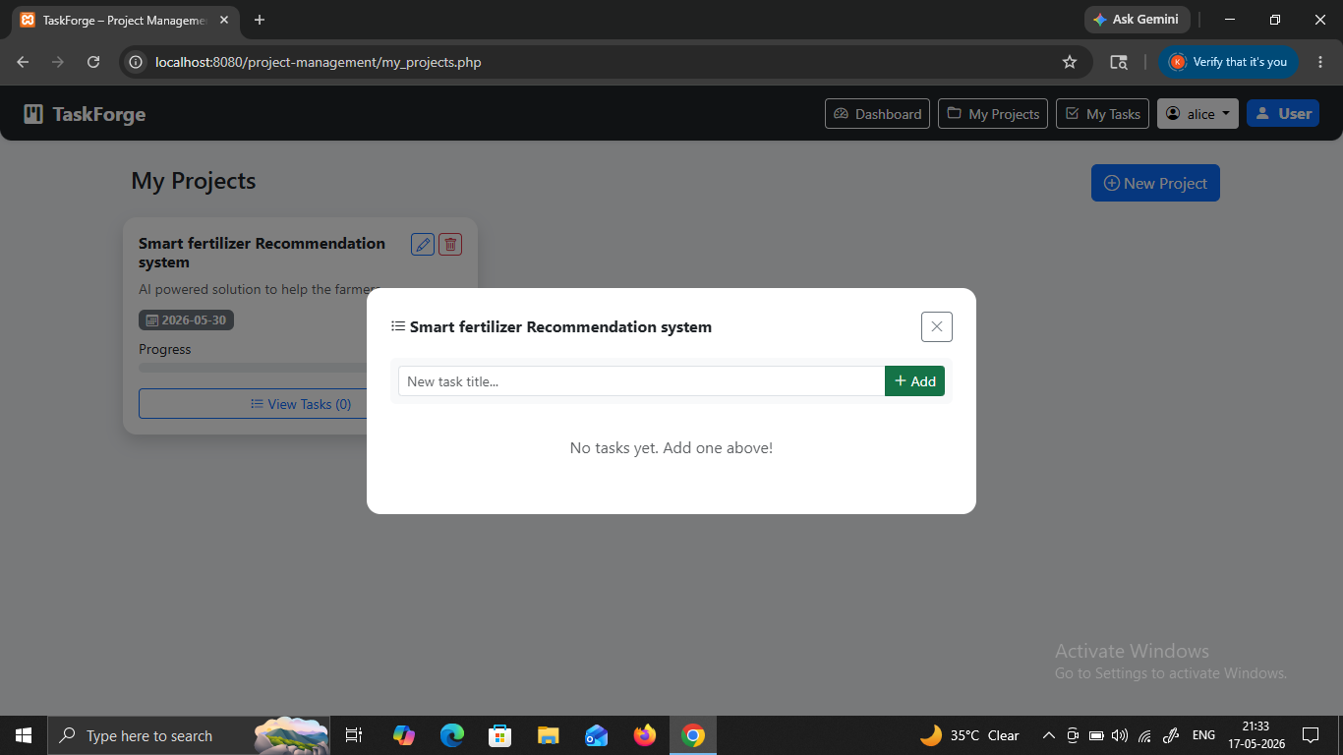
Fig 11: Task Addition Module
The figure displays a popup window for adding tasks into a project. This module allows users to assign and organize tasks within projects. It improves task scheduling and enhances project coordination.
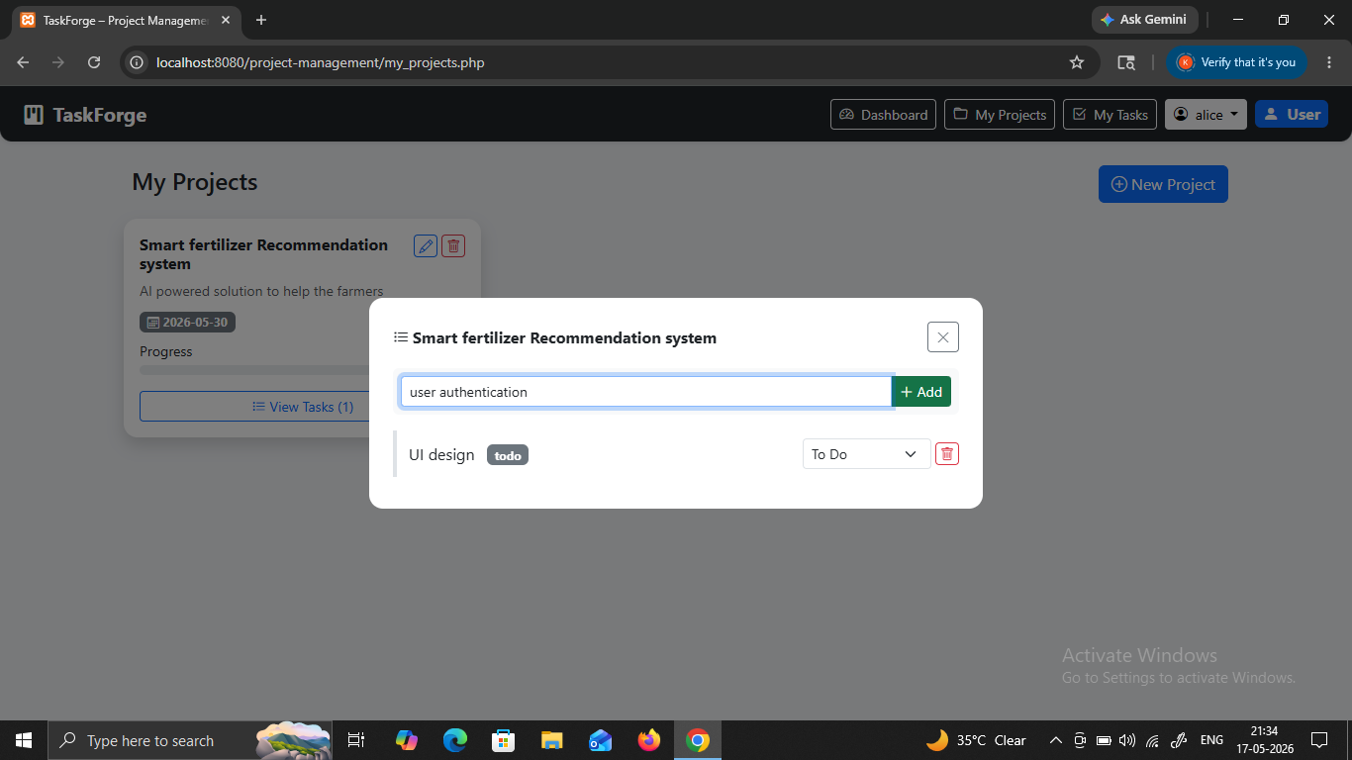
Fig12: Task Management Window
The screenshot shows task details with task names and their current status. This module helps users manage tasks efficiently by tracking task progress. It improves workflow monitoring and ensures organized task execution.
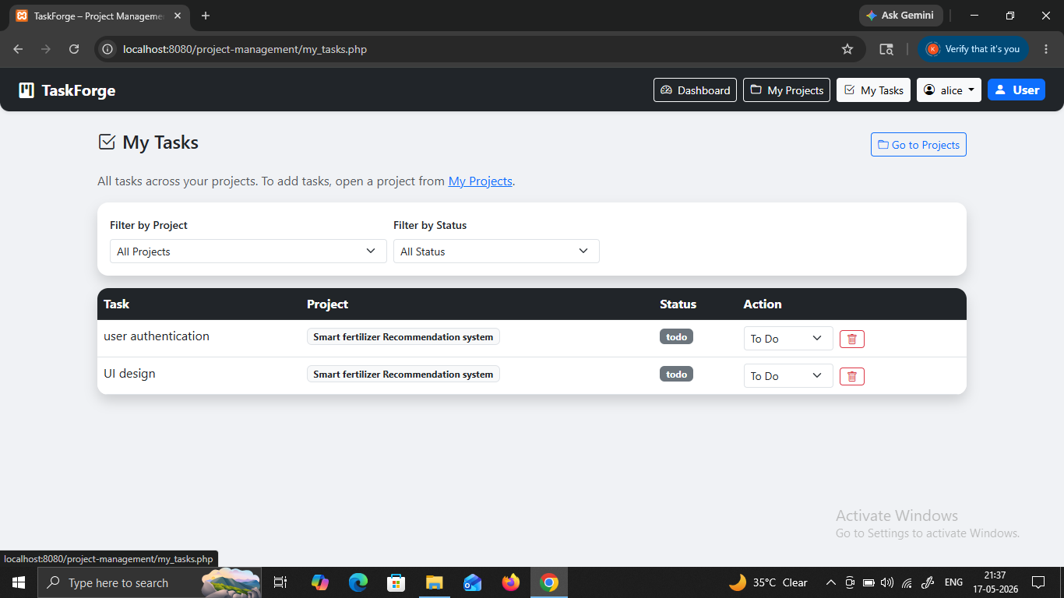
Fig 13: My Task Interface
The figure displays the “My Tasks” section containing task records and their statuses. This module allows users to view all assigned tasks in one place. It improves productivity by providing quick access to pending and completed tasks.
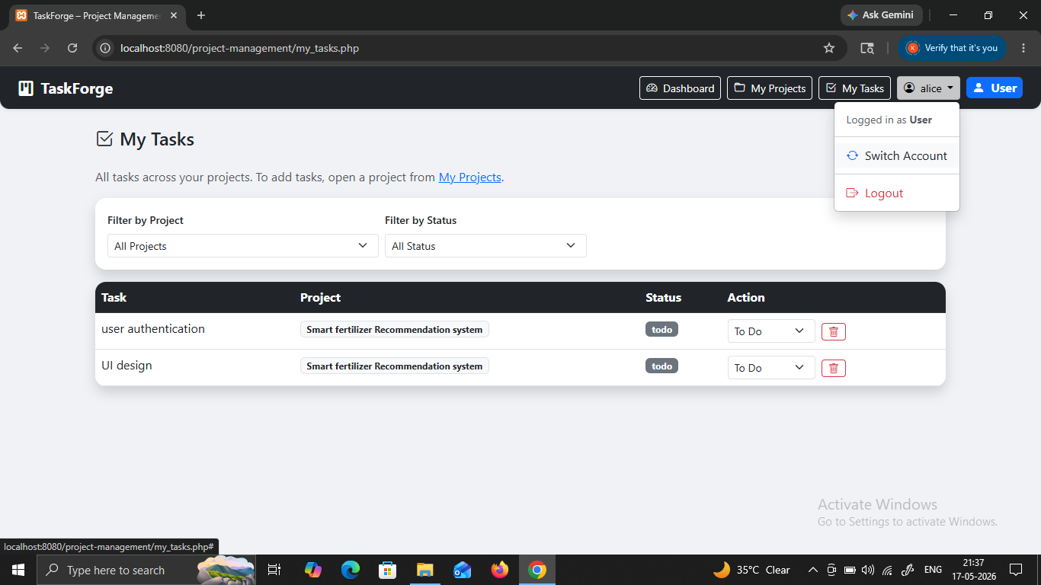
Fig 14: User Profile Dropdown
The screenshot shows account options such as Switch Account and Logout. This feature provides account management functionality. Users can securely switch accounts or log out of the system when required.
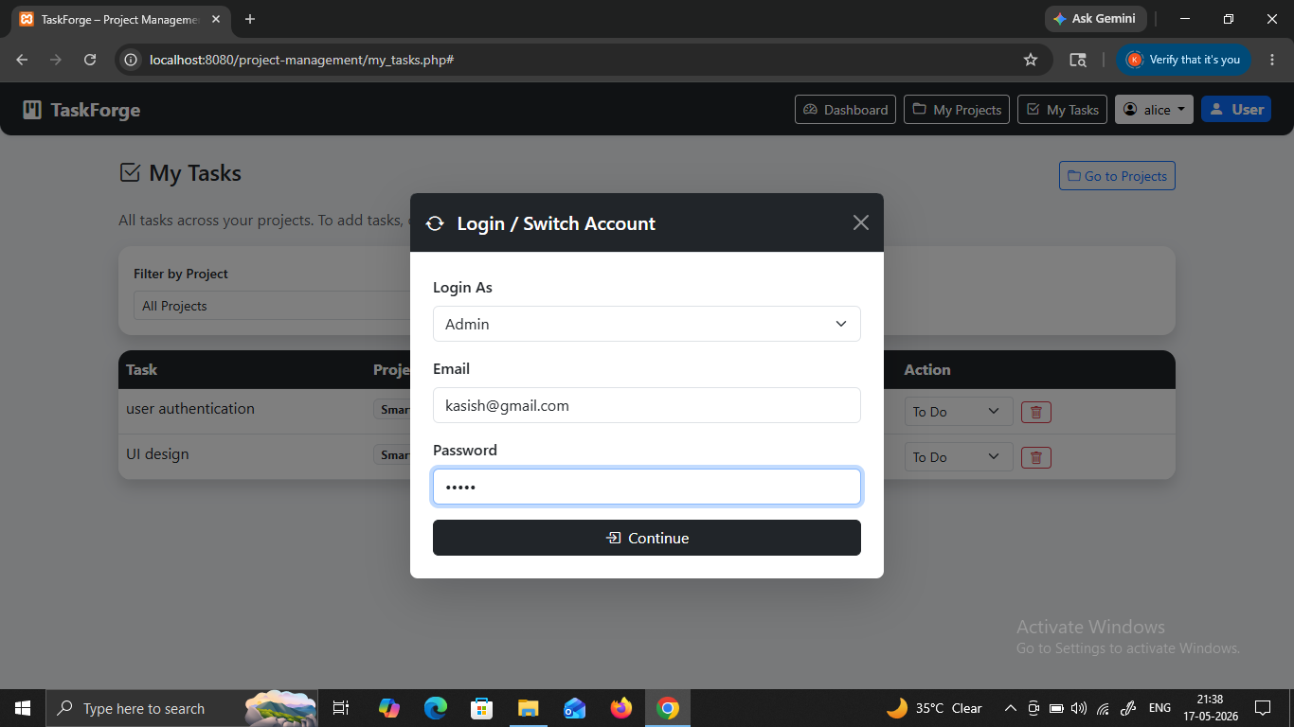
Fig15: Switch Account Module
The figure displays the account switching interface with role selection and login credentials. This module supports multiple user roles within the system. It improves flexibility by allowing administrators and users to access their respective dashboards.
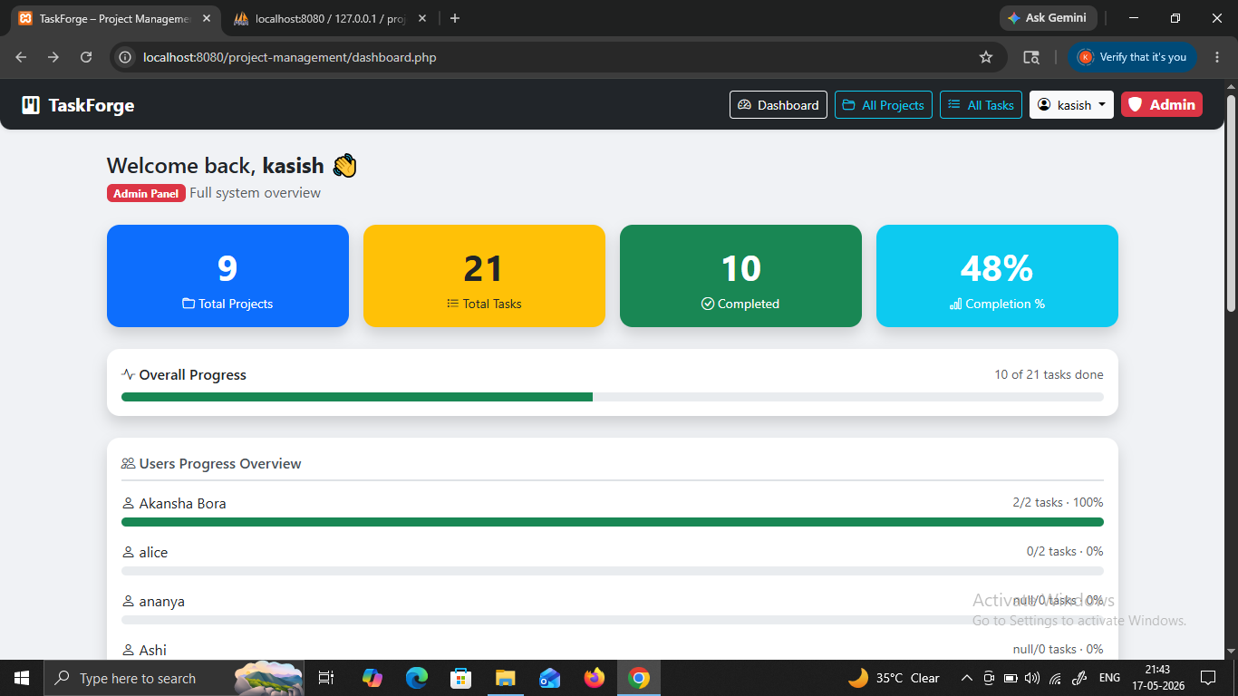
Fig 16: Admin Dashboard
The screenshot shows the administrator dashboard with project statistics and user progress information. This interface enables administrators to monitor project activities and user performance. It centralizes management operations and improves system supervision.
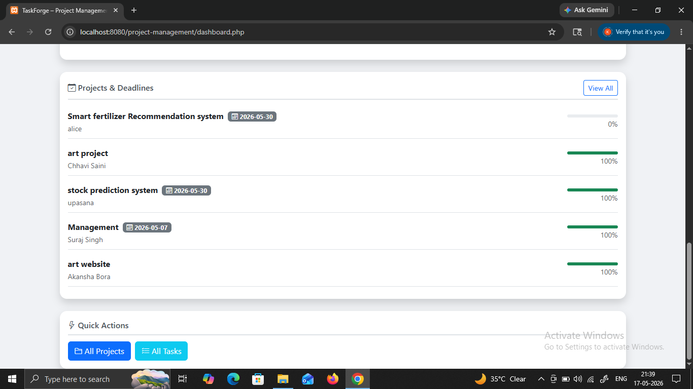
Fig 17: Project Deadline Overview
The figure displays project deadlines and progress percentages for multiple projects. This module helps track project completion timelines and ensures that deadlines are maintained effectively.
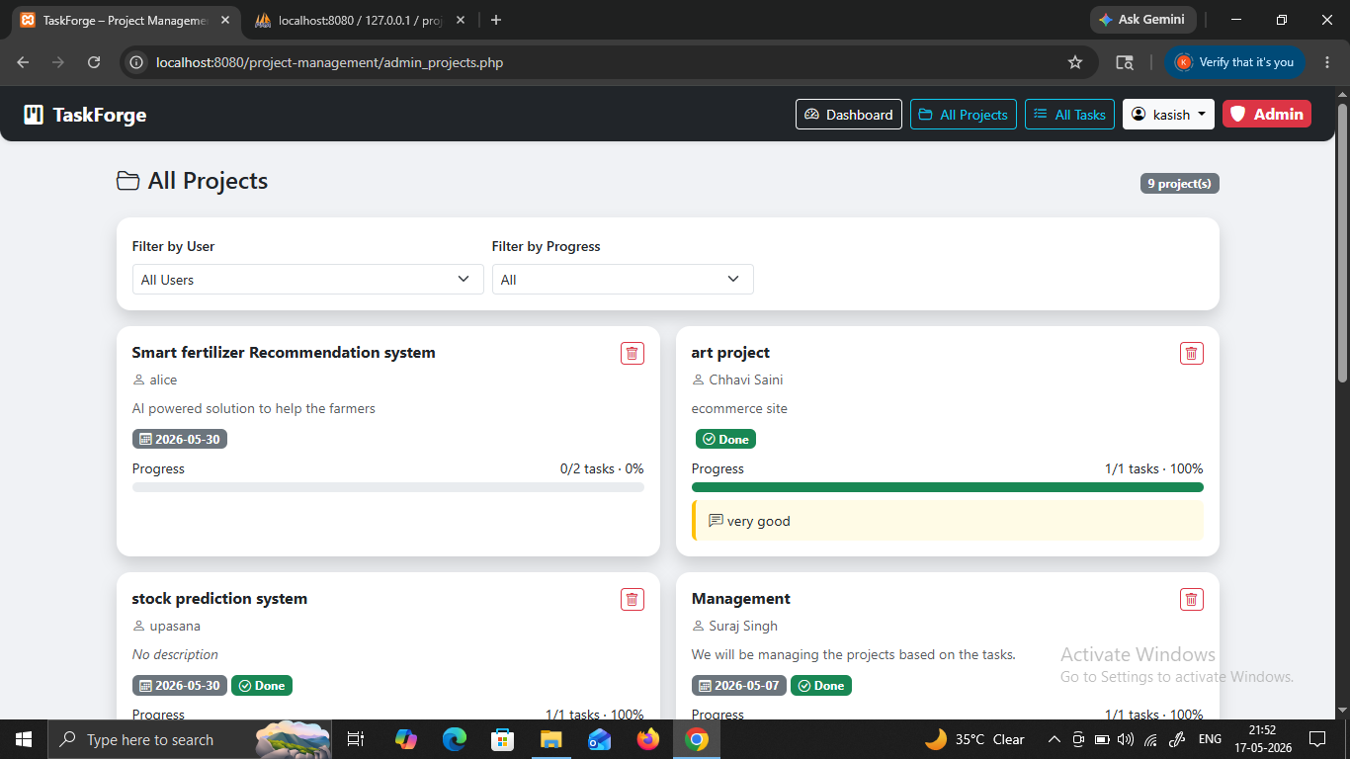
Fig 18: All Projects Interface
The figure displays project deadlines and progress percentages for multiple projects. This module helps track project completion timelines and ensures that deadlines are maintained effectively.
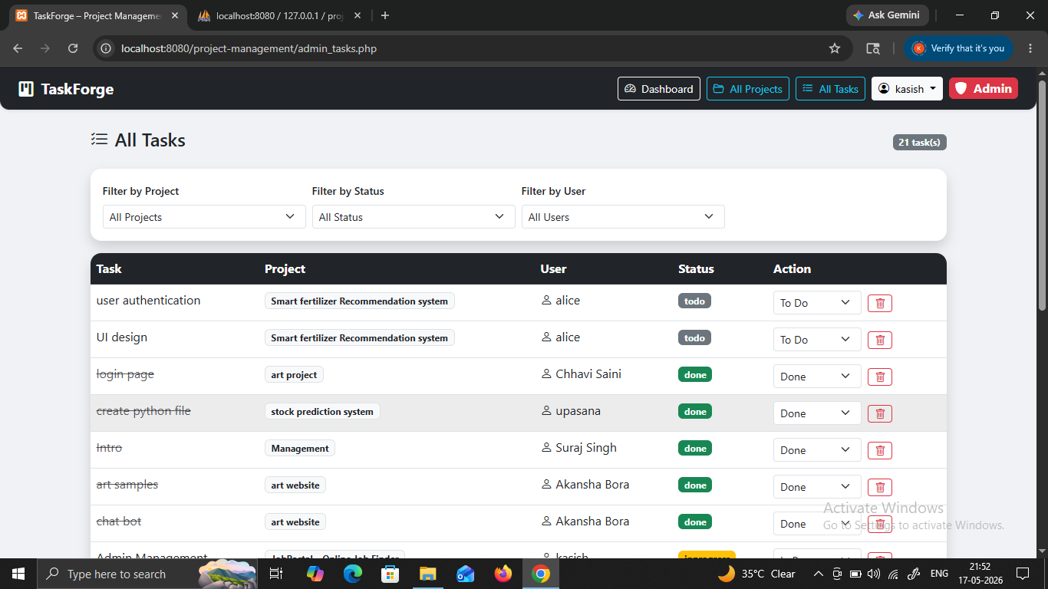
Fig 19: All Tasks Dashboard
The figure shows the complete list of tasks with associated users and statuses. This module provides centralized task monitoring and management. It helps administrators track assigned work and maintain workflow transparency.
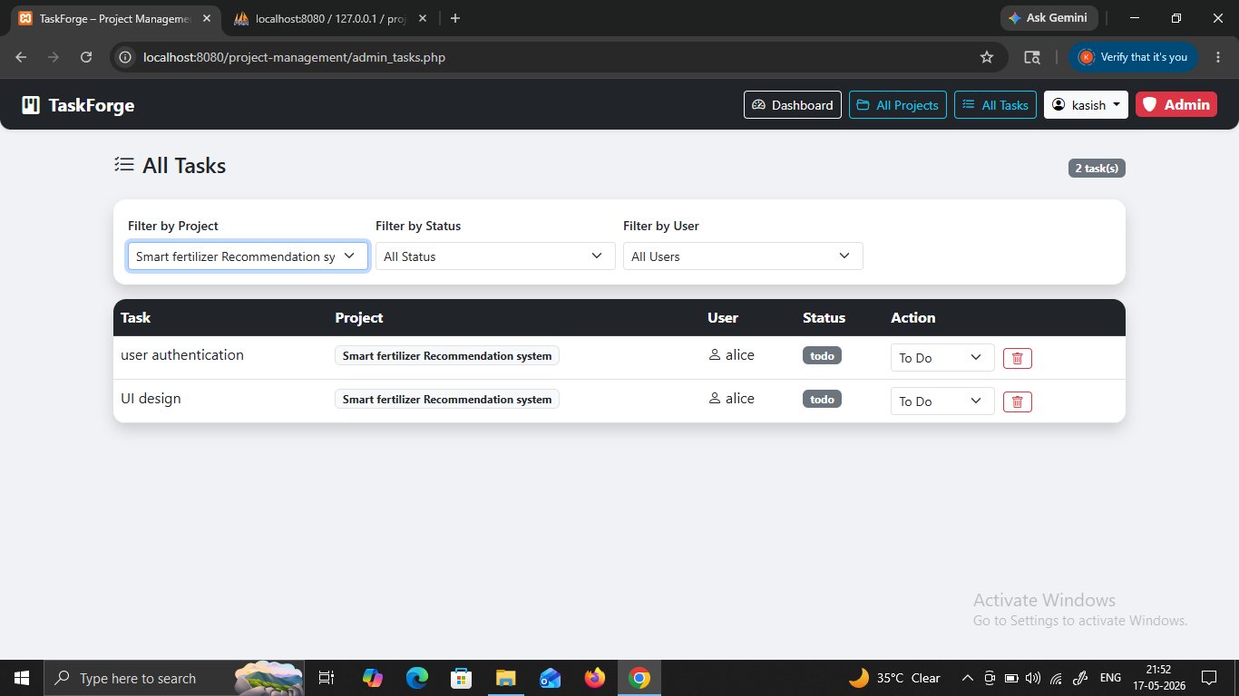
Fig 20: Filtered Task Records
The screenshot displays filtered task records according to selected project criteria. This functionality improves task searching and filtering operations. It helps users quickly identify relevant tasks within large datasets.
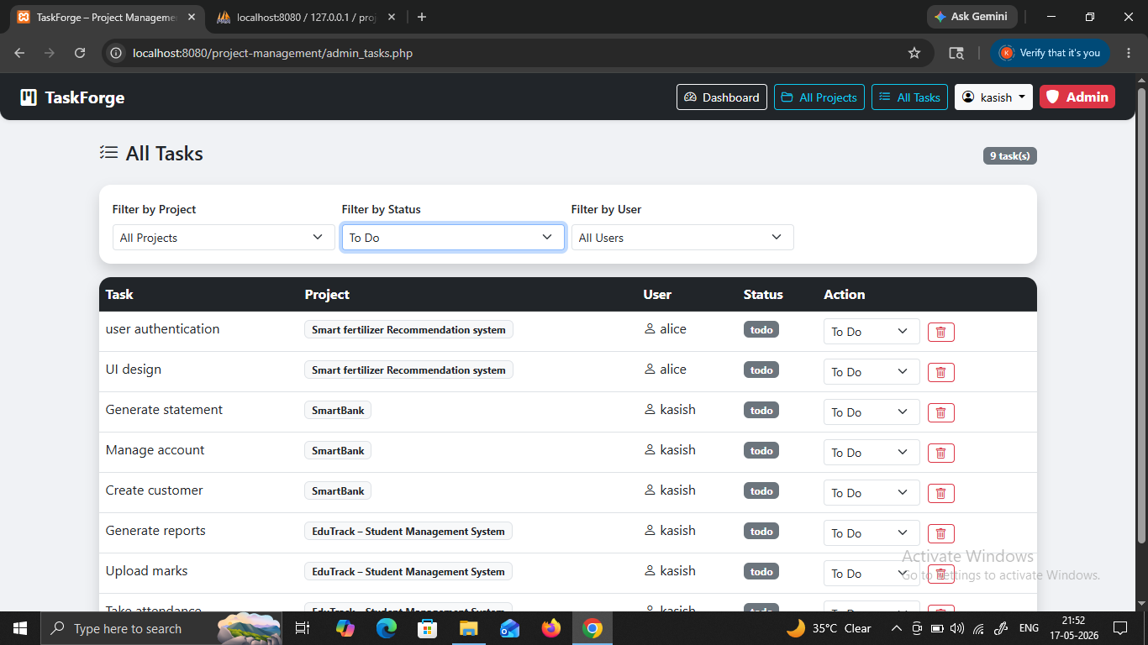
Fig 21: Status-wise Task Monitoring
The figure displays tasks filtered according to individual users and their progress status. This module supports employee performance monitoring and workload management. It helps administrators evaluate individual task contributions.
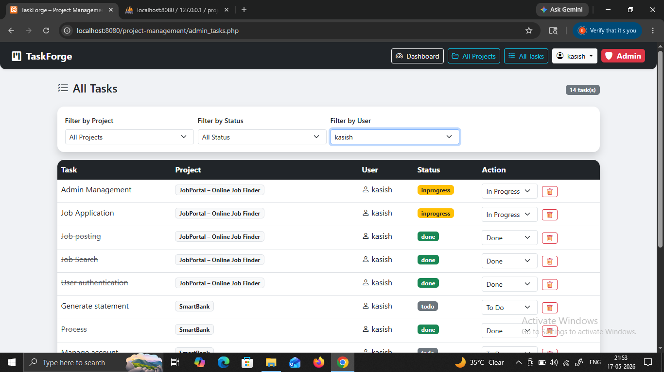
Fig 22: User-wise Task Monitoring
The figure displays tasks filtered according to individual users and their progress status. This module supports employee performance monitoring and workload management. It helps administrators evaluate individual task contributions.
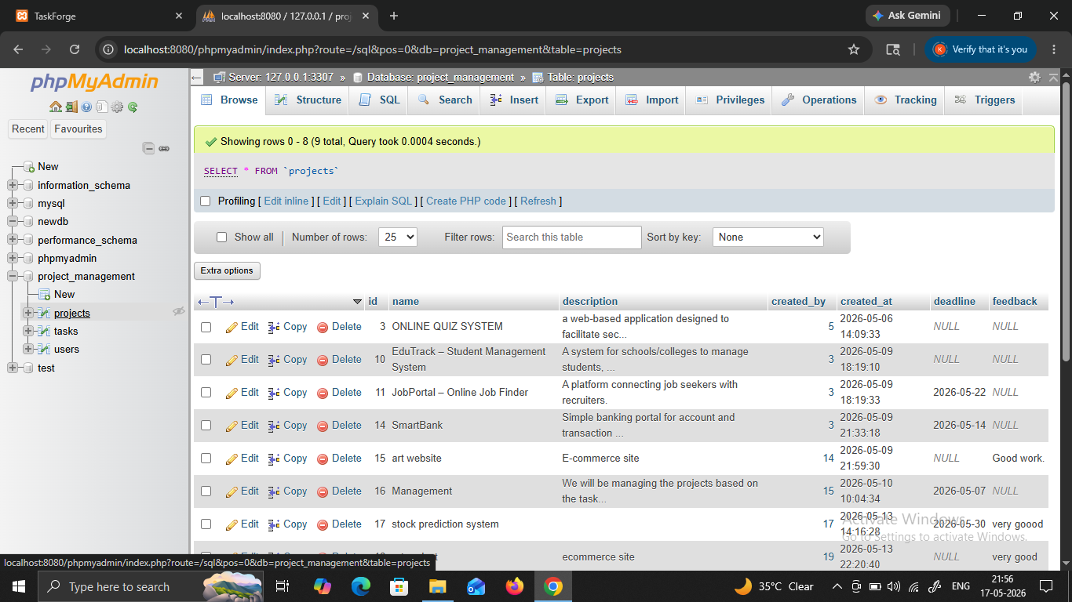
Fig 23: Project Database Table
The screenshot represents the phpMyAdmin database table storing project records. This confirms successful database integration within the application. Project data is securely stored and managed through MySQL tables.
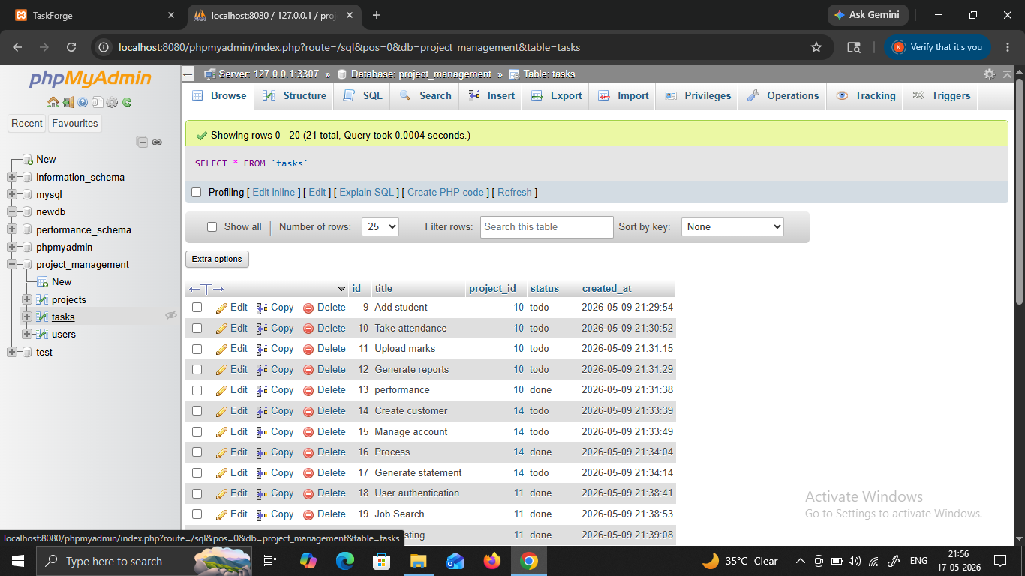
Fig 24: Task Database Records
The figure shows the database table containing task-related information. This module demonstrates how task data is stored and maintained in the backend database for efficient retrieval and management.
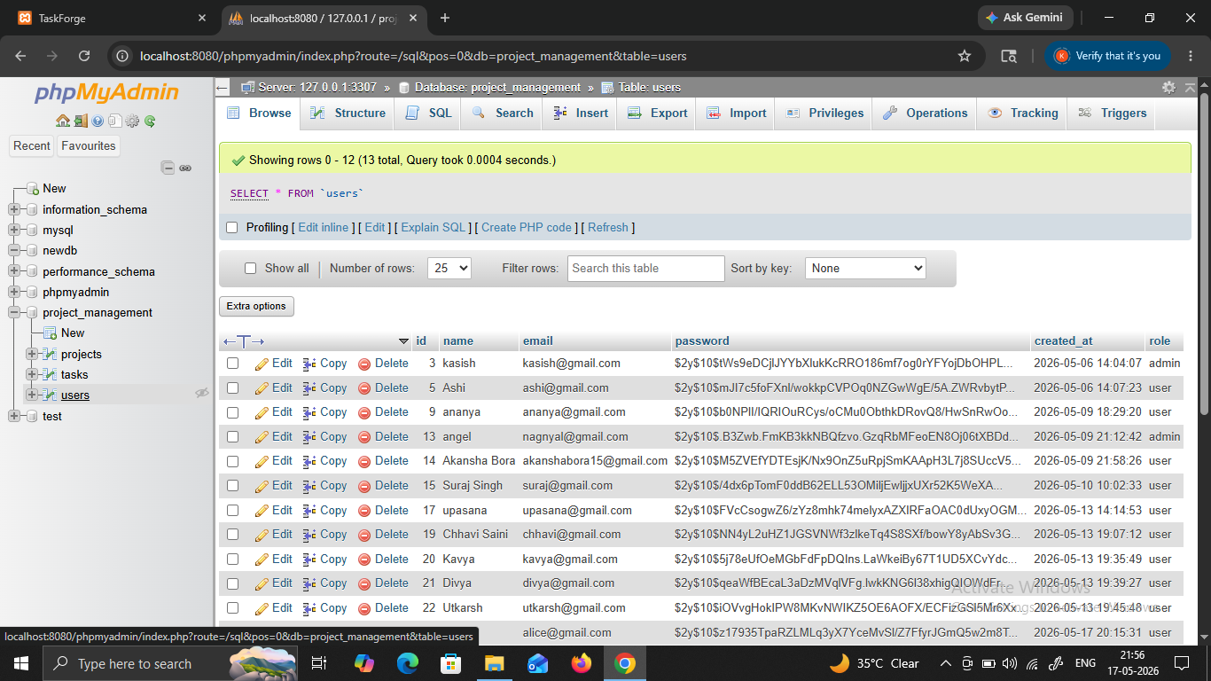
Fig 25: User Information Database
The screenshot displays the database table storing registered user details. This database structure ensures proper management of user credentials and account-related information within the system.

Fig 26: Authentication Data Table
The figure represents database records related to login credentials and authentication details. This module verifies secure data storage practices and supports user authentication functionality in the system..
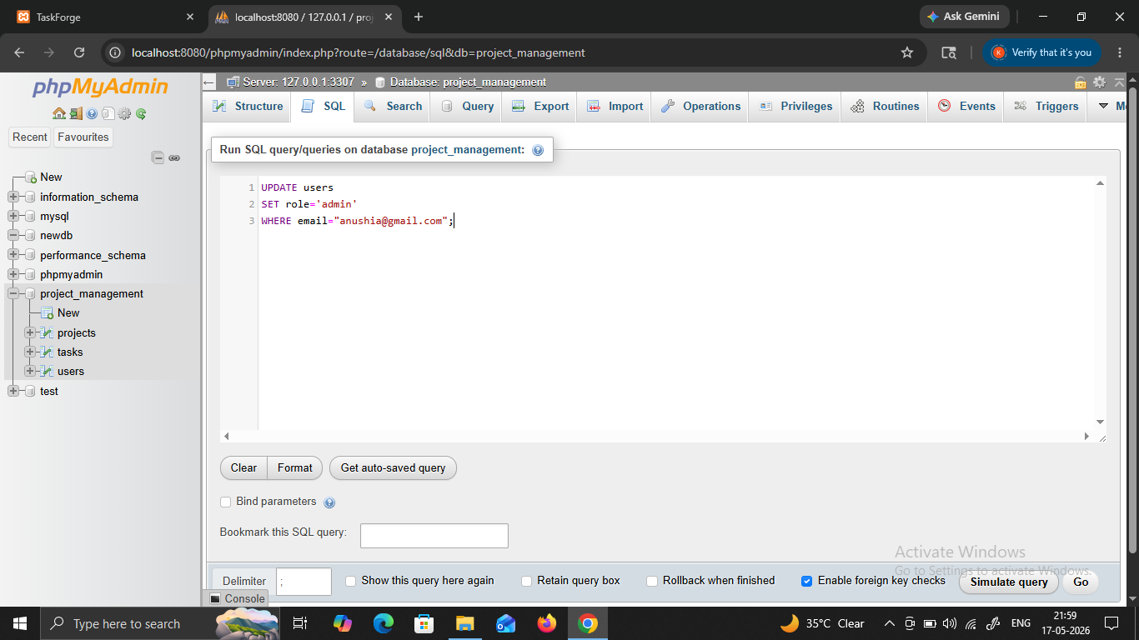
Fig 27: SQL Query Execution Window
The screenshot displays the SQL editor with executed database queries. This module demonstrates backend database operations and confirms successful query execution for project data management.
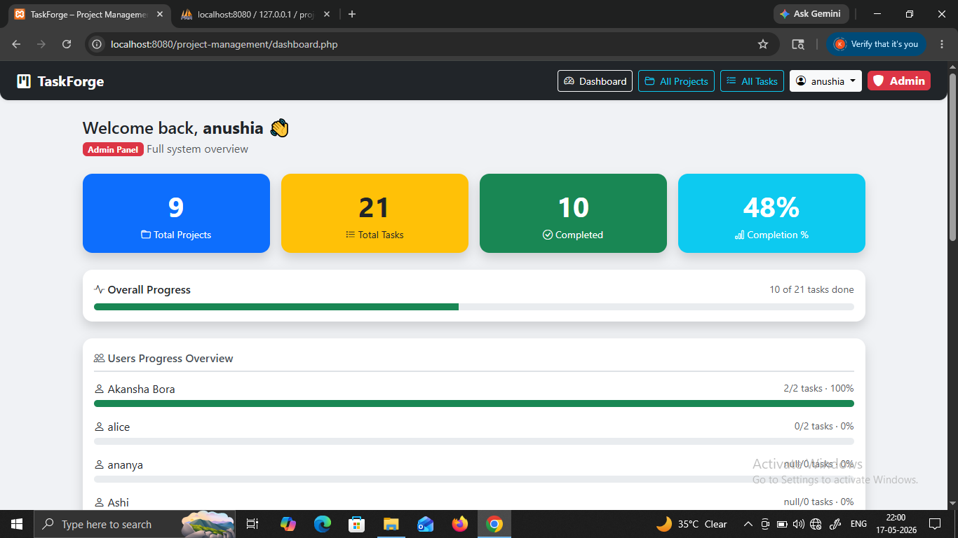
Fig 28: Final System Dashboard
The figure shows the final operational dashboard with project statistics, progress bars, and task summaries. This screenshot confirms the successful implementation of the TaskForge project management system. All modules are functioning properly and providing accurate project monitoring features.

CHAPTER 8: CONCLUSION
TaskForge successfully demonstrates the design and implementation of a full-stack, role-based Project and Task Management System using open-source technologies. The project covers the entire software development lifecycle—from requirements gathering and database design through implementation, testing, and documentation.
The application achieves all eight objectives set out in Chapter 1. Secure authentication using bcrypt and PHP sessions, full CRUD for projects and tasks, a real-time dashboard, an admin oversight panel, RDBMS referential integrity, and a fully responsive Bootstrap interface have all been implemented and verified through 25 test cases—all of which passed.
From an academic perspective, TaskForge illustrates several important computer science concepts for MCA students:
- Relational Database Design: normalization, foreign keys, CASCADE operations, ENUM types.
- Server-Side Scripting: PHP sessions, prepared statements, JSON APIs, role-based access control.
- Client-Side Development: Asynchronous JavaScript (Fetch API), Bootstrap responsive design, dynamic DOM manipulation.
- Security Fundamentals: password hashing, session regeneration, ownership verification before destructive operations.
- Software Engineering: iterative waterfall methodology, DFD and ER diagram documentation, structured test case execution.
The project proves that a functional, secure, and visually appealing web application can be built entirely with free, open-source components—PHP, MySQL, Bootstrap, and XAMPP—without any paid frameworks or cloud services.

CHAPTER 9: FUTURE SCOPE
TaskForge provides a solid foundation upon which many advanced features can be built. The following enhancements are planned or recommended for future versions:

Enhancement | Description | Technology / Approach
Multi-user Project Collaboration | Allow multiple users to be assigned to a single project with configurable permissions (owner, editor, viewer) | Add a project_members junction table; extend RBAC logic
Task Assignment | Allow admins or project owners to assign individual tasks to specific users | Add assigned_to (FK → users.id) column to tasks table
Email Notifications | Send automated emails for deadline reminders, task assignments, and admin feedback | PHP Mailer / SMTP integration; cron jobs for scheduled alerts
File Attachments | Allow users to upload documents, images, or design files to a task | PHP file upload with validation; store files in uploads/ directory; record path in DB
Gantt Chart / Timeline | Visual timeline view of all projects and their deadlines | JavaScript library (e.g., Frappe Gantt) consuming project data API
Comment / Discussion Thread | Allow users to add comments to tasks for discussion | Add task_comments table; real-time updates via polling or WebSocket
Search & Global Filter | Full-text search across all projects and tasks | MySQL FULLTEXT index on name and title columns
Priority Levels for Tasks | Allow tasks to be marked Low / Medium / High / Critical priority | Add priority ENUM column to tasks; update UI with color-coded labels
Dark Mode | User-selectable dark theme to reduce eye strain | CSS custom properties (variables) + localStorage preference persistence
REST API with Token Auth | Expose a full REST API secured with JWT for mobile app consumption | PHP JWT library; Bearer token authentication for stateless API
Reporting & Export | Export project/task data as CSV or PDF reports | PHP CSV export; mpdf/TCPDF library for PDF generation
Cloud Deployment | Deploy TaskForge on a VPS / cloud server for internet access | Apache VPS (DigitalOcean, AWS Lightsail); Let's Encrypt SSL; domain name
Unit & Integration Tests | Automated test suite for all API endpoints | PHPUnit framework; Selenium or Playwright for UI tests
Activity Log / Audit Trail | Log every create/update/delete operation with timestamp and user | Add activity_log table; INSERT trigger or middleware logging

REFERENCES:
[1] PHP Group. (2024). PHP Manual. Retrieved from https://www.php.net/manual/en/
[2] MySQL AB. (2024). MySQL 8.0 Reference Manual. Oracle Corporation. Retrieved from https://dev.mysql.com/doc/refman/8.0/en/
[3] Bootstrap Team. (2023). Bootstrap 5.3 Documentation. Retrieved from https://getbootstrap.com/docs/5.3/
[4] Bootstrap Icons Team. (2023). Bootstrap Icons 1.11. Retrieved from https://icons.getbootstrap.com/
[5] Mozilla Developer Network (MDN). (2024). Fetch API. Retrieved from https://developer.mozilla.org/en-US/docs/Web/API/Fetch_API
[6] Apache Software Foundation. (2024). Apache HTTP Server Documentation. Retrieved from https://httpd.apache.org/docs/
[7] XAMPP Team. (2024). XAMPP – Cross-platform Apache distribution. ApacheFriends. Retrieved from https://www.apachefriends.org/
[8] Connolly, T. M., & Begg, C. E. (2015). Database Systems: A Practical Approach to Design, Implementation, and Management (6th ed.). Pearson Education.
[9] Pressman, R. S., & Maxim, B. R. (2020). Software Engineering: A Practitioner's Approach (9th ed.). McGraw-Hill Education.
[10] Sommerville, I. (2016). Software Engineering (10th ed.). Pearson Education.
[11] MDN Web Docs. (2024). JavaScript Reference – ES6+. Retrieved from https://developer.mozilla.org/en-US/docs/Web/JavaScript
[12] PHP The Right Way. (2024). PHP Best Practices. Retrieved from https://phptherightway.com/
[13] Silberschatz, A., Korth, H. F., & Sudarshan, S. (2020). Database System Concepts (7th ed.). McGraw-Hill Education.
[14] OWASP Foundation. (2024). OWASP Top Ten Web Application Security Risks. Retrieved from https://owasp.org/www-project-top-ten/
[15] W3Schools.com. (2024). PHP Tutorial, MySQL Tutorial, Bootstrap 5 Tutorial. Retrieved from https://www.w3schools.com/

