Part 2: Basic Test Automation Task Scenario:

Automate the testing of the job application form from Part 1.

Instructions:

1. Use Selenium WebDriver or any automation tool you are familiar with.

2. Automate the following test scenarios:

* Valid form submission with all correct inputs.

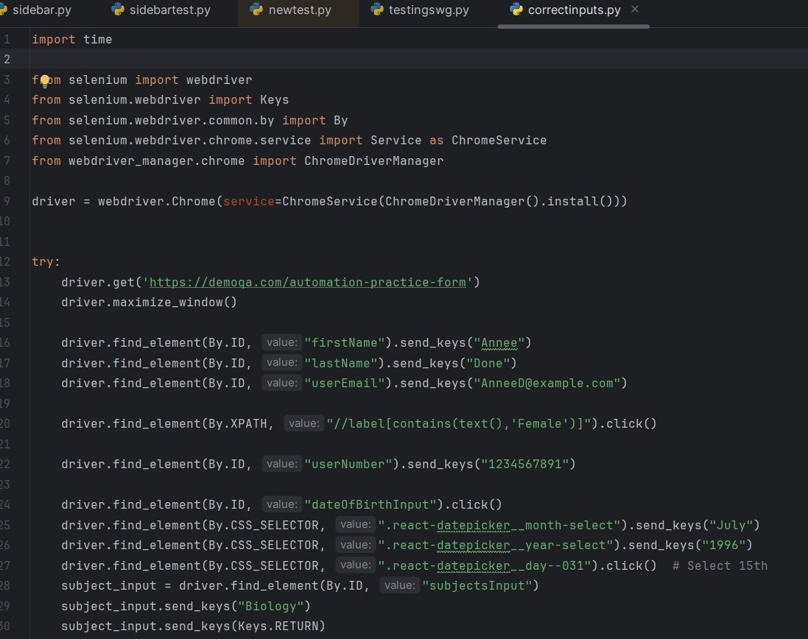

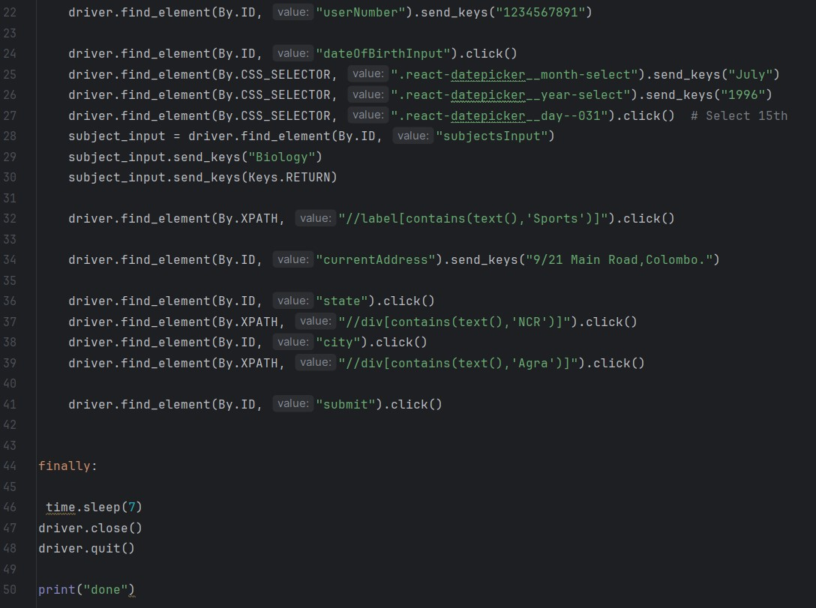

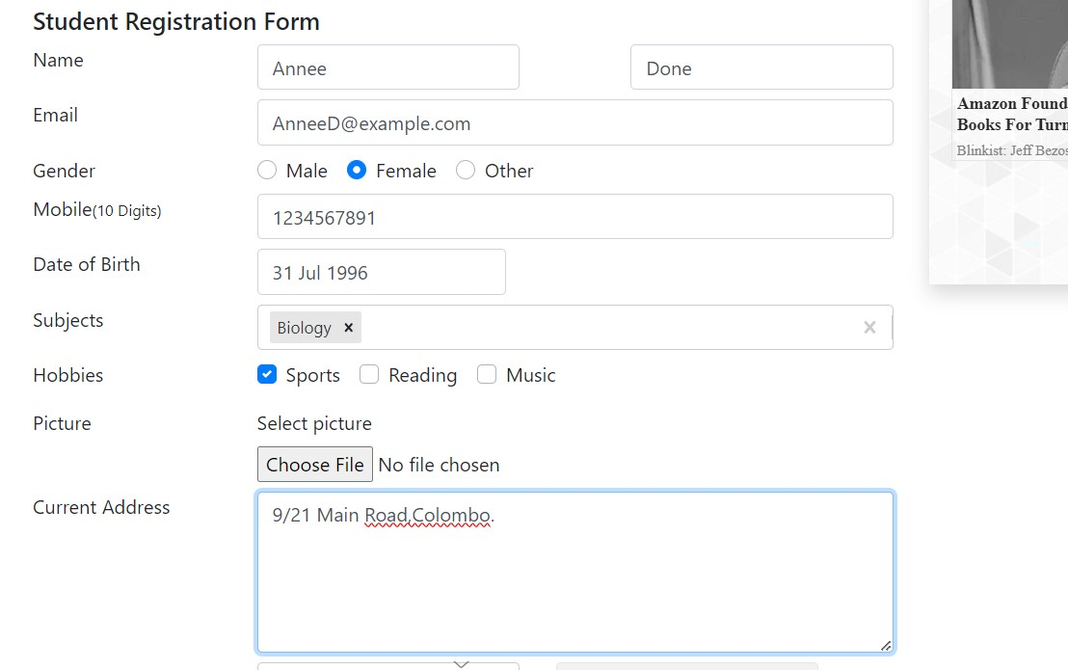

* 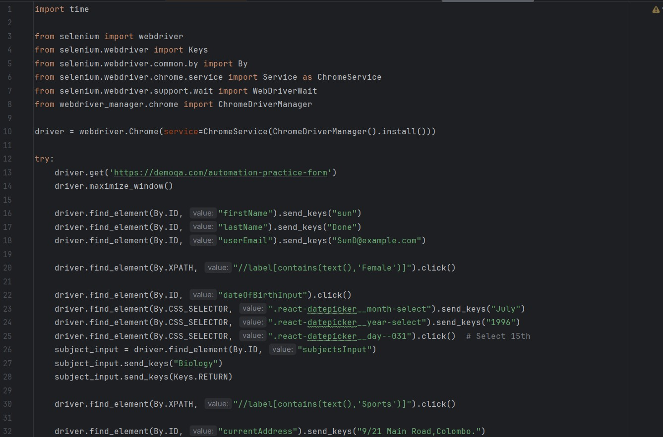Form submission with mandatory fields left blank.

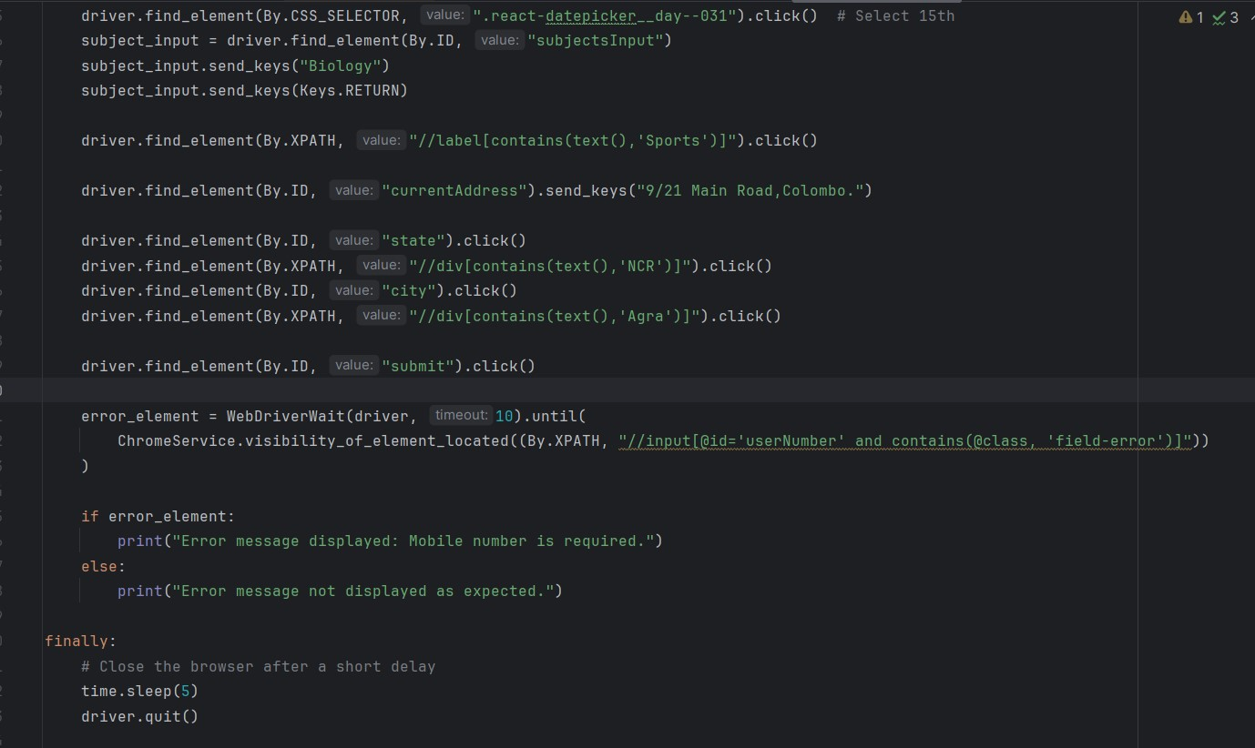

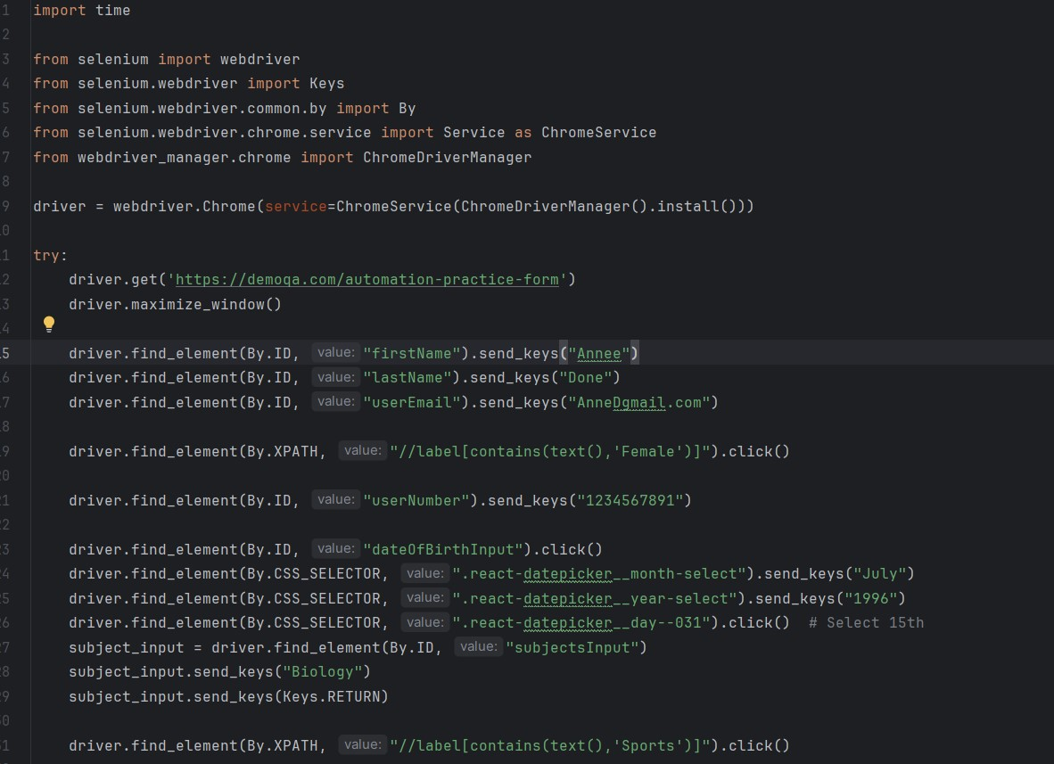

* Invalid email format validation.

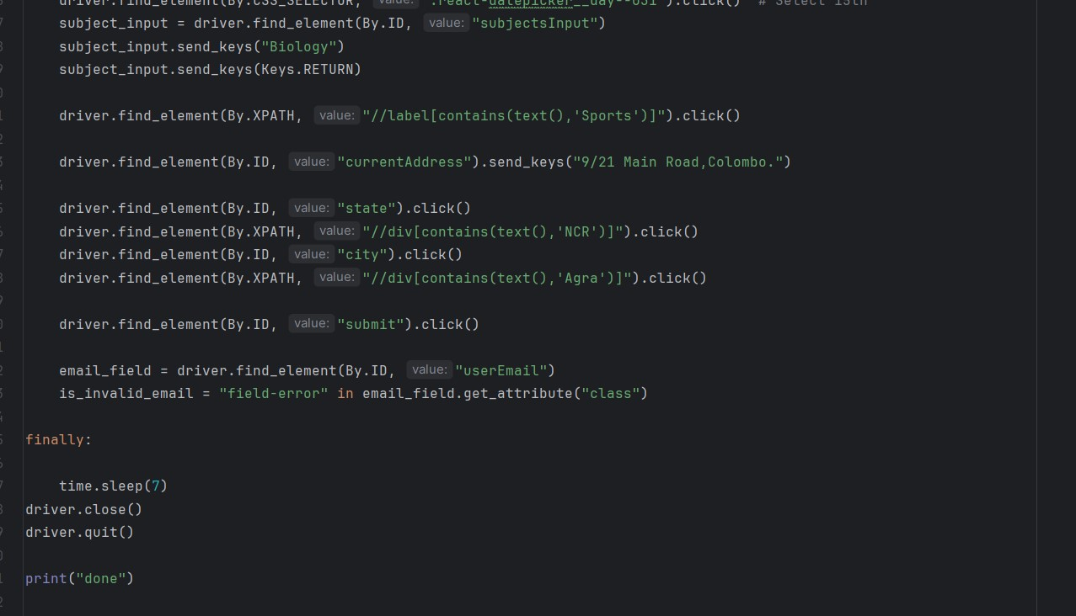

|  |  |  |  |
| --- | --- | --- | --- |
| **Test case** | **Expected Result** | **Actual Result** | **Status** |
| Valid form submission with all correct inputs | User should enter all the correct input | User entered all the correct inputs | Pass |
| Form submission with mandatory fields left blank | Error message or related error icon need to display | Related Error icon appeared | Pass |
| Invalid email format validation | Error message or related error icon need to display | Related Error icon appeared | Pass |