

**School of Computer Science & Engineering Computer Networks Lab**

**(20ECSP305)**

**Evaluation -2**

**Mininet Topology**

***Submitted By***

***Suraksha Mummigatti***

***USN:01FE21BCS090***

***Roll no:311***

***Under the guidance of***

**Dr. M.M. Raikar**

**School of Computer Science & Engineering KLE Technological University**

**1. Introduction**

This document details the design and setup of a wireless network topology using Mininet-WiFi. The network features multiple stations, access points, and hosts, emulating a small-scale wireless network environment.

**2. Topology Description**

The network topology includes the following elements:

* Stations (sta1, sta2): Wireless stations symbolizing mobile devices or client devices.
* Access Points (ap1, ap2): Wireless access points functioning as central hubs to connect stations and hosts.
* Hosts (h1, h2, h3, h4): Network hosts representing stationary devices or servers.
* The network incorporates two access points (APs), each connecting a specific group of hosts and stations.

**3. Configuration Details**

**3.1. Station Configuration**

**Station 1 (sta1):**

MAC address: 00:00:00:00:00:05

IP address: 10.0.0.5/24

Position: 10,10,0

**Station 2 (sta2):**

MAC address: 00:00:00:00:00:06

IP address: 10.0.0.6/24

Position: 20,20,0

**3.2. Access Point Configuration**

**Access Point 1 (ap1):**

SSID: ssid-ap1

Channel: 1

Position: 10,50,0

**Access Point 2 (ap2):**

SSID: ssid-ap2

Channel: 2

Position: 70,50,0

**3.3. Host Configuration**

**Host 1 (h1):**

IP address: 10.0.0.1/24

MAC address: 00:00:00:00:00:01

**Host 2 (h2):**

IP address: 10.0.0.2/24

MAC address: 00:00:00:00:00:02

**Host 3 (h3):**

IP address: 10.0.0.3/24

MAC address: 00:00:00:00:00:03

**Host 4 (h4):**

IP address: 10.0.0.4/24

MAC address: 00:00:00:00:00:04

**3.4. Controller Configuration**

Controller (c1): Responsible for managing the wireless network.

**3.5. Wireless Configuration**

Propagation Model: Log Distance Model with an exponent of 5.

Wi-Fi Nodes Configuration: Configuration C

**4. Network Operation**

The network functions as follows:

Stations sta1 and sta2 begin at positions 10,30,0 and 10,40,0, respectively.

Both stations move to their final positions over 10 seconds.

An HTTP server is initiated on Host 1 (h1) to deliver content.

**Code:**

#!/usr/bin/env python

import sys

from mininet.log import setLogLevel, info

from mn_wifi.cli import CLI

from mn_wifi.net import Mininet_wifi

from mininet.node import Host

def topology(args):

"Creating the Network!!."

# Create Mininet WiFi network object

net = Mininet_wifi()

# Create network nodes

info("--->Creating nodes\n")

sta1 = net.addStation('sta1', mac='00:00:00:00:00:05', ip='10.0.0.5/24', position='10,10,0')

sta2 = net.addStation('sta2', mac='00:00:00:00:00:06', ip='10.0.0.6/24', position='20,20,0')

ap1 = net.addAccessPoint('ap1', ssid='ssid-ap1', channel='1', position='10,50,0')

ap2 = net.addAccessPoint('ap2', ssid='ssid-ap2', channel='2', position='70,50,0')

h1 = net.addHost('h1', ip='10.0.0.1/24', cls=Host, mac='00:00:00:00:00:01')

h2 = net.addHost('h2', ip='10.0.0.2/24', cls=Host, mac='00:00:00:00:00:02')

h3 = net.addHost('h3', ip='10.0.0.3/24', cls=Host, mac='00:00:00:00:00:03')

h4 = net.addHost('h4', ip='10.0.0.4/24', cls=Host, mac='00:00:00:00:00:04')

c1 = net.addController('c1')

# Set propagation model

net.setPropagationModel(model="logDistance", exp=5)

# Configure wireless nodes

info("--->Configuring nodes\n")

net.configureWifiNodes()

# Create links between nodes

info("---> Creating links\n")

net.addLink(ap1, ap2)

net.addLink(h1, ap1)

net.addLink(h2, ap2)

net.addLink(h3, ap1)

net.addLink(h4, ap2)

# Plot network graph

net.plotGraph(max_x=100, max_y=100)

# Start mobility

net.startMobility(time=0)

net.mobility(sta1, 'start', time=1, position='10,30,0')

net.mobility(sta2, 'start', time=2, position='10,40,0')

net.mobility(sta1, 'stop', time=10, position='50,30,0')

net.mobility(sta2, 'stop', time=10, position='60,40,0')

net.stopMobility(time=11)

# Start network

info("--->Starting network\n")

net.build()

c1.start()

ap1.start([c1])

ap2.start([c1])

# Start HTTP server on h1

info("--->Starting HTTP server on h1\n")

h1.cmd('python -m http.server 80 &')

# Run CLI

info("---> Running CLI\n")

CLI(net)

# Stop network

info("xxx---Stopping network---xxx\n")

net.stop()

if __name__ == '__main__':

setLogLevel('info')

topology(sys.argv)

Screenshots:

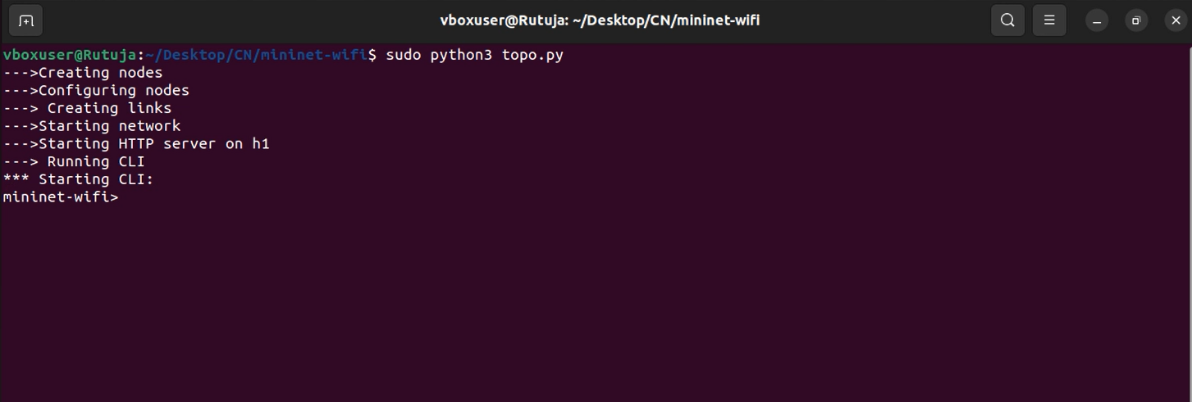

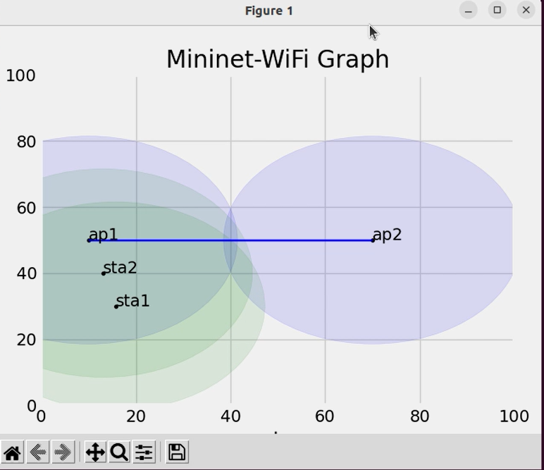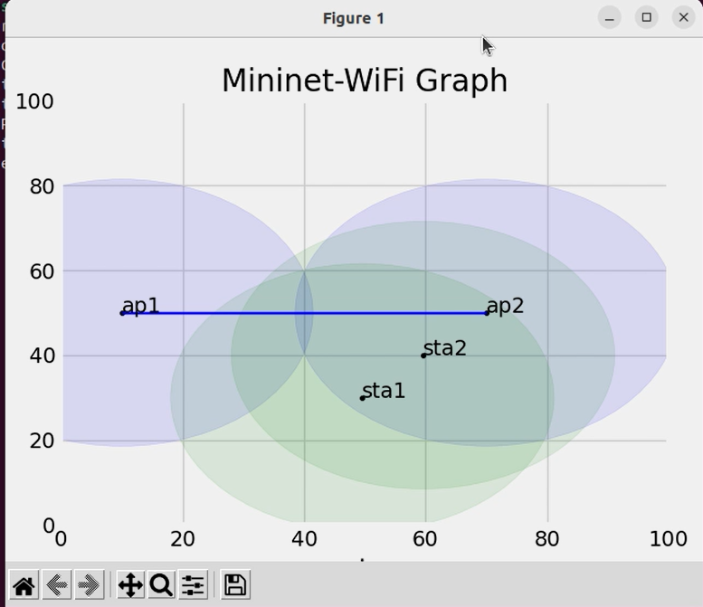

Mobility Graph : sta1,sta2,ap1,ap2

Mininet-wifi>h2 curl h1

(h1 is HTTP server , h2 accessing h1)

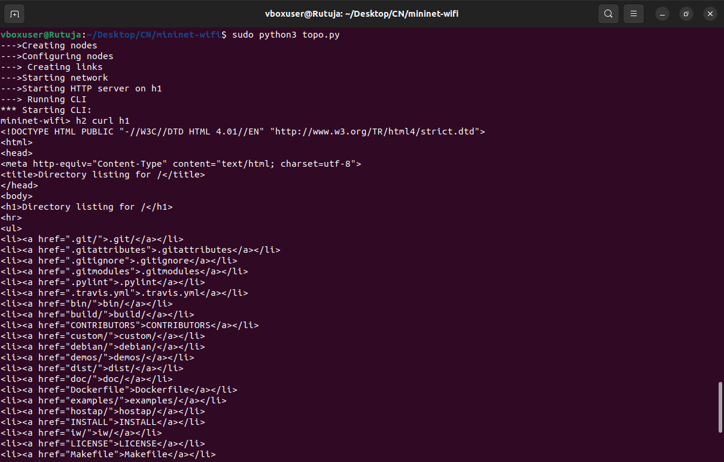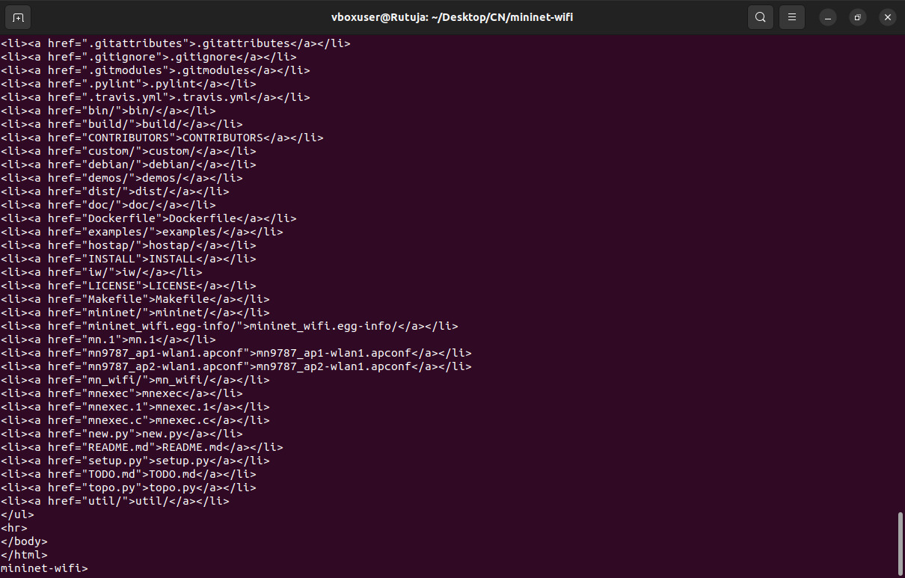

Mininet-wifi>pingall

