FEB-5-JENKINS

* Jenkins is an opensource CI/CD tool.
* Continuous Integration : Code -> Maven(build) -> Test.
* Continuous Deployment : Using Jenkins to deploy the artifact into the application server

JENKINS is a continuous integration tool that allows continuous development , test and deployment of newly created codes.

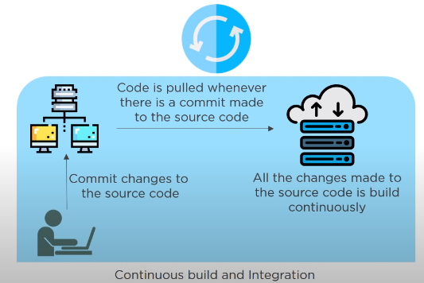

Features of Jenkins :

* Easy Installation and configuration
* Plugins
* Extensible
* Distributed

JENKINS PIPELINE: 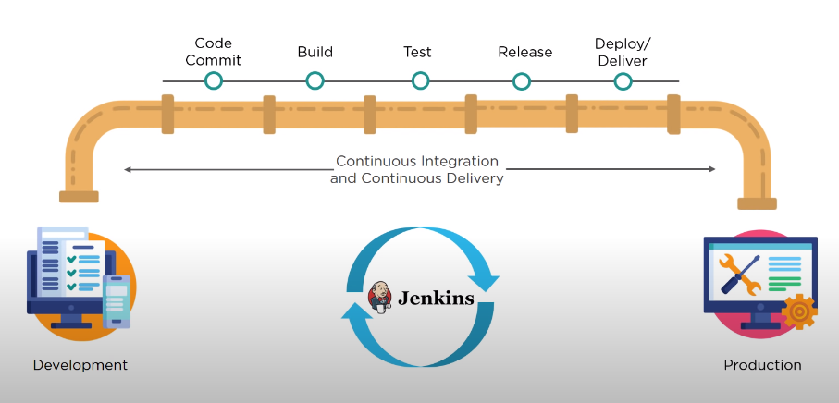

JENKINS ARCHITECTURE :

* Jenkins servers checks the repo at regular intervals and pulls any newly available code.
* Build server builds the code into an executable file.
* Java files are converted into JAR file, incase the build fails , a feedback is sent to the developers.
* Jenkins will deploy the build onto test server, incase the test fails , a feedback is sent to the developers.
* If no fails occur, the build is deployed onto production.

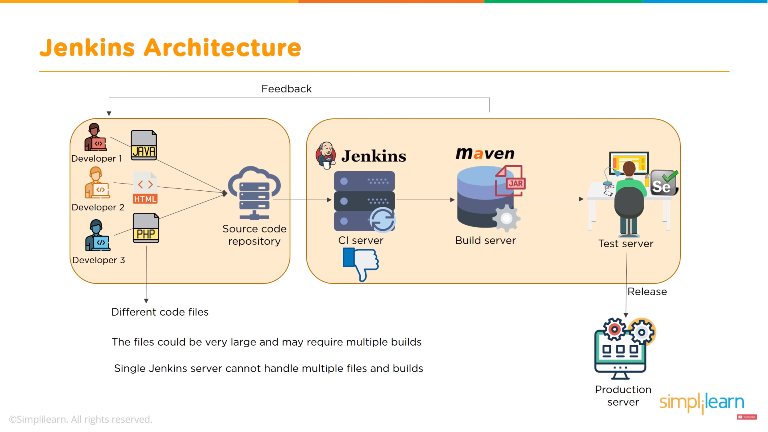

MASTER-SLAVE ARCHITECTURE

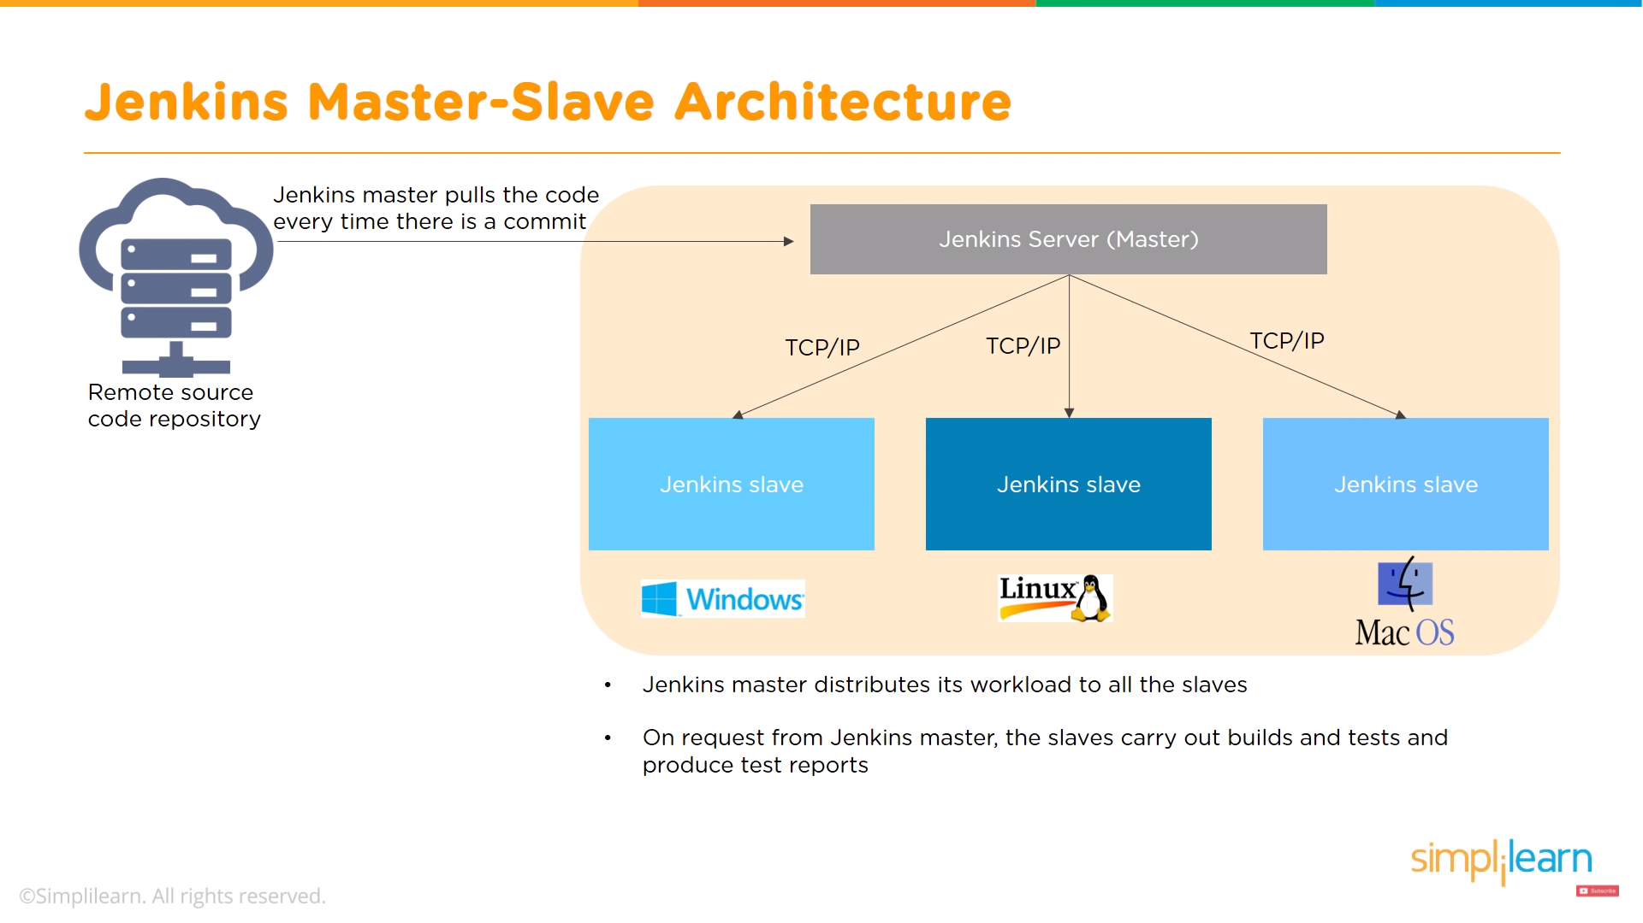

Navigation :

* System Configuration : Plugins are installed and managed , environment for the build is set , global tool configuration is also done.
* Security : Manage users, Security groups and global security configuration.
* Status Information : System info , stats , logs.
* Tools and Actions : Command line Integration, scripting console.

MASTER / SLAVE /NODE :

BY default only 2 builds can be in executor status , any other jobs will be in queue.

We can increase the number of executors, but it can crash the JAVA .

Instead, we can create nodes , where each node gets 2 executors.

PIPELINES :

Job Creation and Deployment into Tomcat

Pipelines & Multibranch Pipelines

Webhooks and pollSCM

Nodes/slaves/agents