/* Query1 */

/*******Top 10 Revenue products*******************/

select c.category as product,sum(p.sales_price * p.quantity) as Top_10_Revenue from order_Retail1 as c, order_retail2 as p group by c.category order by Top_10_Revenue DESC limit 10;

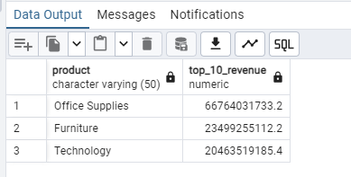

select c.sub_category as product,sum(p.sales_price * p.quantity) as Top_10_Revenue from order_Retail1 as c, order_retail2 as p group by c.sub_category order by Top_10_Revenue DESC limit 10;

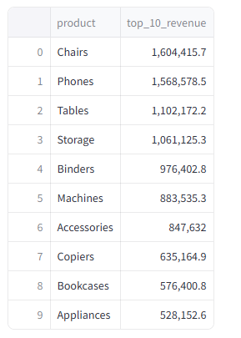

/* Query2 */

/********Top 5 city with high profit margin******************/

select c.city,

case

when sum(p.sales_price - p.cost_price) = 0 then 0

else (sum((p.sales_price - p.cost_price)* p.quantity)/ sum(p.sales_price*p.quantity)) * 100

end as profit_margin from order_retail1 as c, order_retail2 as p group by c.city order by profit_margin desc limit 5;

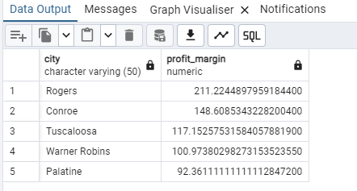

/* Query3 */

/\*\*\*\*\*\*\***total discount given for each category**\*\*\*\*\*\*\*\*\*\*\*\*\*\*\*\*\*\*\*/

select c.category, sum(p.discount) as total_discount from order_retail1 as c, order_retail2 as p group by c.category;

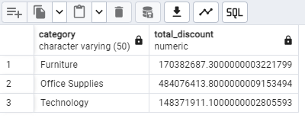

/* Query4 */

/\*\*\*\*\*\*\*\***average sale price per product category**\*\*\*\*\*\*\*\*\*\*\*\*\*\*\*\*\*\*/

select c.category,(sum(p.sales_price * p.quantity)/sum(p.quantity))as Average from order_retail2 as p, order_retail1 as c group by c.category;

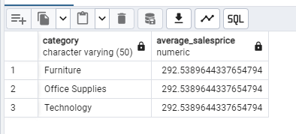

/* Query 5 */

/\*\*\*\*\*\***region with the highest average sale price**\*\*\*\*\*\*\*\*/

select c.region,(sum(p.sales_price * p.quantity)/sum(p.quantity))as highest_average_salesprice from order_retail2 as p, order_retail1 as c group by c.region order by highest_average_Salesprice desc limit 1;

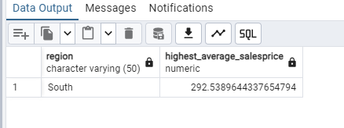

/* Query 6 */

/\*\*\*\*\***total profit per category**\*\*\*\*\*\*\*\*\*\*/

select c.category, sum((p.sales_price-p.cost_price)*p.quantity) as total_profit from order_retail2 as p, order_retail1 as c group by c.category;

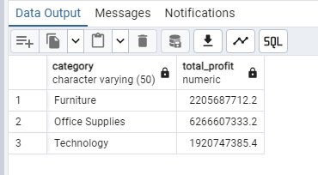

/* Query 7 */

/\*\*\*\*\*\***top 3 segments with the highest quantity of orders**\*\*\*\*\*\*\*\*\*\*\*\*\*/

select c.segment, sum(p.quantity) as highest_quantity from order_retail2 as p, order_retail1 as c group by c.segment order by highest_quantity desc limit 3;

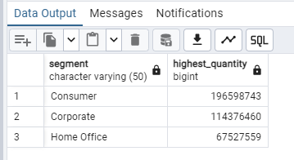

/* Query 8 */

/\*\*\*\*\***average discount percentage given per region**\*\*\*\*\*\*\*\*/

select c.region,avg(p.discount_percent) as discount_percentage from order_retail2 as p, order_retail1 as c group by c.region;

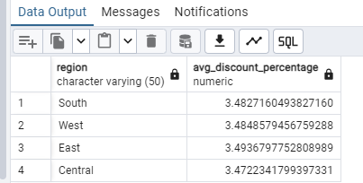

/* Query 9 */

/\*\*\*\*\***product category with the highest total profit**\*\*\*\*\*\*\*/

select c.category,sum((p.sales_price - p.cost_price)*p.quantity) as total_profit from order_retail2 as p, order_retail1 as c group by c.category order by total_profit desc;

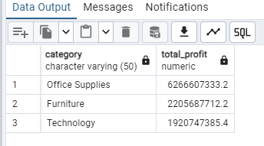

/* Query 10 */

/\*\*\*\*\*\***total revenue generated per year**\*\*\*\*\*\*\*/

select extract(Year from c.order_date) as Year, sum((p.sales_price)*p.quantity) as TotalRevenue from order_retail2 as p, order_retail1 as c group by extract(Year from c.order_date) order by Year;

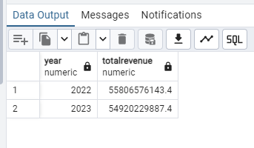

/* Query 11 */

/*****Join to Fetch Complete Order Details with order_id as foreign key*******/

SELECT b.order_id, b.order_date, b.Region, f.cost_price, f.sales_price, f.quantity, f.discount_percent

FROM order_retail1 as b JOIN order_retail2 as f ON b.order_id = f.id;

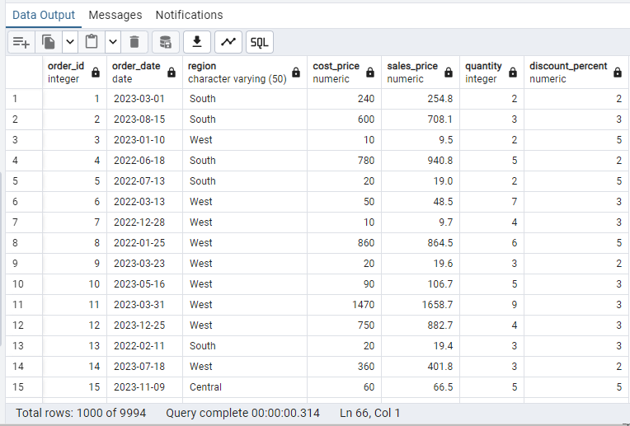

/* Query12 */

/****Calculate Total Revenue per Order*******/

select c.order_id, sum((p.sales_price - p.cost_price)*p.quantity)as total_revenue from order_retail1 as c join order_retail2 as p on c.order_id=p.id group by c.order_id;

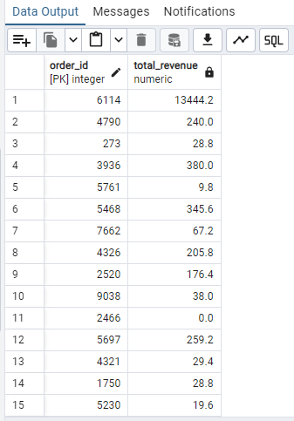

/* Query13 */

/****Calculate Total profit per Order*******/

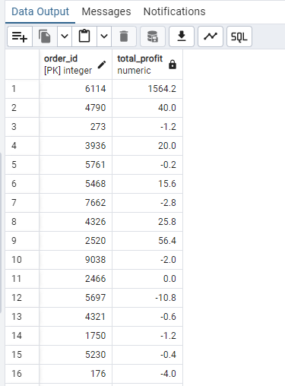

/* Query14 */

/*******Calculate least Revenue by product*************/

select c.sub_category as product,sum(p.sales_price * p.quantity) as least_Revenue from order_Retail1 as c, order_retail2 as p group by c.sub_category order by least_Revenue asc limit 10;

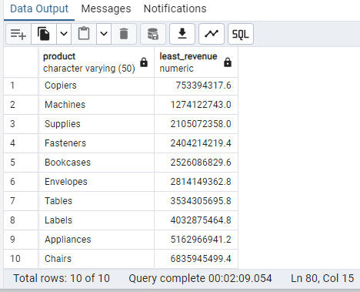

/* Query15 */

/*******Count Orders by Region*************/

select region, sum(order_id) as count_orders from order_retail1 group by region;

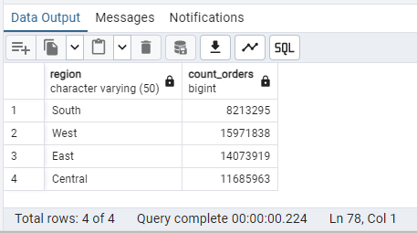

/* Query16 */

/*******Calculate Average Discount by state *************/

select c.state, avg(p.discount_percent) as avg_discount from order_retail1 as c, order_retail2 as p group by c.state;

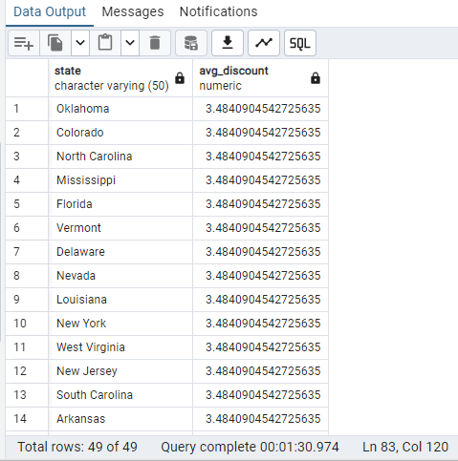

/* Query17 */

/*******Calculate the total revenue generated on month wise *************/

select extract(Month from c.order_date) as Month, sum((p.sales_price)*p.quantity) as TotalRevenue from order_retail2 as p, order_retail1 as c group by extract(Month from c.order_date) order by Month;

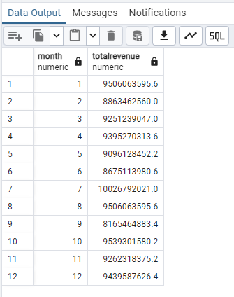

/* Query18 */

/*******Region with the Highest Profit*************/

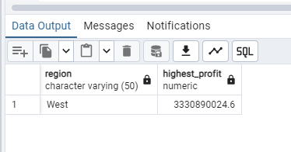

/* Query19 */

/********Identify Orders with No Profit (Profit = 0)********/

select c.order_id,(p.sales_price - p.cost_price)*quantity as profit from order_retail2 as p join order_retail1 as c on c.order_id=p.id where (p.sales_price - p.cost_price)*quantity=0;

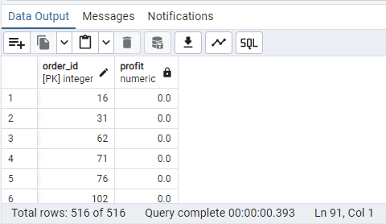

/ * Query20 */

/********Most Frequently Ordered Product Category********/

SELECT c.category, count(p.id) AS OrderCount FROM order_retail1 as c JOIN order_Retail2 as p ON c.order_id = p.id GROUP BY c.category ORDER BY OrderCount DESC LIMIT 1;

