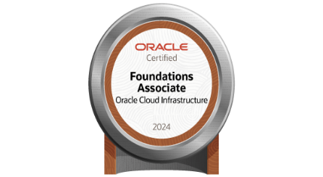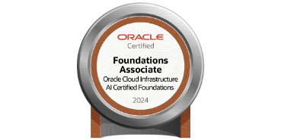**G.Anushiya**   
Plot No: 396

House No 1-1158I

Vasan Valley.

9 th Cross Vayaloor Road

Trichy  
anushiya2014@gmail.com | 8883714441

**Professional Summary**

Motivated and detail-oriented professional transitioning into IT from a successful 6-year teaching career in Computer Science Engineering. Proficient in key IT skills like Python, SQL, Machine Learning, Deep Learning. Passionate about leveraging analytical and problem-solving skills to develop efficient solutions.

**Technical Skills**

* **Programming Languages:** C,C++,Java, Python, SQL
* **Databases:** PostgreSQL, MySQL
* **Cloud Platforms:** AWS (EC2, RDS,S3), Oracle Cloud Infrastructure
* **Machine Learning:** TensorFlow, Scikit-learn, Pandas
* **Web Development:** Streamlit
* **Version Control:** Git, GitHub

**Certifications**

* **Oracle Cloud Infrastructure Foundation Associate**
* **Oracle Cloud Infrastructure 2024 Certified AI Foundations Associate**

**Projects**

**1. Retail Order Data Analysis**

* Analyzed retail order datasets to derive customer insights and optimize inventory management.
* Used SQL for querying data and Pandas for data processing.
* Created visualizations in Matplotlib and Seaborn to represent trends

**2. Multiple Disease Prediction App**

* Developed a web-based application using Streamlit to predict multiple diseases based on user inputs.
* Implemented machine learning models using Scikit-learn for accurate diagnosis.
* Deployed the model using AWS EC2 for real-time predictions.

**3. Car Resale Value Predictor**

* Developed an ML model using Python and Scikit-learn to predict car resale values based on various factors.
* Integrated the model into a Streamlit web application and deployed it on AWS EC2.

**4. CNC Machine Predictive Maintenance**

* Built a deep learning model using TensorFlow to predict maintenance requirements for CNC machines.
* Implemented data preprocessing, model training, and deployment using Streamlit and AWS.

**Work Experience**

**Seshasayee Institute of Technology]**  
*Lecturer (2013-2017)& (2021-2023)*

* Taught [mention subjects] and guided students in various academic projects.
* Conducted research and published papers in [mention areas if applicable].
* Developed strong problem-solving and analytical skills through curriculum planning and mentoring.

**Education**

**ME** – Cauvery College of Engineering and Technology - [2013-2015]

**BE** – Shri Angalamman College of Engineering and Technology - [2008 - 2012]

**Additional Information**

* Strong communication and mentoring skills.
* Passionate about continuous learning and technology.