A Deterministic-First Multi-Agent Framework for Cross-Service Root Cause Analysis and Human-Governed Remediation in Financial Microservices
Anushk Agrawal, Bhoomi Airen, Abhijay Krishnan, Shakila Shaikh
Department of Computer Engineering
Mukesh Patel School of Technology Management & Engineering, NMIMS
Mumbai, Maharashtra, India
agrawal.anushk@gmail.com, airenbhoomi@gmail.com, abhijay.k2004@gmail.com, shakilashaikh48@gmail.com

Abstract—Modern financial platforms are built as networks of interdependent microservices, where a fault in one service often surfaces as a symptom in another. Diagnosis systems that reason from the symptomatic service, or that defer to precedent retrieved by similarity, attribute such faults to the wrong component. We present a deterministic-first multi-agent framework in which root cause is inferred from telemetry by signature matching, and retrieved incidents may adjust confidence but never override that inference. Remediation is a fault-type lookup with no model call, safety rules contain no AI, and execution cannot proceed without an external human approval signal. We evaluate on 48 held-out synthetic incidents against a single-agent baseline that shares every non-diagnostic stage. The shared detector surfaced 10 of the 48, so both arms abstained on 79.2% and every diagnostic result rests on that subset. On it the framework was correct on 10 of 10 against 6 of 10, and on the four cross-service faults on 4 of 4 against 0 of 4, with the baseline naming the symptomatic service each time (Fisher exact, p = 0.0286; a paired sign test gives p = 0.125, so the result is directional and needs replication). Removing retrieval leaves all 48 diagnoses unchanged, and allowing it to override the deterministic conclusion reproduces the baseline exactly. A negative control gives a 4.17% false-positive rate on normal telemetry and 27.08% after recovery. The corpus is synthetic, so absolute accuracy is not a capability claim.
Index Terms—AIOps, root cause analysis, microservices, multi-agent systems, human-in-the-loop

INTRODUCTION

- Motivation
Financial technology platforms have converged on microservice architectures to obtain independent deployability, fault isolation and horizontal scalability under transaction volumes that monolithic designs cannot sustain [18], [21]. The same decomposition that delivers these properties also distributes the evidence required to diagnose a failure. A single fault propagates along synchronous call chains and surfaces as a symptom in a service that is itself healthy. Operational reliability in this domain is not a secondary engineering concern. Payment authorisation, ledger settlement and fraud screening are subject to availability and auditability obligations, and an outage carries direct financial and regulatory consequence [15], [16], [18]. Where a remediation action can restart a service holding uncommitted transactional state, the cost of an incorrect automated decision is not merely a prolonged outage but a potential integrity violation.

- Limitations of Retrieval-First Diagnosis
The intuitive application of large language models to this problem is to present an agent with the telemetry of the service that raised the alert, together with similar historical incidents retrieved by embedding similarity, and to ask it to name a root cause and an action. This design fails on precisely the class of fault that matters most, and it fails systematically rather than randomly. The failure has two compounding sources. First, the telemetry presented is that of the symptomatic service, which for a cross-service fault is not the faulty one. Second, retrieval by similarity over symptom-service telemetry returns incidents that share surface features with the query, which are disproportionately incidents whose root cause is the symptom service. The agent then reasons correctly from precedent that happens to be wrong. This is not a hypothetical failure mode. Independent work reports the same pattern from a different direction: OperAID [4] finds that when large language model agents are denied live observability, 95.3% of their failures are confident diagnoses of plausible but incorrect root causes, and argues that text-similarity scoring would rate such responses favourably while execution shows complete failure. The gap between plausibility and functionality is the central evaluation problem in this area.
- Research Questions
RQ1. Does decomposing diagnosis into deterministic inference with retrieval as advisory evidence improve root-cause identification over a single-agent model given identical evidence, and is any improvement confined to cross-service faults? RQ2. Is the improvement attributable to the architectural constraint on retrieval, or to retrieval itself? RQ3. What are the operational limits of the resulting system in terms of detection coverage, false alarms on healthy telemetry, and computational cost?
- Contributions
  - A deterministic-first pipeline in which retrieval is archi-tecturally advisory. Root cause is determined by fault-signature matching against documented thresholds; retrieved incidents may raise or lower recorded confidence but cannot change the conclusion. We show this constraint, rather than retrieval, is the entire measured difference between the arms (Section VI).
  - Governance as a structural property rather than a convention. Safety Validation contains no AI component and is evaluated before a human is consulted; the workflow graph cannot advance past the approval stage without an external resume signal; each remediation retry raises a fresh approval rather than inheriting one. Across the reported evaluation, executions without approval were zero by measurement, not by assertion.
  - A controlled architectural ablation. We reconstruct the conventional retrieval-first design inside the same code-base and show it reproduces the single-agent baseline exactly, converting an attribution argument into a controlled result.
  - A critique of hallucination measurement in operational settings, with a stronger measure, and a demonstration that our own stronger measure remains a lower bound for a specific and reproducible parsing reason.
  - A negative control on healthy telemetry, which surfaces a post- recovery false-alarm rate six times higher than the normal-phase rate.
- Scope and Claims
We state the boundaries before the results, because several are consequential.
Not that the absolute accuracy generalises. The reported corpus is synthetic, and the generator’s fault formulas share constants with the diagnostic thresholds, so a threshold matcher was evaluated on data generated to exceed exactly those thresholds. We state the consequence rather than leave it implied. Had the thresholds been miscalibrated the system would abstain rather than answer wrongly, because it abstains whenever no signature matches; the visible effect would therefore be a lower answered fraction, not a higher error rate. The between-arm comparison is unaffected by the circularity for a separate reason: both arms received byte-identical inputs, the baseline was given the same retrieved incidents, and the baseline’s failure is a misattribution to the symptomatic service rather than a threshold error, so no calibration of our thresholds could have produced it. What the circularity does bound is the absolute figure, which should be read as an upper bound obtained under favourable conditions rather than as a capability claim. LATS-RCA [3] reports 91.3% on an open benchmark against 65.1% on real production incidents and treats that gap as its finding; we expect a comparable gap and have not measured it.
Not that the system achieves high coverage. Measured over all incidents rather than answered ones, accuracy is 20.8%, because detection surfaced only 10 of 48.
Not that unsafe-action prevention is demonstrated. The count is zero. Dry-run execution never failed, so no retry escalated to the high-risk action the ledger-service rule guards.
Not that the local model is adequate for narration. It exceeded a 30-second timeout on 9 of 10 incidents. That the diagnostic accuracy was unaffected is a claim about the architecture, not about the model.
Not that the system performs root cause analysis in the general sense the title may suggest. It classifies the fault type from symptom-service telemetry and resolves the responsible service through a fixed domain mapping. Where a system must infer an unknown dependency structure, this design does not apply, and Section VII-E says what would be required instead.
- Paper Organisation
Section II reviews related work. Section III presents the framework. Section IV describes the dataset, baseline and experimental protocol. Section V reports results, Section VI the ablations, Section VII discusses implications, Section VIII threats to validity, and Section IX concludes.

RELATED WORK
- Graph-Based Root Cause Localisation
A substantial body of work formulates root cause analysis as inference over service-dependency or telemetry-correlation graphs. CausalRCA [5] unifies metrics, traces, logs and topology into a temporal causal candidate graph, adds retrieval-augmented incident reasoning, and reports 86.0% top-1 and 95.0% top-3 accuracy on DeathStarBench, with an ablation indicating that the retrieval module and the causal graph contribute complementary strengths across fault categories. GALR [7] fuses multimodal signals into a service call graph, applies a graph-attention module with temporal-aware edge attention, and injects LLM-derived anomaly and uncertainty scores into node representations. TransTVDiag [8] replaces a GraphSAGE encoder with a Graph Transformer using degree centrality and shortest-path structural encodings, improving hit ratio by 5.3% while reducing inference time by 83.8%. HEMA-RCL [6] organises hierarchical expert agents under a global orchestrator, reaching consensus through belief propagation with causal enhancement to reduce hub misidentification. These methods establish that precise localisation is achievable without deep application instrumentation. They also share a prerequisite that our setting does not satisfy: a populated dependency or correlation graph derived from distributed tracing across many services. Our system operates on four services and reaches the symptom-to-cause relation through a documented domain mapping instead. Section VII-E returns to this as a conceded limitation rather than a design advantage.

- LLM-Based Agents for Fault Diagnosis and Remediation
LATS-RCA [3] formulates root cause analysis as a reflection- guided tree search over hypotheses, achieving 91.3% on the LO2 benchmark with small variance across frontier models, and reports both a computational cost analysis and a substantially lower 65.1% on real production incidents from a commercial web-hosting provider. OperAID [4] evaluates agents through a closed-loop pipeline of fault injection, diagnosis, remediation and execution- based verification on a live Open5GS Kubernetes deployment, finding across 900 experiments that tool access raises average success from 10.9% to 61.1% and that model size alone does not predict operational success. Souza and Colaço Júnior [10] conduct a randomised complete block design experiment over 360 executions in Kubernetes, reporting a 71.1% success rate for the strongest configuration against a computed random-chance baseline of 0.91%, and observing that smaller models incurred higher total cost through redundant reasoning cycles. AgentTrace [9] reconstructs causal graphs from execution logs to localise failures in deployed multi-agent workflows without requiring model inference at debugging time. Three methodological practices from this group inform our design directly: execution-based verification rather than output plausibility [4], explicit comparison against a computed random- chance baseline [10], and reporting the benchmark-to-production gap as a finding rather than a caveat [3].
- Self-Healing Architectures and Autonomic Computing
The MAPE-K reference model remains the organising abstraction for self-healing systems. Aribe and Oracion [11] implement a modular MAPE-K framework with an AutoFix-inspired recovery mechanism, evaluated over twenty runtime failure scenarios, reporting a mean fault-detection F1 of 90.7%, a recovery success rate of 93.2% and a 56.2% reduction in time-to- recovery. Yazdanparast [12] surveys self-healing methods and their failure-mode taxonomies. Mali et al. [22] combine AI-based anomaly detection with automated recovery orchestration. Konda [19] and Meyer et al. [20] integrate machine-learned anomaly detection with recovery, the latter combining detection and root cause analysis in a single pipeline to reduce mean time to recovery. Our pipeline maps onto MAPE-K directly: telemetry capture is Monitor, detection and root cause analysis are Analyse, remediation proposal and safety validation are Plan, and execution with recovery verification is Execute, with the retrieval memory serving as the shared Knowledge base. The distinguishing feature is that the transition from Plan to Execute is gated by a mandatory human decision.
- Fault Tolerance in Financial Microservice Systems
Anderson et al. [21] catalogue fault-tolerance patterns for financial microservices including circuit breaker, retry, bulkhead, timeout and fallback. Deshpande [18] examines Spring Boot and Spring Cloud for scaling banking applications under PSD2, GDPR and Basel III obligations. Singh [13] proposes a machine-learning- driven self-healing framework for Fin-Tech platforms combining supervised detection, unsupervised pattern discovery and reinforcement-learned recovery policy. Gaddam [14] presents a four-layer autonomous financial platform comprising observability, intelligence, decision and execution layers. Singh [15] argues for a prevention-first posture with built-in governance for high-availability banking infrastructure. Nagaraja et al. [16] couple fraud detection with autonomous response and infrastructure stabilisation, reporting a 35% reduction in system instability. Fahmi et al. [17] detect artifact-state anomalies in microservice-based financial applications at design time. This literature establishes the domain requirement for auditability and governance but, with the partial exception of [15], treats human oversight as an operational practice rather than an architecturally enforced constraint.
- Anomaly detection as a precondition for root cause anal-ysis
Soldani and Brogi [1] survey anomaly detection and root cause analysis in multi-service applications and organise the field by signal modality, noting a recurring trade-off between setup cost, accuracy and explainability. BARO [2] makes the dependency explicit: because root cause analysis techniques generally presuppose accurate anomaly detection, and no detector guarantees that accuracy, inaccurate detection propagates directly into localisation error. BARO addresses this with multivariate Bayesian online change point detection and a nonparametric hypothesis test that is less sensitive to detection quality. This is the published counterpart of our own strongest negative finding. Our diagnostic layer was correct on every incident it answered, and the system’s overall accuracy was nonetheless 20.8%, because the detector surfaced only a fifth of the corpus (Section VII-A).
- Evaluation Methodology and Integrity Constraints
A withdrawn preprint in this area [26] reported a multi-agent versus single-agent comparison that a subsequent code audit found to rest on a source constant: the multi-agent arm’s action list was fixed in the source rather than produced by the model, and the scorer read only that field, so the reported superiority measured a constant. We cite it for the methodological lesson alone and imply no criticism of its authors, whose own audit and withdrawal is the behaviour the field should want. The lesson generalises: this is the natural failure mode of any deliberately deterministic multi-agent pipeline, and ours is one, since its remediation proposer is a hardcoded template lookup. Any paper presenting such a comparison should therefore be expected to demonstrate that its scored quantity is not constant. We treat that as an obligation rather than an assurance and discharge it in Section V-B with a permanent regression test.
- Research Gap
Across the reviewed work, three gaps are consistent. No system treats human approval as an architecturally enforced precondition for execution. Retrieval is used to inform or to determine the conclusion, but its authority relative to deterministic evidence is not treated as an experimental variable. And hallucination, where measured at all, is measured as reference to non-existent entities rather than as misrepresentation of real ones.

PROPOSED FRAMEWORK
- Overview and Design Principles
Fig. 1 shows the system architecture: the four monitored services, the telemetry path, the components of the orchestration layer and the two stores it depends on. Fig. 2 shows the same system as a control flow, tracing a single incident from a telemetry record to a terminal state and marking the three points at which the pipeline can refuse to proceed.
The two views are separated deliberately. The architecture answers what exists and what talks to what; the flow answers what may happen and in what order, which is where this design differs from the reviewed alternatives. Readers comparing this work against retrieval-first pipelines should look at the flow, not the architecture, because the components are largely conventional and the ordering constraints are not.
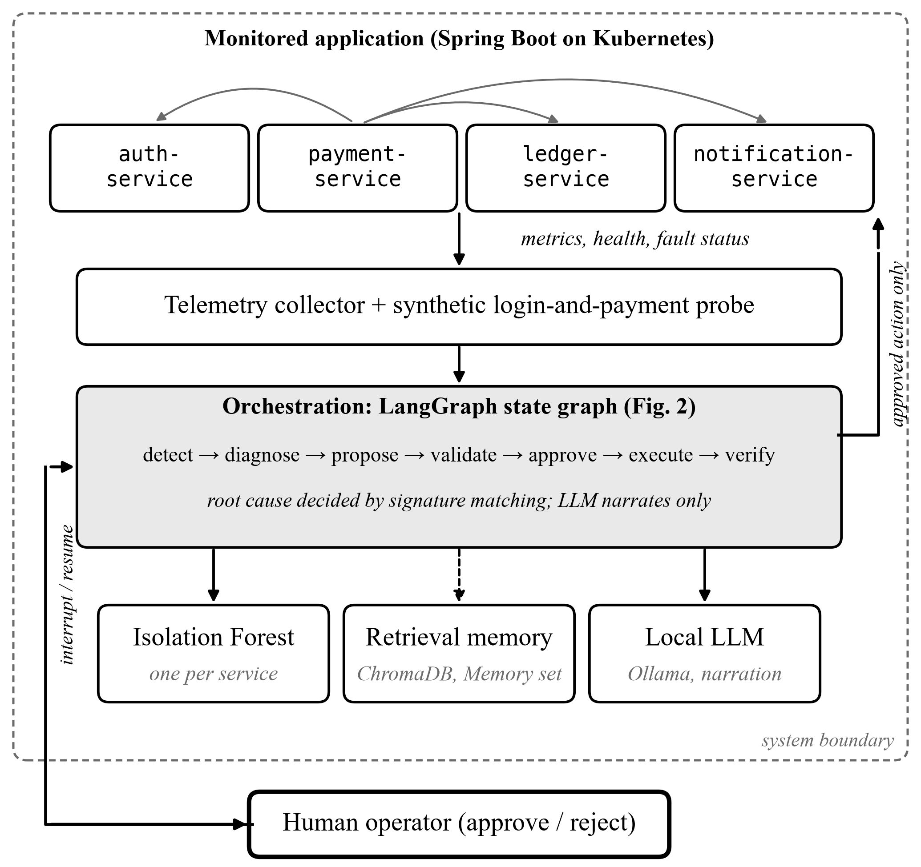
Fig. 1. System architecture. The operator sits outside the system boundary and reaches the orchestrator only through the approval interrupt; actions reach the cluster only after approval. The dashed edge marks retrieval, whose output is advisory.
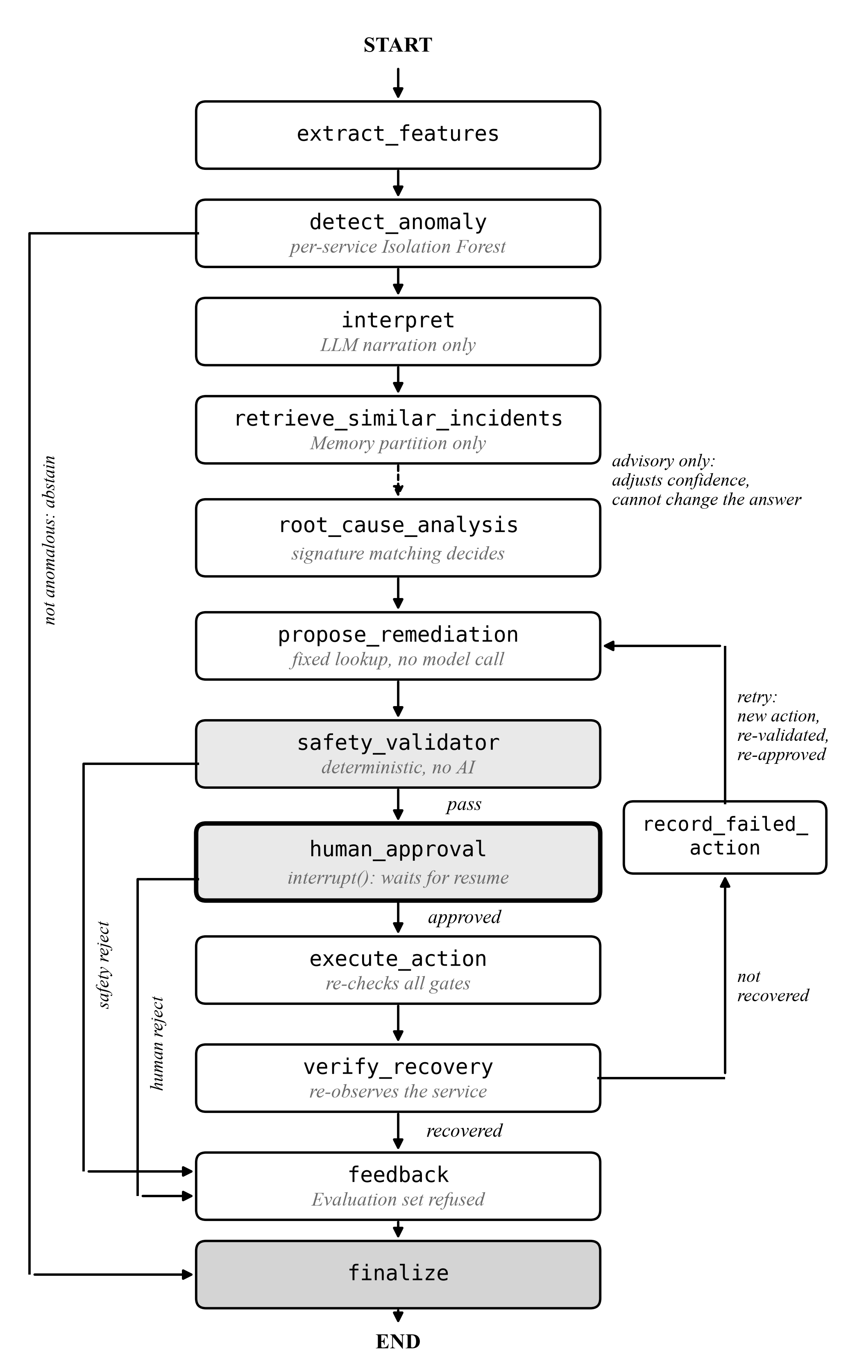
Fig. 2. LangGraph state graph as compiled in the implementation (13 nodes). The dashed edge carries retrieved incidents, which may adjust confidence but not the conclusion. The left lanes are the three refusal routes: abstention, deterministic safety rejection and human rejection. The retry path returns to remediation proposal, never to diagnosis, and passes safety validation and approval again.

TABLE I Fault taxonomy

Fault | Injected at | Symptom visible at | Class
memory-leak | payment-service | payment-service | same-service
db-lock | ledger-service | ledger-service | same-service
auth-key-error | auth-service | payment-service | cross-service
notification-latency | notification-service | payment-service | cross-service

Four principles govern the design, each of which is falsifiable and is tested later in this paper. Determinism where a rule suffices. Any stage expressible as a threshold or a lookup is implemented as such. Model inference is confined to narration. Retrieved incidents are evidence, not commands. Retrieval may adjust recorded confidence and supplies provenance; it cannot change a conclusion reached from telemetry. Governance is structural. Safety Validation precedes human consultation and contains no model call; the graph cannot advance past approval without an external signal. Refusal over fabrication. An unmeasurable quantity is reported as unmeasurable, and an abstention is scored separately from a wrong answer.
- Monitored System and Fault Taxonomy
The testbed is a four-service transactional application: an authentication service issuing JWTs, a payment orchestration service, a ledger service holding account balances in PostgreSQL behind pessimistic row locking, and a notification service. The payment service calls the others synchronously, which is what allows a fault elsewhere to surface as a payment-side symptom.

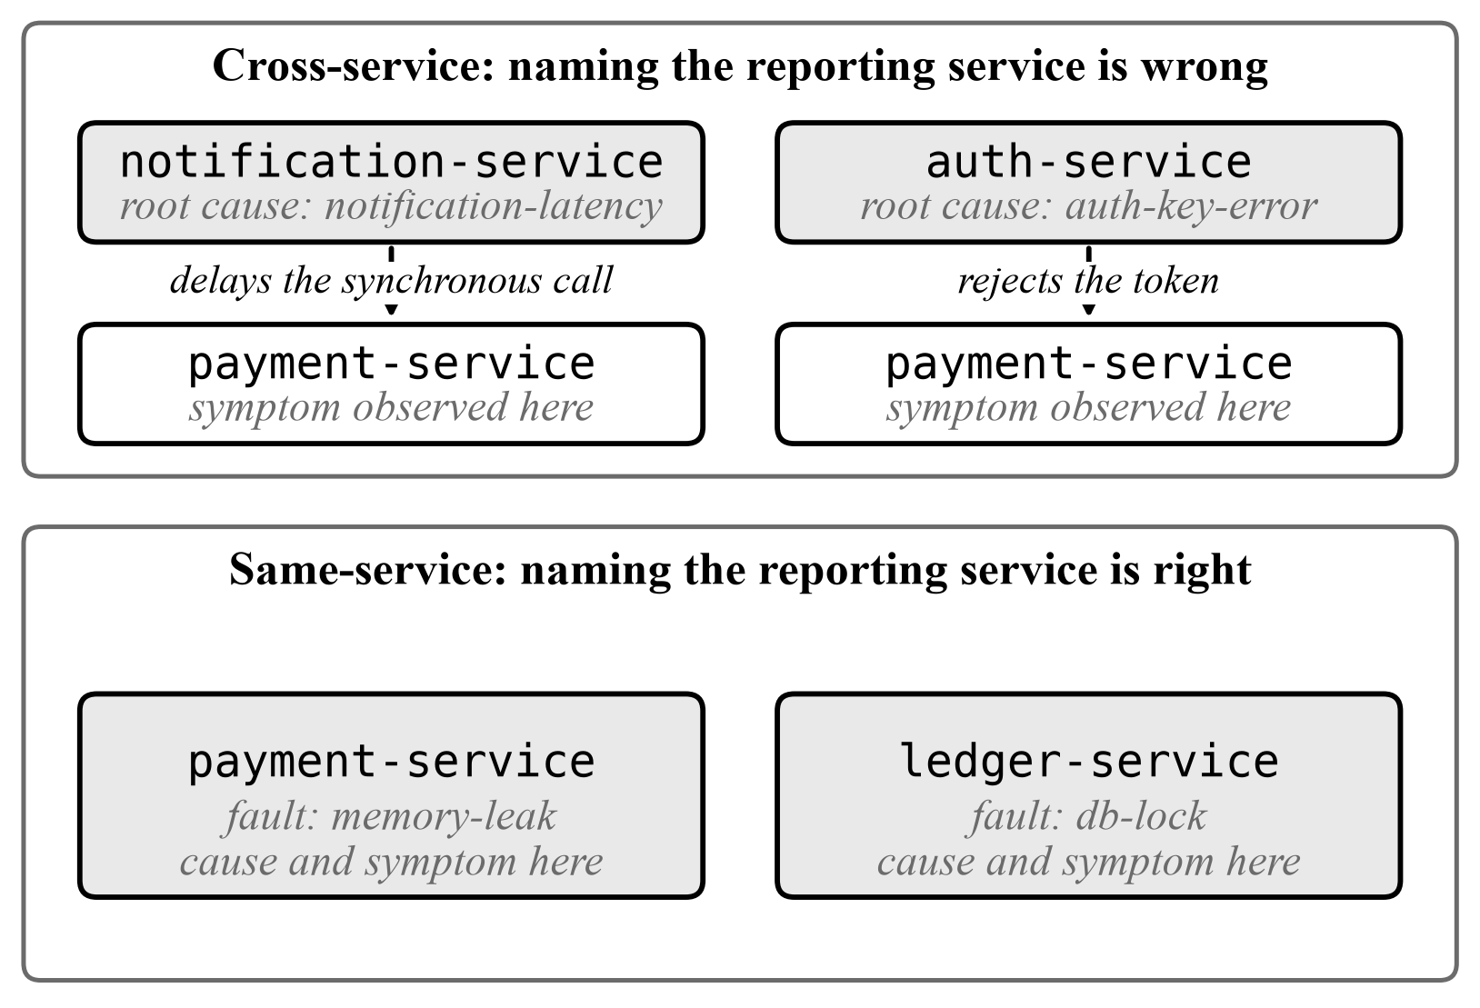

Fig. 3. Same-service and cross-service fault manifestations.

The two cross-service faults are the experimental object of the paper. A system that reasons only from the symptomatic service will attribute both to payment-service.
- Telemetry Capture
A collector polls each service’s health endpoint, a curated subset of its Prometheus metrics and its fault-status endpoint on a fixed interval, tolerating any single service being unreachable by recording a collection error rather than terminating. Metrics are extracted selectively rather than scraped wholesale: JVM heap used, committed and maximum; HikariCP pool state for the ledger service; HTTP server and client request counts, error counts and mean durations; and process and system CPU utilisation. A synthetic login-and-payment probe runs each cycle, because the authentication and latency faults manifest only on a real request path. The probe deliberately caches its token across cycles, so that a token obtained before an authentication fault continues to be presented and begins to fail, reproducing the experience of an already-authenticated user.
- Anomaly Detection
One Isolation Forest [23] is trained per service rather than one shared model, because the curated feature set is service-specific: HikariCP fields apply only to the ledger service and HTTP client fields only to the payment service. Training uses 100 estimators, a contamination parameter of 0.1 and a fixed random seed of 42. Training data is restricted to normal-phase and recovery-phase telemetry drawn from incidents in the
Memory partition. This restriction is enforced in code rather than by convention: the loader reads only the Memory file and exposes no parameter that could redirect it to the Evaluation file.

- Retrieval Memory
Retrieval follows the retrieval-augmented generation pattern [25]. Each Memory-partition incident is rendered as a short template- structured postmortem narrative and embedded into a persistent local ChromaDB collection using the bundled default embedding model, so that no cloud service is involved. Queries retrieve the three nearest incidents by cosine similarity.

- Root Cause Analysis
Root cause is determined in three ordered steps. Signature matching. Observed metrics are compared against documented per-service baseline ranges and fault-specific thresholds. A match yields a fault type. Symptom-to-cause resolution. The fault type is mapped to its root-cause service through a documented domain mapping, which for the two cross-service faults names a service other than the one whose telemetry was examined. Retrieval adjudication. Retrieved incidents are compared with the conclusion. Agreement raises recorded confidence to high; disagreement lowers it to medium and is recorded explicitly as metric_signature+rag_disagreement. Neither changes the conclusion. Where no signature matches, and only then, the nearest retrieved incident may supply the answer, recorded as rag_only. Where neither applies, the system abstains. An optional model-generated narrative explains the conclusion already reached. Its prompt contains no recommendation field, and its failure is non-fatal.

- Remediation Proposal
Remediation is a deterministic fault-type-to-action lookup with no model call. Each proposal carries an action category, a target service, a risk level and a type-level guarantee that human approval is required. The proposer walks a fixed escalation ladder on failure: a targeted fault reset, then a service restart, then escalation to a human, never re-proposing a category that has already failed.

- Safety Validation
The validator contains no AI, no model call and no network access. It independently re-checks every field of a proposal against a whitelist of permitted action categories and target services, and implements a domain rule: any action with risk level high targeting the ledger service is rejected, because that service holds uncommitted transactional state behind a pessimistic locking boundary. A rejected proposal is routed through feedback to finalisation and never reaches a human, on the principle that a rule violation should not consume operator attention.

- Mandatory Human Approval
Approval is implemented as a graph-level interrupt. The workflow is compiled with a checkpointer and physically cannot advance past the approval node without an external resume signal carrying an explicit decision. This is a structural property of the execution model, not a documented convention. Three further properties hold: a human approval cannot override a safety rejection, because safety is evaluated first and independently; the decision and its free-text reason are recorded verbatim in the final result; and each retry after a failed remediation raises a fresh interrupt, so an approval granted for one action is never inherited by a different one.
- Execution, Verification and Feedback
Execution is the only component that mutates the running system, and it re-checks all three gates immediately before acting rather than trusting graph routing. It can perform exactly one of three things: POST a service’s own fault-reset endpoint, delete a pod so its deployment recreates it, or nothing. There is no generic command path, and the Kubernetes client refuses any service outside the four in this system. Verification re-observes the target’s fault-status and health endpoints rather than trusting the remediation call’s own success response. This is what makes a false recovery detectable at all. Completed runs are written back into retrieval memory in the same postmortem format, including failures and rejections rather than rewriting them as successes.

EXPERIMENTAL SETUP
- Dataset Construction
The incident schema and the reconstruction pipeline were built against raw telemetry captured during controlled fault-injection experiments on a live deployment, and the synthetic generator’s fault-phase formulas mirror each real fault mechanism with baseline ranges anchored to values observed there. The run reported in this paper, however, contains no real incident. All 68 incidents in the corpus were produced by the deterministic generator, 20 in the Memory partition and 48 in the Evaluation partition, because no cluster was available on the machine used for the reported run. We state this plainly because the distinction matters for every absolute figure below. Each incident records its phase boundaries, per-service metric averages for the normal, fault-active and recovery phases, metric deltas, observed errors, correlation identifiers and a generated postmortem narrative.
- Memory and Evaluation Partitioning
The corpus is split deterministically under seed 42, stratified by fault type, into a 20-incident Memory partition used exclusively for retrieval and detector training, and a 48-incident Evaluation partition used exclusively for measurement. The Evaluation partition contains 12 incidents of each fault type, of which 24 are cross-service.
- Leakage Prevention
Separation is enforced in code at three independent layers. The collection builder never opens the Evaluation file; it checks for identifier overlap before writing anything and re-verifies by direct lookup afterwards. The feedback writer refuses any incident belonging to the Evaluation partition, and fails closed when the Evaluation file cannot be read, so that “cannot check” is never silently treated as “nothing to check”. Finally, the evaluation harness verifies the guard live before any measurement is recorded: it attempts a write-back of a genuine Evaluation incident and aborts the entire run unless the refusal occurs. The probe identifier and refusal reason are recorded in the results artefact.
- Single-Agent Baseline
The baseline is a genuinely separate implementation: one prompt, one model call producing root cause and action together, importing nothing from the root-cause, remediation or interpretation modules. Every stage that is not the diagnostic step is shared by importing the identical node objects, and a test asserts node identity so the arms cannot drift apart. The isolated variable is therefore agent decomposition, not retrieval, not detection and not downstream governance. The baseline receives the same retrieved incidents. Its failure modes are recorded rather than repaired: a hallucinated service or invented action becomes a countable parse issue, and an invented action is coerced to something non-executable. It does not retry, so the comparison uses one attempt per incident for both arms.
The choice of baseline requires a defence, because a weak control would manufacture the result. We compare against a single model call because the variable under test is agent decomposition, and holding the number of diagnostic reasoning steps at one isolates it. A stronger control exists and we did not build it. An agent following the ReAct pattern [24], able to query services during diagnosis, would very likely close part of the gap, since OperAID [4] reports that tool access alone raises success from 10.9% to 61.1%. Two properties of our result limit how much that concession costs. The baseline does not fail through lack of evidence, having received the identical telemetry record and the identical retrieved incidents; it fails by following the retrieved precedent to the symptomatic service. And Ablation B reproduces its exact scores from the multi-agent arm by changing one rule, which shows the gap is attributable to retrieval authority rather than to reasoning effort. A tool-augmented baseline is nonetheless the comparison this design should face next, and we name it as future work rather than claim superiority over agents we did not run.
- Replay Protocol
Each Evaluation incident is converted into the single raw telemetry record a monitor would have seen. Three decisions carry methodological weight. The symptom service’s record is replayed, because a real monitor cannot know in advance that the cause lies elsewhere. The fault-active phase averages are used, unmodified. The self-reported fault flag is withheld. Each service exposes an endpoint stating whether its own fault injection is active, which for a same-service fault is effectively an answer key. A genuine unknown incident does not arrive with such a flag, so neither does a replayed one. The simulated operator approves everything reaching it, deliberately. Gating execution on ground truth would make recovery metrics measure how well remediation works when the diagnosis is already known to be correct.
- Evaluation Metrics
We report five categories. Performance covers accuracy over all incidents, accuracy when answered, abstention rate, macro precision, recall and F1, and cross- and same-service accuracy reported separately. System covers detection latency, time to first approval pause and anomaly detection rate. AI covers model calls, wall-clock time, reasoning availability and two hallucination measures. Human covers incidents reaching approval, decisions recorded and unsafe actions prevented, together with the safety invariant, executions without approval.

TABLE II
Root-cause output for five distinct telemetry inputs
Input (service, distinguishing metric) | Fault type | Root cause | Method
payment-service, heap used 5.0 × 10⁸ | memory-leak | payment-service | signature
payment-service, server error count 25 | auth-key-error | auth-service | signature
payment-service, client duration 5200 ms | notification-latency | notification-service | signature
ledger-service, HikariCP active 10 | db-lock | ledger-service | signature
payment-service, all metrics at baseline | none | payment-service | fallback

- Implementation Configuration

TABLE III Implementation configuration
Component | Configuration
Anomaly detection | Isolation Forest, 100 estimators, contamination 0.1, seed 42
Features | Per-service curated schema (JVM memory, HikariCP, HTTP server/client, CPU)
Training data | Normal and recovery phases, Memory partition only
Vector store | ChromaDB, persistent, local
Embedding | ChromaDB bundled default model (local ONNX)
Retrieval depth | 3 nearest incidents, cosine similarity
Language model | llama3.2:3b, self-hosted via Ollama, 30 s timeout
Orchestration | LangGraph checkpointed state graph, 13 nodes
Execution mode | Dry run (replay)
Feedback | Disabled during measurement

Table III records the full configuration. Infrastructure metrics were not collected. Two conventions distinguish this protocol. An unmeasurable quantity is reported as unmeasurable with a stated reason, never as a number. And an abstention is scored separately from a wrong answer, because conflating them rewards a system that guesses. Our system emits a single root-cause service rather than a ranked list, so the Top-k and mean reciprocal rank metrics prevalent in graph-based localisation work [5], [7], [8] are not applicable; our accuracy figures correspond to Top-1.
- Environment and Reproducibility
The reported run executed on Windows 11 with Python 3.12.2 in replay mode with execution in dry run and feedback disabled. Determinism is enforced by fixed seeds and by deriving all pseudo-random offsets from a specified stable checksum rather than from the interpreter’s randomised string hash, a defect found and corrected during this work. A regression test executes the generator in a separate process, because a same-process test cannot detect per-process hash randomisation. The software carries 316 automated tests across three Python packages and 47 across four Java services, all passing.

RESULTS
- Root Cause Identification Accuracy

- Verification That the Scored Output Is Not Constant

Following the obligation set out in Section II-F, we audit empirically whether the scored output varies with input. The root- cause analysis was given five telemetry inputs and its output recorded (Table II).
baseline Rows one to three are all payment-service records and yield three different root-cause services, so the output is driven by metric values rather than by the identity of the reporting service. Row five shows abstention from naming a fault type rather than emission of a default. This audit is enforced by a permanent regression test. A second-order disclosure. Once a fault type is determined, the root-cause service follows from a fixed domain mapping that the ground-truth labels also use. Root-cause accuracy is therefore arithmetically equal to fault-type accuracy for this system, and is not an additional independent capability. The defensible claim is narrower than “the system identifies root causes” and should be read as: the system identifies the fault type from symptom-service telemetry alone, and consequently does not attribute cross-service faults to the service reporting the symptom.
TABLE IV
Root-cause identification results

Metric |  | Multi-agent | Single-Agent Baseline
Accuracy over all 48 incidents |  | 20.8% | 12.5%
Accuracy when answered |  | 100% (10/10) | 60.0% (6/10)
Abstention rate |  | 79.2% | 79.2%
Precision / Recall / F1 (macro) | 100% / 100% / 100% |  | 37.5% / 50.0% / 41.7%
Cross-service accuracy |  | 100% (4/4) | 0% (0/4)
Same-service accuracy |  | 100% (6/6) | 100% (6/6)
Blamed symptom service  Cross-service faults |  | 0 | 4 of 4
Errored incidents |  | 0 | 0
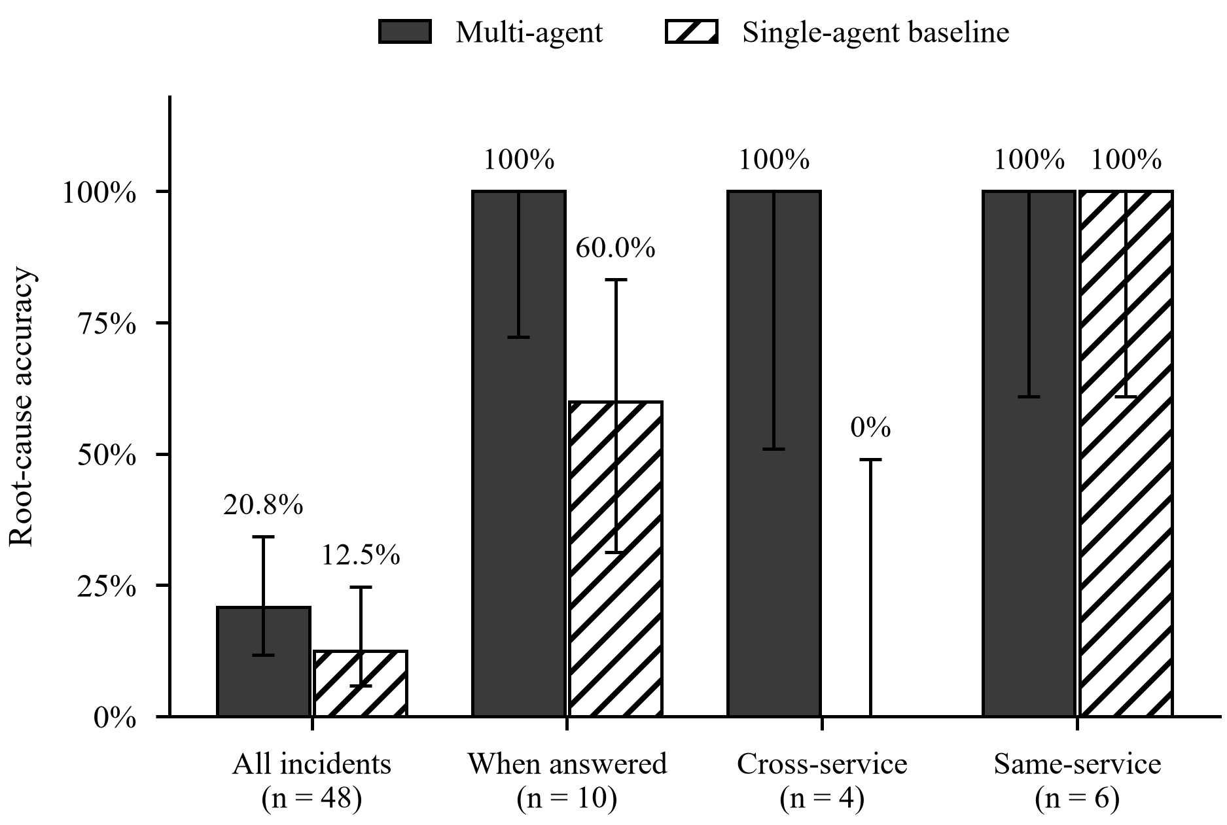

Fig. 4. Root-cause accuracy by arm with 95% Wilson confidence intervals.

Table IV reports the headline results. With 95% Wilson intervals, multi-agent accuracy when answered is 1.000 [0.722, 1.000] and cross-service accuracy is 1.000 [0.510, 1.000]; the baseline’s cross-service accuracy is 0.000 [0.000, 0.490]. The intervals are wide, and deliberately reported as such. Against a random-chance baseline computed as one of four services, the multi-agent arm’s 10 of 10 is significant at p = 9.5 × 10⁻⁷; against joint identification of service and fault type, one of sixteen, at p = 9.1 × 10-
13. The baseline is also above chance (p = 0.020 and p = 1.0 × 10⁻⁵ respectively), so the comparison between arms, not the comparison against chance, is the meaningful one. On the cross-service subset the difference between arms is significant by Fisher’s exact test, two sided, p = 0.0286. Over all answered incidents it is not (p = 0.0867). Treating the design as paired – both arms saw the same ten incidents, with four discordant pairs, all favouring the multi-agent arm – an exact sign test gives p = 0.125. We report the paired test as the conservative statistic and do not claim significance over all answered incidents. The defensible statistical claim is confined to the cross-service subset. Two features of the table matter more than the headline. The arms are identical on same-service faults and maximally separated on cross-service ones, so the entire difference is confined to incidents where the reporting service is not the faulty one. And the baseline’s errors are not scattered: on every one of the four cross-service incidents it answered, it named payment-service, the symptom service.
TABLE V
False-positive rate on healthy telemetry

Condition | False positives | Rate | 95% Wilson CI
Normal phase | 2 / 48 | 4.17% | [1.15%, 13.98%]
Recovery phase | 13 / 48 | 27.08% | [16.57%, 41.00%]
Combined | 15 / 96 | 15.62% | [9.70%, 24.19%]
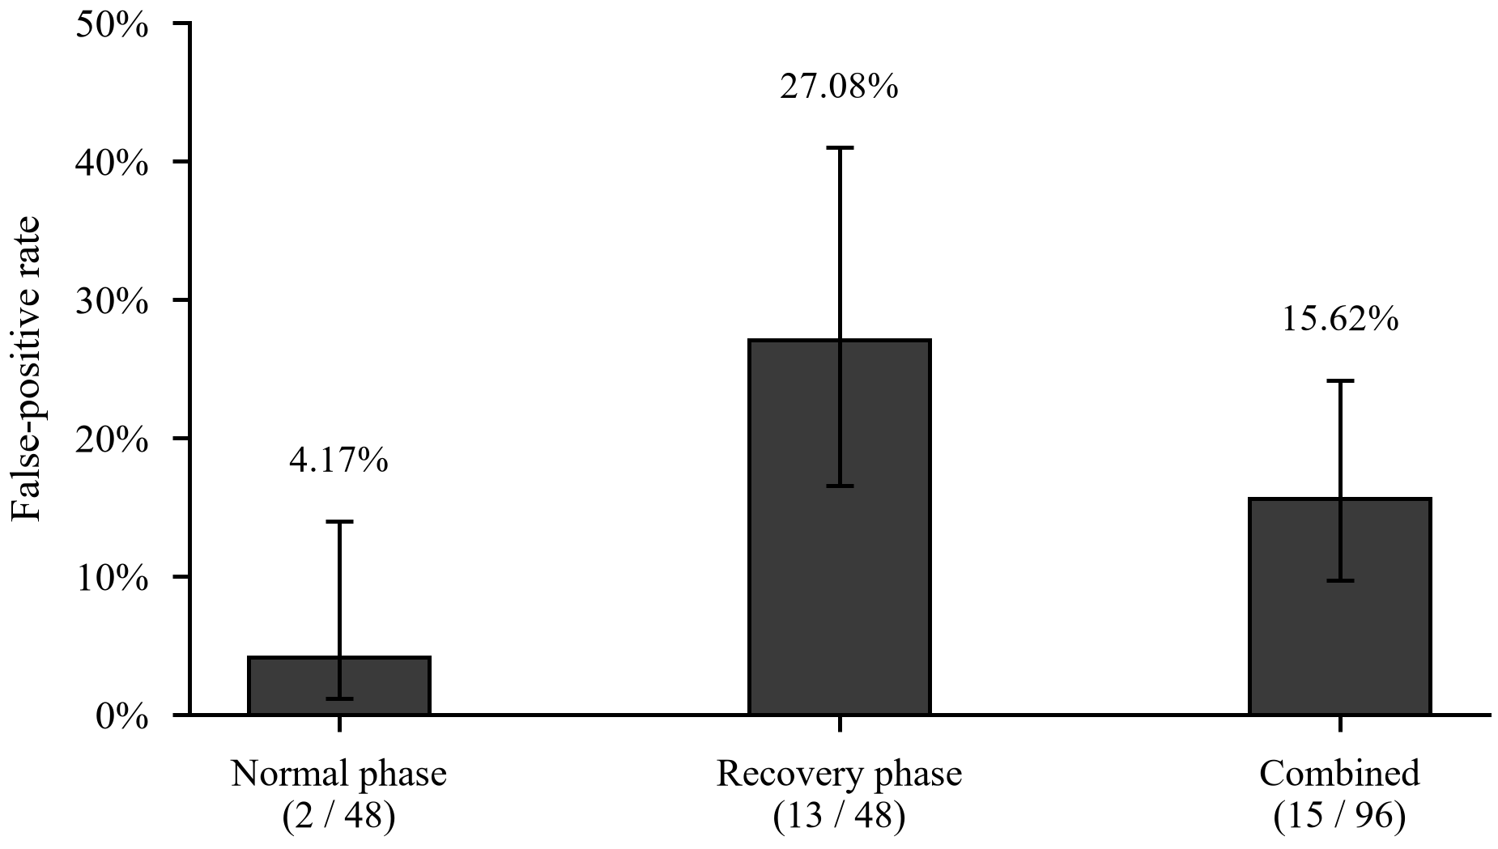

Fig. 5. False-positive rate on healthy telemetry by phase with 95% Wilson confidence intervals.

System-Level Metrics

TABLE VI System-level metrics
Metric | Multi-agent | Single-agent
Detection latency (detection path only), mean | 0.0061 s | 0.0061 s
Detection latency, median | 0.0052 s | 0.0052 s
Time to approval pause (incl. diagnosis), mean | 8.5 s | 2.12 s
Anomaly detection rate | 20.8% | 20.8%
MTTR | not measurable in replay | not measurable in replay
Recovery success rate | not measurable in replay | not measurable in replay
False recovery rate | not measurable in replay | not measurable in replay

- Attribution Mechanism

Breaking the ten answered multi-agent incidents down by determination method gives a clean partition (Table VII). Determination method Incidents Correct Class metric_signature+rag_agreement 5 5 all same- service rag_only 1 1 same- service, no signature matched metric_signature+rag_disagreement 4 4 all cross-service On every cross-service incident, retrieval disagreed with the correct conclusion, returning memory-leak incidents rooted at payment-service that match on the surface features of payment- service telemetry. The baseline received the same retrieved incidents and followed them. This is not an inference from aggregates. On four of four cross-service failures the baseline’s own reasoning cites the retrieved incidents as its justification, three of them naming the retrieved identifiers outright. That the same three Memory incidents are cited across both cross-service fault types, whose telemetry signatures are entirely different, indicates the failure is driven by retrieved precedent rather than by anything in the incident itself.
TABLE VII Determination method for the ten answered multi-agent incidents
Determination method | Incidents | Correct | Incident class
metric_signature+rag_agreement | 5 | 5 | all same-service
rag_only | 1 | 1 | same-service, no signature matched
metric_signature+rag_disagreement | 4 | 4 | all cross-service

Table VI gives the system-level measurements. Detection is shared by construction and the two columns agree to six decimal places; divergence would have indicated a harness defect. Detection latency and time-to-approval-pause are reported separately and deliberately: an earlier harness conflated them by timing the first graph invocation, which runs to the approval pause and therefore includes retrieval, diagnosis and narration, overstating detection latency by roughly three orders of magnitude. The error was found by inspecting an anomalous mean against a near-zero median. Detection by fault type: memory-leak 4 of 12, auth-key-error 2 of 12, db-lock 2 of 12, notification-latency 2 of 12. The three unmeasured metrics require an active fault to remediate, and therefore a live cluster; they are reported as unmeasurable rather than as the 100% a dry run would trivially produce.
- Negative Control on Healthy Telemetry
Table V reports the negative control. The normal-phase rate is acceptable. The recovery-phase rate is more than six times higher and is an operationally significant defect: after a fault has been cleared, metrics have not yet returned to baseline, and the system continues to

TABLE VIII
AI-related metrics
TABLE IX
Run-to-run reproducibility
Arm | Identical predictions across runs
Multi-agent | 48 / 48
Single-agent baseline | 48 / 48
Run-to-Run Reproducibility

Model calls per incident (mean) Model calls, total  Wall clock per incident (mean) | 0.4167  20  8.5 s | 0.2083  10  2.12 s
Incidents producing reasoning text | 1 of 10 | 10 of 10
Hallucination: cited a metric absent from evi- | 0% (1 sample) | 0% (over 10)
dence
Hallucination: claimed a baseline-range value | 0% | 10.0% (1 of 10)
was elevated
Response parse-issue rate | 0% | 0%

raise anomalies on a service that has just been successfully repaired. In a closed loop with automated remediation, this is the precondition for a remediation storm, in which a successful fix is followed by repeated re-detection and further action. We report this as a limitation of the detector configuration rather than of the architecture, and note that it is invisible to any evaluation that replays only fault-window telemetry, which is what our own main experiment does.
- Model-Related Metrics
Table VIII reports the model-related measurements. Token cost is replaced by inference time and call count, following the self-hosted-model substitution documented in Section IV-G. Narration was unavailable on 9 of 10 incidents because the self-hosted 3-billion-parameter model exceeded the 30-second timeout, and diagnostic accuracy was 100% regardless. The failure is a property of the model and the timeout budget rather than of the pipeline, and it is reported because its having no effect on the conclusion is precisely the architectural claim under test. The two hallucination rows measure different things, and the difference is the finding. The conventional definition returns 0% for the baseline, and that 0% is a real measurement rather than a broken detector: eight genuine metric citations were detected across the ten reasoning texts, all present in the evidence. But on one incident the baseline justified “memory leak” by citing a committed-heap value of 86.4 MB as evidence of a heap increase, when that value lies inside the documented 70–90 MB range for the ser-vice. The metric was real; its stated significance was invented. Worth stating plainly, because it cuts against a convenient reading: that diagnosis was correct. The incident genuinely was a payment-service memory leak. The unsupported claim was in the justification, not the conclusion. For an operator reviewing a recommendation this is the more troubling case, not the less, because a right answer supported by a reason that does not hold is indistinguishable at review time from a right answer that is grounded. Both measures are lower bounds, in a specific and demonstrable way. Three of the four cross-service failures also cite a heap figure inside the documented 30–45 MB range while describing it as elevated: 30.7 MB, 30.5 MB and 35.0 MB. Neither measure catches them. The metric-name proxy misses them because the metrics are real. The stronger measure misses them because it parses only values written adjacent to their metric name, and the model wrote these as bare parentheticals. So at least four unsupported significance claims exist in this run and one is counted.
- Run-to-Run Reproducibility
Table IX compares the two runs. The multi-agent result is reproducible by construction. That the single-agent result is equally reproducible was not

TABLE X
Human-in-the-loop and safety metrics

Metric | Multi-agent | Single-agent
Incidents reaching human approval | 10 | 10
Approved / Rejected | 10 / 0 | 10 / 0
Unsafe actions prevented by safety validator | 0 | 0
Executions without approval | 0 | 0

guaranteed and is worth stating: a model-driven diagnosis produced the same 48 answers twice, including the same four wrong ones. What varied is the part that does not affect the conclusion, and it varied more than a count would show. Narration succeeded on exactly one incident in each run, but not the same incident. And on the baseline, all ten reasoning texts differed textually between runs while all ten extracted conclusions were identical. The prose was different on every incident that produced any, in both arms, and not one of the 96 diagnoses moved. This is stronger evidence for the architectural claim than a stable count would have been.
- Human-in-the-Loop Outcomes
Table X reports the human-in-the-loop outcomes. The last row is the safety invariant, reported as a measured quantity rather than asserted. Unsafe action prevention is zero because dry-run execution never failed, so no retry escalated to the high-risk action the ledger-service rule guards; that rule is evidenced instead by regression tests and by a live session, and is not claimed as a demonstrated result of this evaluation.

ABLATION STUDIES
- Ablation Design
Two ablations, both disabled by default in the shipped configuration, both recorded in every run’s environment block, and both covered by tests asserting they are off by default. Ablation A removes retrieval entirely. Does retrieval contribute anything? Ablation B permits retrieved incidents to override a deterministic signature match. What would this system score if built the conventional way?
- Ablation A: Removing Retrieval
Table XI reports Ablation A. Finding A1: retrieval is diagnostically inert for the multi-agent pipeline. Every performance metric is identical with and without retrieval, to four decimal places. Retrieval changes only the recorded confidence label and the determination method. It does not change a single diagnosis across 48 incidents. This is unflattering to the architecture as advertised, and we state it plainly: the retrieval-augmented component contributes nothing to diagnostic accuracy here. The honest characterisation of its role is corroboration and provenance, not diagnosis. A caveat in the other direction:

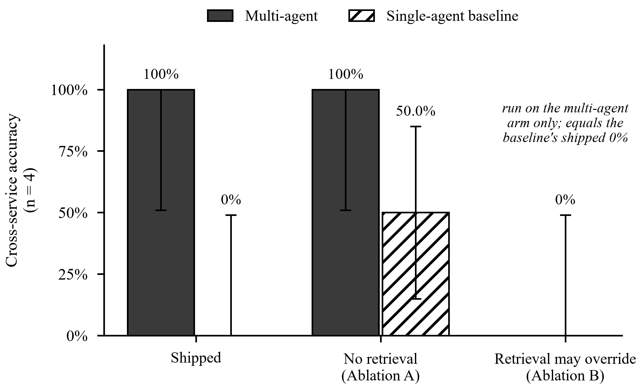

Fig. 6. Cross-service accuracy under both ablations, with 95% Wilson intervals (n = 4). Ablation B was run on the multi-agent arm only.

TABLE XI
Ablation A: removing retrieval

Metric | Multi (shipped) | Multi, no retrieval | Baseline (shipped) | Baseline, no retrieval
Accuracy (all incidents) | 20.8% | 20.8% | 12.5% | 6.3%
Accuracy (when answered) | 100% | 100% | 60.0% | 30.0%
Cross-service accuracy | 100% | 100% | 0% | 50.0%
Same-service accuracy | 100% | 100% | 100% | 16.7%
Blamed the symptom service | 0 | 0 | 4 | 0
F1 (macro) | 1.00 | 1.00 | 0.42 | 0.18
Incidents answered | 10 | 10 | 10 | 10

retrieval cannot help a signature matcher already at 100%, and on a live corpus where signature matching is imperfect it has room to contribute that it does not have here.
Finding A2: for the single-agent baseline, retrieval is load-bearing and harmful. Same-service accuracy collapses from 100% to 16.7%; cross-service accuracy improves from 0% to 50.0%; symptom-service blaming falls from 4 of 4 to 0 of 4. The coherent reading is that retrieval was substituting for reasoning. With precedent available the model pattern-matches to it, which is exactly right on same-service faults and exactly wrong on cross-service ones. Remove the precedent and it loses the easy cases but stops being systematically dragged toward the symptom service
Finding A3: the same intervention leaves one arm unchanged and reorganises the other. That asymmetry is itself evidence for the architectural claim: in the multi-agent pipeline retrieval is advisory by construction, so removing it changes confidence labels; in the baseline it is causal, so removing it changes answers.
Finding A0, reported first among the caveats. All 48 predictions are identical with and without retrieval, but the paths differ on ten of them, and one is not a coincidence-free match. On one incident no signature matched, so with retrieval the answer came from the nearest retrieved incident and without it the pipeline fell back to naming the symptom service. Both produced the right answer, but only
TABLE XII
Ablation B: allowing retrieval to override

Metric | Multi (shipped) | Multi + override | Single-Agent Baseline
Accuracy (all inci- | 20.8% | 12.5% | 12.5%
dents)
Accuracy (when | 100% | 60.0% | 60.0%
answered)
Cross-service | 100% | 0% | 0%
accuracy
Same-service | 100% | 100% | 100%
accuracy
Blamed the symp- | 0 | 4 | 4
tom service
F1 (macro) | 1.00 | 0.4167 | 0.4167
Incidents answered | 10 | 10 | 10

because that is a same- service fault where the fallback’s default happens to be correct. A1 is a claim about scores, not about reasoning being unchanged.
- Ablation B: Permitting Retrieval to Override
Table XII reports Ablation B. Finding B1: removing the constraint reproduces the baseline exactly. Not approximately. Every metric in the override column equals the baseline’s value to four decimal places, including the macro F1 and the count of symptom-service attributions. The determination-method breakdown shows why: five agreements unchanged, one retrieval-only, and four overrides – precisely the four cross-service incidents, each flipped to retrieval’s answer. Under this ablation the pipeline retains everything else that distinguishes it: per-service detectors, signature matching, a deterministic proposer, safety validation and staged approval. All of that apparatus is worth exactly zero once retrieval is allowed to override the conclusion. The system collapses to its own baseline.

Finding B2. This converts the Section V-B attribution from an interpretation into a controlled result. The claim “the advantage comes from refusing to defer to retrieval” is no longer an explanation of a correlation; it is the measured consequence of toggling exactly that constraint with everything else held fixed.

DISCUSSION
- Detection Coverage as the Operational Bottleneck
The diagnostic layer was correct on every incident it answered, and the system’s accuracy over all incidents was 20.8%, because the shared detector surfaced only 10 of 48. This is the system’s real operating characteristic, and it is a detection problem. The mechanism is specific. Isolation Forest saturates outside its training range: every learned split threshold for a feature lies inside the observed range, so any value beyond it takes the same branch at every node. A swept measurement confirmed a 2 GB heap scoring identically to a 50 MB one. Extreme deviations are therefore as invisible as moderate ones, for the same reason. We characterise this rather than tune it away. BARO [2] makes the general form of this argument and addresses it with change-point detection that does not presuppose accurate anomaly flags. That is the most promising direction for this system’s principal weakness. An important mitigation is already present: the deterministic signature matcher does not share this weakness, so the diagnosis stays correct wherever detection fires. The deterministic layer compensating for the machine-learned layer’s blind spot is itself a result in favour of the decomposed design.

- Architectural Resilience Under Model Degradation
The narration layer was unavailable for 90% of the incidents the multi-agent arm answered, and not one conclusion changed. A system that had delegated diagnosis to that model would have produced nothing for those incidents. This is the “deterministic conclusion, model narration” split working exactly as designed, demonstrated by accident rather than by construction. The reproducibility comparison sharpens it: across two runs the prose differed on every incident that produced any, in both arms, while all 96 diagnoses were identical. The component that behaves inconsistently is precisely the component that changes nothing. This has a direct engineering implication. Where a diagnosis must be auditable, the model should narrate a conclusion it cannot alter. Where the model determines the conclusion, as in the baseline, its non-determinism becomes the system’s non- determinism.

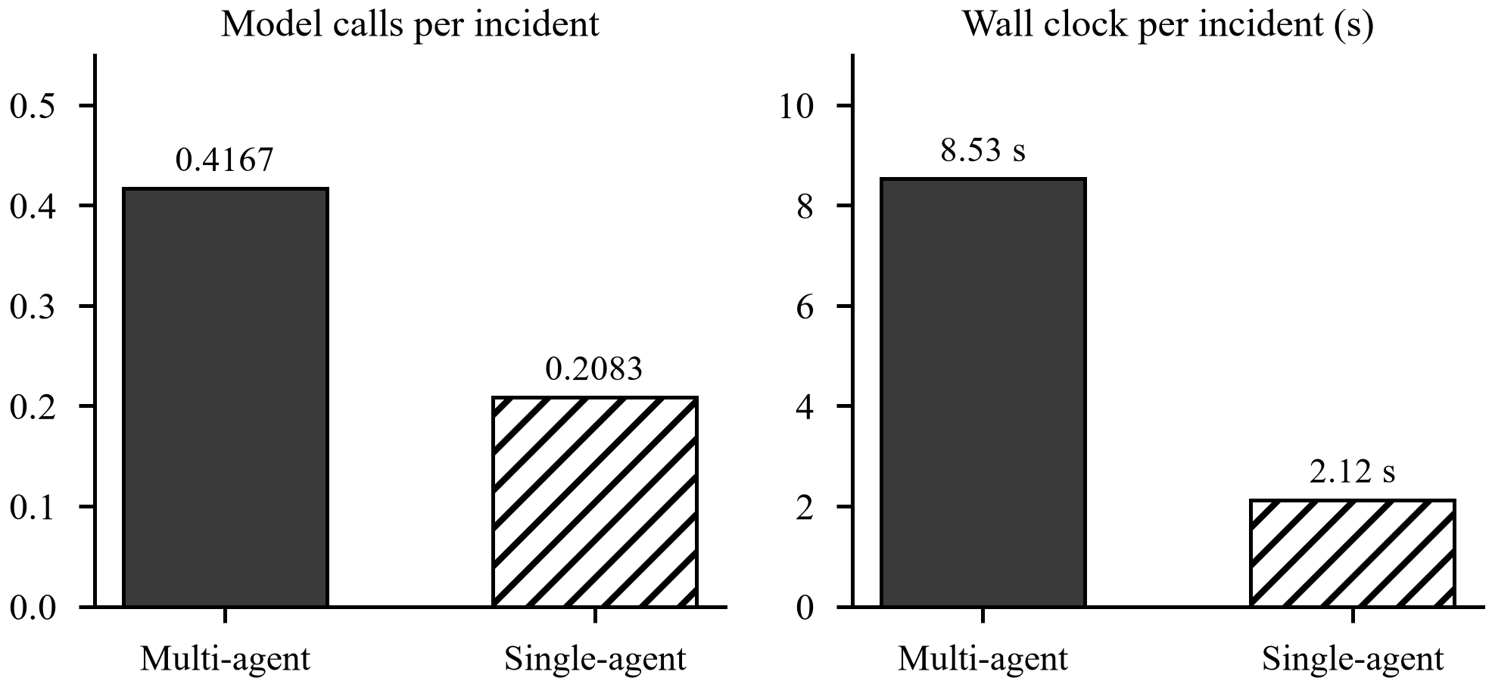

Fig. 7. Model calls and wall-clock time per incident by arm.

- A Stronger Operational Definition of Hallucination
The conventional operational definition of hallucination – citing a metric absent from the evidence – returns near-zero for a model whose actual failure is misrepresenting the significance of metrics that are present. Our data shows this concretely: 0% under the conventional measure, 10.0% under a measure comparing each cited value against its documented baseline range, and at least four such claims present in a run where one is counted. The lesson generalises beyond this system. A hallucination metric defined as reference to a non-existent entity will read as near-zero for any model whose failure mode is misdescribing real entities. In operational settings, where every quantity the model cites is drawn from real telemetry, that is the failure mode that actually occurs. We also note what our stronger measure does not do: it scores the justification, not the answer. A flagged incident may still be diagnosed correctly, and in this run it was.

- Computational Cost of Architectural Decomposition
The multi-agent arm used twice the model calls and 4.017 times the wall clock of the baseline. The benefit is confined entirely to cross-service diagnosis; on same-service faults the two are indistinguishable and the decomposition is pure overhead.
This mirrors a trade-off reported elsewhere in the literature. LATS-RCA [3] reports roughly 75 API calls and 13 minutes per incident; OperAID [4] finds a 2.9-fold cost increase buying a 5.5 point accuracy gain. Our overhead is small in absolute terms because most stages are deterministic Python and the sole model call is optional narration.

- Scope of the Contribution and Conceded Limitations
Three concessions. The two arms are identical on same-service faults. The contribution is narrow and should be stated narrowly. The symptom-to-cause relation is supplied by a documented domain mapping. Graph-based approaches [5], [6], [7], [8] derive this relation from observed dependencies, which generalises to systems whose topology is not known in advance. Ours does not. On a four-service system with a known synchronous call chain the mapping is defensible; on a system of a hundred services it is not, and a learned or traced dependency graph would be required. Unsafe-action prevention is zero, and we do not claim it.

- Regulatory and Operational Deployment Considerations
Three properties matter for a regulated financial deployment. Every executed action is preceded by a recorded human decision with a free-text reason, giving a complete audit trail. Every retry requires its own approval, so an operator cannot be deemed to have consented to an action they never saw. And the safety rule protecting the transactional service is evaluated deterministically and before human consultation, so an operator cannot approve past it. The negative-control finding in Section V-D is the counterweight and should be addressed before any closed-loop deployment: a 27% false-positive rate on post-recovery telemetry, combined with automated remediation, is a remediation-storm risk.

THREATS TO VALIDITY
Internal validity. The two arms share every non-diagnostic node by importing identical objects, and a test asserts node identity, so drift between arms is excluded by construction. Both receive byte- identical replayed records. The simulated operator approves uniformly, which removes operator judgement as a confound but also means approval accuracy is definitionally equal to diagnostic accuracy and is not an independent measurement. The self- reported fault flag is withheld to prevent an answer-key leak on same-service faults. External validity. The corpus is synthetic and the testbed has four services and four fault types. Real incidents exhibit multi- factor causes, incomplete observability and cascading failures that this corpus does not contain. LATS-RCA [3] reports 91.3% on a benchmark and 65.1% on production incidents; we expect a comparable degradation and have not measured it. Results are from one application, one model and one machine. Construct validity. The most serious threat is a circularity: the synthetic generator’s fault formulas and the diagnostic signature thresholds derive from the same documented baseline constants, so a threshold matcher was evaluated on data generated to exceed those thresholds. The comparison between arms is unaffected, since both received identical inputs and the baseline’s failure is not an artefact of this, but the absolute accuracy is not a capability claim. Separately, root-cause accuracy equals fault-type accuracy by construction (Section V-B), so the two are one capability reported twice. Our hallucination measures are lower bounds by acknowledged parsing limits. Statistical validity. The answered subset is 10 incidents and the cross-service subset is 4. Confidence intervals are correspondingly wide and are reported. The cross-service difference is significant by Fisher’s exact test (p = 0.0286) but the conservative paired sign test over four discordant pairs is not (p = 0.125), and we do not claim significance over all answered incidents (p = 0.0867). Two runs cannot characterise a distribution; they establish stability, not its parameters.
The fault taxonomy is deliberately small and every incident carries a single injected fault. Four faults are the minimum that separates the capability under test, since two must be same-service and two cross-service for the comparison in Section V-A to mean anything. The cost is that cascading failures, concurrent faults and partial degradations are absent, and these are common in production. A corpus containing them would test whether the signature matcher degrades gracefully when two signatures fire at once, which the present corpus cannot ask.
A third dependency belongs with the two above and is stated here rather than left for a reader to find. The anomaly detectors are trained on normal-phase and recovery-phase telemetry drawn from the Memory partition, which the same generator produced. Generator, detection thresholds and detector training data therefore all descend from one set of documented baseline constants. The Memory and Evaluation partitions remain disjoint, so no incident is both trained on and scored, but the detector has never been asked to generalise across distributions. This is the strongest reason to treat the live re-run as necessary rather than optional.

CONCLUSION AND FUTURE WORK
- Conclusion
We presented a deterministic-first multi-agent framework for root cause analysis and human-governed remediation in financial microservices, organised around the constraint that retrieved incidents are evidence rather than commands. On 48 held-out incidents the framework was correct on 4 of 4 cross-service faults where a single-agent model given byteidentical evidence was correct on 0 of 4, naming the symptom service every time (p = 0.0286). The arms were indistinguishable on same-service faults, so the contribution is confined to, and defined by, cross-service attribution. Two ablations establish the mechanism. Retrieval contributes zero diagnostic accuracy to the pipeline, and permitting it to override the deterministic conclusion reproduces the baseline exactly. The advantage is therefore attributable to the architectural constraint, not to the retrieval component, and this is a controlled result rather than an interpretation. We further report that detection, not diagnosis, bounded the system at 20.8% coverage; that a negative control reveals a 27% false-positive rate on post-recovery telemetry; and that the conventional hallucination metric measures the wrong thing in operational settings.
- Future Work
  - Replace the detector. Change-point detection in the manner of BARO [2] directly targets the binding constraint and the saturation behaviour documented in Section VII-A.
  - Compare against a tool-augmented baseline. An agent able to query services during diagnosis, in the manner of ReAct [24], is the control this design should face next, and Section IV-D explains why the present single-call baseline is the narrower test.
  - Fix the post-recovery false-alarm rate, through a stabilisation window after a verified recovery or a detector trained explicitly on recovery-phase telemetry.
  - Derive the dependency relation rather than declare it, using distributed tracing, removing the concession in Section VII-E and generalising beyond four services.
  - Run the live evaluation. Recovery success rate, false recovery rate and MTTR require an active fault, and become measurable with no code change under a live-mode run on a cluster.
  - Validate on real incidents, to quantify the benchmark-to-production gap [3] for this design.
  - Study operator behaviour at the approval gate, including whether approval fatigue erodes the governance property this architecture provides.
Data and Code Availability
The implementation, the incident corpus with its Memory and Evaluation partitions, the evaluation harness, both ablation configurations, the negative control, per-incident results, computed metrics and the raw run records of both independent runs are available at https://github.com/Anushk0/Self-Healing-Microservices. The full evaluation reproduces with a single command, and metrics may be recomputed from a saved run without re-executing the pipeline.
Declarations
Ethics. This work involved no human participants and no personal data. All telemetry was generated by the authors’ own fault-injection experiments and by a deterministic synthetic generator. The simulated operator described in Section IV-E is a software component, not a person.
Conflicts of interest. The authors declare no competing interests.
Funding. This research received no external funding.
Author contributions. All authors contributed to the design of the framework, the experimental protocol and the manuscript, and all approved the submitted version.
References
- J. Soldani and A. Brogi, “Anomaly detection and failure root cause analysis in (micro) service-based cloud applications: A survey,” ACM Computing Surveys, vol. 55, no. 3, art. 59, 2022.

- L. Pham, H. Ha, and H. Zhang, “BARO: Robust root cause analysis for microservices via multivariate Bayesian online change point detection,” 2024, doi: 10.1145/3660805.
- A. Naakka, Y. Wang, and M. V. Mäntylä, “LATS-RCA: Language agent tree search for root cause analysis in microservices,” arXiv:2605.03505, 2026.
- A. Góes de Castro, K. Vandikas, S. Ferlin, M. Chiesa, and C. Esteve Rothenberg, “OperAID: Benchmarking LLM agents for autonomous Kubernetes fault remediation,” in Proc. IEEE NetSoft, 2026, doi: 10.1109/NETSOFT70012.2026.11603505.
- J. Kou, Z. Qing, R. Wei, F. Xue, W. Huang, and H. Zhuang, “CausalRCA: Causal graph-augmented retrieval for root cause analysis in microservice systems,” in Proc. IEEE EIBDCT, 2026, doi: 10.1109/EIB-DCT69742.2026.11566729.
- C. Qiu, “Hierarchical expert multi-agent framework for causal root cause localisation in cloud-native microservices,” in Proc. IEEE EIECT, 2025, doi: 10.1109/EIECT68017.2025.11331781.
- W. Zhang, Z. Yang, F. Peng, L. Zhang, Y. Chen, and R. Chen, “GALR: Graph-based root cause localisation and LLM-assisted recovery for microservice systems,” Electronics, vol. 15, no. 243, 2026.
- Á. Kiss and K. Nehéz, “A graph transformer-based framework for multi-modal failure diagnosis in microservice systems,” Int. J. Cloud Applications and Computing, vol. 16, no. 1, 2026.
- Z. G. Wang, “AgentTrace: Causal graph tracing for root cause analysis in deployed multi-agent systems,” in ICLR Workshop on Agents in the Wild, 2026.
- R. G. dos Santos Souza and M. Colaço Júnior, “Cloud microservices: An empirical study of MCP-orchestrated LLM agents for incident triage,” in Proc. CSBC/SEMISH, 2026.
- S. G. Aribe Jr. and R. J. G. Oracion, “When web apps heal themselves: A MAPE-K based approach to fault tolerance and adaptive recovery,” Int. J. Informatics and Communication Technology, vol. 15, no. 2, pp. 729–740, 2026, doi: 10.11591/ijict.v15i2.pp729-740.
- Z. Yazdanparast, “A survey on self-healing software system,” arXiv:2403.00455, 2024.
- P. Singh, “Self-healing architecture: Using ML to enhance system resilience in FinTech platforms,” J. Artificial Intelligence, Machine Learning and Data Science, vol. 2, no. 1, 2024, doi: 10.51219/JAIMLD/Prashant-singh/573.
- K. R. Gaddam, “Towards autonomous financial platforms: Leveraging AI agents and microservices for self-healing infrastructure,” World
J. Advanced Research and Reviews, vol. 26, no. 2, 2025, doi: 10.30574/wjarr.2025.26.2.1912.
- T. Singh, “Self-healing infrastructure: Predictive automation for high-availability banking systems,” Int. J. AI, Big Data, Computational and Management Studies, vol. 7, no. 1, 2026, doi: 10.63282/3050-9416.ijaibdcms-v7i1p120.
- M. Nagaraja, D. R. Palavali, A. Jain, and R. Y. Hosamani, “Self-healing security orchestration for financial fraud systems: Autonomous incident response and infrastructure stabilization,” in Proc. IEEE SoutheastCon, 2026, doi: 10.1109/SoutheastCon63549.2026.11476294.
- F. Fahmi, P.-S. Huang, and F.-J. Wang, “Detecting artifact anomalies in microservice-based financial applications,” in Proc. IEEE Int. Conf. Services Computing, 2020, doi: 10.1109/SCC49832.2020.00061.
- R. A. Deshpande, “Application of Spring Boot microservice architecture for scaling banking applications,” The American J. Engineering and Technology, vol. 7, no. 9, 2025, doi: 10.37547/tajet/volume07issue09-
09.
- R. Konda, “Machine learning-based self-healing systems: Automated failure detection and recovery in microservices,” Int.
J. for Multidisciplinary Research, vol. 3, no. 5, 2021, doi: 10.36948/ijfmr.2021.v03i05.43946.
- O. Meyer, E. Johnson, and J. Brown, “A unified framework for anomaly detection and root cause analysis in microservice systems,” Computer Life, vol. 13, no. 2, 2025, doi: 10.54097/1gw77589.
- M. Anderson, J. Thompson, R. Williams, E. Carter, D. Martinez, and
- Srinivas, “Resilient architecture design for financial microservices using fault tolerance patterns,” Int. J. Scientific Research in Science, Engineering and Technology, 2020, doi: 10.32628/ijsrset2072905.
- S. Mali, S. Gavale, D. Ganage, S. Bhalekar, and S. Jadhav, “Self-healing microservices and AI-based anomaly detection system,” Int. Research J. Modernization in Engineering Technology and Science, vol. 7, no. 11, 2025.
- F. T. Liu, K. M. Ting, and Z.-H. Zhou, “Isolation forest,” in Proc. IEEE Int. Conf. Data Mining, 2008, pp. 413–422.
- S. Yao, J. Zhao, D. Yu, N. Du, I. Shafran, K. Narasimhan, and Y. Cao, “ReAct: Synergizing reasoning and acting in language models,” in Proc. ICLR, 2023.
- P. Lewis et al., “Retrieval-augmented generation for knowledge-intensive NLP tasks,” in Proc. NeurIPS, 2020.
- “Multi-agent LLM orchestration achieves deterministic, high-quality decision support for incident response,” arXiv:2511.15755, Nov. 2025. Withdrawn by the author.

