Assignment 05: Assignment and practice of AI Image Generator

Leonard AI image:



Canva AI image:

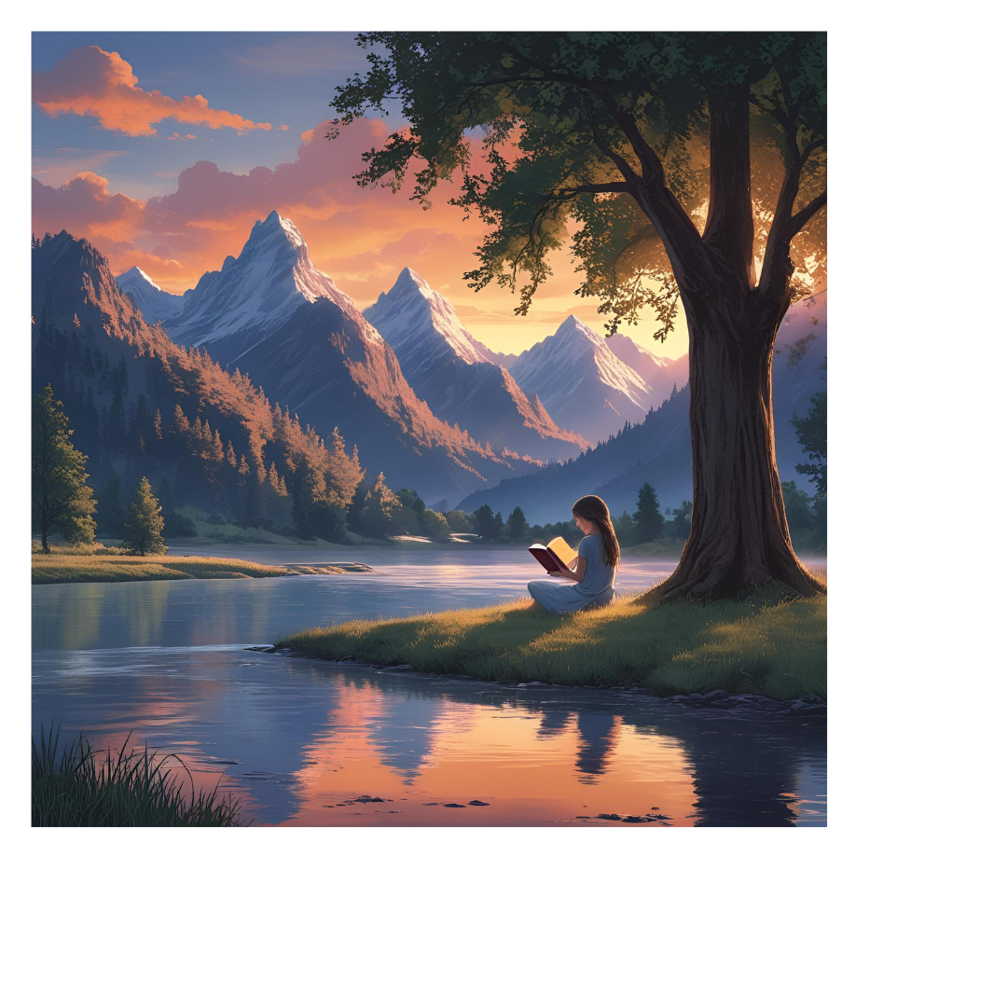

Key difference between leonard AI image vs Canva AI image:

### **1. Image Quality**

* **Leonardo AI**: Known for high-quality, photorealistic outputs. Its results often rival those of Midjourney while offering enhanced style control.
* **Canva AI (Dream Lab)**: Produces decent visual quality suitable for design assets and marketing materials. However, its image realism is generally milder than Leonardo’s.

### **2. Prompt Accuracy & Control**

* **Leonardo AI**: Offers robust prompt enhancement features—rewriting partial prompts and providing control over styles.
* **Canva AI**: Integrated into Canva’s editor for smooth design workflows, but offers less granular control. It doesn’t let you adjust lighting, camera angles, or styles beyond preset templates.
* **conclusion**: Leonardo provides superior prompt fidelity and flexibility, while Canva focuses on ease of use within a broader design tool.

### **3. Style Flexibility**

* **Leonardo AI**: Exceptional variety, with fine-tunable “Elements,” multi-model support, and live editing
* **Canva AI**: Styles are limited to what’s available in Dream Lab + Canva’s templates—less expansive but practical for straightforward design tasks.
* conclusion: Leonardo excels in versatility; Canva keeps it simple for everyday design.

### **4. Usability**

* **Leonardo AI**: Offers powerful tools and a clean interface, but with a steeper learning curve due to its depth. Geared toward experienced creatives and developers.
* **Canva AI**: Extremely beginner-friendly; AI generation sits right in the familiar Canva editor for quick creation, resizing, layering, and editing.
* **Conclusion:** Canva wins for accessibility and speed, especially for non-designers. Leonardo is better for users needing precision and depth.

### **5. Licensing & Terms**

* **Leonardo AI**:  
  + Commercial use is allowed—even on free plans—but be cautious with public generation, which may grant usage rights to Leonardo.
* **Canva AI**:  
  Images follow Canva’s standard content license, generally allowing use in marketing, presentations, ads, etc.,