PDE3823 – Formal Proposal Form

Student Name | Anushka Narsima Amarnath
Student Number | M00851749
Study Status | BEng CS Third Year
Campus | Dubai Campus
Date of Submission | 07/03/2025
BEng Programme Name | BEng Computer Systems Engineering
Name of Allocated/Chosen Supervisor | Ms. Geethu Joy
Proposed Title | Variable Speen Limits with Reinforcement Learning for Traffic Flow Optimization
Type | This project involves the design & implementation of a software system that understands road conditions & outputs varying speed limits to control traffic flow. It will use reinforcement learning to do so, and simulate the environment to observe effects.
Keywords | Traffic Flow, Variable Speed Control, Reinforcement Learning
Problem Definition | Traffic affects every person at an individual level, at the cost of time and fuel. From a wider view, it contributes to more accidents, higher emissions, and has been a challenge for the authorities to manage. The ideal situation on a road to avoid congestion is for all vehicles to run at a constant speed and distance, but it hardly followed in the real world. Applying different speed limits at different points of a road can help achieve this, slow down incoming vehicles when there’s an accident up ahead, etc.
Study Area Review | A promising approach to this problem is with reinforcement learning, where the agent responds to changing environments. There are 2 main papers that have implemented this (2016 & 2022), and both have pros and cons at different steps of their approach. One uses a scalable framework, but uses a base MDP instead of an POMDP. The more recent one does this along with a better algorithm but did not consider predictions and uses a different simulator that is not as scalable. Both do not include a safety aspect that has been recently suggested for the 2nd algorithm. The scalable framework also has an upgraded version.

Research Question | How to formulate an impactful, efficient & scalable system that can optimize traffic flow? How does it perform compared to previous approaches? How to implement it in the real world?
Aims & Objectives | - To design a robust RL algorithm to output speed limits given current road conditions, along with predicted & incoming data  - To test & simulate in an upgraded & scalable framework  - To combine the strengths of previous papers while eliminating their cons  - To make this usable by authorities to reduce congestion  - To apply this to UAE data
Deliverables | The deliverables of this project are:  - A solution that outputs varying speed limits  - A simulation of effect of the system of real-world roads  - Thorough study of technologies & techniques considered  - Documentation of timeline, requirements, detailed steps followed
Project Type | Software development project with simulation – AI / Reinforcement Learning

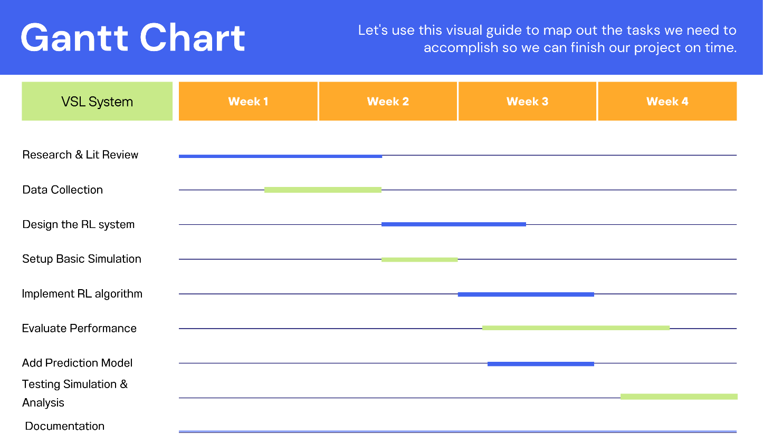
Research/system analysis and design Methodology | The design methodology to be adopted will be the Agile methodology. Agile Methodology Is an iterative approach towards project management. It divides whole project into modules which encourages continuous improvement.  The research methodology for this project will be mixed methods, and the project would come under the build category. It is qualitative, exploratory and applied research, exploring AI algorithms, using optimised versions for problem at hand, and applying them to a real-world scenario.
Resources Audit | Potential tools to be used – Python with RL Libraries like stable-baseline3 or ray-RLLib. METANET framework built for traffic simulation, possibly new & improved I-METANET if given access. TOMO’s traffic APIs claim to have all data required.
Research Ethical Approval Request | To be Done
If no, please give details:
Declaration A | - I have studied the Ethical Approval section.  - I have established that my study does not require additional human participation.  (iii) I agree to re-apply for approval if the nature or goals of my project change.
Declaration B | Project goals involve human participation:  - I have studied the Ethical Approval section.  - My study involves human participation through  - observation  - questioning.  - Participants will be selected without coercion.  - I will obtain informed consent from each participant using proper Form.  - I have arrangements in place for the protection of personal data.  - I agree to re-apply for approval if the nature or goals of my project change.
Declaration C | My project does not fulfil the conditions for automatic Ethical Approval and I am applying separately to the Ethics Committee.

Signed (digitally) Date 10/03/2025

