Banner Accounts Receivable
Interactive Help POC
Technical Design for Simulated TTVDCAT_POC, TSADETC_POC, and TSADETL_POC Pages

Purpose: provide a lightweight Oracle-backed simulation for demonstrating browser-overlay, RAG-driven, interactive page help without connecting to a live Banner database.

Item | Value
Scope | Category validation, detail-code setup, student account transactions, balance calculations, and help provenance
Database | Oracle-compatible design; POC tables are deliberately prefixed POC_
UI pages | TTVDCAT simulation, TSADETC simulation, TSADETL simulation

1. Executive Summary
The POC should model a three-level dependency chain: a category is created on the TTVDCAT simulation; one or more detail codes are created on the TSADETC simulation and assigned to that category; student account transactions are then entered on the TSADETL simulation using a valid, active detail code. The help layer can explain both forward usage (where a value is used) and backward provenance (where the value is maintained).
The proposed implementation uses seven core POC tables. Only three are page-owned tables; the others are small supporting validation and identity tables needed to make the demonstration realistic.
POC table | Role | Simulated Banner concept
POC_AR_CATEGORY | Category code validation | TTVDCAT / detail category validation
POC_AR_DETAIL_CODE | Student detail-code control | TSADETC main-window concepts; Banner stores detail-code control data in AR control tables
POC_PERSON | Synthetic student/account identity | SPRIDEN-like identity lookup for the demo
POC_TERM | Term validation | STVTERM-like term validation
POC_AR_TRANSACTION | Student charge/payment activity | TSADETL account-detail concepts; TBRACCD-like transaction data
POC_AR_ACCOUNT_SUMMARY | Optional cached/demo summary | Calculated balance region on TSADETL
POC_HELP_METADATA | RAG/help facts and page-field lineage | POC-specific metadata, not a Banner table

2. Scope and Assumptions
- The pages are simulations, not replicas of all Banner behavior.
- Only the fields visible in the supplied screenshots and fields required for useful validation are included.
- All table and column names beginning with POC_ are new POC objects and are not asserted to be Banner-delivered objects.
- The design uses synthetic internal person keys rather than production PIDMs.
- Amounts use Banner-like sign behavior: positive charges increase the account balance; positive payments are stored as credits by converting them to a negative signed amount.
- A production integration should replace the POC metadata and queries with institution-approved Banner views, APIs, and security rules.

3. Page-to-Table and Field Mapping

3.1 TTVDCAT Simulation - Detail Category Code Validation
UI field | POC column | Required | Validation / behavior
Code | POC_AR_CATEGORY.CATEGORY_CODE | Yes | Uppercase; 1-4 characters; unique; cannot contain spaces
Description | POC_AR_CATEGORY.DESCRIPTION | Yes | 1-60 characters
System Required | POC_AR_CATEGORY.SYSTEM_REQUIRED_IND | Yes | Y/N; system-required rows cannot be deleted in the POC

Interactive-help examples: “Where is category FA used?” returns matching detail codes from POC_AR_DETAIL_CODE. “Where do I maintain this category?” returns TTVDCAT simulation.

3.2 TSADETC Simulation - Detail Code Control
UI field | POC column | Required | Validation / behavior
Detail Code | DETAIL_CODE | Yes | Uppercase; 1-4 characters; unique
Detail Code Description | DESCRIPTION | Yes | 1-60 characters
Type | TYPE_CODE | Yes | C = charge, P = payment
Category | CATEGORY_CODE | Yes | Foreign key to POC_AR_CATEGORY
Grant Type | GRANT_TYPE_CODE | No | Optional POC text/code; no external dependency unless separately configured
Priority | PRIORITY_NO | Yes | 000-999; stored as number 0-999 and formatted as three digits
Active | ACTIVE_IND | Yes | Y/N; inactive codes cannot be used for new transactions

3.3 TSADETL Simulation - Student Account Detail
UI field | POC source | Required | Validation / calculation
ID | POC_PERSON.BANNER_ID | Yes | Must resolve to an active synthetic person
Name | POC_PERSON.DISPLAY_NAME | Display | Derived after ID lookup
Detail Code | POC_AR_TRANSACTION.DETAIL_CODE | Yes | Must exist and be active in POC_AR_DETAIL_CODE
Detail Code Description | POC_AR_DETAIL_CODE.DESCRIPTION | Display | Derived from detail code
Amount | POC_AR_TRANSACTION.AMOUNT | Yes | Must be greater than zero on entry
Balance | POC_AR_TRANSACTION.OPEN_BALANCE | Display | Initial signed amount; may be reduced by future application logic
Term | POC_AR_TRANSACTION.TERM_CODE | Yes | Must exist and be active in POC_TERM
Transaction Number | POC_AR_TRANSACTION.TRANSACTION_NO | Display | Sequential per student account
Transaction Date | POC_AR_TRANSACTION.TRANSACTION_DATE | Yes | Defaults to current date
Original Charge | POC_AR_TRANSACTION.ORIGINAL_CHARGE_IND | Yes | Y/N; default N
Query / Account Balance | Calculated | Display | Sum of signed open balances for the student
Amount Due | Calculated | Display | For POC, same as account balance unless future-dated logic is added

4. Logical Data Model
POC_AR_CATEGORY (1)
|
| CATEGORY_CODE
v
POC_AR_DETAIL_CODE (many)
|
| DETAIL_CODE
v
POC_AR_TRANSACTION (many) ----> POC_PERSON (1)
|
+----------------------> POC_TERM (1)
POC_HELP_METADATA stores page/field definitions and lineage statements
used by the RAG/help service. POC_AR_ACCOUNT_SUMMARY is optional and can
be refreshed from POC_AR_TRANSACTION.
Deletion should be restricted when a parent row is referenced. For example, a category cannot be deleted while detail codes use it, and a detail code cannot be deleted while transactions use it. Use deactivation instead.

5. Oracle DDL
The following DDL is complete for the proposed POC schema.
CREATE TABLE poc_ar_category (
category_code VARCHAR2(4 CHAR) NOT NULL,
description VARCHAR2(60 CHAR) NOT NULL,
system_required_ind CHAR(1) DEFAULT 'N' NOT NULL,
active_ind CHAR(1) DEFAULT 'Y' NOT NULL,
created_at TIMESTAMP DEFAULT SYSTIMESTAMP NOT NULL,
created_by VARCHAR2(30 CHAR) DEFAULT USER NOT NULL,
updated_at TIMESTAMP DEFAULT SYSTIMESTAMP NOT NULL,
updated_by VARCHAR2(30 CHAR) DEFAULT USER NOT NULL,
CONSTRAINT pk_poc_ar_category PRIMARY KEY (category_code),
CONSTRAINT ck_poc_ar_cat_code_upper CHECK (category_code = UPPER(category_code)),
CONSTRAINT ck_poc_ar_cat_sys CHECK (system_required_ind IN ('Y','N')),
CONSTRAINT ck_poc_ar_cat_active CHECK (active_ind IN ('Y','N'))
);
CREATE TABLE poc_ar_detail_code (
detail_code VARCHAR2(4 CHAR) NOT NULL,
description VARCHAR2(60 CHAR) NOT NULL,
type_code CHAR(1) NOT NULL,
category_code VARCHAR2(4 CHAR) NOT NULL,
priority_no NUMBER(3) DEFAULT 0 NOT NULL,
active_ind CHAR(1) DEFAULT 'Y' NOT NULL,
created_at TIMESTAMP DEFAULT SYSTIMESTAMP NOT NULL,
created_by VARCHAR2(30 CHAR) DEFAULT USER NOT NULL,
updated_at TIMESTAMP DEFAULT SYSTIMESTAMP NOT NULL,
updated_by VARCHAR2(30 CHAR) DEFAULT USER NOT NULL,
CONSTRAINT pk_poc_ar_detail_code PRIMARY KEY (detail_code),
CONSTRAINT fk_poc_ar_det_category FOREIGN KEY (category_code)
REFERENCES poc_ar_category (category_code),
CONSTRAINT ck_poc_ar_det_type CHECK (type_code IN ('C','P')),
CONSTRAINT ck_poc_ar_det_priority CHECK (priority_no BETWEEN 0 AND 999),
CONSTRAINT ck_poc_ar_det_active CHECK (active_ind IN ('Y','N'))
);
CREATE TABLE poc_person (
person_key NUMBER GENERATED BY DEFAULT AS IDENTITY,
banner_id VARCHAR2(9 CHAR) NOT NULL,
display_name VARCHAR2(120 CHAR) NOT NULL,
active_ind CHAR(1) DEFAULT 'Y' NOT NULL,
credit_limit NUMBER(12,2),
CONSTRAINT pk_poc_person PRIMARY KEY (person_key),
CONSTRAINT uk_poc_person_banner_id UNIQUE (banner_id),
CONSTRAINT ck_poc_person_active CHECK (active_ind IN ('Y','N'))
);
CREATE TABLE poc_term (
term_code VARCHAR2(6 CHAR) NOT NULL,
description VARCHAR2(60 CHAR) NOT NULL,
start_date DATE,
end_date DATE,
active_ind CHAR(1) DEFAULT 'Y' NOT NULL,
CONSTRAINT pk_poc_term PRIMARY KEY (term_code),
CONSTRAINT ck_poc_term_active CHECK (active_ind IN ('Y','N')),
CONSTRAINT ck_poc_term_dates CHECK (
start_date IS NULL OR end_date IS NULL OR start_date <= end_date
)
);
CREATE TABLE poc_ar_transaction (
transaction_id NUMBER GENERATED BY DEFAULT AS IDENTITY,
person_key NUMBER NOT NULL,
transaction_no NUMBER(9) NOT NULL,
detail_code VARCHAR2(4 CHAR) NOT NULL,
term_code VARCHAR2(6 CHAR) NOT NULL,
entry_amount NUMBER(12,2) NOT NULL,
signed_amount NUMBER(12,2) NOT NULL,
open_balance NUMBER(12,2) NOT NULL,
transaction_date DATE DEFAULT TRUNC(SYSDATE) NOT NULL,
created_at TIMESTAMP DEFAULT SYSTIMESTAMP NOT NULL,
created_by VARCHAR2(30 CHAR) DEFAULT USER NOT NULL,
CONSTRAINT pk_poc_ar_transaction PRIMARY KEY (transaction_id),
CONSTRAINT uk_poc_ar_tran_no UNIQUE (person_key, transaction_no),
CONSTRAINT fk_poc_ar_tran_person FOREIGN KEY (person_key)
REFERENCES poc_person (person_key),
CONSTRAINT fk_poc_ar_tran_detail FOREIGN KEY (detail_code)
REFERENCES poc_ar_detail_code (detail_code),
CONSTRAINT fk_poc_ar_tran_term FOREIGN KEY (term_code)
REFERENCES poc_term (term_code),
CONSTRAINT ck_poc_ar_tran_entry_amt CHECK (entry_amount > 0)
);
CREATE INDEX ix_poc_ar_tran_person_term
ON poc_ar_transaction (person_key, term_code);
CREATE INDEX ix_poc_ar_tran_detail
ON poc_ar_transaction (detail_code);
CREATE TABLE poc_help_metadata (
help_id NUMBER GENERATED BY DEFAULT AS IDENTITY,
page_code VARCHAR2(8 CHAR) NOT NULL,
field_name VARCHAR2(60 CHAR),
topic VARCHAR2(100 CHAR) NOT NULL,
help_text CLOB NOT NULL,
source_page_code VARCHAR2(8 CHAR),
source_object_name VARCHAR2(30 CHAR),
target_page_code VARCHAR2(8 CHAR),
target_object_name VARCHAR2(30 CHAR),
active_ind CHAR(1) DEFAULT 'Y' NOT NULL,
CONSTRAINT pk_poc_help_metadata PRIMARY KEY (help_id),
CONSTRAINT ck_poc_help_active CHECK (active_ind IN ('Y','N'))
);

6. Transaction Insert Logic
Do not let the browser directly calculate signs or transaction numbers. Place this logic in an API/service or PL/SQL procedure.
-- Core rules before insert:
-- 1. Resolve person by BANNER_ID and require ACTIVE_IND = 'Y'.
-- 2. Fetch detail code; require ACTIVE_IND = 'Y'.
-- 3. Validate TERM_CODE in POC_TERM and require ACTIVE_IND = 'Y'.
-- 4. Set SIGNED_AMOUNT:
-- charge (TYPE_CODE = 'C') -> +ENTRY_AMOUNT
-- payment (TYPE_CODE = 'P') -> -ENTRY_AMOUNT
-- 5. Set OPEN_BALANCE = SIGNED_AMOUNT.
-- 6. Set TRANSACTION_NO = MAX(TRANSACTION_NO) + 1 for the person,
-- protected by a lock or database sequence strategy.

7. Validation Rules by Page

7.1 TTVDCAT
Event | Rule | Suggested message
Insert/update | Code and description are required | Enter a category code and description.
Insert/update | Code must be uppercase and unique | Category code already exists or is not uppercase.
Delete | Reject when SYSTEM_REQUIRED_IND = Y | System-required category codes cannot be deleted.
Delete | Reject when referenced by detail codes | Category is used by one or more detail codes; deactivate it instead.
Deactivate | Allow deactivation; existing detail codes remain queryable | Category deactivated. Existing references were preserved.

7.2 TSADETC
Event / field | Rule | Suggested message
Category | Must exist and be active in POC_AR_CATEGORY | Enter a valid active category code maintained on TTVDCAT.
Type | Only C or P | Type must be C (charge) or P (payment).
Priority | 0 through 999 | Priority must be between 000 and 999.
Term/Aid Year Based | Both cannot be Y in this reduced POC | Choose either Term Based or Aid Year Based.
Refund/Direct Deposit | Recommended only for payment detail codes | Refund and direct-deposit options are normally used with payment codes.
Deactivate | Allowed even when transactions exist | Detail code deactivated; it cannot be used for new transactions.
Delete | Reject when transactions exist | Detail code has account activity and cannot be deleted.

7.3 TSADETL
Event / field | Rule | Suggested message
ID | Required; resolve active person | Enter a valid active student ID.
ID | Optionally block when account hold exists | Account has an AR hold; transaction entry is not permitted.
Detail Code | Must exist and be active | Invalid or inactive detail code.
Detail Code | Description and type are display-derived | No manual entry; values are returned from detail-code control.
Amount | Required and > 0 | Amount must be greater than zero.
Term | Required and valid in POC_TERM | Enter a valid active term code.
Aid Year | Required for aid-year-based detail code | Aid year is required for this detail code.
Dates | Default to current date | Effective and transaction dates are required.
Save | Signed amount determined by detail-code type | Charge saved as debit; payment saved as credit.
Delete | Prefer void status rather than physical delete | Transaction was voided and retained for audit history.

8. Balance Calculations and Immediate Help Queries
For the POC, the balance is the sum of OPEN_BALANCE for active transactions. Positive totals represent an amount owed; negative totals represent a credit balance. This is intentionally simpler than full Banner application-of-payments behavior.
-- Total account balance for one student
SELECT p.banner_id,
p.display_name,
NVL(SUM(t.open_balance), 0) AS account_balance
FROM poc_person p
LEFT JOIN poc_ar_transaction t
ON t.person_key = p.person_key
AND t.status_code = 'A'
WHERE p.banner_id = :p_banner_id
GROUP BY p.banner_id, p.display_name;
-- Balance for one student, detail code, and term
SELECT p.banner_id,
t.detail_code,
t.term_code,
NVL(SUM(t.open_balance), 0) AS detail_term_balance
FROM poc_person p
JOIN poc_ar_transaction t
ON t.person_key = p.person_key
WHERE p.banner_id = :p_banner_id
AND t.detail_code = UPPER(:p_detail_code)
AND t.term_code = :p_term_code
AND t.status_code = 'A'
GROUP BY p.banner_id, t.detail_code, t.term_code;
-- Where is a category used?
SELECT c.category_code,
c.description AS category_description,
d.detail_code,
d.description AS detail_code_description,
d.type_code,
d.active_ind
FROM poc_ar_category c
LEFT JOIN poc_ar_detail_code d
ON d.category_code = c.category_code
WHERE c.category_code = UPPER(:p_category_code)
ORDER BY d.detail_code;
-- Where is a detail code used?
SELECT t.detail_code,
COUNT(*) AS transaction_count,
COUNT(DISTINCT t.person_key) AS account_count,
SUM(t.open_balance) AS total_open_balance
FROM poc_ar_transaction t
WHERE t.detail_code = UPPER(:p_detail_code)
AND t.status_code = 'A'
GROUP BY t.detail_code;

9. RAG / Interactive Help Content Model
The RAG service should combine static page documentation with live POC query results. Static facts belong in POC_HELP_METADATA or a vector store; numeric answers should be generated from parameterized SQL against the POC tables.
User question | Answer source | Expected behavior
Where is category FA used? | POC_AR_DETAIL_CODE query | List detail codes whose CATEGORY_CODE = FA; explain that categories are maintained on TTVDCAT.
Where does this TSADETC Category value come from? | Metadata + POC_AR_CATEGORY lookup | Explain provenance from TTVDCAT and show description/status.
What does Type P mean? | POC_HELP_METADATA | Explain payment/credit behavior in the POC.
Can I use an inactive detail code? | Metadata + detail-code row | No for new transactions; existing history remains visible.
What is this student's total balance? | Parameterized balance SQL | Return sum of active OPEN_BALANCE rows.
What is the balance for ID, detail code, and term? | Parameterized detail-term SQL | Return aggregate and optionally list contributing transactions.
Where is this detail code used? | POC_AR_TRANSACTION aggregate | Return account count, transaction count, and open balance.

10. Sample Seed Data
INSERT INTO poc_ar_category
(category_code, description, system_required_ind)
VALUES ('FA', 'Financial Aid', 'N');
INSERT INTO poc_ar_category
(category_code, description, system_required_ind)
VALUES ('FEE', 'Registration Fees', 'Y');
INSERT INTO poc_ar_category
(category_code, description, system_required_ind)
VALUES ('CSH', 'Cash', 'N');
INSERT INTO poc_ar_detail_code
(detail_code, description, type_code, category_code, priority_no,
refundable_ind, receipt_ind, active_ind)
VALUES
('TUIT', 'Tuition Charge', 'C', 'FEE', 100, 'Y', 'N', 'Y');
INSERT INTO poc_ar_detail_code
(detail_code, description, type_code, category_code, priority_no,
refundable_ind, receipt_ind, active_ind, like_term_ind)
VALUES
('PELL', 'Federal Pell Grant', 'P', 'FA', 10, 'Y', 'N', 'Y', 'Y');
INSERT INTO poc_ar_detail_code
(detail_code, description, type_code, category_code, priority_no,
refundable_ind, receipt_ind, active_ind)
VALUES
('CASH', 'Cash Payment', 'P', 'CSH', 20, 'Y', 'Y', 'Y');
INSERT INTO poc_term
(term_code, description, aid_year_code, start_date, end_date)
VALUES
('202620', 'Spring 2026', '2526', DATE '2026-01-12', DATE '2026-05-08');
INSERT INTO poc_person
(banner_id, display_name, credit_limit)
VALUES
('D00010001', 'Demo Student One', 0);

11. Acceptance Test Scenarios
ID | Scenario | Expected result
CAT-01 | Create category FA | Saved and visible on TTVDCAT simulation
CAT-02 | Create duplicate FA | Rejected by unique key
CAT-03 | Delete category used by detail code | Rejected; user is told to deactivate
DET-01 | Create detail code with missing category | Rejected
DET-02 | Create payment detail code PELL under FA | Saved; category description can be displayed
DET-03 | Deactivate PELL | Existing transactions remain visible; new transactions rejected
TRN-01 | Enter 1,000 tuition charge | SIGNED_AMOUNT and OPEN_BALANCE = +1000
TRN-02 | Enter 250 payment | SIGNED_AMOUNT and OPEN_BALANCE = -250
TRN-03 | Ask for total balance | Returns 750
TRN-04 | Ask for balance by student/detail/term | Returns sum for the selected filter
HELP-01 | Ask where category FA is used | Returns detail codes using FA
HELP-02 | Ask where TSADETC Category comes from | Returns TTVDCAT provenance and current category record

12. Screenshot of pages
TTVDCAT- (There will be a Save button at bottom, which got missed in the screenshot)-
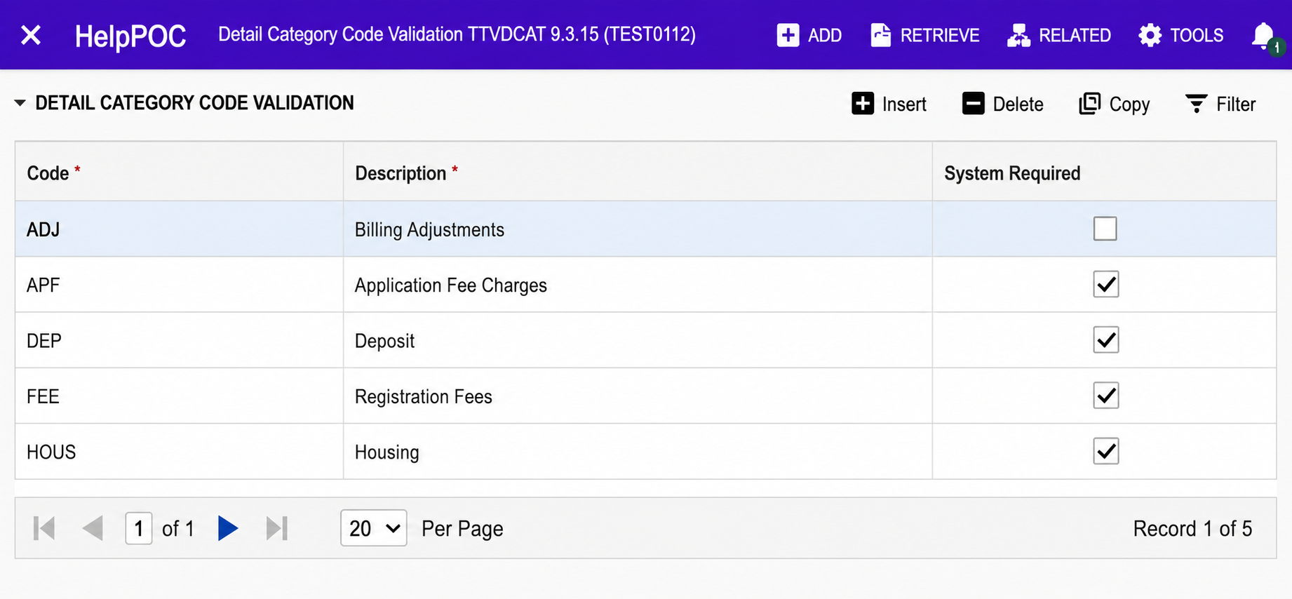

TSADETC-(There will be a Save button at bottom, which got missed in the screenshot)-
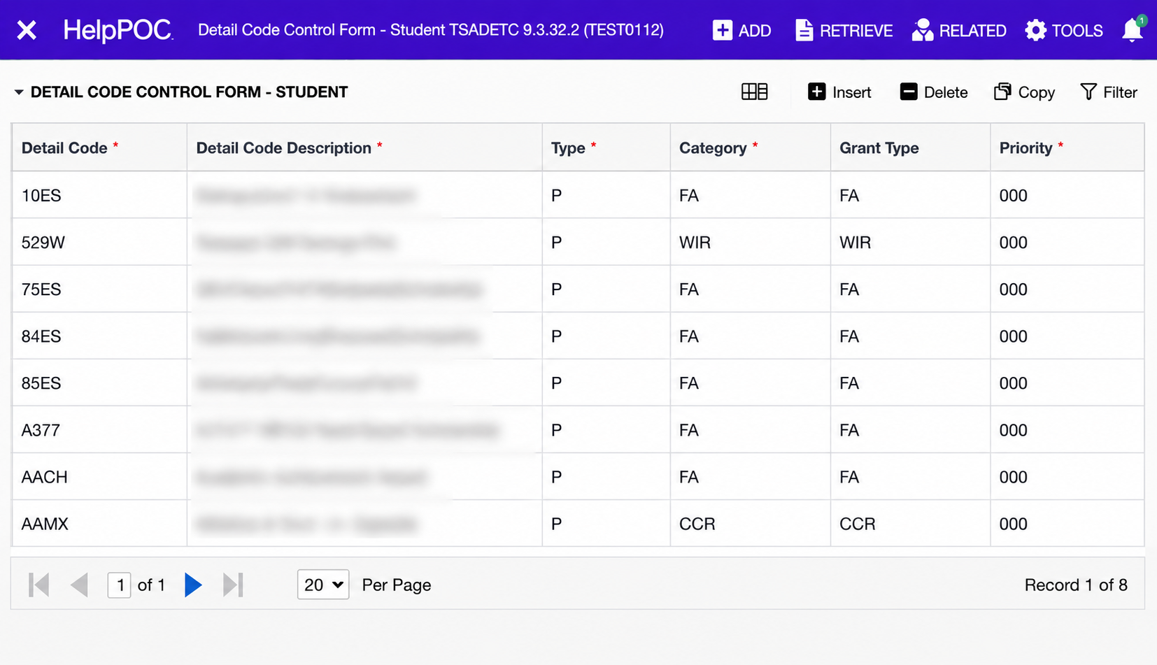

TSADETL
