CAB Approval & UAT Sign-off
Verification Workflow — Technical Overview
CP10 (Change Advisory Board Approval) • CP38 (Business UAT Sign-off)

1. Purpose
This document explains, in plain language, how the two automated audit checkpoints — CP10 (CAB Approval) and CP38 (UAT Sign-off) — verify compliance. It covers the Jira integration via Atlassian's Rovo MCP, the email integration via Microsoft Graph, the narrow role the LLM plays in the process, and the evidence-screenshot capture step. It is written as a readable overview; exact API calls and edge-case handling live in the accompanying technical reference (cp38-cp10-integration.md) in the project's docs folder.

2. The One Rule Both Checkpoints Follow
Identity and eligibility are always decided by a deterministic check — never by the LLM. The LLM is only ever asked one narrow question: does this email's wording explicitly say “approved” or “signed off”? It never decides who someone is, or whether they are allowed to approve. That decision is made by simple, auditable string comparison, before the LLM is ever called.
Each checkpoint is therefore a chain of gates, cheapest and safest first, where each gate only runs because the one before it passed. If any gate fails, everything after it is skipped — CP10, for example, never even searches the mailbox if the Jira ticket is not yet in the right state.

3. Workflow Diagram
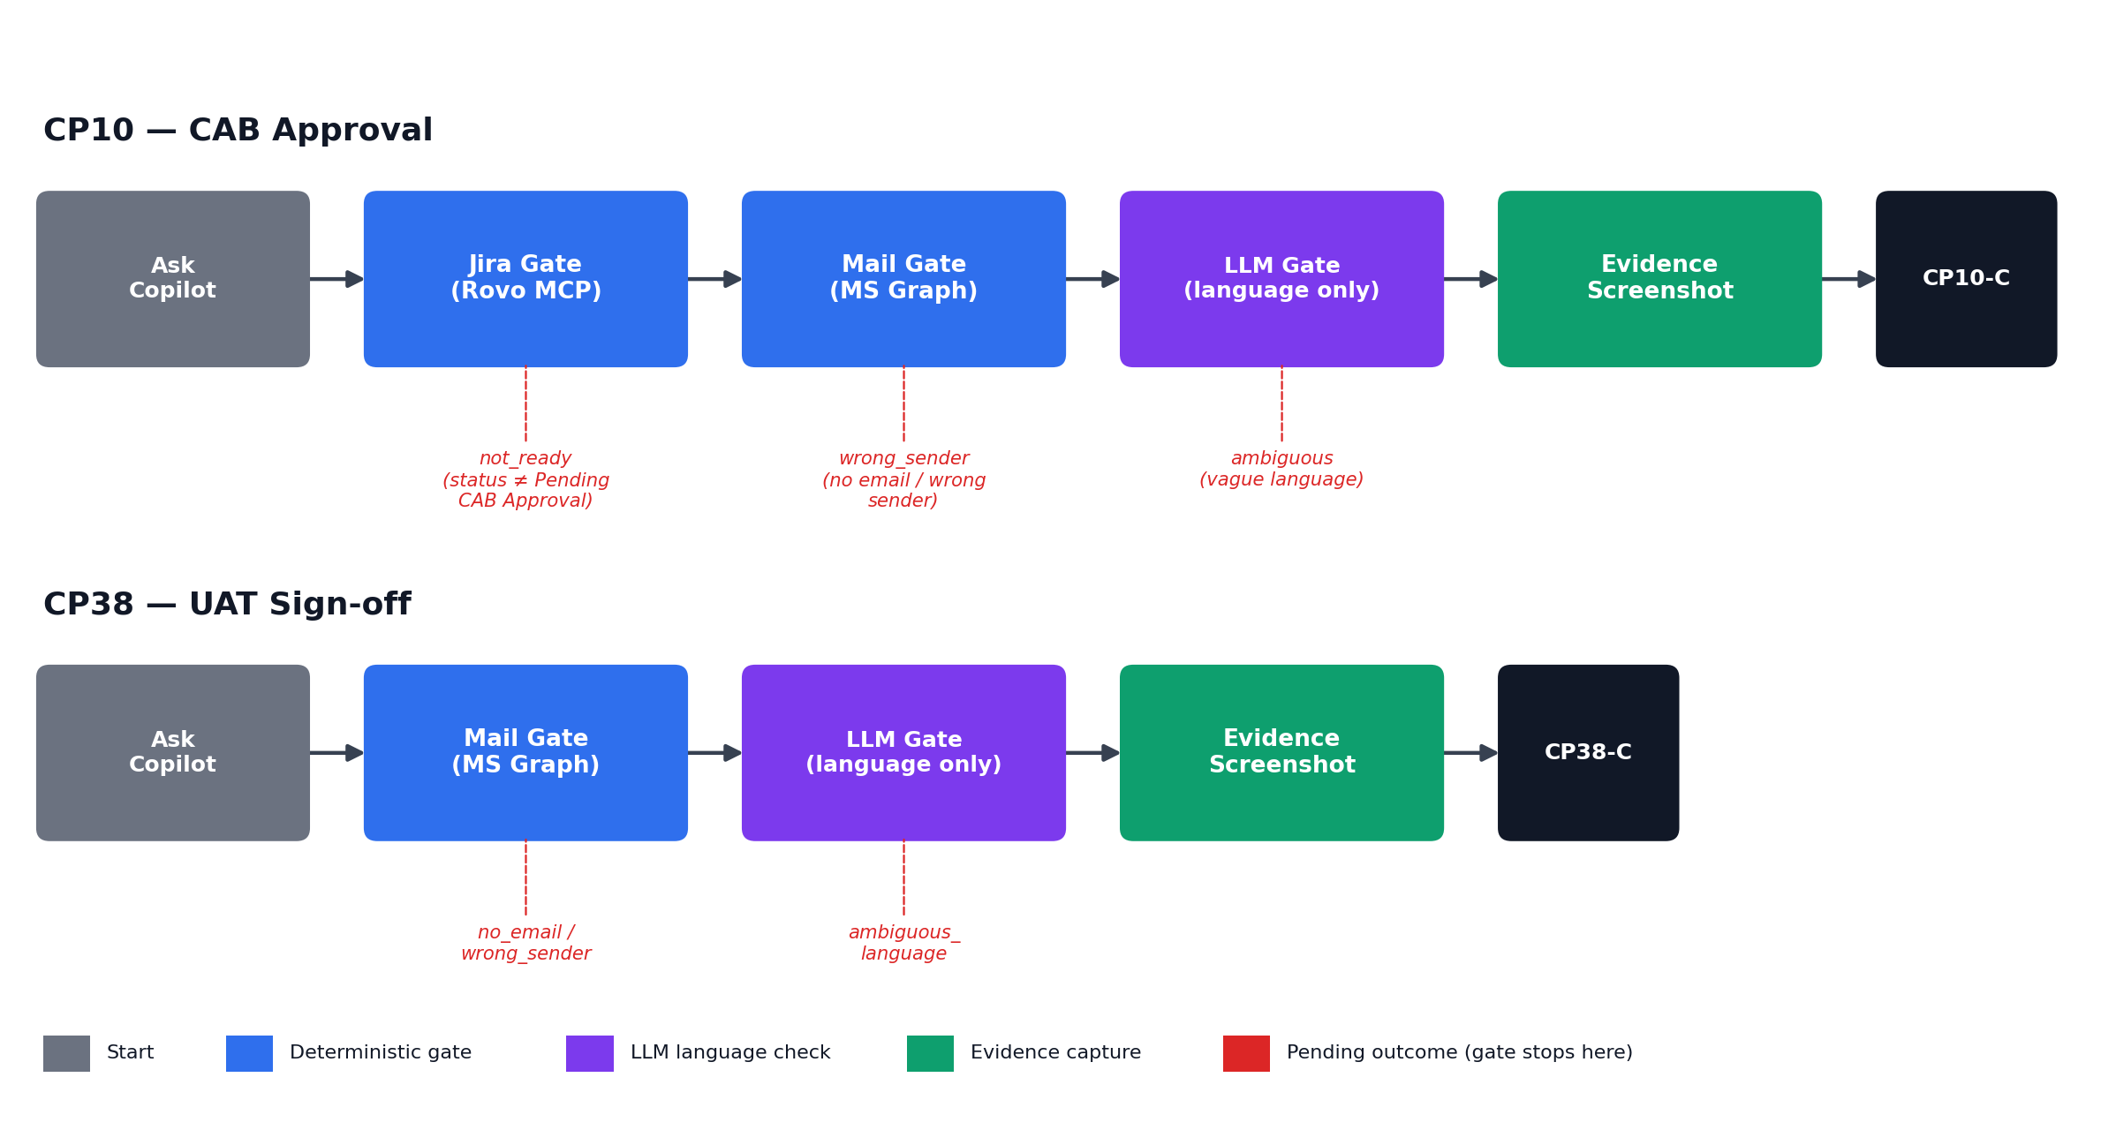
Figure 1 — CP10 and CP38 verification gate chains, including where each Pending outcome stops the flow.

4. CP10 — CAB Approval, Step by Step

Step 1 — Ask the Copilot
A question such as “Check CP10 for PIT Armour” resolves deterministically — keyword and project-name matching, never an LLM guess — to a specific Jira ticket (e.g. POC-3).

Step 2 — Jira Gate (via Rovo MCP)
The app connects to Atlassian's Rovo MCP server (https://mcp.atlassian.com/v2/mcp) as an MCP client, authenticated via OAuth 2.1 with PKCE (no client secret; a one-time interactive login grants read-only access, tokens then refresh automatically). Two of the server's tools are called:
- getAccessibleAtlassianResources — resolves the Atlassian site
- getJiraIssue(issueIdOrKey, view: “full”) — fetches the ticket
The ticket's status must read exactly “Pending CAB Approval.” If it does not, the check stops here — outcome not_ready — and the mailbox is never searched. The ticket's Reporter field is read as the authorized approver's identity (the real ticket has no separate “CAB Approver” custom field, so the existing Reporter field stands in for it).
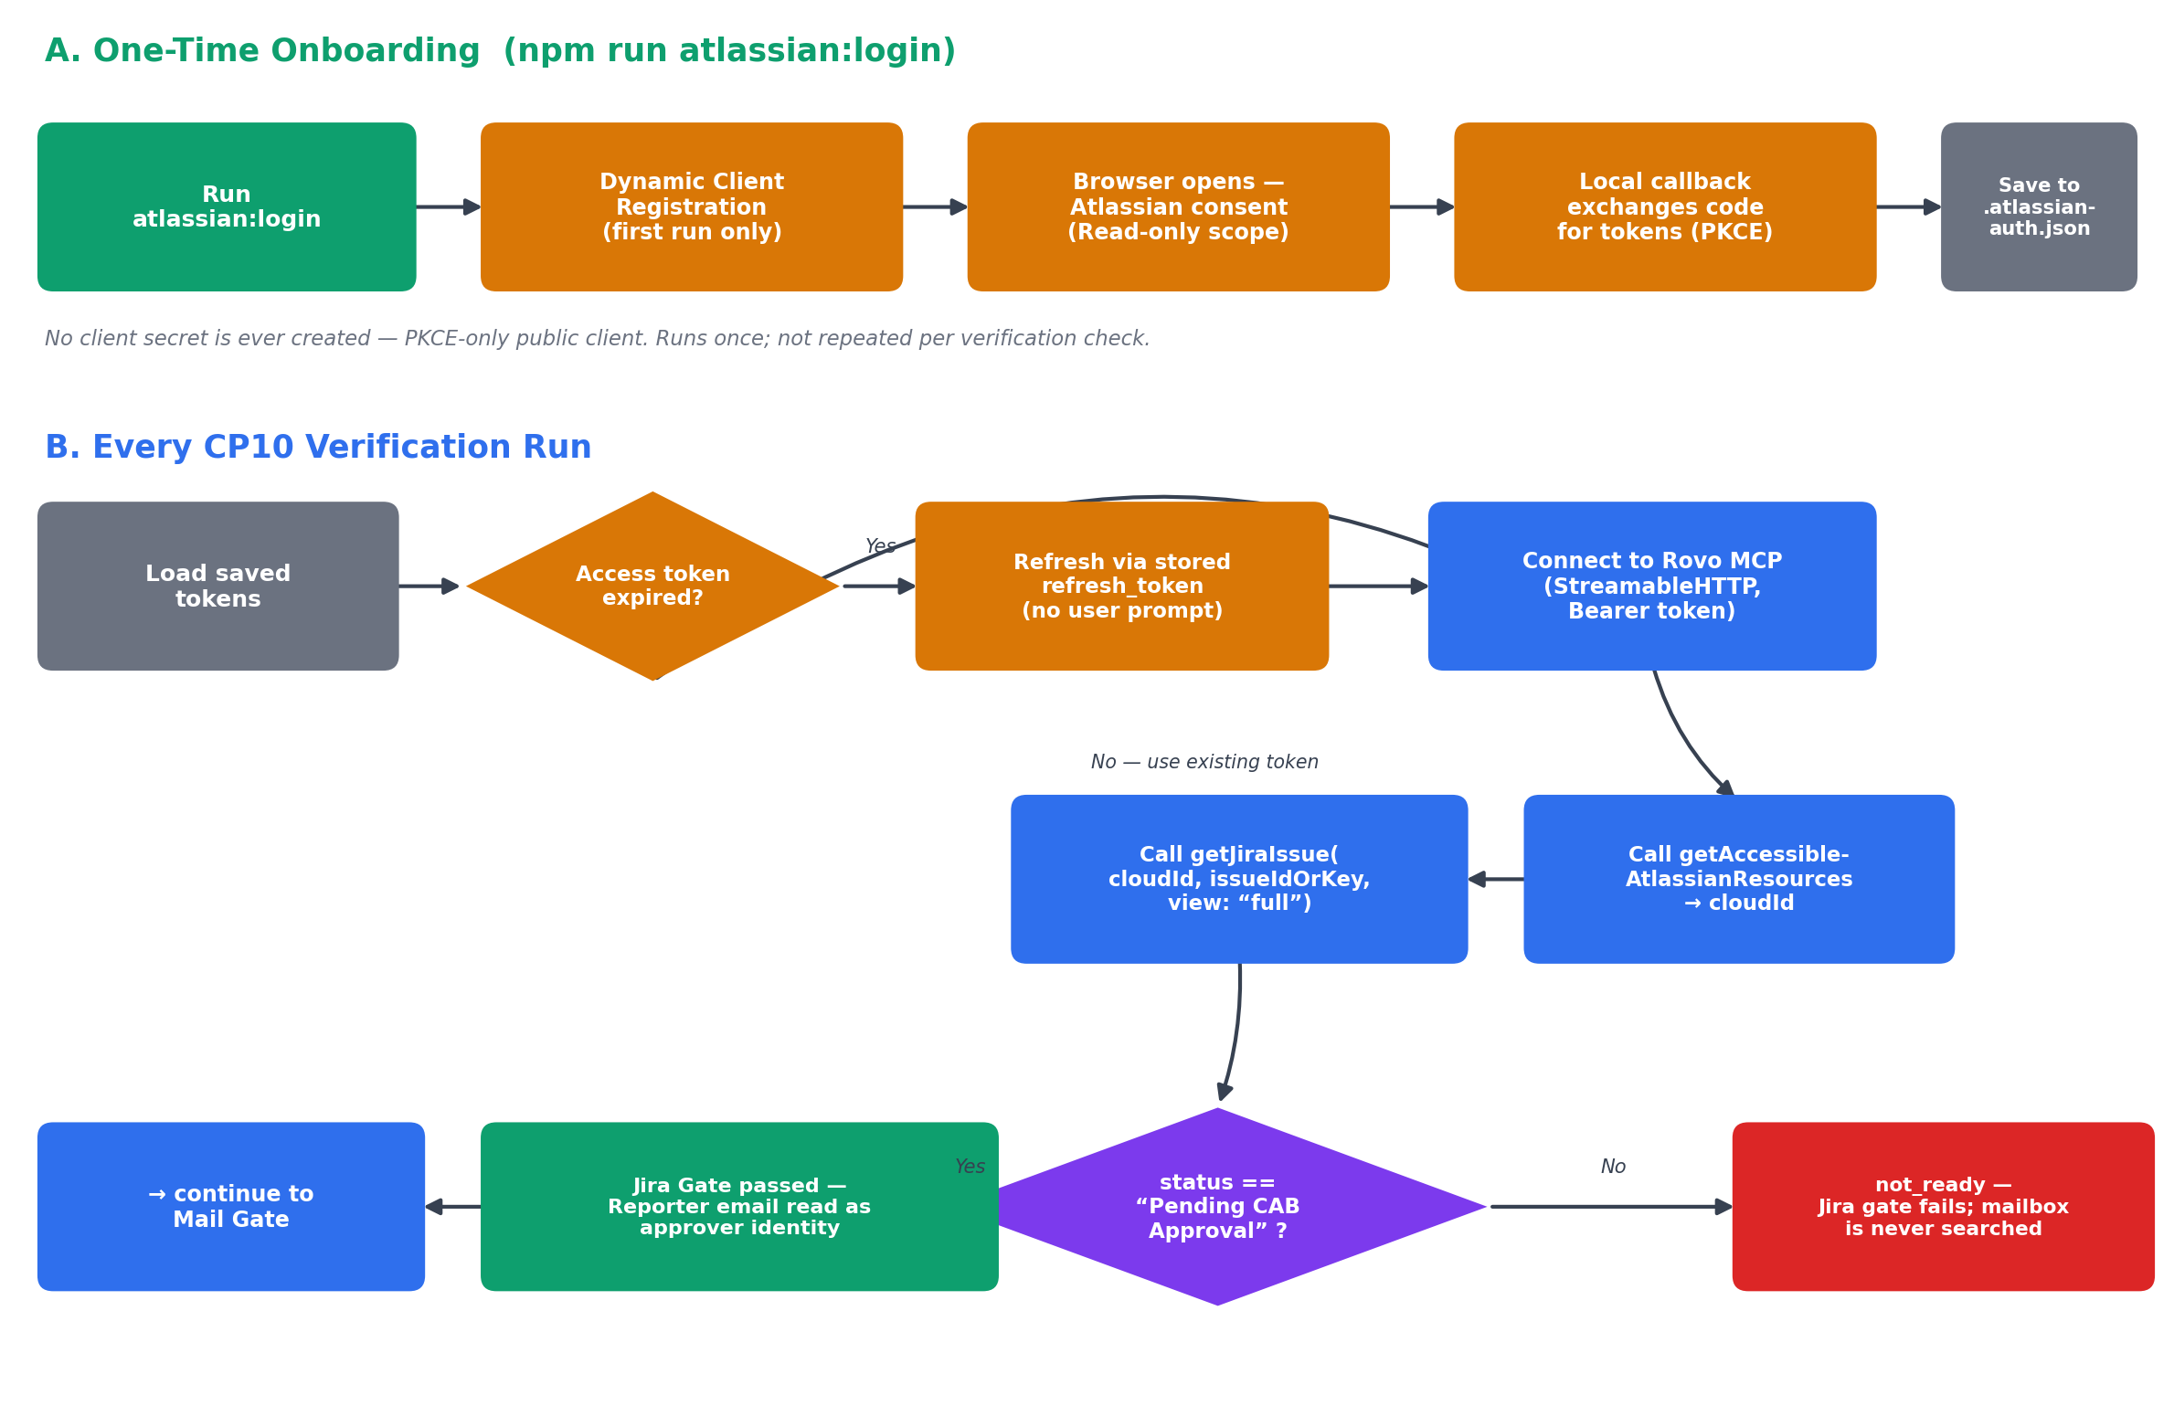
Figure 2 — Onboarding once (interactive OAuth 2.1 + PKCE login) versus what happens on every CP10 run (token reuse/refresh, the two Rovo MCP tool calls, and the Jira-gate decision).

Step 3 — Mail Gate (via Microsoft Graph)
Only once the Jira gate passes is the shared mailbox searched for an email whose subject matches the ticket. If no matching email exists, or its sender does not exactly match the Jira ticket's Reporter email, the check stops — outcome wrong_sender. The LLM is never consulted for this decision.

Step 4 — LLM Gate (language only)
Only once the sender is confirmed correct does the LLM read the email body and judge one thing: is this explicit approval language (“approved for implementation,” “sign off on this release”), or vague and conditional? A parse failure or anything unclear defaults to not approved — it is never silently promoted to compliant.

Step 5 — Evidence Capture
As soon as a matching email exists — regardless of which gate it ultimately passes or fails — a screenshot of that email is captured and saved (see Section 6). This means even a wrong_sender or ambiguous Pending result still shows the auditor exactly what was received.

Result
CP10-C (Compliant) only if all three gates passed. The dashboard's CP10 gate stepper (Jira → Mail → LLM) reflects exactly which gate the check reached, with an Undo control per gate.

5. CP38 — UAT Sign-off, Step by Step
Same shape as CP10, minus the Jira gate (CP38 has no ticket-state precondition):
- Ask the Copilot — e.g. “What's the status of PIT Armour's UAT sign-off?” resolves to the CP38 project config (fixed authorized signer name/email, fixed subject-line convention).
- Mail Gate — search the shared mailbox for the configured subject. No match → no_email. A match from anyone other than the configured authorized signer → wrong_sender (deterministic comparison, LLM never consulted).
- LLM Gate — the same shared classifier used by CP10 checks the body for explicit sign-off language.
- Evidence Capture — as soon as any matching email is found, it is screenshotted; wrong_sender and ambiguous_language results get a screenshot too, not just the compliant one.
- Result — CP38-C only if sender and language both check out.

6. Evidence Capture — What It Actually Does
Once a relevant email is found, the evidence-capture step:
- Re-fetches that email's HTML body from Graph (the earlier search fetched plain text, which is what the LLM reads; HTML is fetched separately, only for the screenshot).
- Wraps it in a small styled page — subject, sender, and received time (converted to IST) — followed by the email body.
- Renders that page in a headless Chromium browser (Playwright) and takes a full-page screenshot.
- Saves the PNG under the project's evidence folder, named by checkpoint, project, and message id (e.g. cp10-project-a-<message-id>.png).
The dashboard — both the CP10 gate panel and the Copilot chat reply — shows a “View screenshot” link that lazily fetches and displays that image on demand.
Scope note: this feature only works in local / Node development. The project's actual deployment target is Cloudflare, whose Workers runtime cannot spawn a real browser process or write to a persistent filesystem — so this is explicitly a local-development-only feature for now.
A capture failure (a Graph error, a Playwright crash, etc.) is logged and swallowed — it never changes the compliance outcome. The screenshot is supporting evidence, never part of the decision itself.

7. Why Rovo MCP Instead of Calling the Jira API Directly
The specification calls for Jira access “via Rovo MCP, OAuth 2.1” rather than a hand-rolled REST call — so the code is a genuine MCP client connecting to Atlassian's own remote MCP server, not a direct integration with Jira's REST API. In practice that means:
- Authentication is user-delegated OAuth 2.1 (PKCE, dynamic client registration — no manually created Atlassian developer-console app, no client secret at all), unlike Graph's app-only email credential.
- A one-time interactive login opens a browser for consent once; after that, tokens refresh automatically for the life of the integration.
- The set of things the app can call is whatever tools Rovo MCP exposes (getAccessibleAtlassianResources, getJiraIssue, etc.), discovered live from the server rather than assumed.
- The granted scope is read-only by deliberate choice — CP10 only ever reads one ticket; it never writes back to Jira.

8. Where Each Piece Lives
Piece | File
CP10's full gate chain | src/lib/cp10-verify.ts
CP38's full gate chain | src/lib/cp38-verify.ts
Shared LLM language classifier | src/lib/approval-classifier.ts
Microsoft Graph auth | src/lib/graph-auth.ts
Atlassian OAuth 2.1 provider | src/lib/atlassian-auth.ts
Rovo MCP client connection | src/mcp/rovo-mcp-client.ts
Evidence screenshot capture | src/lib/evidence-screenshot.ts
Copilot chat UI (routes CP10 vs CP38) | src/components/audit/Cp38Copilot.tsx
CP10 gate-progress UI | src/components/audit/Cp10VerticalProgress.tsx

For full API-call-level detail — exact Graph query parameters, MCP tool payloads, every edge case handled, and the environment-variable reference — see cp38-cp10-integration.md in the same docs folder.

