Game Design Document

Fill up the following document

Write the title of your project.

* The Quest For Heavenly Realms

What is the goal of the game?

* The goal of the game is to reach destination by completing all three levels.
* Player have to collect butterflys to have energy to fight.

Write a brief story of your game.

* Lien is the crown prince of the strongest realm of the heaven“Xian le”. He has gain immortality at age of 17 only because of his power and skills.Order has directely came from heaven toLien(playingcharacter) to destroy the kingdom of demon “Boris”(villain) and to kill him. Boris has destructed all the realms of heaven by his demonic power. So, in order to save all the realms and kill Boris, Lien has to come down from heaven to complete his given task.

Which are the playing characters of this game?

* Playing characters are the ones who respond to the user based on the input from the user.
* Cars, monkeys, dinos, wizards, etc., are the playing characters in the game.

|  |  |  |
| --- | --- | --- |
| Number | Character Name | What can this character do? |
| 1 | Lien | He has great skill in fighting with swords.  He has a weapon called Frost Nova by he can kill Boris but it will unlocked after compleation of 2 level. |
| 2 |  |  |
| 3 |  |  |
| 4 |  |  |
| 5 |  |  |
| 6 |  |  |
| 7 |  |  |
| 8 |  |  |

Which are the Non-Playing Characters of this game?

* Non-Playing characters are the ones that don't have an action or behavior when the user interacts with the game.
* Hurdles, stones, bananas, coins, etc., are non-playing characters in the game.

|  |  |  |
| --- | --- | --- |
| Number | Character Name | What can this character do? |
| 1 | Zombies | It can kill the PC by their infected blood. |
| 2 | Boris | Boris has power to kill PC with his only one Beam of destruction. |
| 3 | Butterflys | San is the friend of Lien. He has come in disguise of butterflys to help his friend by giving him energy to fight. |
| 4 | Monster | It can reduce energy of PC by touching it. |
| 5 | Giants | It can kill PC but for gaining points PC has to kill it . |
| 6 | Hydra | It has a spell called Wave of lava. It can kill instantly PC. But It can be killed by Frost Nova. |
| 7 |  |  |
| 8 |  |  |

Draw your imagination of this game. What does this game look like?

* Draw the game either on your computer or on paper.
* Add images of the game scenes to show each of the playing and non-playing characters at least once.

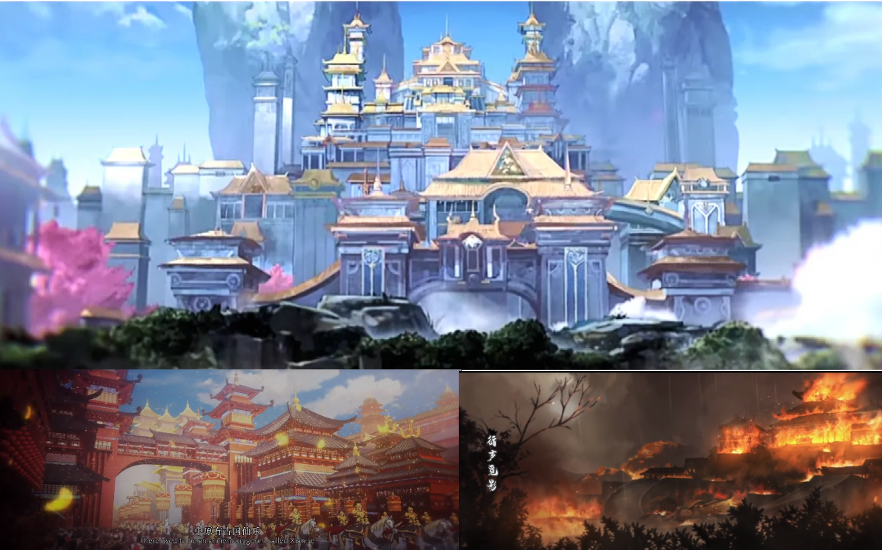

It is few scene from th game which I have created.

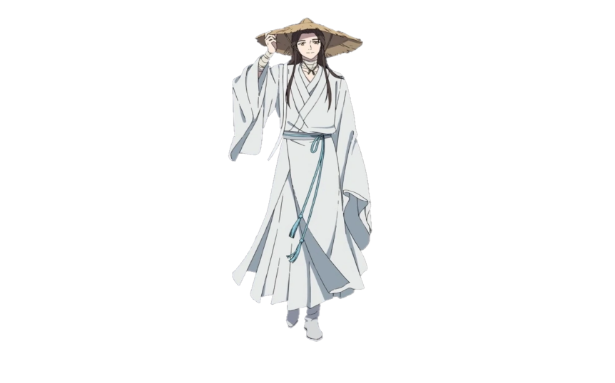He is the playing character(PC).

How do you plan to make your game engaging?

* By increasing difficulty of level little by litte.
* By adding sounds
* By adding new things in each level so, that player get engage for long time.
* By unlocking Frost Nova power in last level to make it more interesting.
* By adding different types of mechanics in each level So, it don’t get boring.