I have index.html

Letter_practise.html

**What You Currently Have:**

You trained a **CNN model on the MNIST dataset**, saved it as mnist_digit_model.keras, and then wrote a script that:

* **Loads the trained model**
* **Reads a user-drawn digit**
* **Predicts the digit using the model**
* **Loads standard digit images from a folder**
* **Compares the user-drawn digit with the standard digit image using cosine similarity**

This **works for individual digit prediction and evaluation**. It’s perfect for a command-line or script-based desktop app.

Trained model on google colab

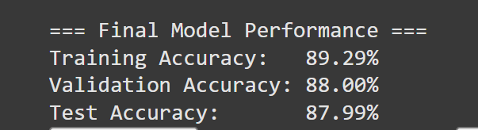

**How the words to pronounce are selected :  
How this list is composed:**

* Commonly mispronounced or confused words
* Words with silent letters (kn, wr, gh)
* Words with tricky vowel sounds (ea, oo, ou, etc.)
* Words with consonant blends (str, thr, pl, etc.)
* High-frequency words but irregular spelling/pronunciation
* Multisyllabic words that cause difficulty
* Words often found in early reading/learning materials for kids

We are using this

|  |  |  |  |  |
| --- | --- | --- | --- | --- |
| **Indian English** |  |  |  |  |
| [vosk-model-en-in-0.5](https://alphacephei.com/vosk/models/vosk-model-en-in-0.5.zip) | 1G | 36.12 (NPTEL Pure) | Generic Indian English model for telecom and broadcast |  |

• Browsers usually record audio in webm or ogg format by default, **not WAV**.

• Vosk requires **16kHz mono 16bit PCM WAV** format, so this setup might fail unless you convert the audio format before sending it or on the backend.