MLOPS ASSIGNMENT 1
Course: MLOps (S1-25_AIMLCZG523)
Deliverable: Final End-to-End Pipeline Report
Submitted by:
Anushka Sharma (2024ab05067)
Aalekh Srivastava (2024aa05408)
Saket Kumar (2024aa05390)
Samudrala Hari Chandana (2024aa05734)
Sandip Mondal (2024aa05708)

1. Project Overview
In the modern healthcare landscape, machine learning offers rapid diagnostic capabilities that can assist medical professionals. However, a standalone model is insufficient for clinical deployment. This project implements a robust, production-ready Machine Learning Operations (MLOps) pipeline designed for the classification of heart disease. The primary objective is to automate the entire lifecycle of the machine learning model, effectively bridging the gap between data science experimentation and production operations.
Key goals achieved in this project include:
- Reproducibility: Ensuring that data processing and model training can be repeated with consistent results.
- Automation: Reducing manual intervention through CI/CD pipelines and scripted setups.
- Scalability: Utilizing containerization and orchestration to handle varying loads.
- Observability: Implementing logging and metrics to monitor system health in real-time.

2. Repository Structure
The project follows a standard MLOps directory structure to ensure separation of concerns. Below is a detailed breakdown of the files and their purposes:
File / Directory | Description
app.py | Flask REST API application that serves the model predictions.
Dockerfile | Defines the production container environment (Python 3.9 slim).
k8s_deployment.yaml | Kubernetes Deployment definition managing replicas and resources.
k8s_service.yaml | Kubernetes Service definition exposing the API via LoadBalancer.
assignment.ipynb | Jupyter notebook for EDA, feature engineering, and model training.
heart_disease_pipeline.pkl | Serialized Scikit-learn Pipeline (preprocessing + model).
scaler.pkl | Serialized scaler artifact.
requirements.txt | Pinned Python dependencies for reproducible environments.
test/ | Directory containing automated test suites (test_model.py).
scripts/ | Helper scripts (e.g., verify_setup.sh).
.github/workflows/ | GitHub Actions CI pipeline definitions.

3. Data Science Workflow

3.1 Data Source & Preprocessing
The project utilizes the UCI Heart Disease dataset (ID 45). Data is fetched programmatically using the `ucimlrepo` library to ensure version consistency vs manual downloads.
Key Preprocessing Implementation:
- Imputation: Missing values in 'ca' (major vessels) and 'thal' are imputed with the mode (most frequent value) to preserve data volume.
- Encoding: Categorical variables ('sex', 'cp', 'slope', etc.) are transformed using One-Hot Encoding to prevent ordinal assumptions.
- Scaling: Numerical features are normalized using StandardScaler to unit variance, crucial for the distance-based stability of the model.

3.2 Model Architecture
The final model is encapsulated in a Scikit-learn `Pipeline`. This ensures that raw input data during inference undergoes the exact same transformations (Scaling, Encoding) as the training data.
Artifact: `heart_disease_pipeline.pkl` (contains Preprocessor + Classifier).

3.3 Experiment Tracking
MLflow is integrated to track model iterations. It automatically logs:
- Hyperparameters: max_depth, n_estimators, etc.
- Metrics: Accuracy, Recall, F1-score.

4. Engineering & Deployment

4.1 API Service (app.py)
The model is served as a microservice using Flask.
- Endpoint: POST /predict
- Input: JSON object representing patient features.
- Output: JSON with prediction (0/1) and confidence score.

4.2 Containerization
We use Docker to package the application. The `Dockerfile` uses `python:3.9-slim` to minimize image size. The serialized model is copied directly into the image, making the container self-sufficient.

4.3 Orchestration (Kubernetes)
The application is designed for Kubernetes (Minikube verified).
- Deployment: Manages pod replicas and enforces resource limits (CPU/Memory).
- Service: Exposes the pods via a LoadBalancer on port 80, routing to container port 5000.

5. Continuous Integration (CI/CD)
Continuous Integration is managed via GitHub Actions (`.github/workflows/mlops_pipeline.yml`). Every push to `main` triggers:
- 1. Environment Setup (Python 3.9)
- 2. Linting (flake8): Checks for syntax errors and coding standards.
- 3. Automated Testing (pytest): Executing `test/test_model.py`.
The test suite includes:
- Existence Checks: Verifying model artifacts (`.pkl`) and data files exist.
- Model Loading: ensuring the pipeline object deserializes correctly.
- Inference Smoke Test: Running a dummy prediction to verify output shape and type.

6. Monitoring & Observability
The application is instrumented with `prometheus-flask-exporter`. The `/metrics` endpoint exposes:
- System Metrics: CPU usage, Memory usage.
- Application Metrics: Request latency, Status codes.
- Business Metrics: `prediction_requests` counter to track model usage volume.

7. Conclusion
This project successfully demonstrates the transition of a machine learning model from a Jupyter notebook to a production-grade microservice. By establishing pipelines for Data, Code, and Deployment, we minimize manual errors and accelerate the time-to-market for model updates.

Appendix: Evidence
Refer to the 'screenshots/' folder in the repository for high-resolution evidence.
Required screenshots include:
- EDA results
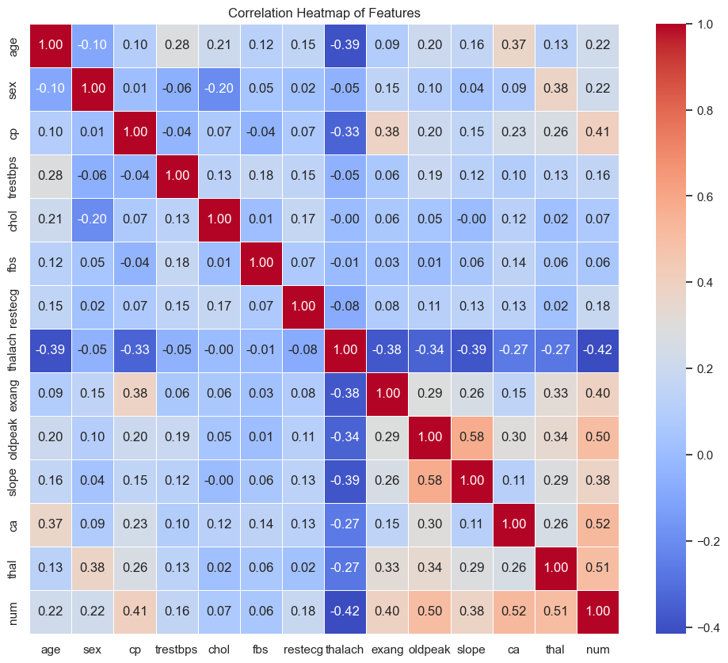

- Model training
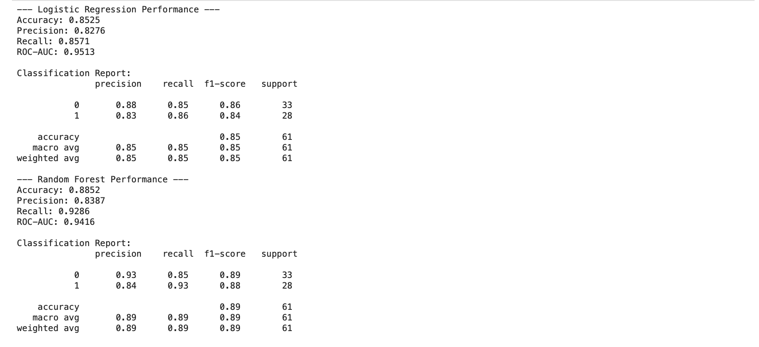
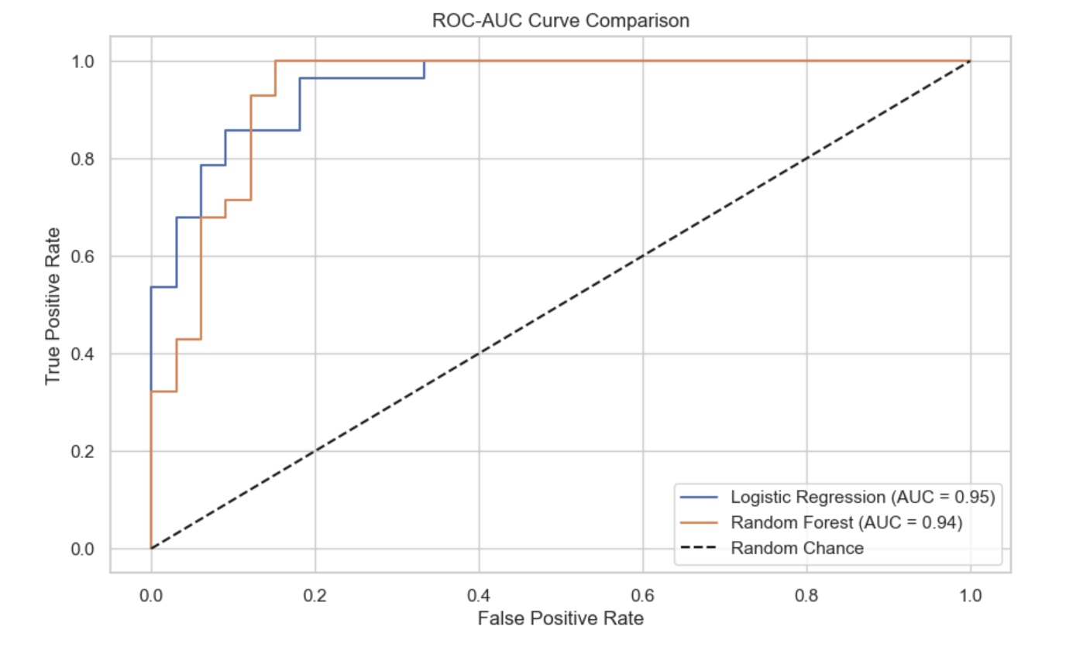
- MLFlow Experiment Tracking
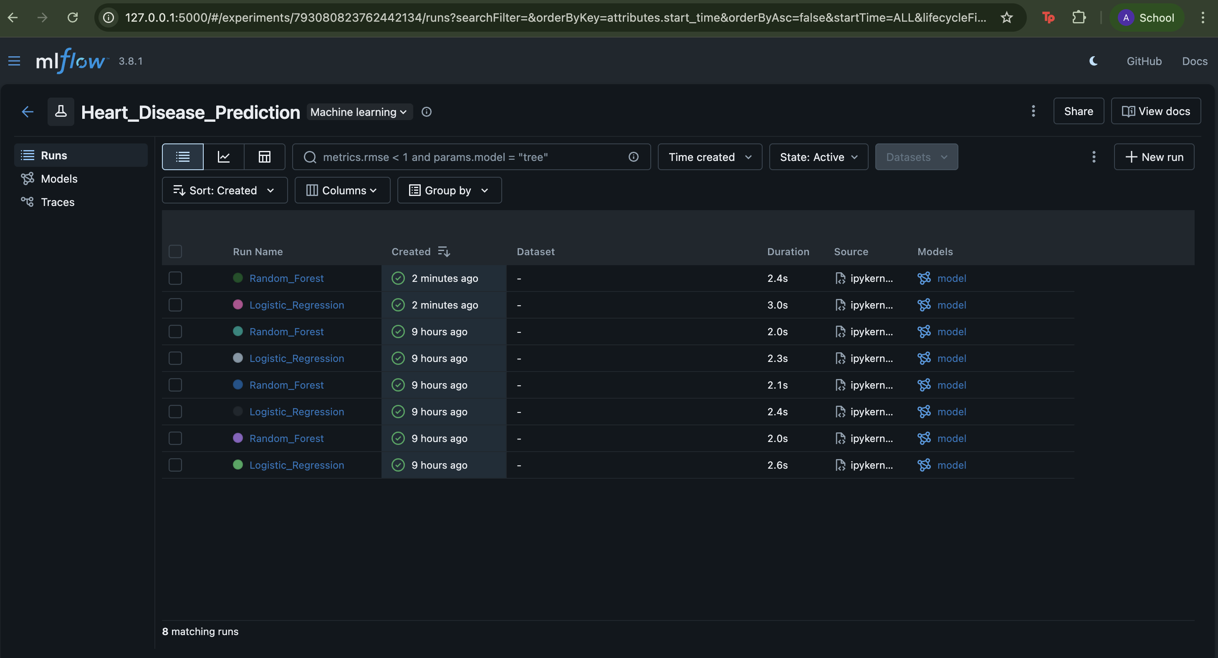

- Deployment Status: Output of `kubectl get all`.
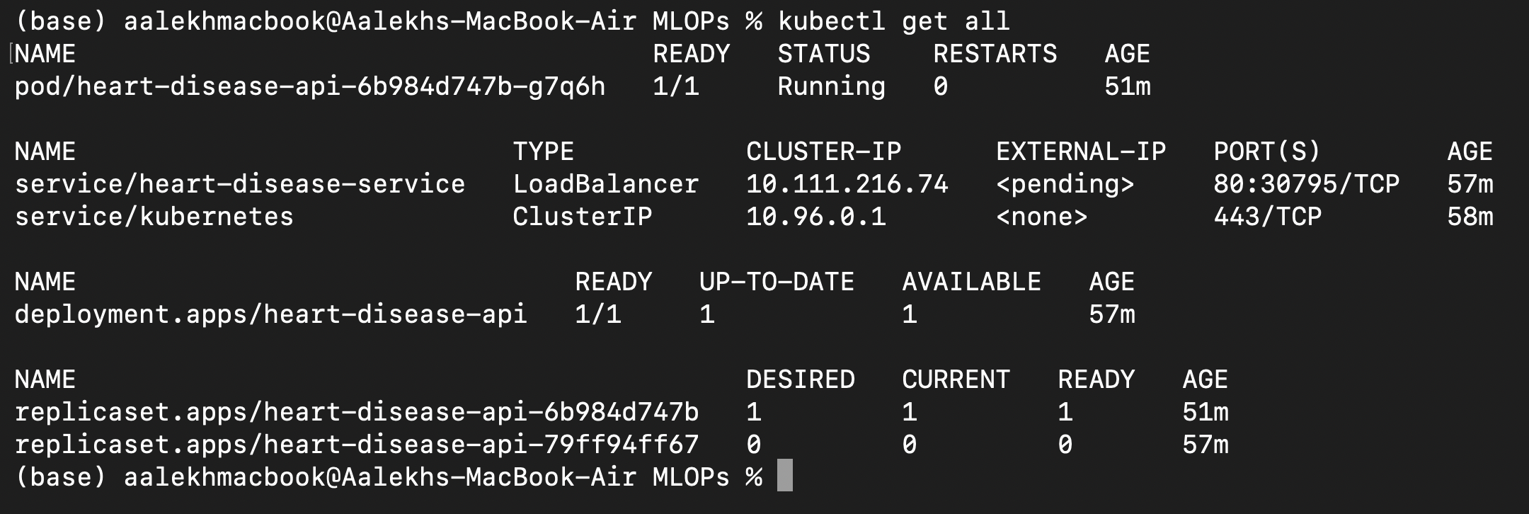

- API Test: `curl` command output showing a successful prediction.
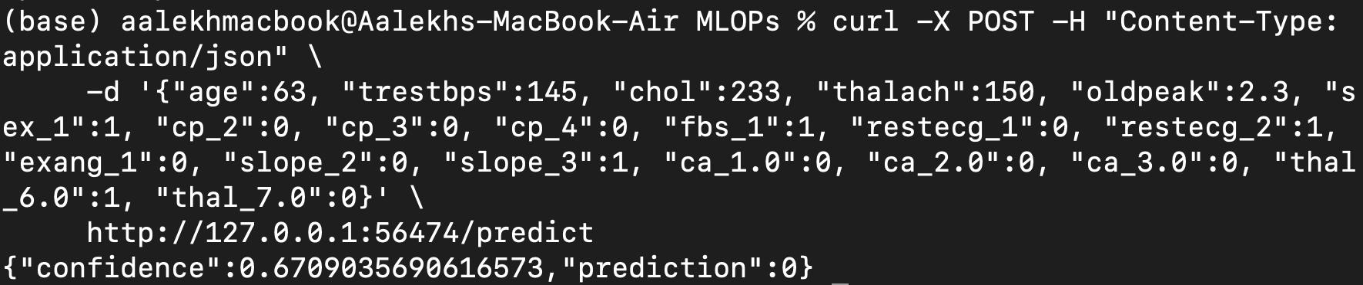

- CI Pipeline: GitHub Actions dashboard showing success.
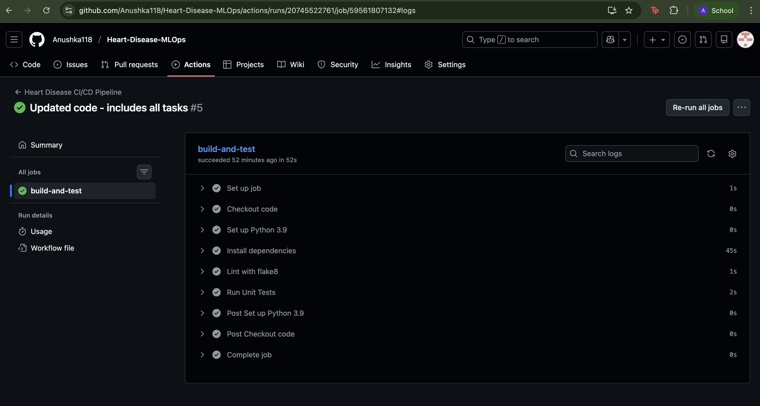
- Metrics: Browser view of the `/metrics` endpoint