
Shri. Vile Parle Kelavani Mandal's
Institute of Technology, Dhule
Survey No. 499, Plot No.2, Behind Gurudwara, Mumbai Agra Highway, Dhule (MS)
Name:- Anushka Paras Jain  Roll no:- 01 Date :- / /  Branch :-Final Year B.Tech (Computer Department)  Exp. No:-2  Subject:- Cloud Computing Lab | Sign :-
 | Remark :-
Aim: Create a scenario in wordpress for Social Marketing, Search engine and Sharing Tools
Theory :
1. What is XAMPP?
- XAMPP stands for cross-platform, Apache, MySQL, PHP and Perl. It’s a simple and lightweight solution that allows you to create a local web server for testing purposes.
- Since XAMPP is cross-platform, it also works on Mac and Linux, but today we’re going to focus on how to set up XAMPP on Windows 10.
- WordPress isn’t a stand-alone application and requires server software in order to run. XAMPP provides the necessary environment needed to run WordPress on a local machine.
2. Install Xampp
- Click on Databases near the top-left, and you’ll be prompted to create a new database. I’ve called mine “WP.”
- When you’ve entered a name, click Create and close the window.

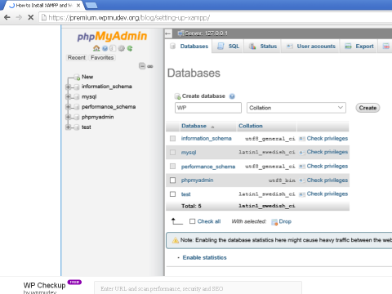
3. Download and Install WordPress:
- Download the latest version of Word Press.
- https://wordpress.org/download/
- In order to get WordPress working with XAMPP, we need to unzip WordPress in the right folder. Go to the XAMPP folder on your computer and open the htdocs folder – C:/Program Files/XAMPP/htdocs.
- Unzip WordPress into its own folder and rename it whatever you like. For consistency, I’m going to call this installation of WordPress “WP” to match the name of the database I just created.
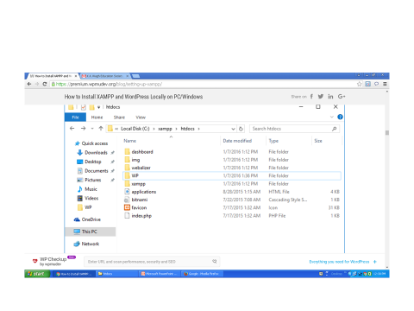
- Open the WP folder where you saved WordPress, find the wp-config-sample.php file and rename it wp-config.php. Open the file and scroll down until you see the following lines:
- 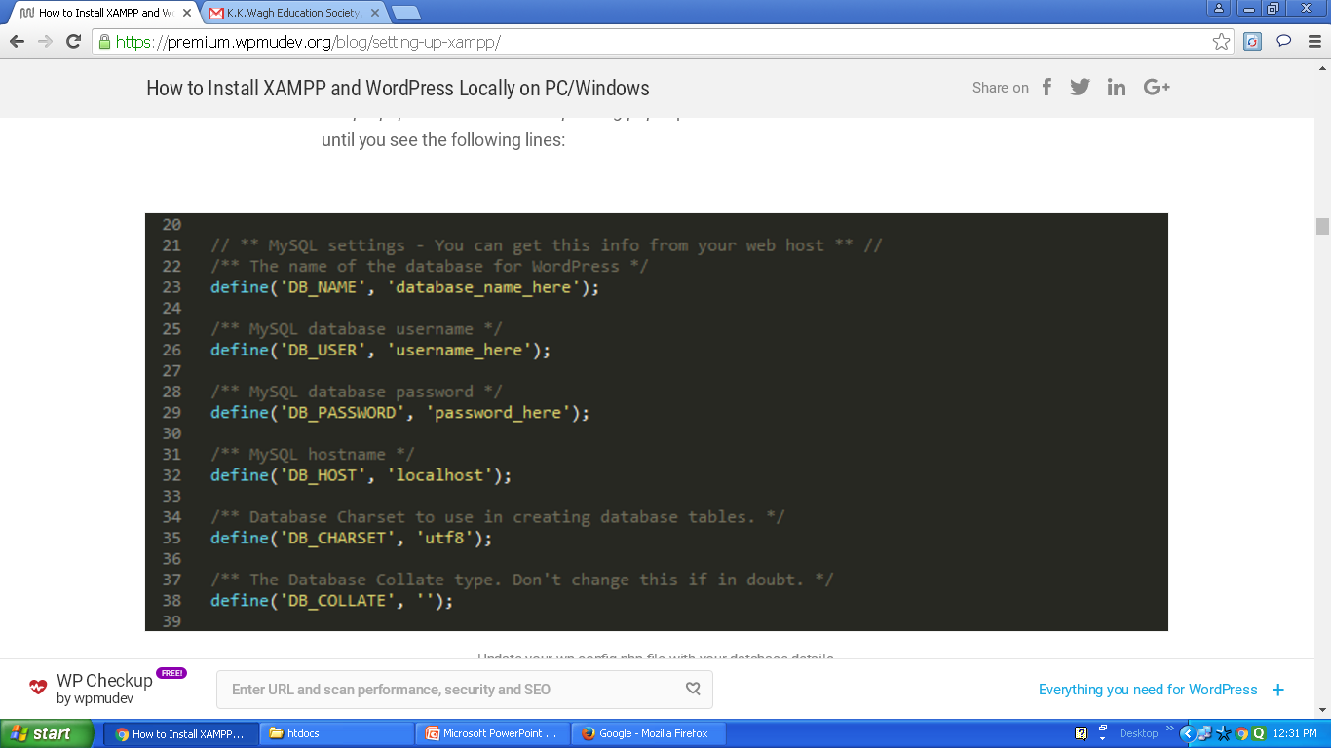

- These lines of code define the login details for your database:
- Replace“database_name_here” with the name of your database, which in my case is “WP”
- Replace “username_here” with “root” and leave “password_here” blank
- Save the file and close it
- Now we can get on with actually installing WordPress.

4. Open your browser:
Open your browser and go to http://localhost/wp/
- You should see the translation screen that comes before the famous five minute WordPress installation process.
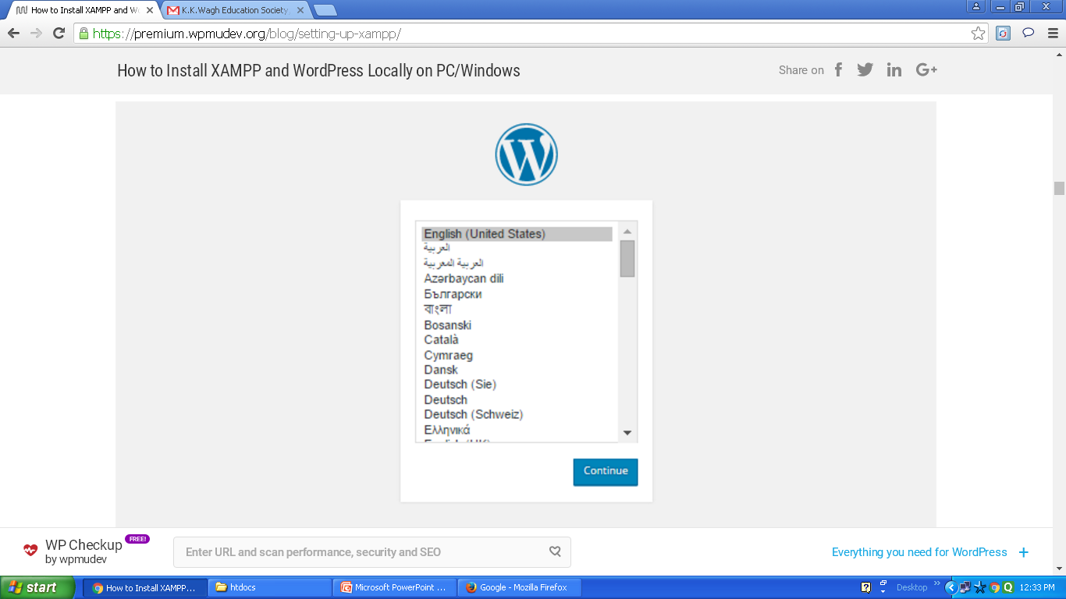

5. Create the Login Page & Registration form for any Application using wordpress

