
Shri. Vile Parle Kelavani Mandal's

Institute of Technology, Dhule
Survey No. 499, Plot No.2, Behind Gurudwara, Mumbai Agra Highway, Dhule (MS)

Name:- Anushka Paras Jain  Rollno:- 01 Date :- / /2020  Branch :-Final Year B.Tech (Computer Department)  Exp. No:-4  Subject:- Cloud Computing Lab | Sign :-
 | Remark :-

Aim: Working in Codenvy to demonstrate Provisioning and Scaling of a website
Steps:
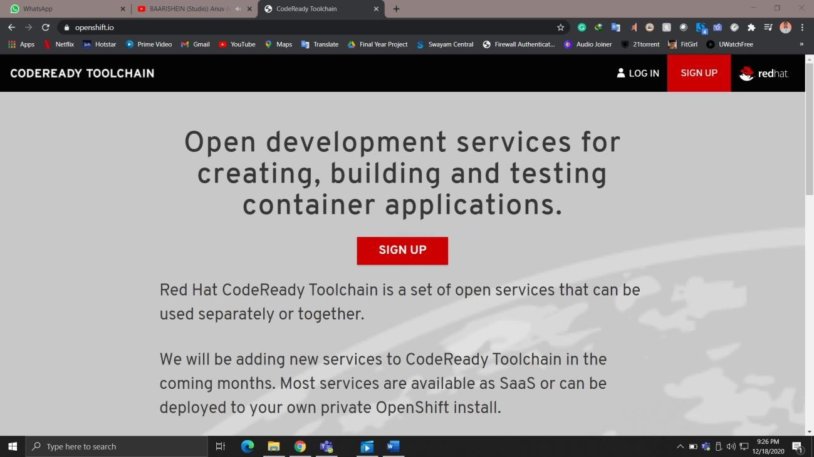

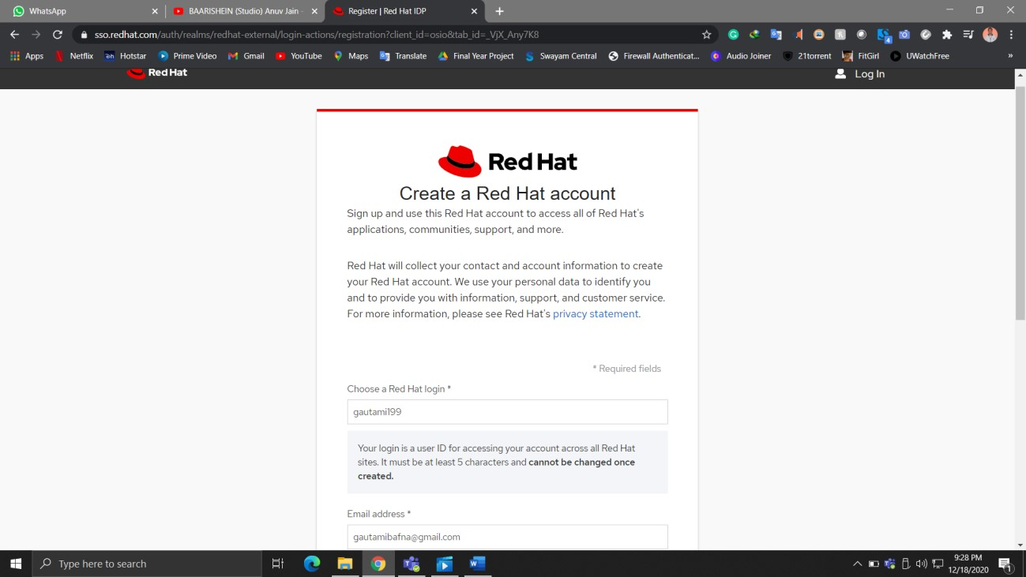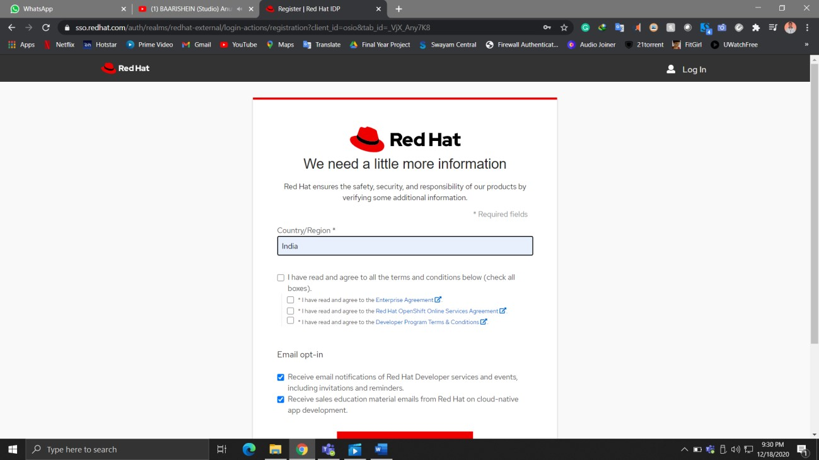
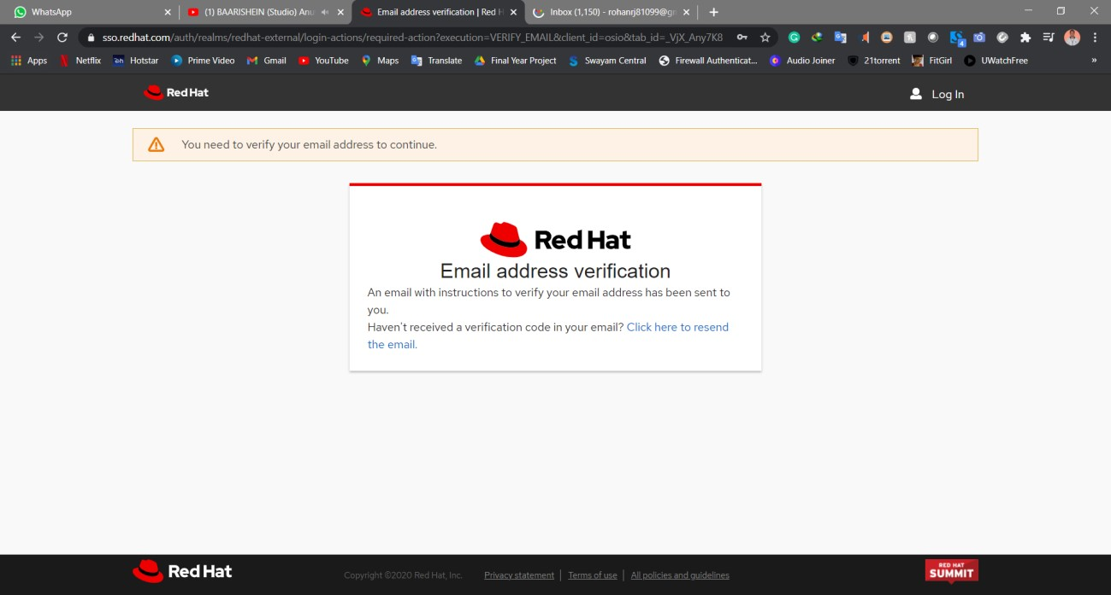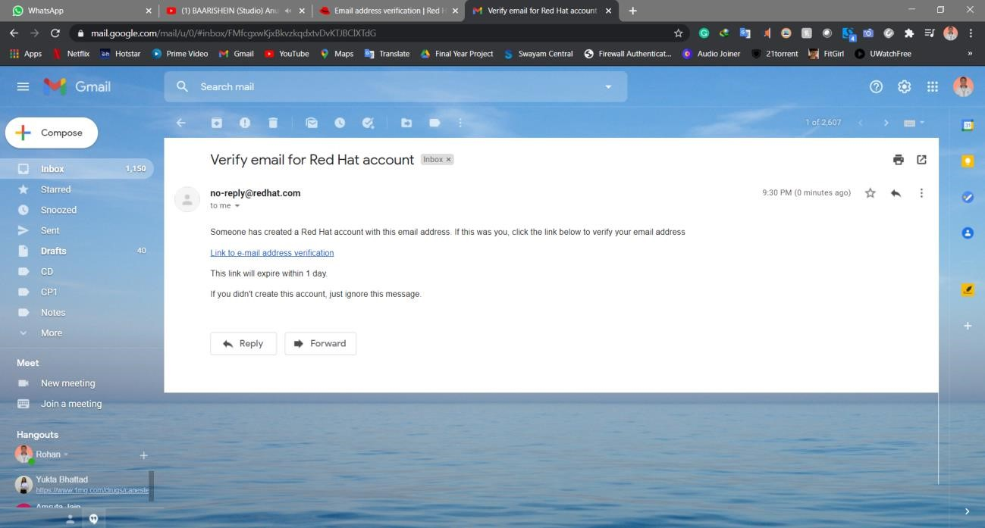
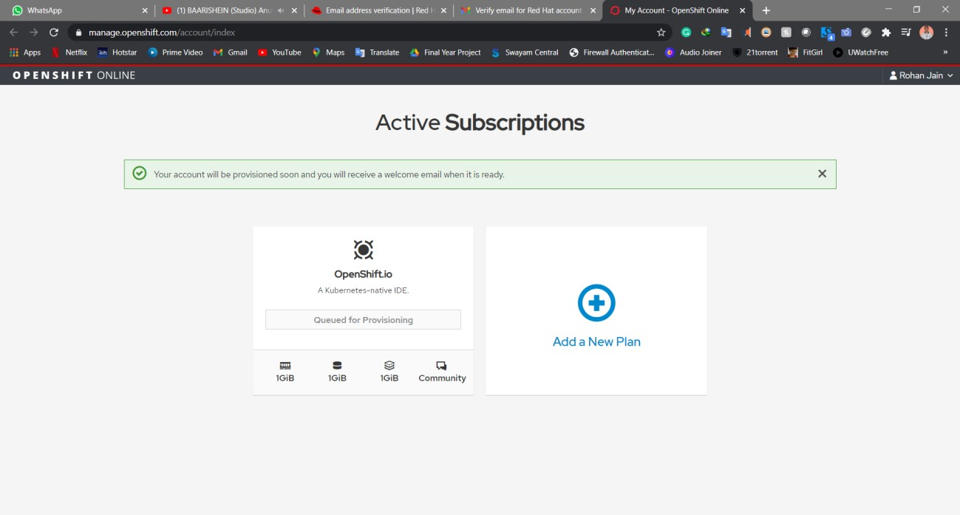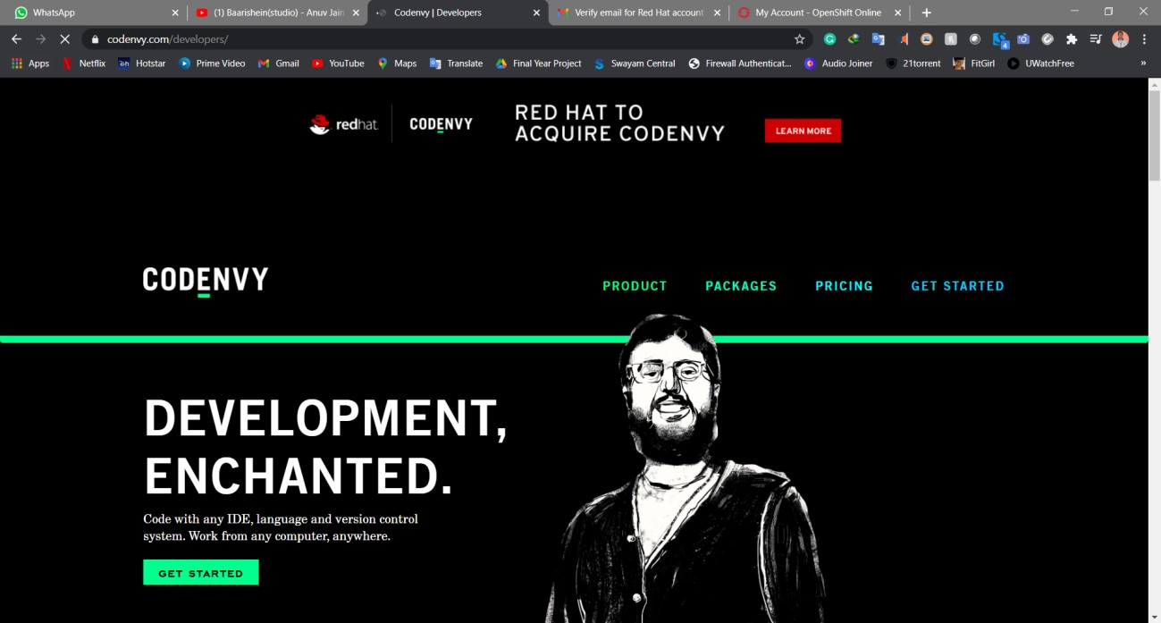
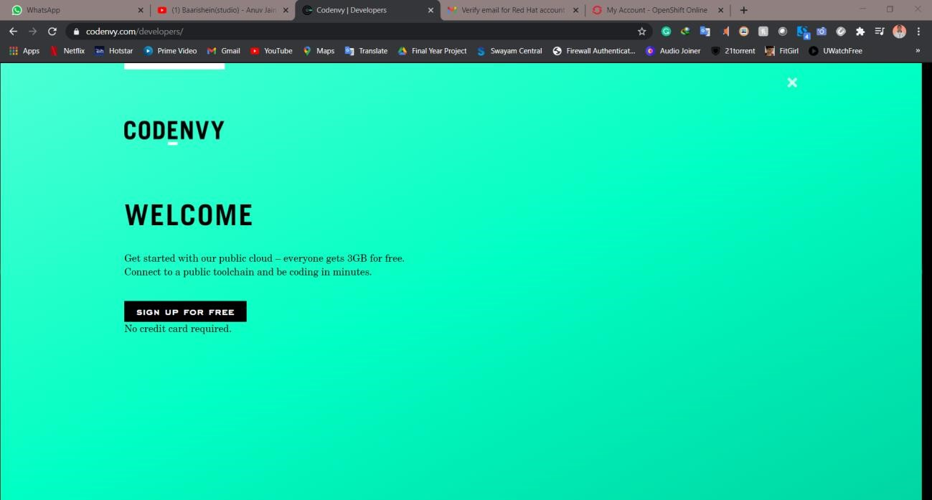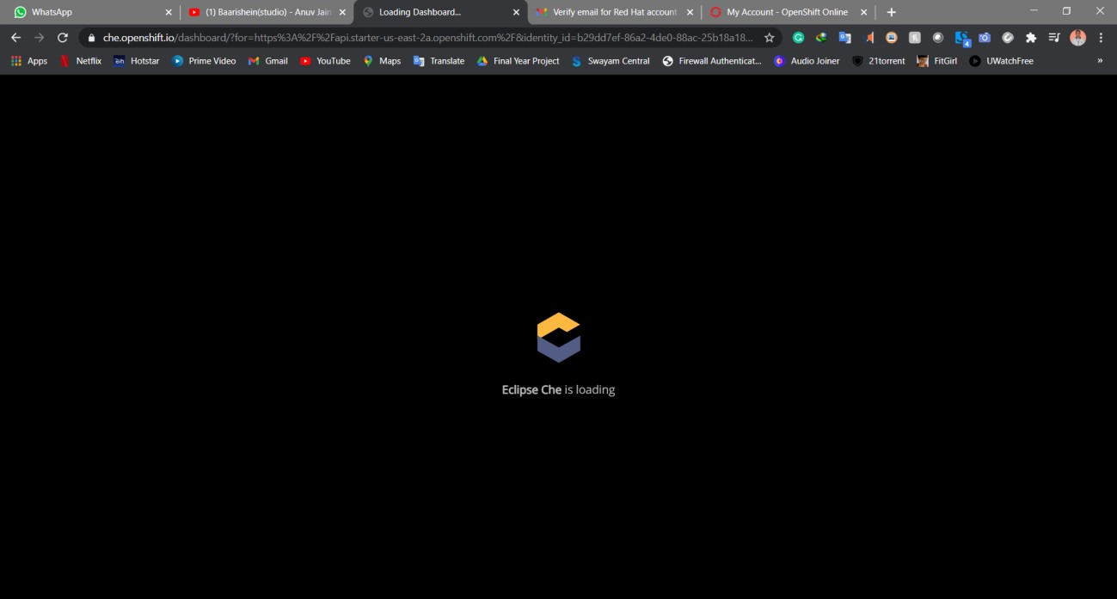
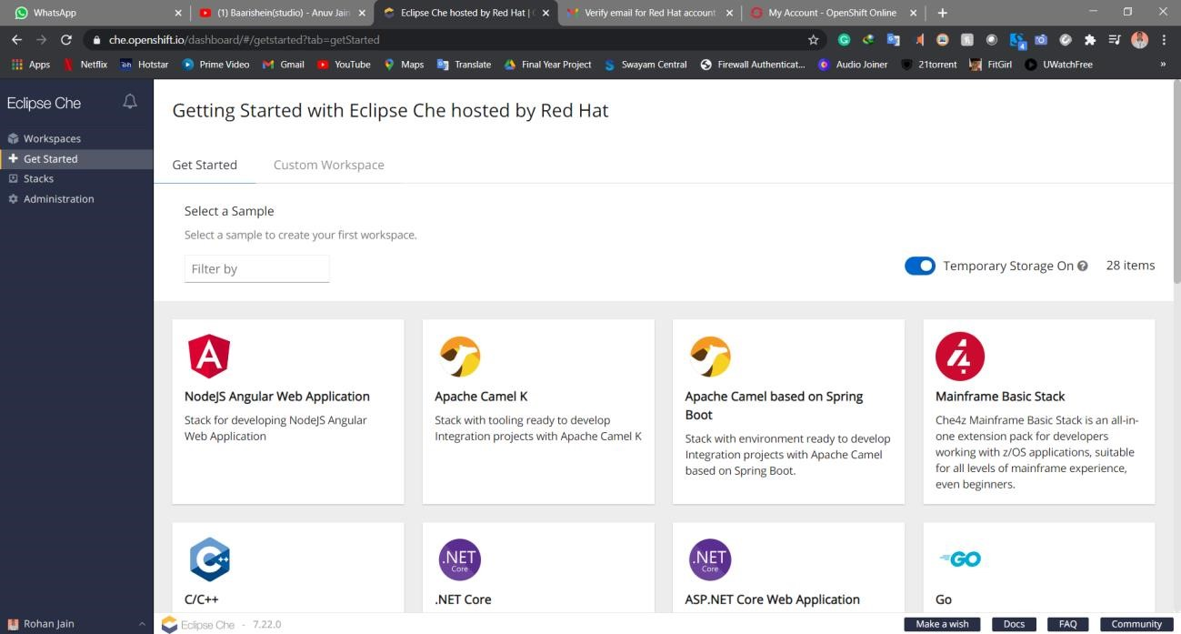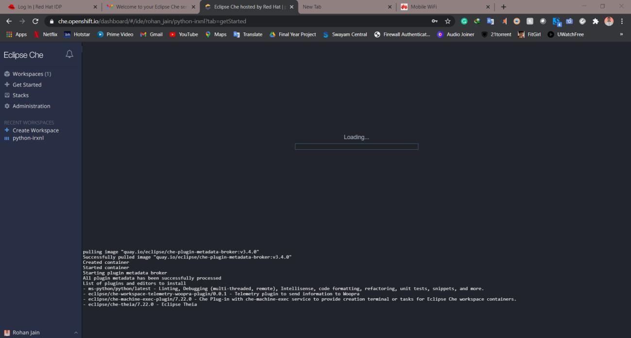
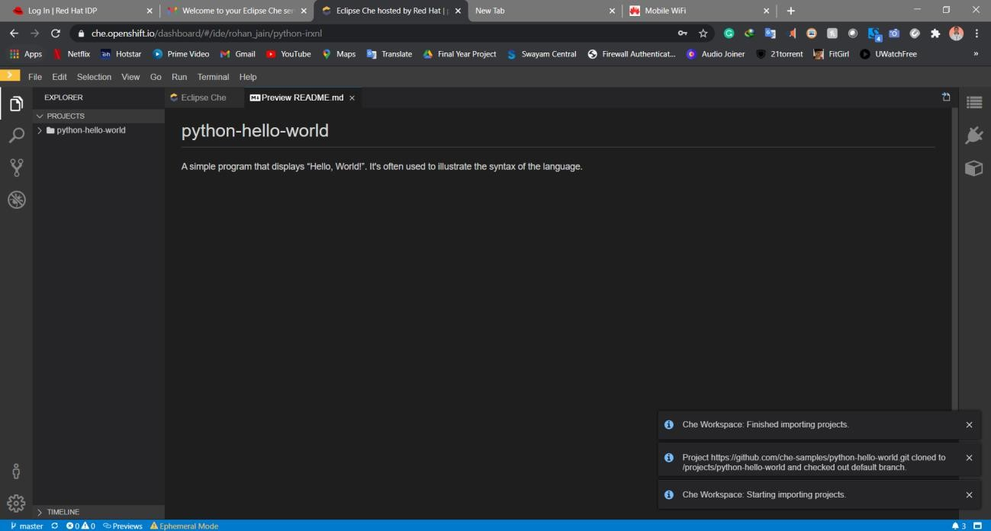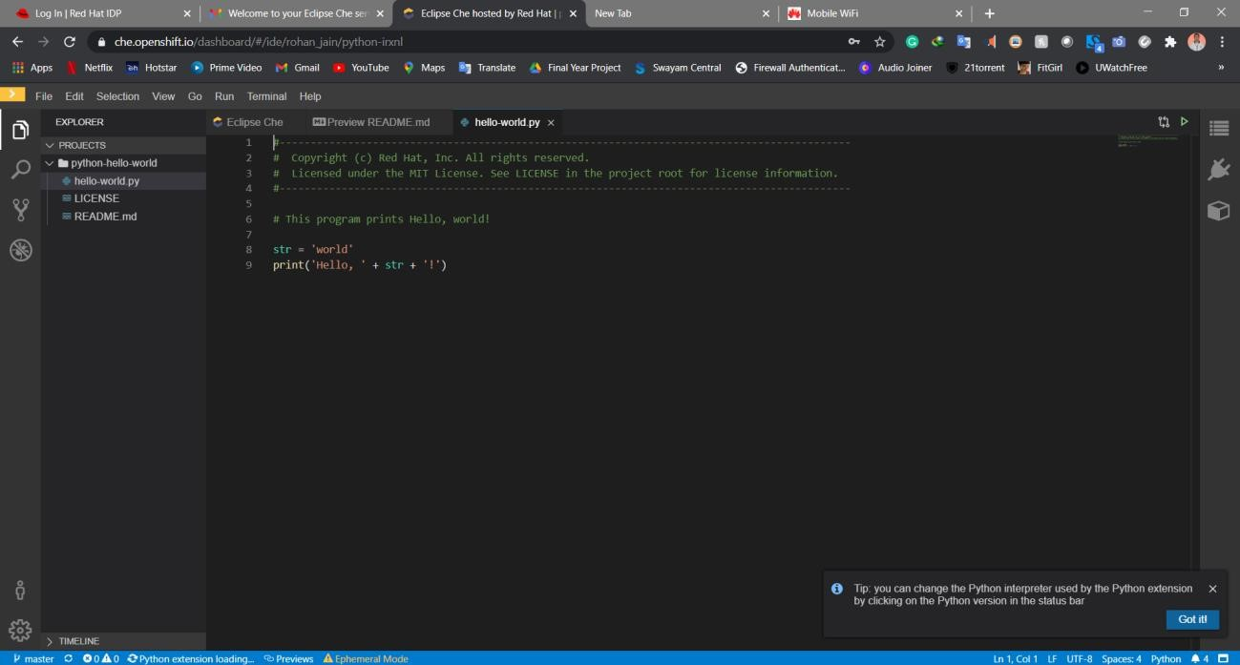

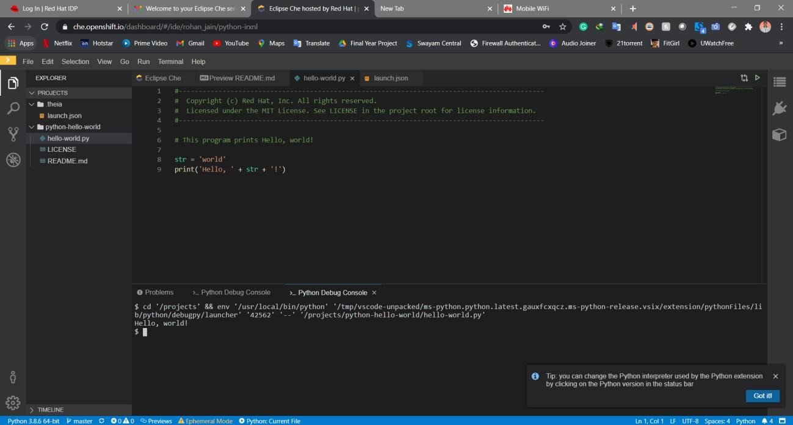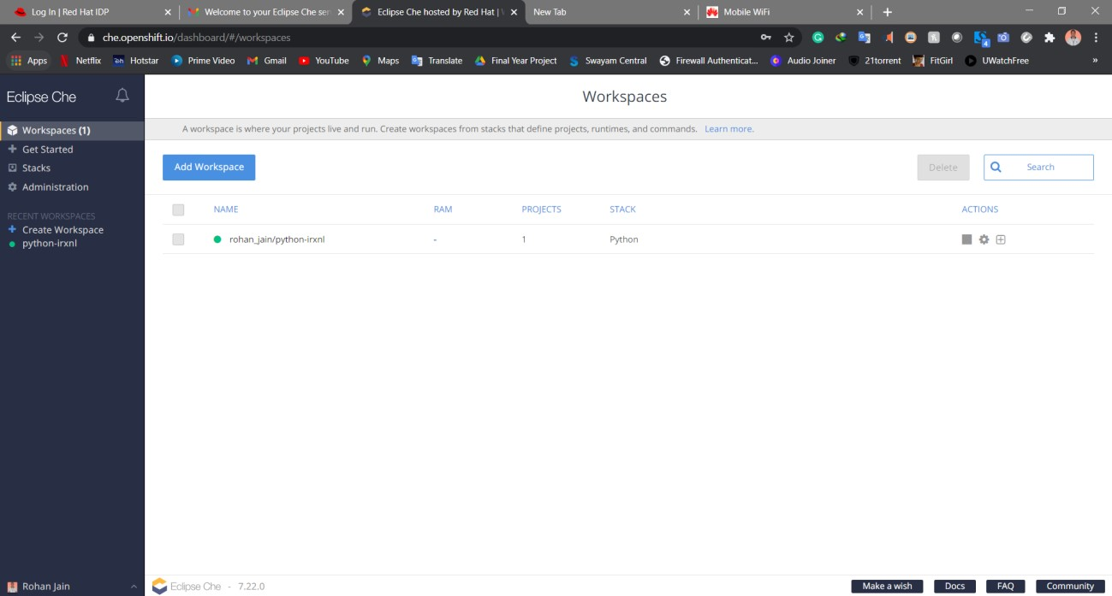

Conclusion: We have seen how to use Codenvy and how to create workspace and use that workspace to deploy the desired code.

